TUTORIAL 14: SELENIUM WEB ELEMENTS AUTOMATION
STUDENT PRACTICAL EXECUTION & SCREENSHOT REPORT
Course: Software Testing & Quality Assurance | Enrollment No: 2604040330001
Target Application: Selenium Web Form (https://www.selenium.dev/selenium/web/web-form.html) | Submission Date: October 2026

1. Practical Purpose & Element Locator Strategy
This tutorial exercises automation across diverse HTML form web elements using Selenium WebDriver: Text Box, Password, Text Area, Dropdown (Select), Checkbox, Radio Button, Date Picker, and Submit Button, followed by response page verification.
2. Python Automation Script Code Screenshot
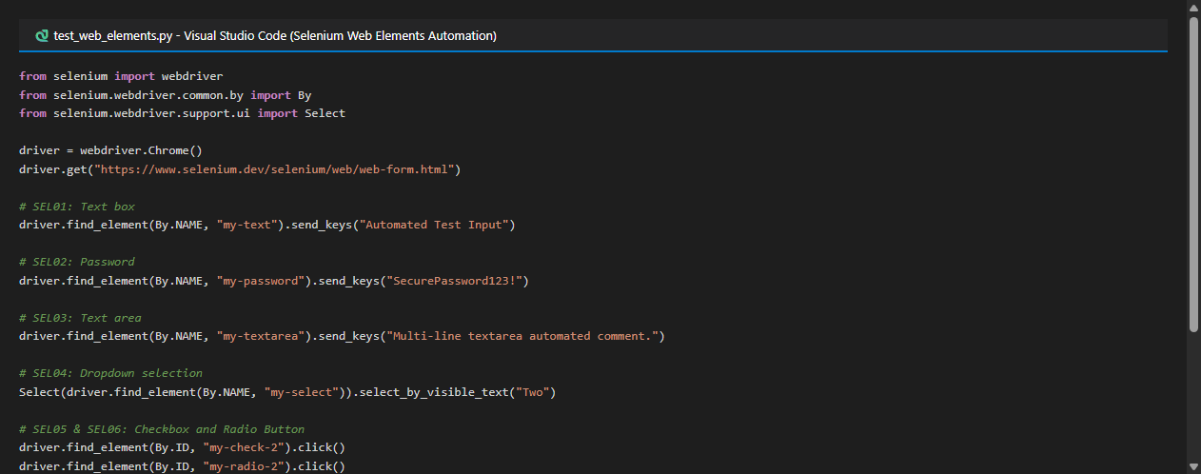
3. Test Execution & Evidence (SEL01 to SEL09)
TC ID | SEL01
Test Case | Text box
Test Data | Input: 'Automated Test Input'
Expected Result | Text entered correctly and retained in element
Actual Result | Text box populated with test string.
Status | PASS
Screenshot | 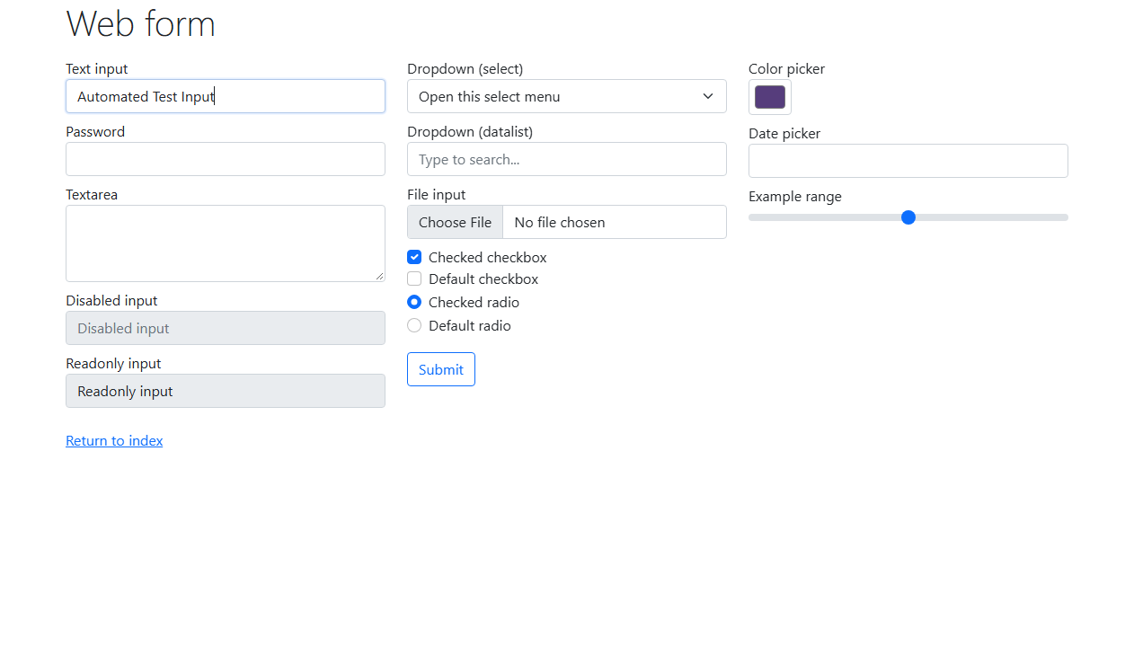
Defect ID | N/A

TC ID | SEL02
Test Case | Password
Test Data | Input: 'SecurePassword123!'
Expected Result | Password entered with characters masked
Actual Result | Password input populated with masked security dots.
Status | PASS
Screenshot | 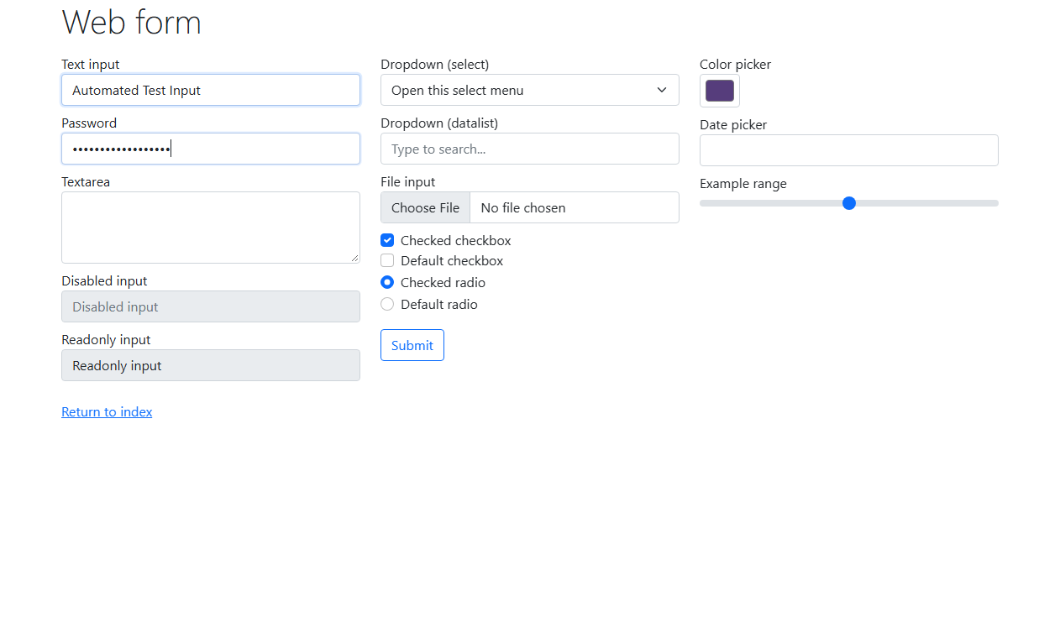
Defect ID | N/A

TC ID | SEL03
Test Case | Text area
Test Data | Input: 'Multi-line test comment...'
Expected Result | Text area populated with multi-line comment
Actual Result | Text area accepted multi-line content.
Status | PASS
Screenshot | 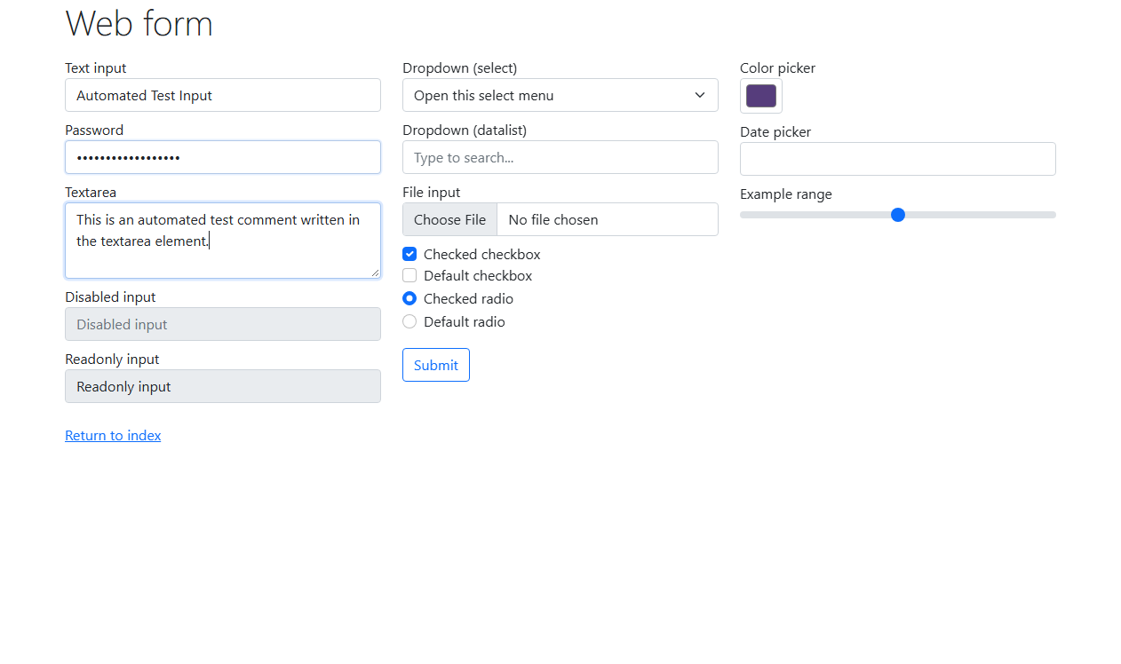
Defect ID | N/A

TC ID | SEL04
Test Case | Dropdown
Test Data | Select Option: 'Two'
Expected Result | Dropdown option 'Two' selected and active
Actual Result | Option 'Two' selected via Select class.
Status | PASS
Screenshot | 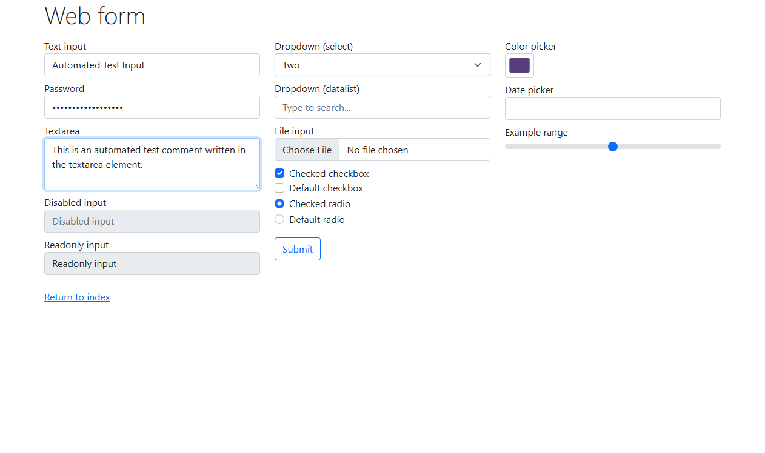
Defect ID | N/A

TC ID | SEL05
Test Case | Checkbox
Test Data | Element: #my-check-2
Expected Result | Checkbox toggle state changes to checked
Actual Result | Checkbox 2 toggled to selected state.
Status | PASS
Screenshot | 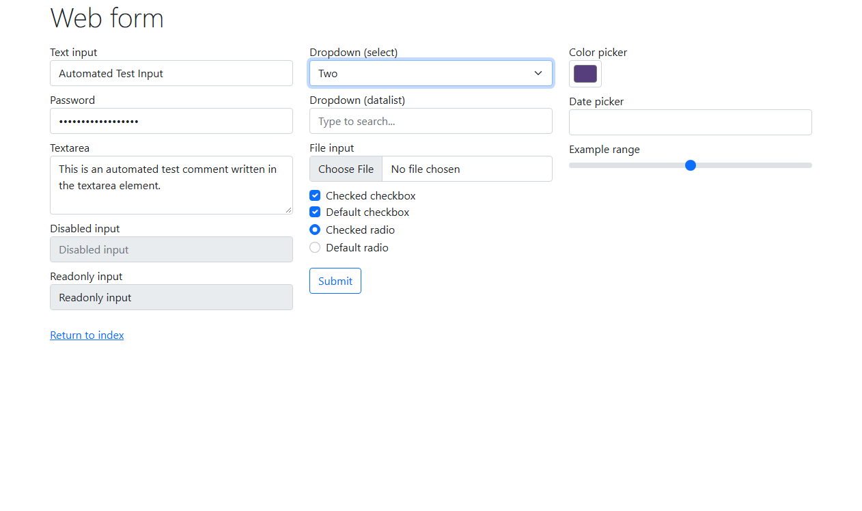
Defect ID | N/A

TC ID | SEL06
Test Case | Radio button
Test Data | Element: #my-radio-2
Expected Result | Radio button 2 selected; button 1 deselected
Actual Result | Radio button 2 toggled; mutual exclusivity verified.
Status | PASS
Screenshot | 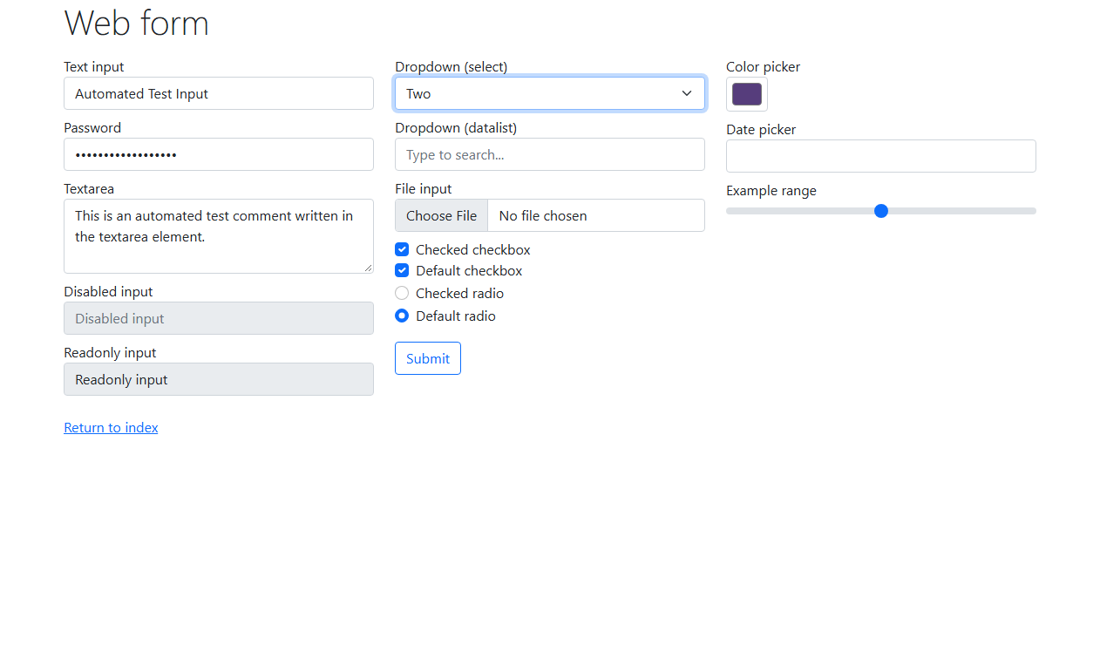
Defect ID | N/A

TC ID | SEL07
Test Case | Date
Test Data | Date: '10/22/2026'
Expected Result | Date input populated with formatted date
Actual Result | Date field updated with 10/22/2026.
Status | PASS
Screenshot | 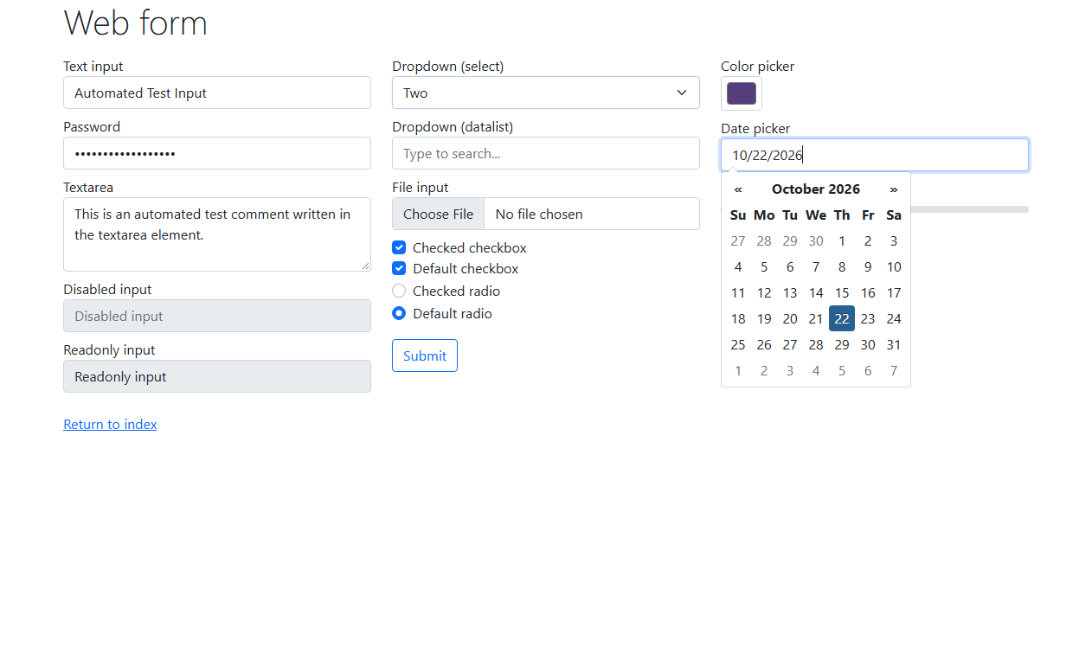
Defect ID | N/A

TC ID | SEL08
Test Case | Submit
Test Data | Action: Click Submit button
Expected Result | Form submitted via HTTP POST to handler
Actual Result | Submit button clicked; form dispatched.
Status | PASS
Screenshot | 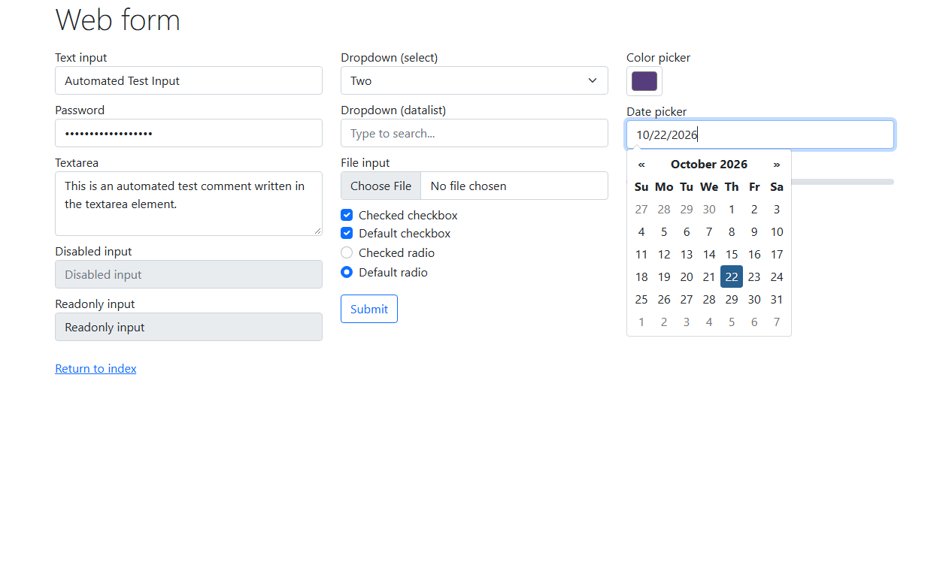
Defect ID | N/A

TC ID | SEL09
Test Case | Result verification
Test Data | Expected: 'Received!' header text
Expected Result | Response page displays 'Form submitted' and 'Received!'
Actual Result | Confirmation page verified with text 'Received!'.
Status | PASS
Screenshot | 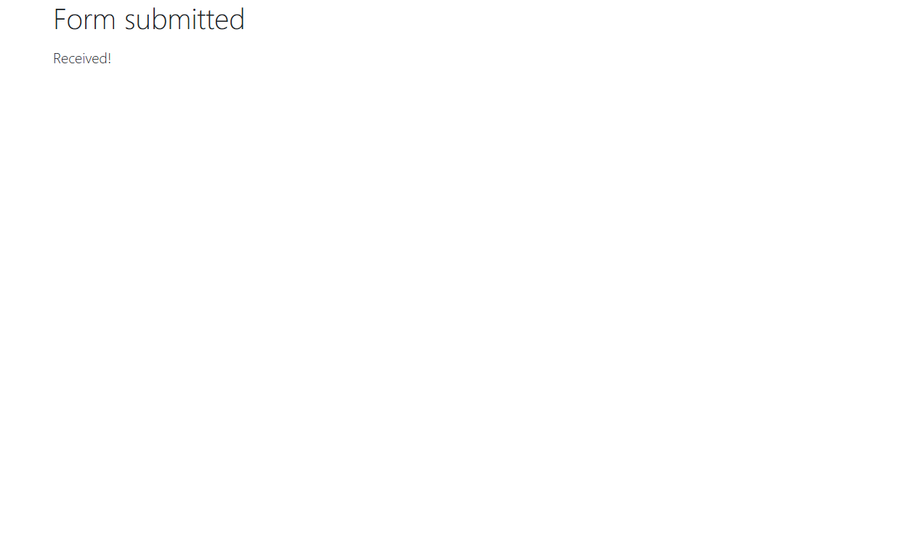
Defect ID | N/A

