K-Net User Guide
Cash Advance, Liquidation, Reimbursement & Revolving Fund Workflow System
Screenshots captured from the live K-Net staging environment (lsbizportal.lemonsquare.com.ph/k-net).

1. Getting Started
K-Net is accessed through the LS BizPortal. You do not log into K-Net directly — you log into the shared company portal, then open the K-Net tile.

1.1 Logging In
- Go to the BizPortal login page.
- Enter your username and password, then click Login.
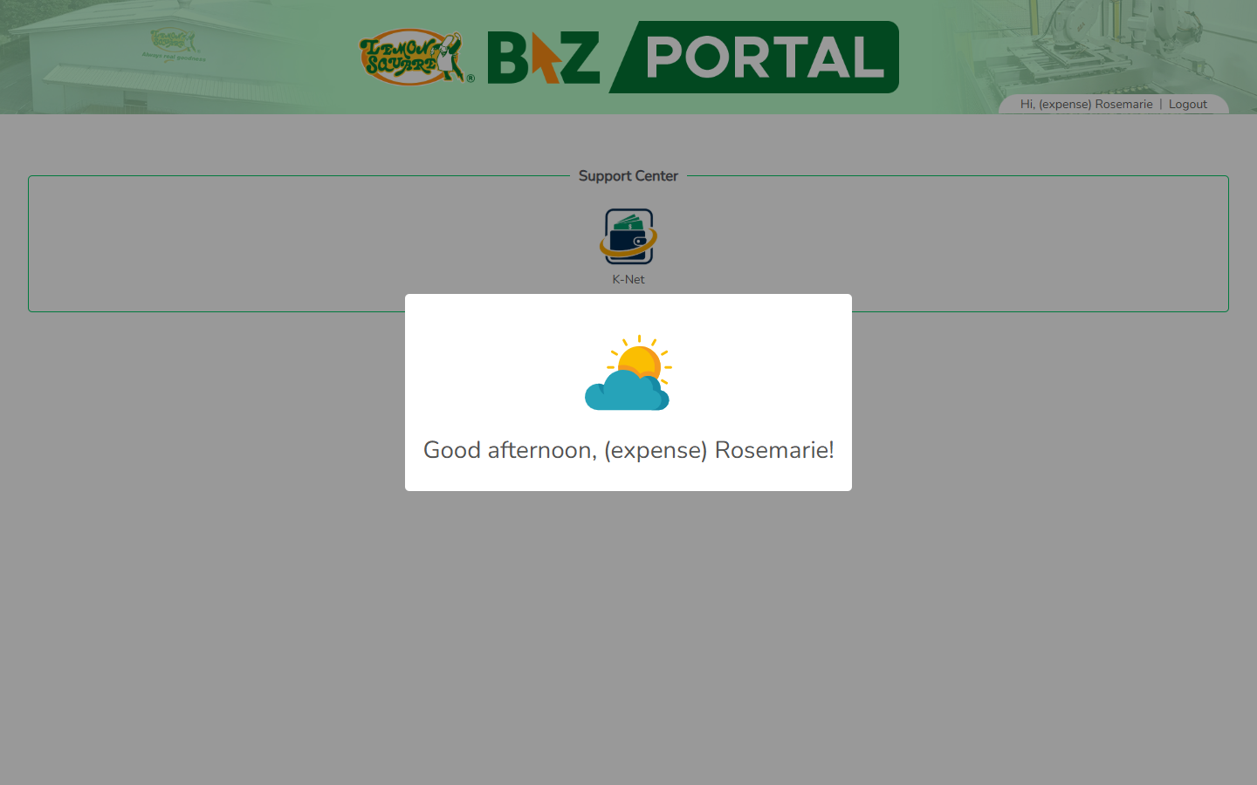
- Click the K-Net tile under Support Center to open the app.

1.2 The Dashboard
After opening K-Net you land on your personal Dashboard: your open Cash Advances, items For Liquidation, Pending Reimbursements, your Remaining Fund balance (if you hold a revolving fund), recent Fund History, and anything needing your attention.
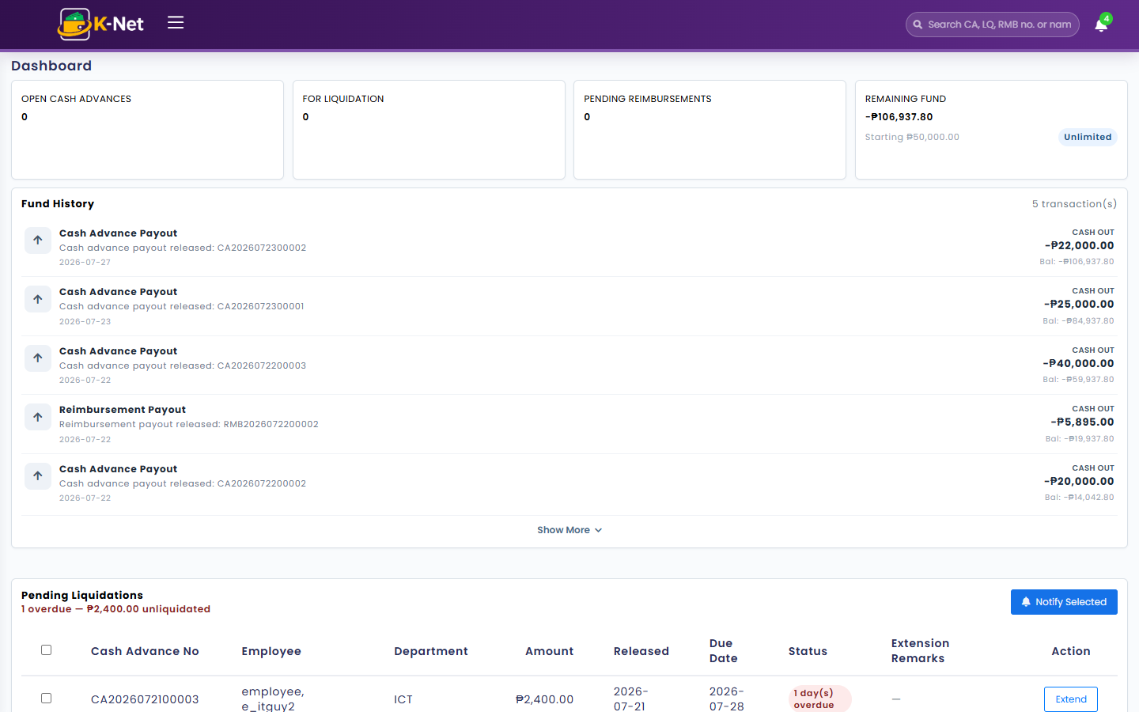
Note: The exact tiles you see depend on your role — a plain requester sees a simpler dashboard than a fund holder or approver.

2. Cash Advance (with K-Flow Approval)
Who uses this: Any employee who needs company funds in advance of an expense.
This is the most important flow to understand because a Cash Advance does not stay inside K-Net the whole time — it is briefly handed off to K-Flow, a separate company approval system, before coming back into K-Net to finish its own approval matrix.

2.1 Cash Advance List
Opens to your own request history: totals for the amount you have requested, how much is pending, for liquidation, and approved, plus a filterable table of every request you’ve filed.
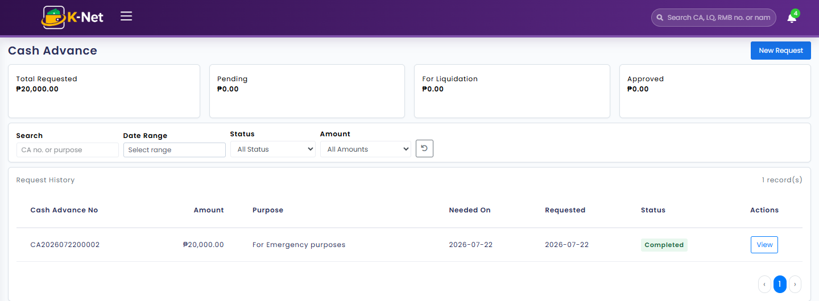

2.2 Step 1 — File a New Request
- Click New Request.
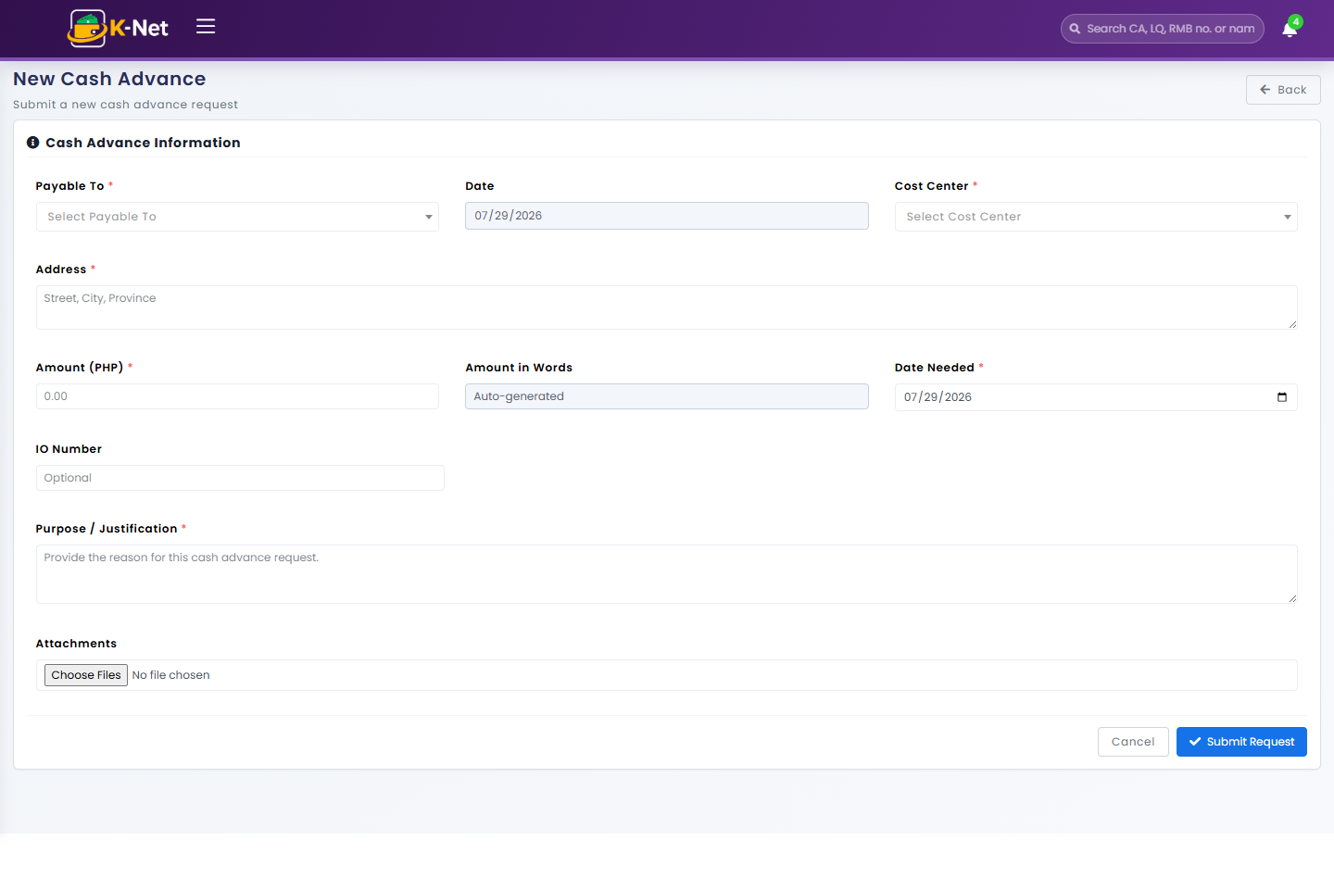
- Fill in Payable To, Cost Center, Address, Amount, Date Needed, Purpose, and attach any supporting documents.
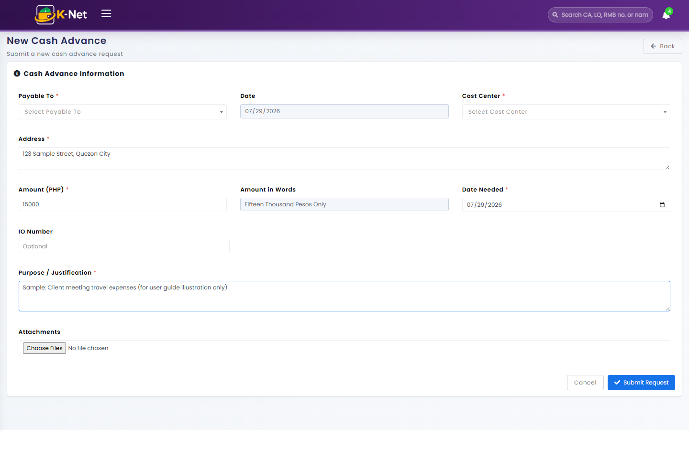
Note: The form above is filled with sample data for illustration only — it was not submitted, to avoid creating a test transaction in the live system.
- Click Submit Request.

2.3 Step 2 — Routed to K-Flow
Immediately after you submit, K-Net hands the request off to K-Flow (the company-wide workflow/e-signature system) for its own review. While this is happening, the request’s status briefly reads "Routed to K-Flow" and it will not yet appear as pending inside K-Net’s own Approvals screen.
Note: There is currently no request sitting in this in-between state to screenshot live — in this test environment K-Flow tends to resolve within seconds of submission. Rather than create a new test transaction to force-capture this transient screen, this step is documented from the code/config instead of a live screenshot.

2.4 Step 3 — K-Flow Callback into K-Net’s Approval Matrix
Once K-Flow finishes its own sign-off, it calls back into K-Net, and the request enters K-Net’s own configurable Approval Matrix (see Section 7). Depending on the matrix rule that matches the request’s department and amount, it either needs one or more designated approvers, or — if the requester is also the sole configured approver — it is auto-approved.

2.5 Example: Self-Approved Request (requester = approver)
Below is a real completed Cash Advance where the requester was also the matrix’s only approver, so K-Net auto-approved it immediately after the K-Flow callback.
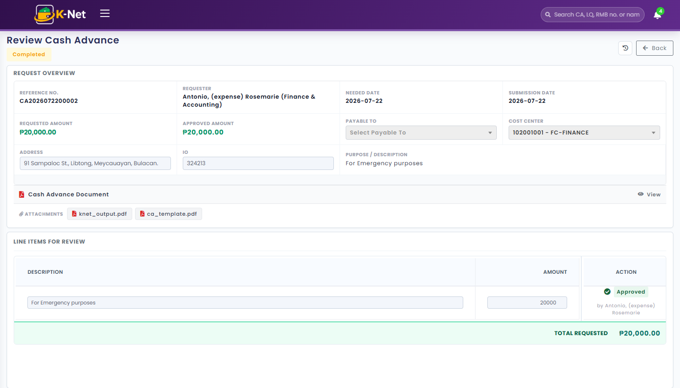
Clicking the history icon (top right) shows the full timeline: submission, payment advisory/release, and the auto-approval.
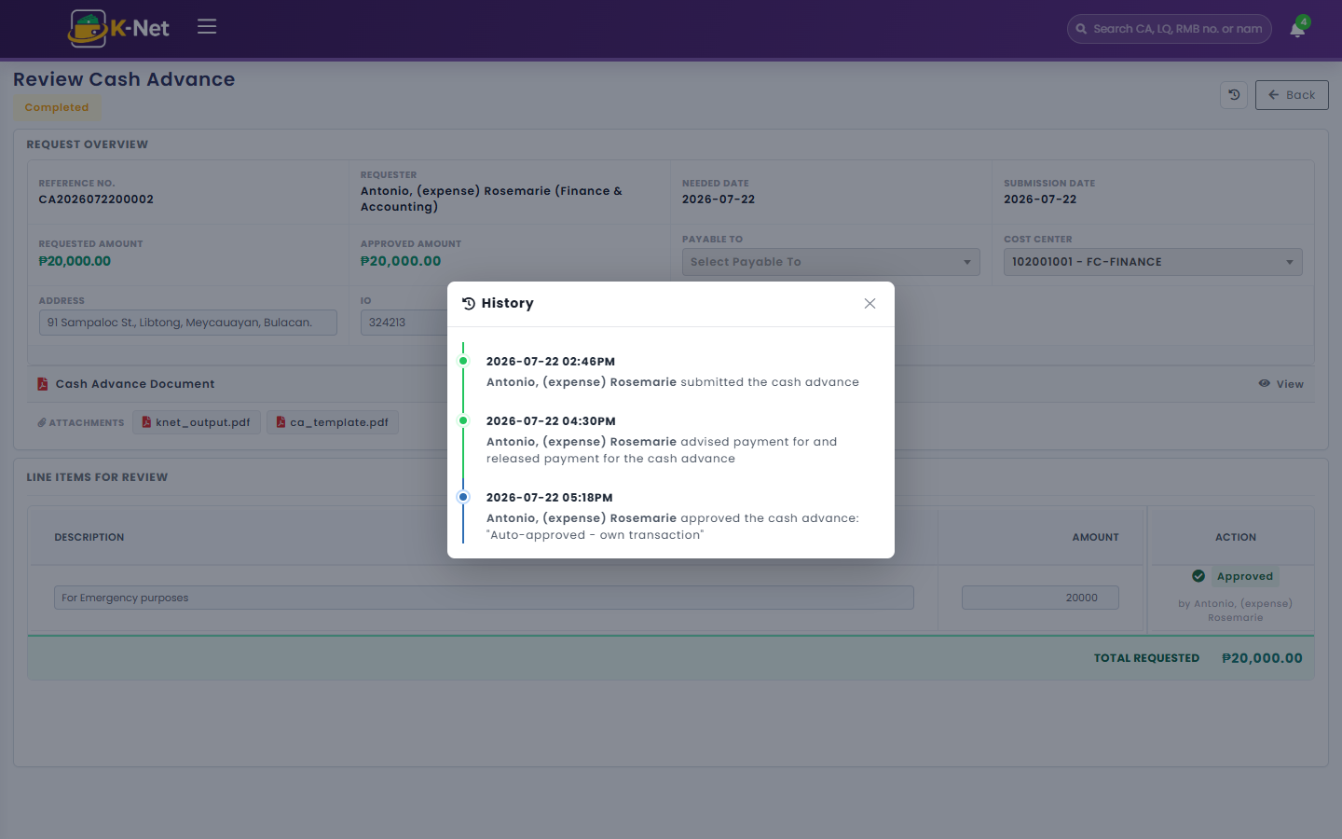

2.6 Example: Approved by a Different Person
Here is a real Cash Advance filed by one employee and approved by a different person entirely — the more typical case where the K-Flow callback is followed by an actual reviewer decision rather than auto-approval.
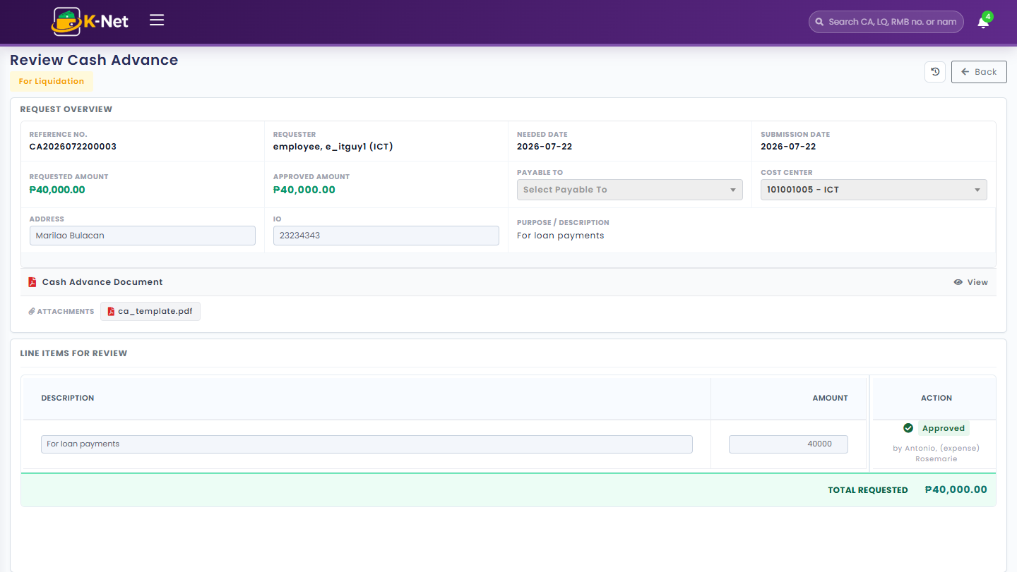
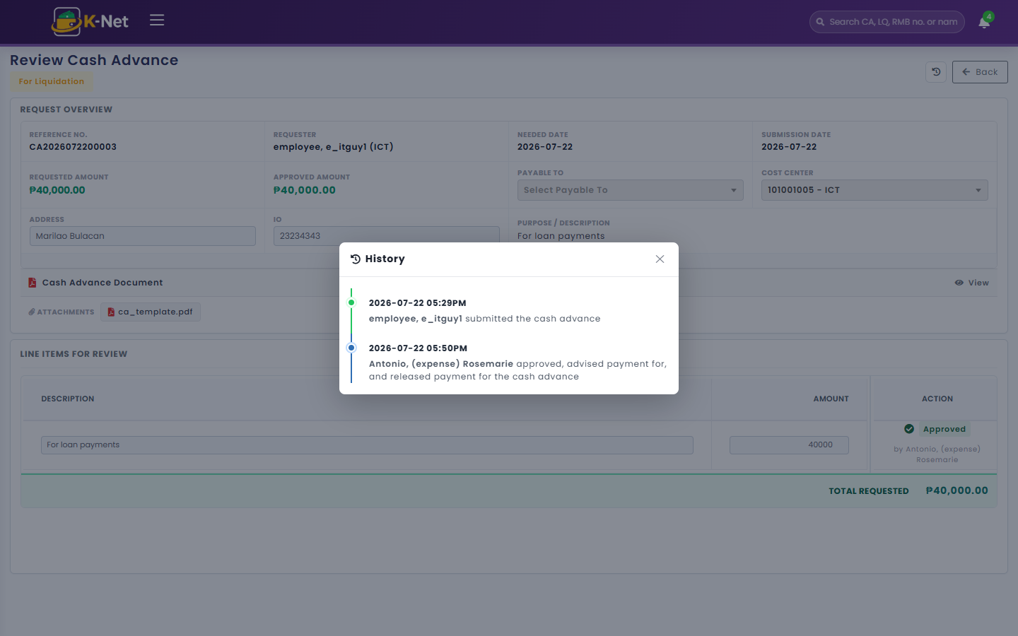

2.7 Step 4 — Release and Liquidation
- Once approved, Accounting advises and releases payment (status becomes For Release, then For Liquidation).
- The Cash Advance cannot go straight to Completed — it must be liquidated first (see Section 3).

3. Liquidation
Who uses this: Anyone who was released a Cash Advance and needs to report how it was actually spent.
Liquidation is how an employee reports actual spend against a released Cash Advance: attach receipts, break the spend into expense-type line items, and let the system compute the variance (excess or shortage) against the original advance.
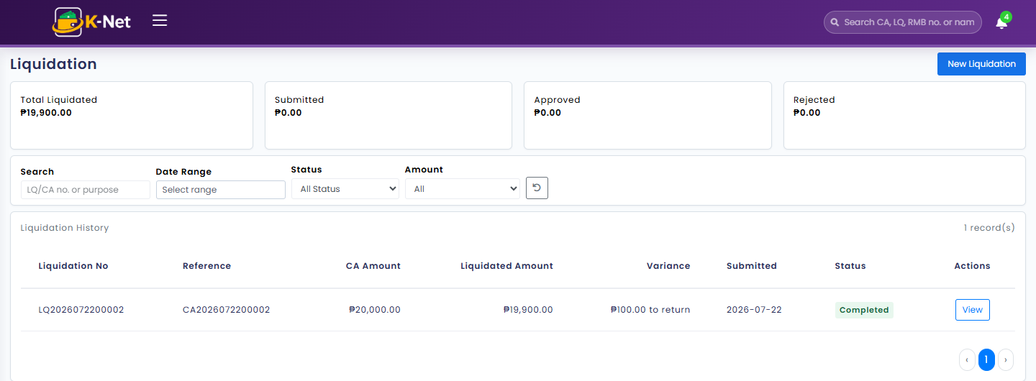
Note: An excess becomes an Expense Reimbursement (Section 4); a shortage is returned.

4. Expense Reimbursement
Who uses this: Anyone claiming repayment for a personally-paid expense, or the overage from a Liquidation.
Reimbursement requests go through the same kind of approval matrix as Cash Advance, then get paid out once approved.
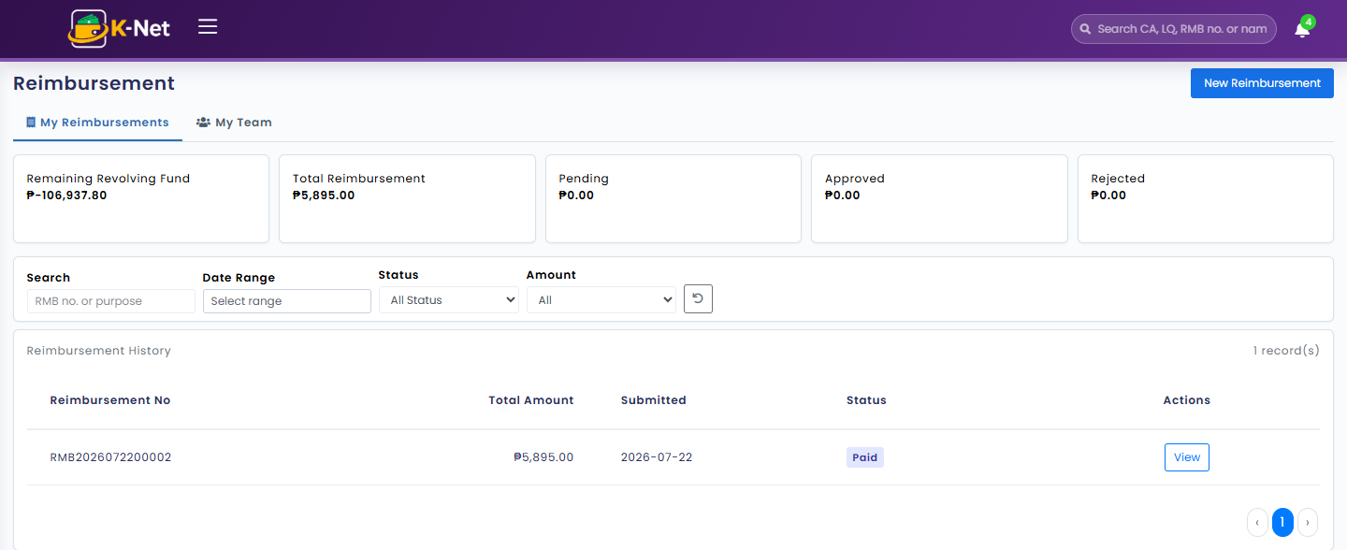

5. Approvals
Who uses this: Approvers, Supervisors, Accounting, and ICT — anyone with a decision to make on a request.
This is the approver’s workbench, with three tabs.

5.1 Pending Approvals
Everything currently awaiting this user’s decision, across Cash Advance, Liquidation, and Reimbursement.
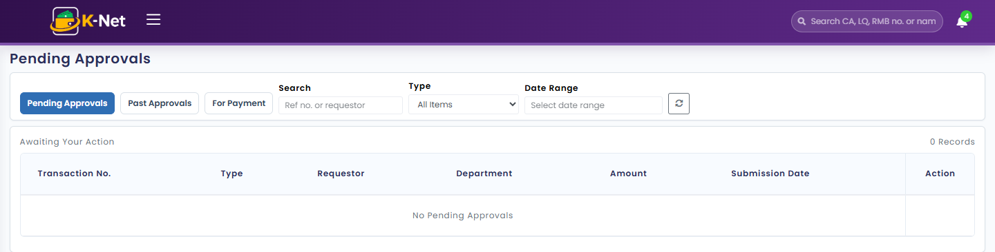

5.2 Past Approvals
A read-only log of everything this user has already decided on.
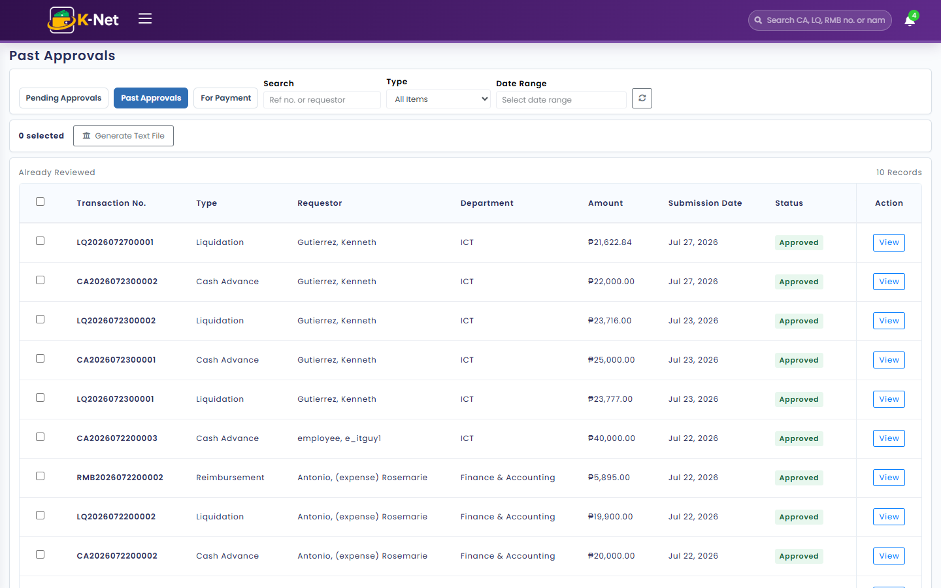

5.3 For Payment
For users with payment capability: mark items as Payment Advised and/or Payment Released, individually or in a batch.
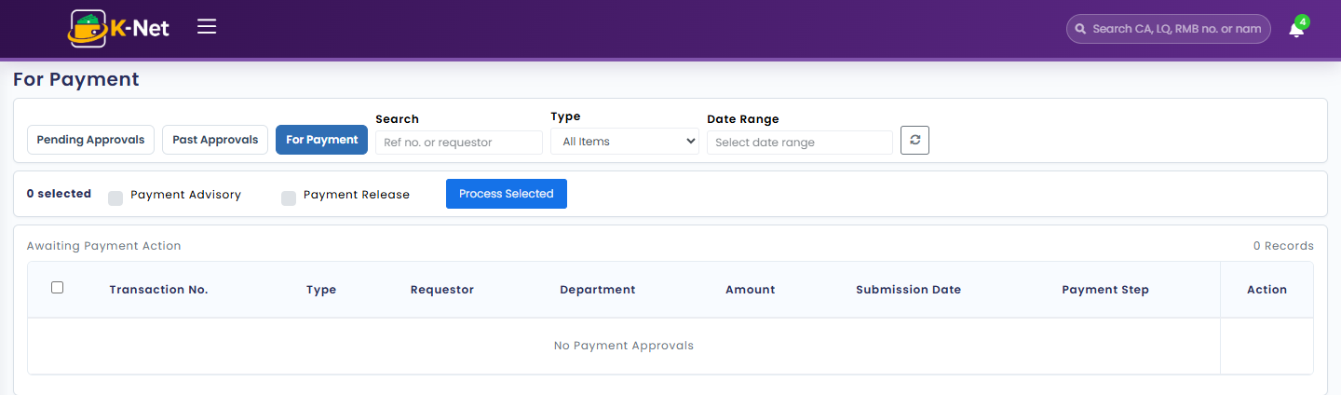

6. Approval Matrix (Maintenance)
Who uses this: Accounting, ICT, and system administrators — this configures who approves what for everyone else.
Every approval rule that governs Cash Advance, Liquidation, and Reimbursement lives here: which department and amount range it applies to, and the ordered (or parallel) list of approvers.
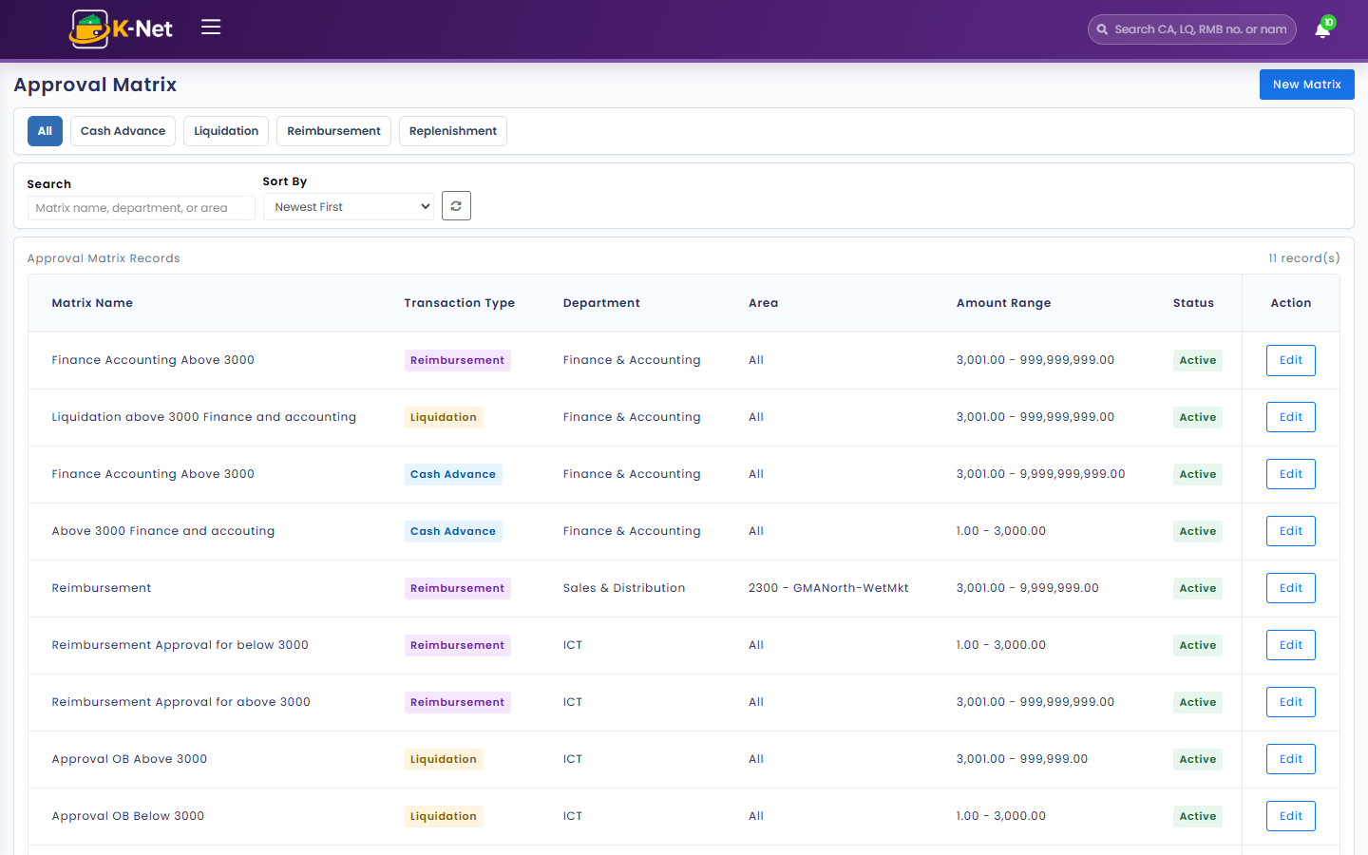

6.1 Creating a New Rule
- Click New Matrix.
- Name the rule, pick the Transaction Type, Department, and Min/Max amount range.
- Add one or more approvers, set their order and approval type (Sequential or Parallel), and any Payment Controls (Advisory, Release, or both).
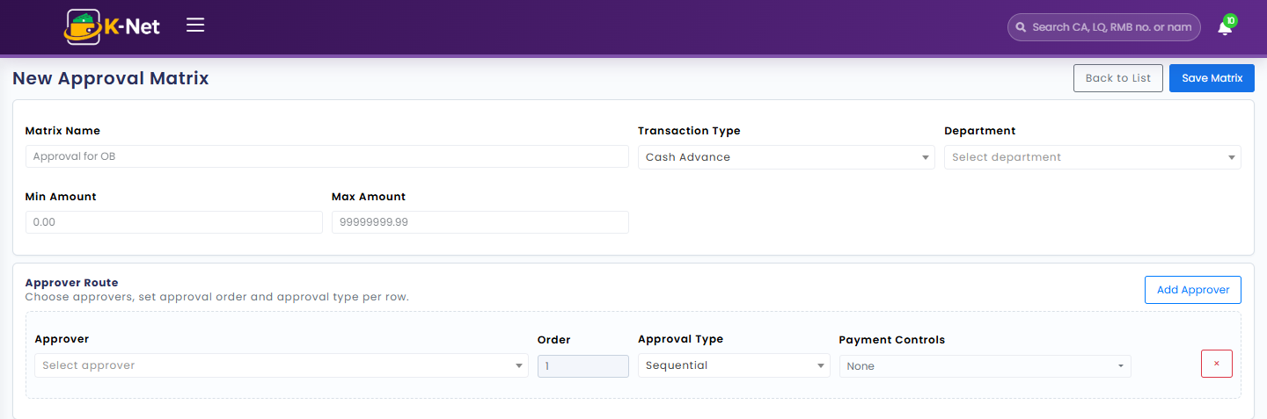

6.2 Editing an Existing Rule
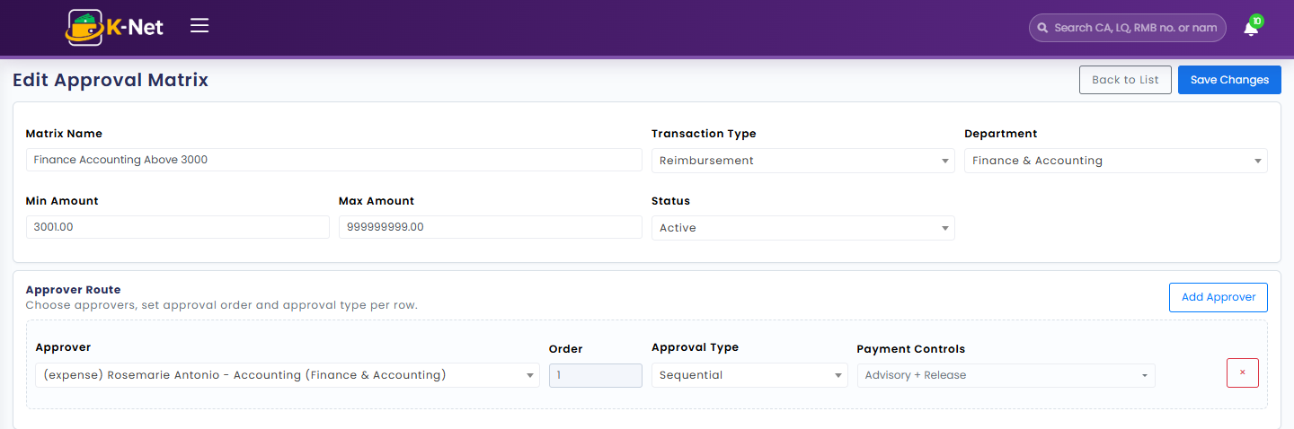

7. Expense Types (Maintenance)
Who uses this: Accounting and ICT.
The master list of expense categories/GL codes used on every Cash Advance, Liquidation, and Reimbursement line item.
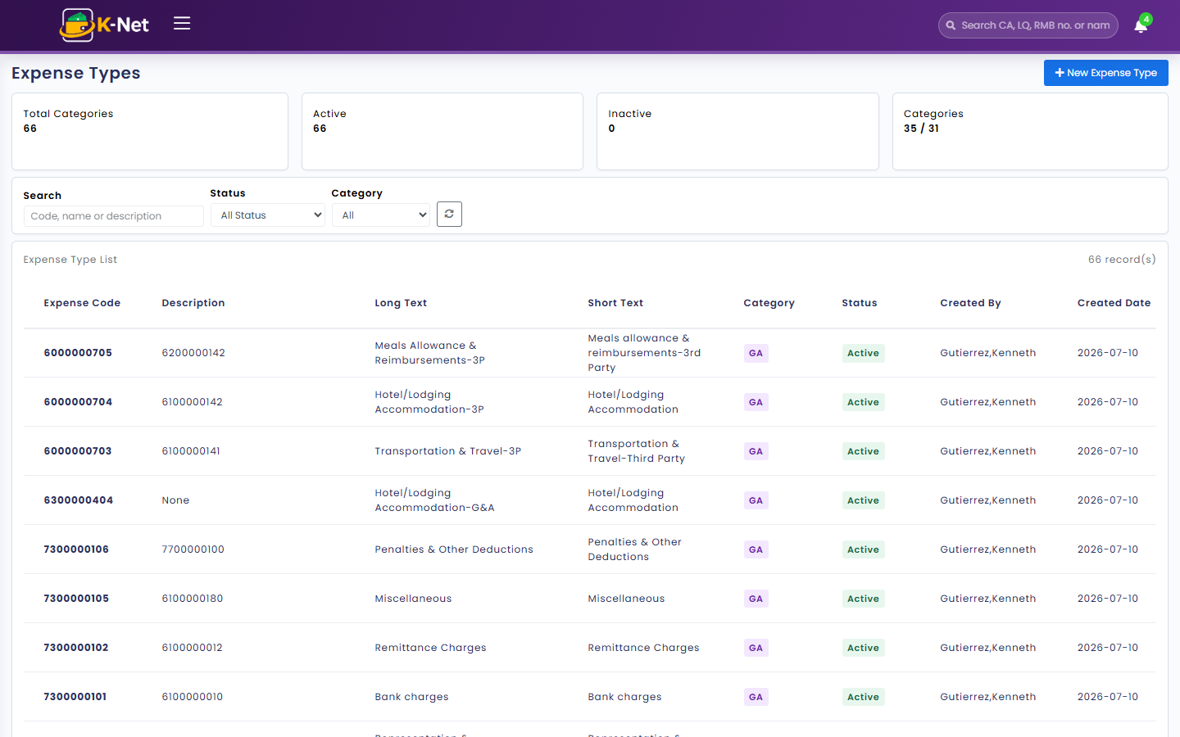

8. Revolving Fund (Maintenance)
Who uses this: Accounting, ICT, and Supervisors.
Set up revolving funds, assign fund holders, and record fund movements (top-ups, adjustments, cash-ins).
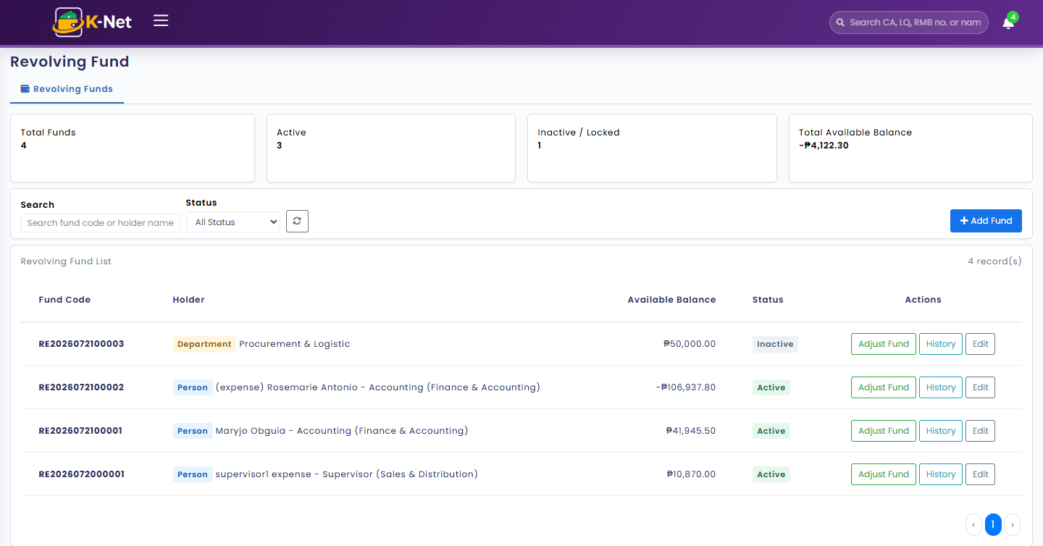

9. Notification Templates (Maintenance)
Who uses this: Accounting and ICT.
Manages the subject/body of system emails sent on workflow events, using {{placeholder}} merge tokens.
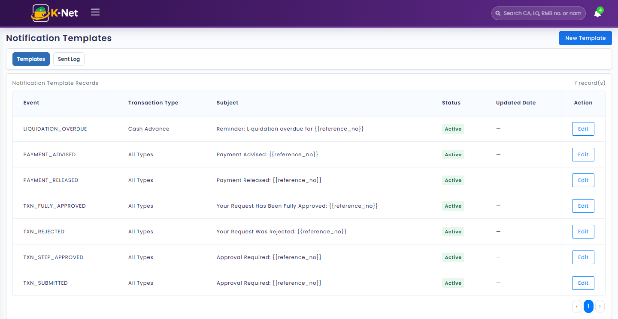

10. Reports
Every transaction type has its own report for searching, filtering, and exporting to Excel. Several cross-cutting reports also roll data up for finance and management.

10.1 Cash Advance Report
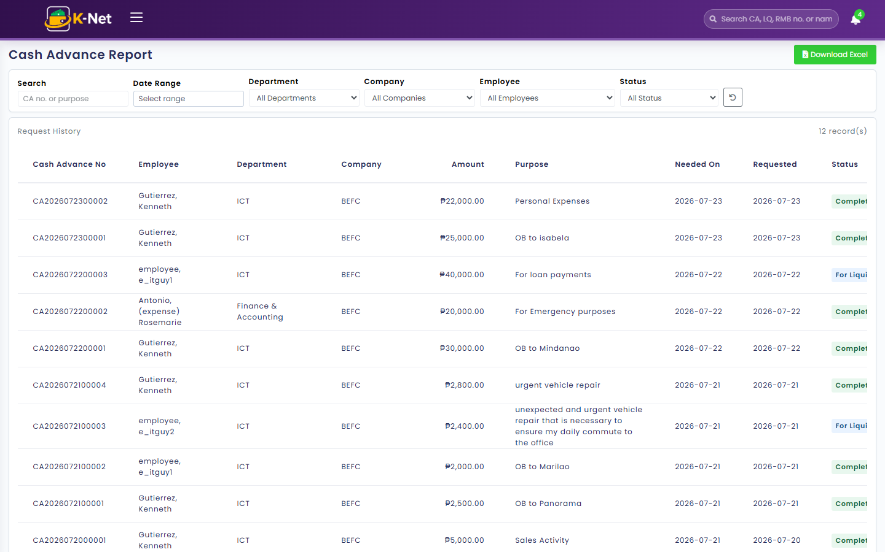

10.2 Liquidation Report
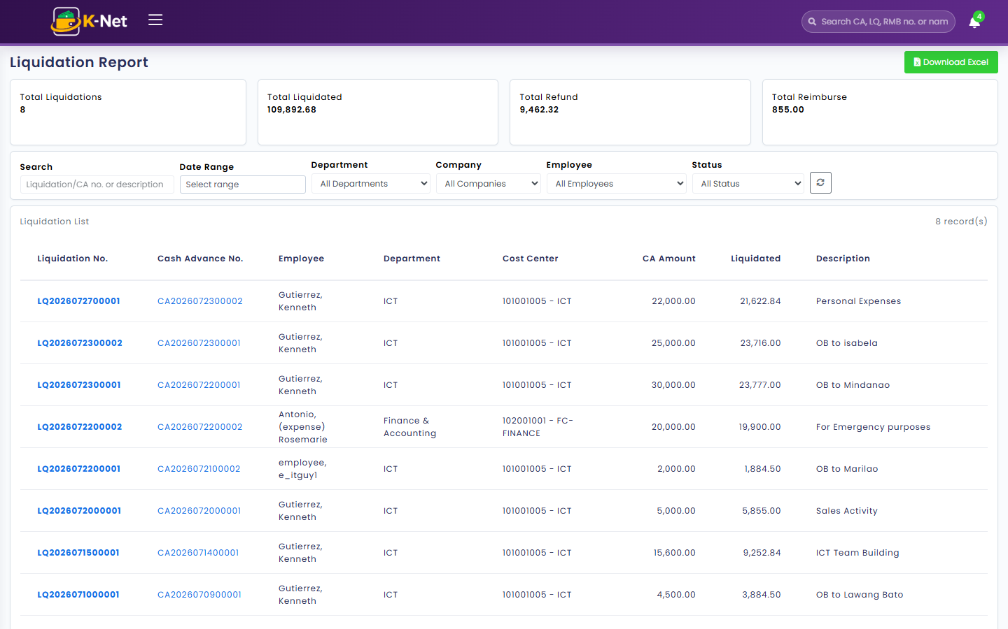

10.3 Expense Reimbursement Report
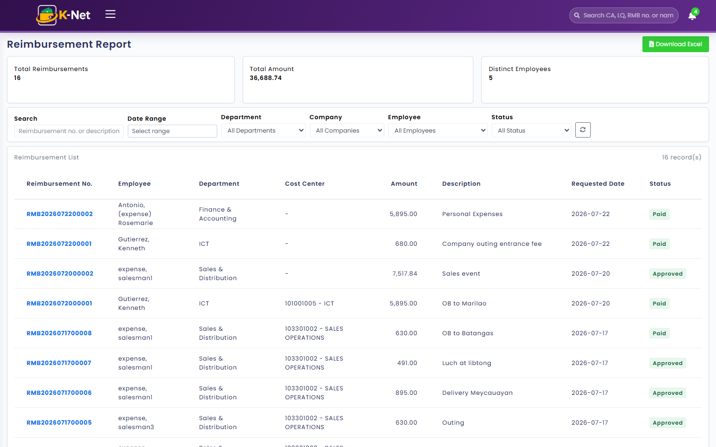

10.4 My Transaction History
Who uses this: Every user — a self-service view of your own transactions.
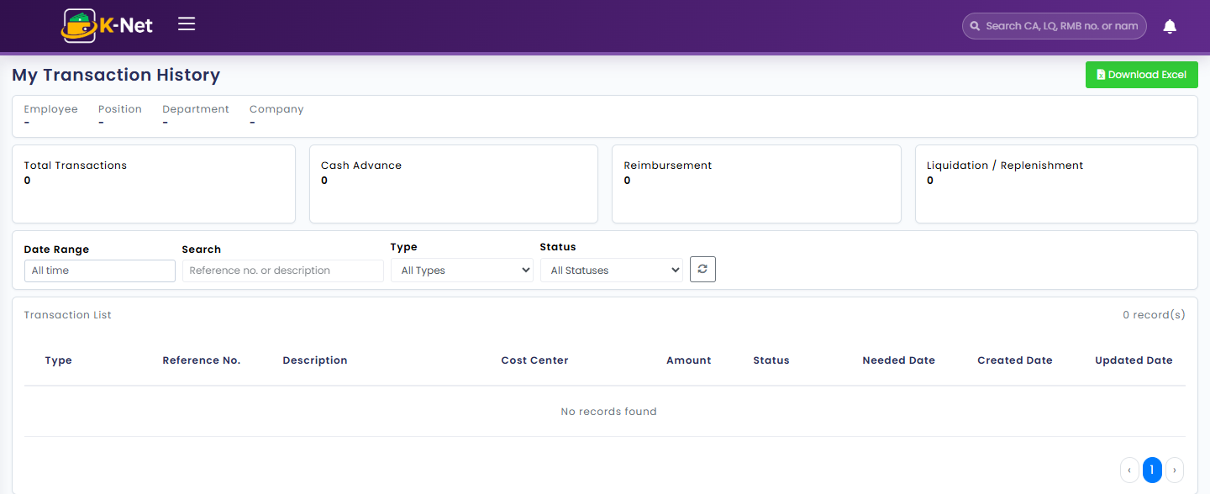

10.5 Executive Dashboard
Who uses this: Approvers and system administrators — the company-wide "workflow health" view.
KPI tiles, monthly spend trend, pending-approval aging (where the process is bottlenecking), and spend breakdowns by department and GL code, with a full exportable detail table.
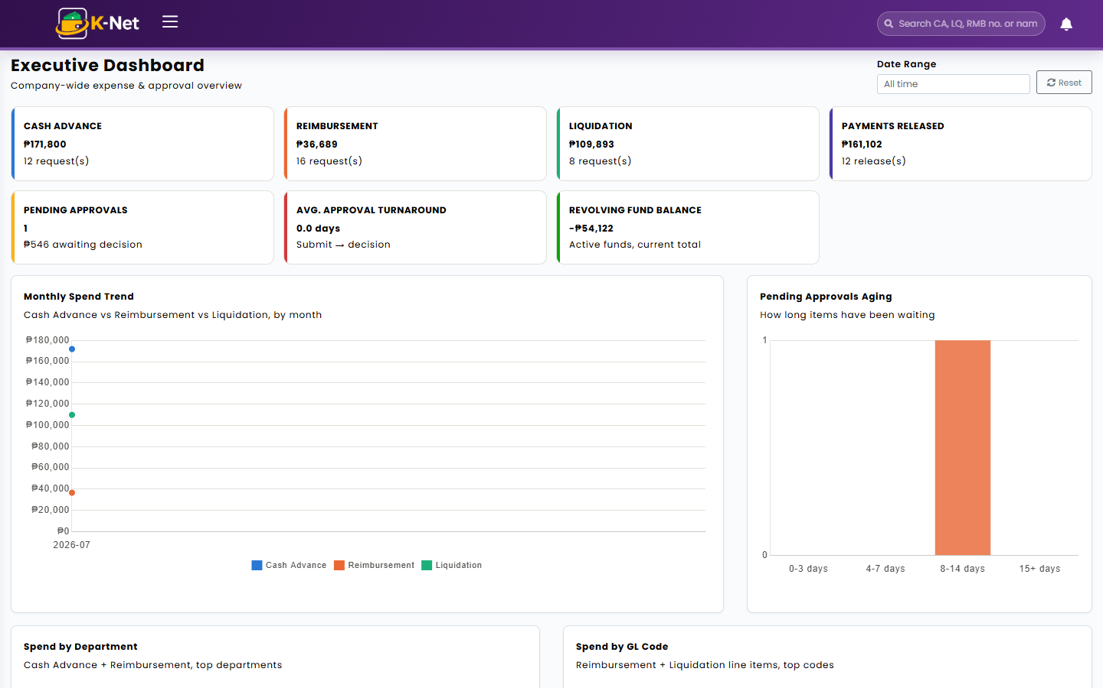

10.6 GL Breakdown
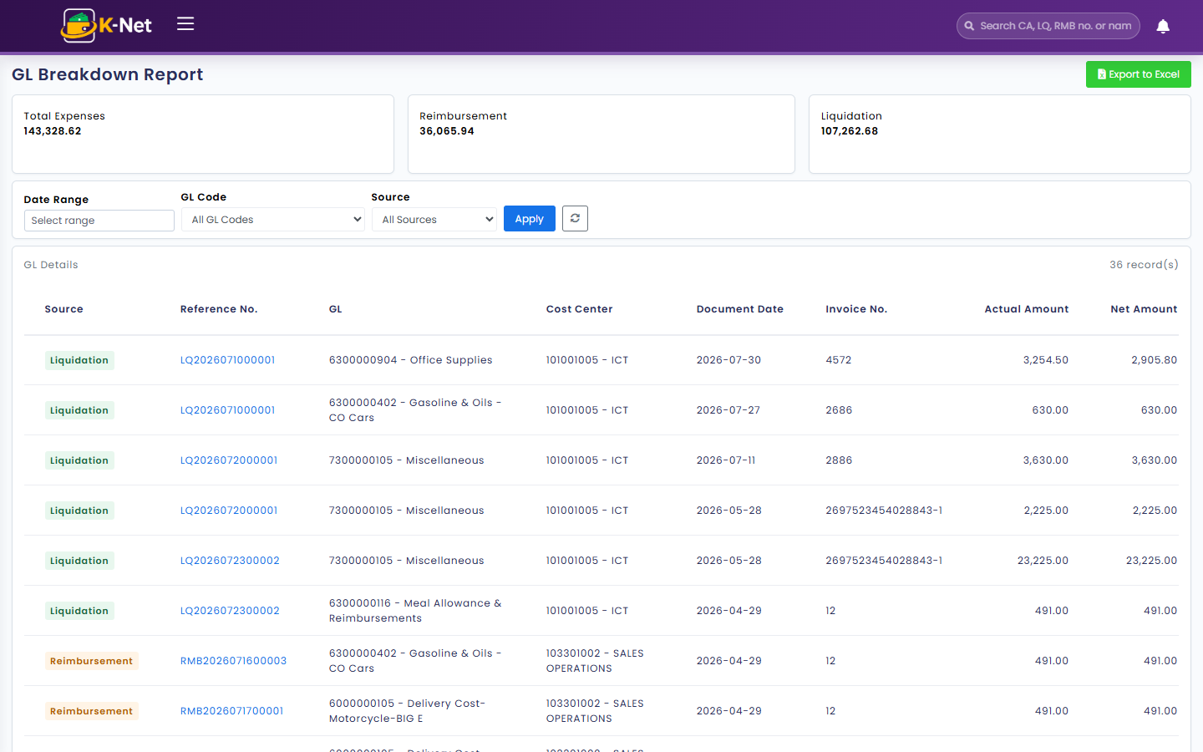

10.7 Cost Center Utilization
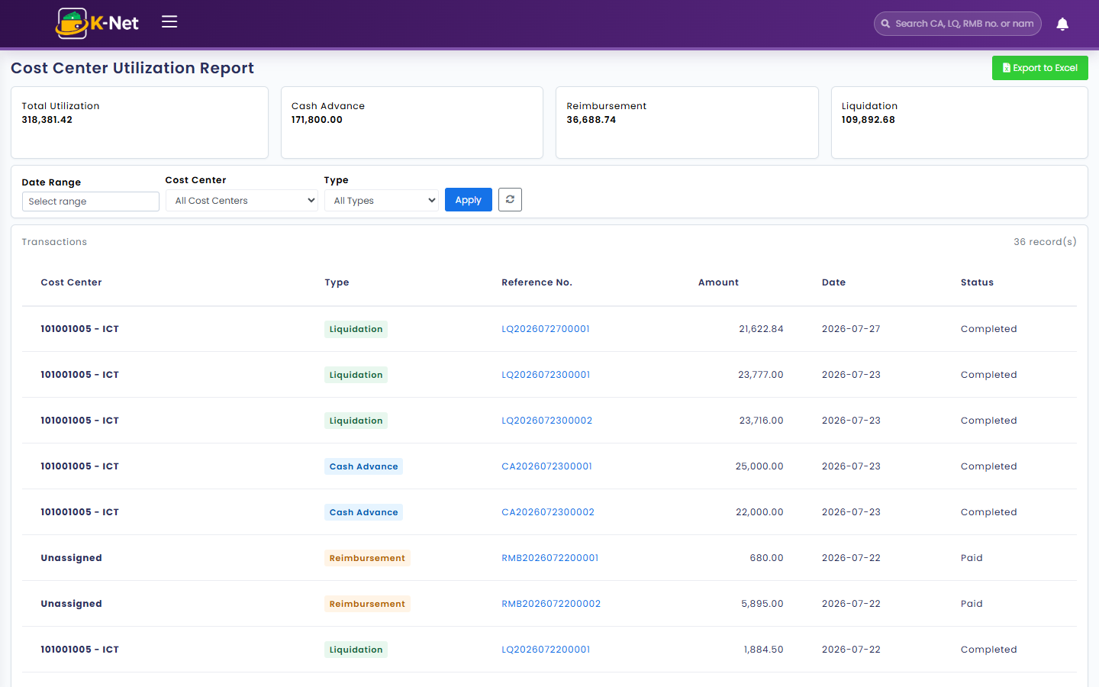

10.8 Cash Advance vs Liquidation Variance Report
Flags cash advances that are outstanding or mismatched against what was actually liquidated — the key report for chasing unresolved advances.
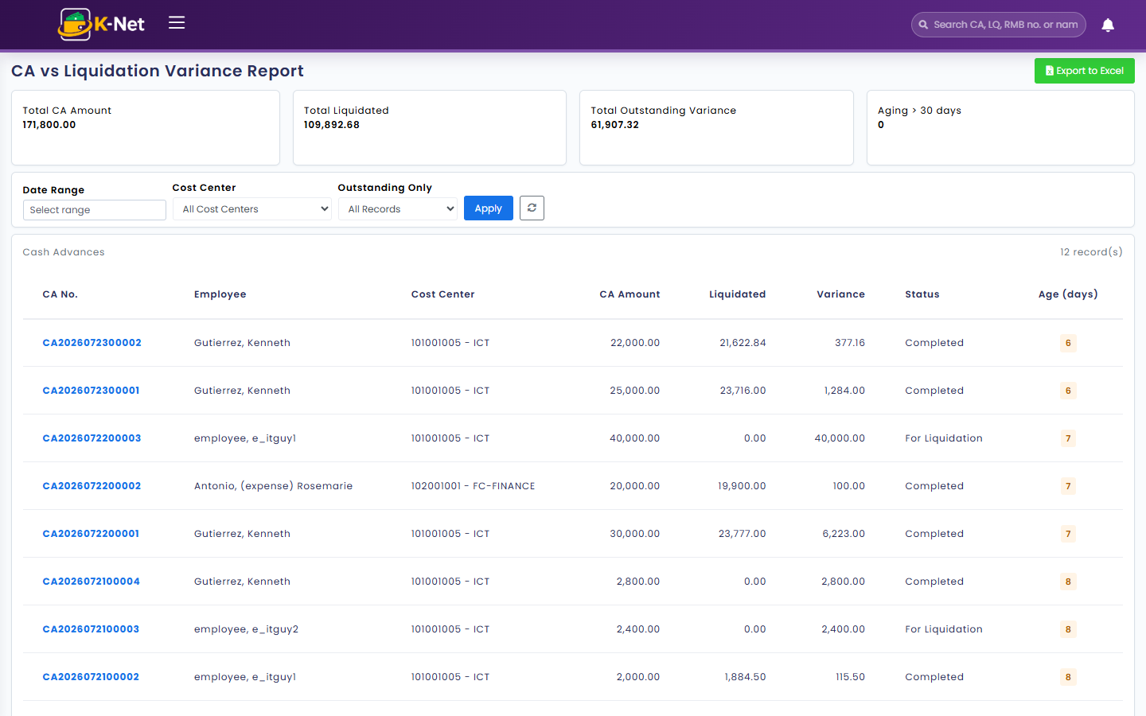

10.9 Payment Advisory & Release Register
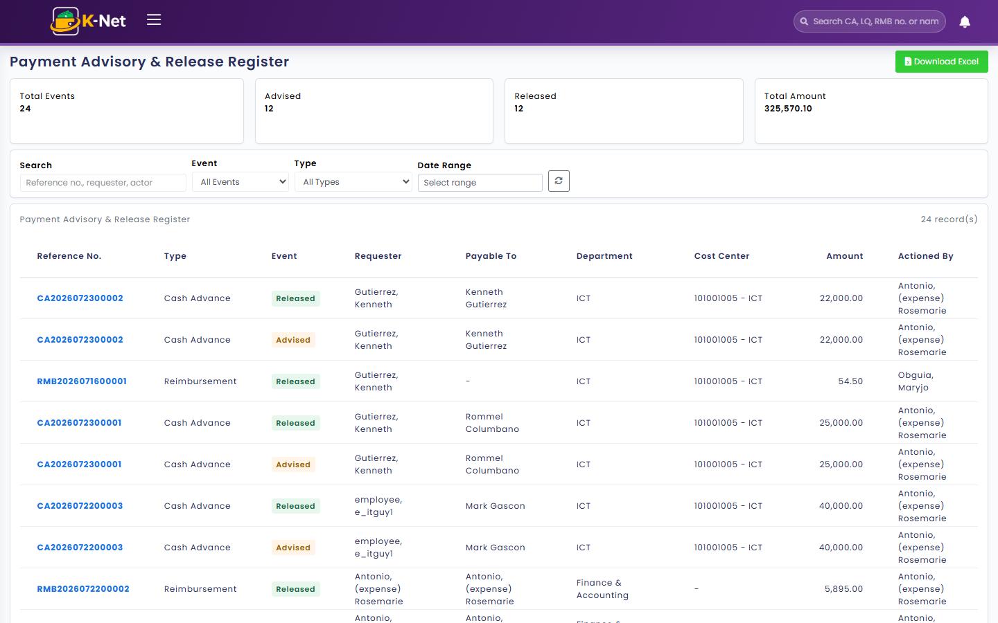

10.10 Revolving Fund Ledger
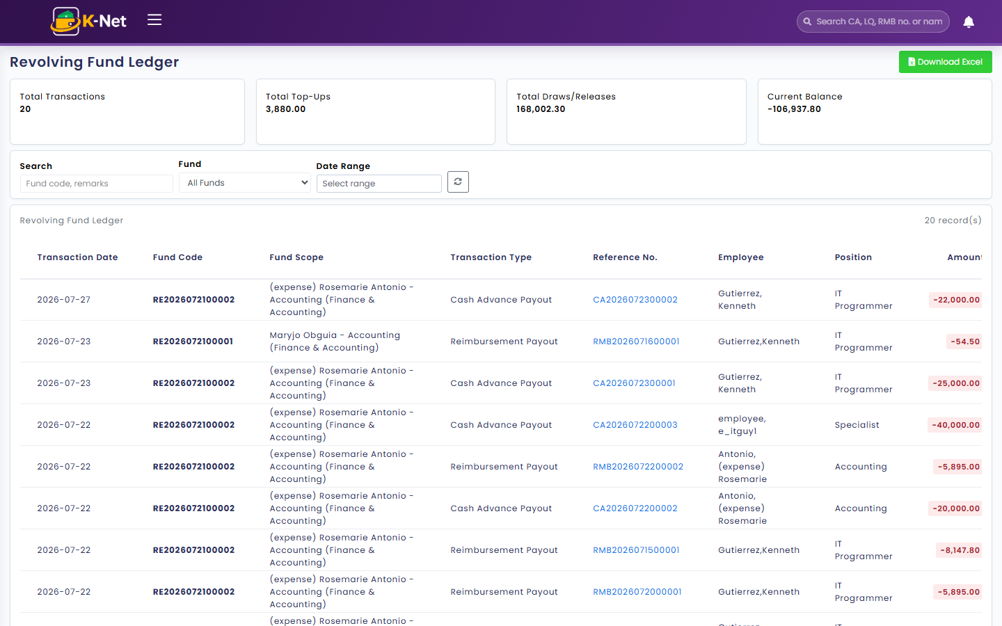

11. Bank Account Masterlist (Maintenance)
Who uses this: ICT and system administrators only.
Employee bank account records used for payment disbursement. Account numbers are masked by default; a reveal icon shows the full number when needed.
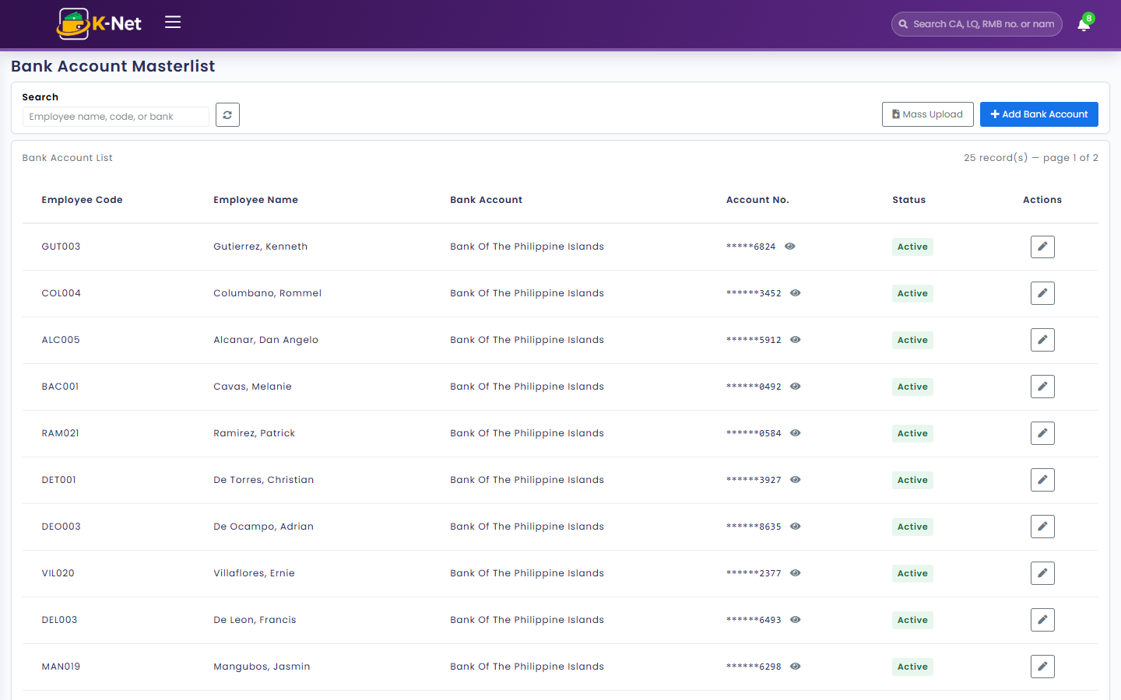
Note: Account numbers in this screenshot are masked as they would normally appear — the reveal action was intentionally not used here since it would expose real employee bank data.

12. Cost Center (Maintenance)
Who uses this: ICT and system administrators only.
Master list of cost centers (SD — Sales & Distribution, or GA — General & Administrative) used to tag transactions for departmental reporting.
