Flight Distance

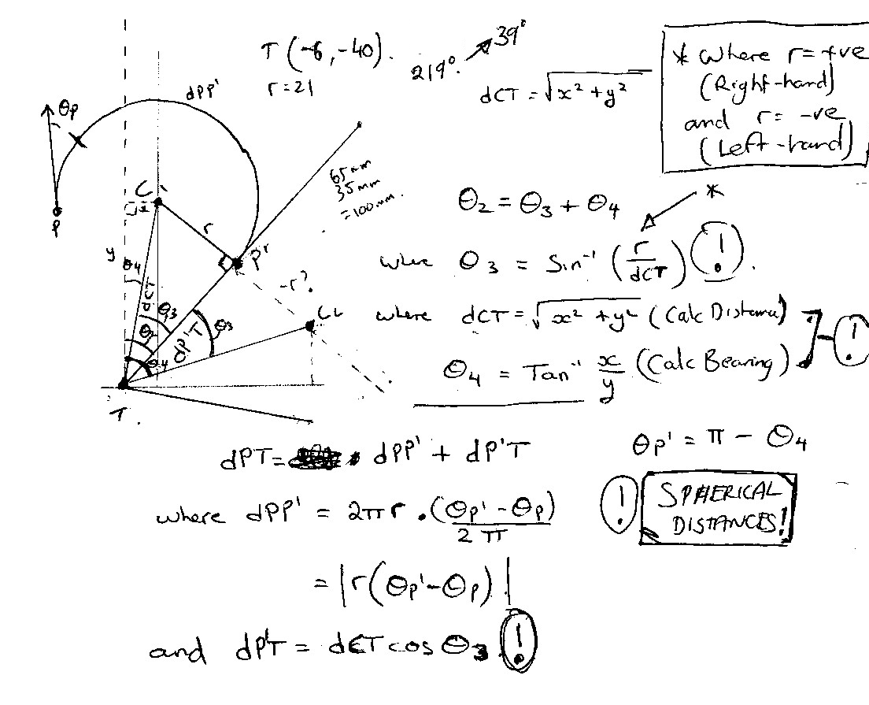

The following Haskell functions are an implementation of the above notes. There is a guard ‘if’ on the dPP1 calculation that differs from the notes, in order to ensure the correct distance around the arc is used.

These calculations work in planar-geometry and need revising for complete accuracy in spherical geometry. I have marked with “!” any calculations need to be addressed for this.

distance (x1,y1) (x2,y2) =
let xd = x2-x1
yd = y2-y1
in sqrt(xd*xd + yd*yd)

degrees r =
(r*180/pi)

safe_angle s | s > pi = s-2*pi
| s < -pi = s+2*pi
| otherwise = s

flight_solve thetaP r (cx,cy) (tx,ty) =
let
-- Angle calculations
thetaP1 = safe_angle(pi + theta3 + theta4)
theta3 = asin(r/dCT)
theta4 = atan((tx-cx)/(ty-cy))
dCT = distance (cx,cy) (tx,ty)

-- Distance calculations
dP1T=dCT*cos(theta3)
dPP1=if safe_angle(thetaP1 - safe_angle(thetaP)) < 0 then
r*(2*pi+thetaP1-safe_angle(thetaP))
else
r*safe_angle(thetaP1 - safe_angle(thetaP))
in
(degrees(thetaP1), dPP1 + dP1T,dPP1,degrees(thetaP1),degrees(thetaP))

fsa1 a = flight_solve (a*pi/180) 21 (0,0) (-6,-40)
fsa2 a = flight_solve (a*pi/180) (21) (0,0) (-40,-13)

Vertical Navigation
