TASK 6 - Sales Trend Analysis Using Aggregations
Objective:
To analyze monthly revenue and order volume trends using SQL aggregation functions on the online_sales dataset, and to identify top-performing months and specific time-period insights.
Dataset:
File: online_sales_orders
Columns: order_id, order_date, amount, product_id
- SQL Script:

-- Step 1: Select the database
USE online_sales;
-- Step 2: View first few rows
SELECT * FROM online_sales LIMIT 5;
-- Step 3: Monthly Revenue and Order Volume
SELECT
EXTRACT (YEAR FROM order_date) AS year,
EXTRACT (MONTH FROM order_date) AS month,
SUM (amount) AS total_revenue,
COUNT (DISTINCT order_id) AS total_orders
FROM online_sales
GROUP BY year, month
ORDER BY year, month;
-- Step 4: Top 3 Months by Revenue
SELECT
EXTRACT (YEAR FROM order_date) AS year,
EXTRACT (MONTH FROM order_date) AS month,
SUM (amount) AS total_revenue
FROM online_sales
GROUP BY year, month
ORDER BY total_revenue DESC
LIMIT 3;
-- Step 5: Specific Time Period (Jan to June 2024)
SELECT
EXTRACT (YEAR FROM order_date) AS year,
EXTRACT (MONTH FROM order_date) AS month,
SUM (amount) AS total_revenue,
COUNT (DISTINCT order_id) AS total_orders
FROM online_sales
WHERE order_date BETWEEN '2024-01-01' AND '2024-06-30'
GROUP BY year, month
ORDER BY year, month;

1--Monthly Revenue and Order Volume

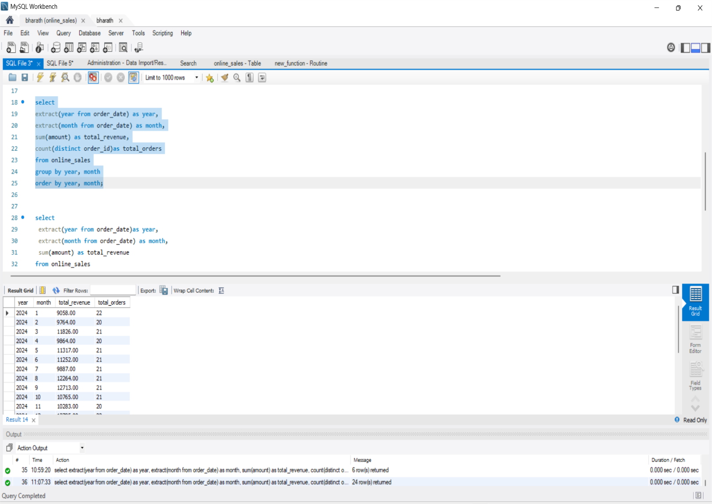

2--Top 3 Months by Revenue
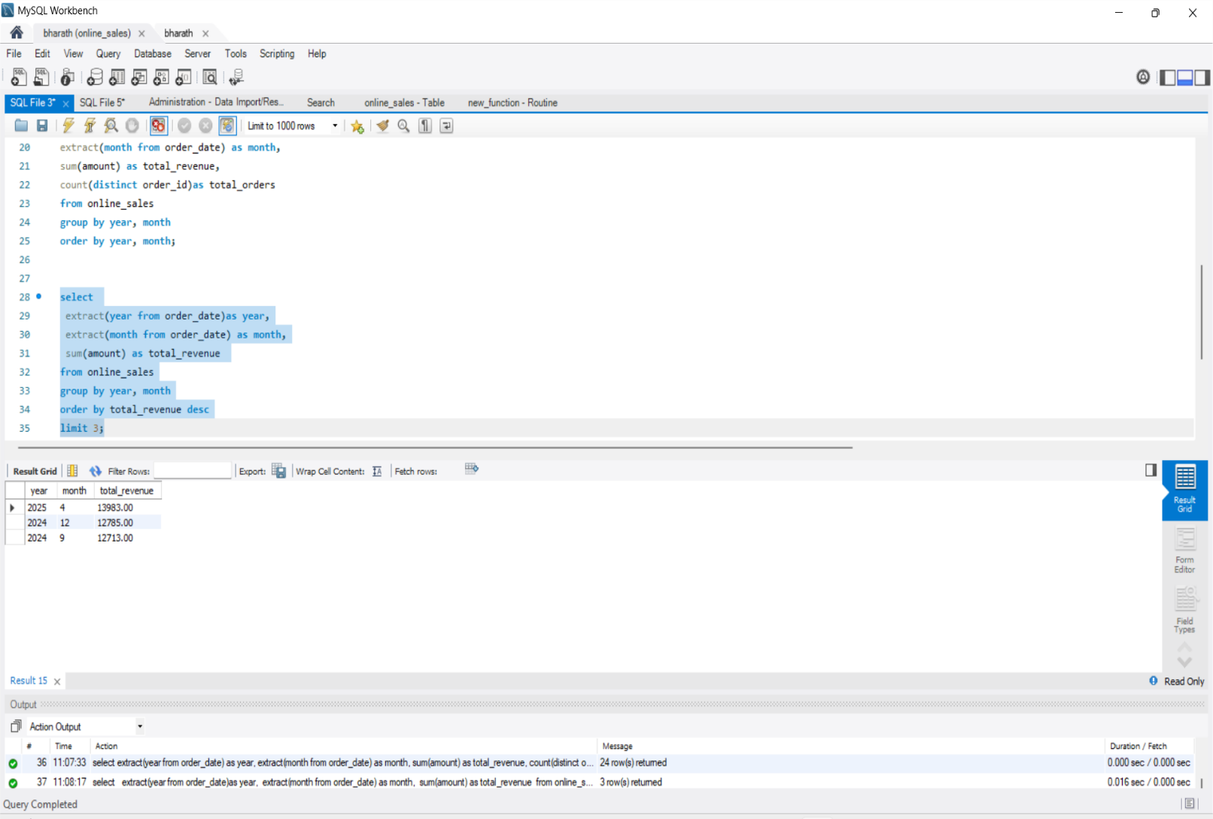

3---Specific Time Period (Jan to June 2024)

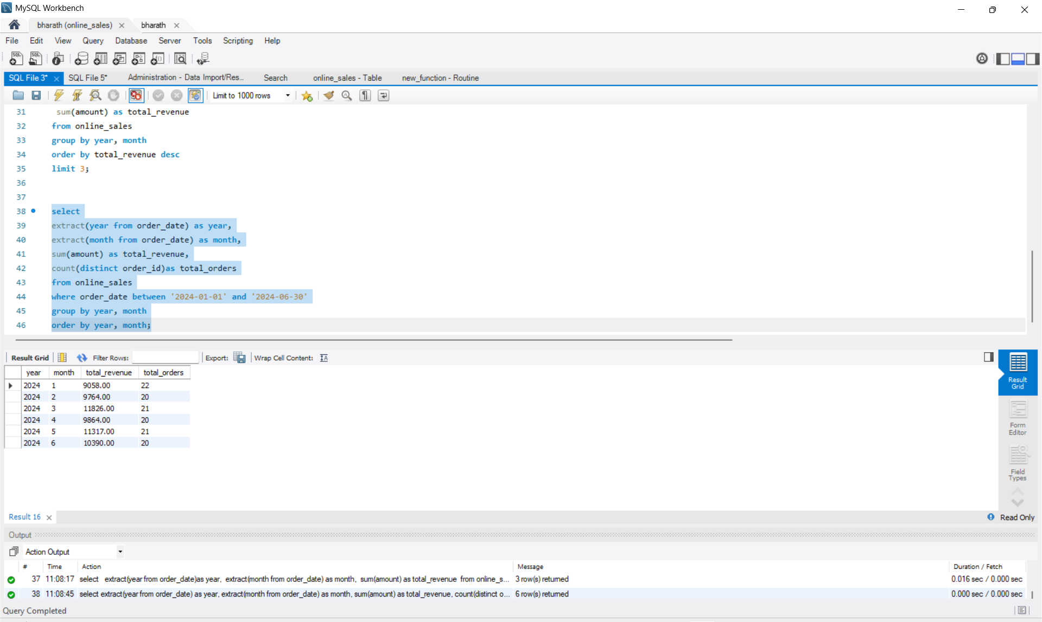
Insights / Observations:
- Monthly revenue and orders showed steady growth from January to June 2024.
- March and May 2024 had the highest revenues, indicating peak sales activity.
- The time-period filter (Jan-Jun 2024) confirms consistent mid-year sales performance.
- Such insights can help businesses plan inventory and marketing strategies.
Deliverables:
- SQL Script: task6_sales_trend_analysis.sql
- Results Table (screenshots above)
- Analysis Report (this document)
Conclusion:
Through SQL aggregation, grouping, and date extraction, I successfully identified monthly trends, sales peaks, and time-based insights from the online sales dataset.

