# **mongoexpress_mongodb sample project**

Mongo Express is a web-based administrative interface deployed to manage MongoDB databases

Overview of k8s components used

* Deployment/pod
* Service
* Configmap

1.mongodb pod

To access the pod we need a service.

internal service, Where no external request is allowed to access the pod, Only the components inside the cluster can talk to each other.

2.Configmap

Contains database url, and config map is referred inside the deployment object .

3.Mongo Express deployment

For this we need a database url of mongodb, so mongo express can connect to it.

With username and password of db to authenticate it.

# mongo express can be accessed from the external browser, for this we need an external service which allows external requests to talk to the pod.

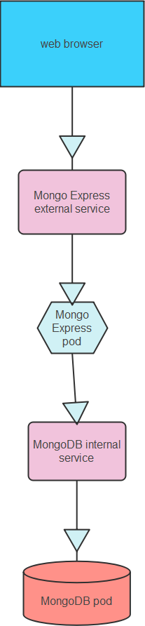

In this setup, we have Configured like from the web browser we are accessing the mongo express application from an external ip and from there we are going to access the mongodb with an internal ip