ACID PROPERTIES & ISOLATION
2520030074
K. Bhargavi
STEP-1: DATABASE
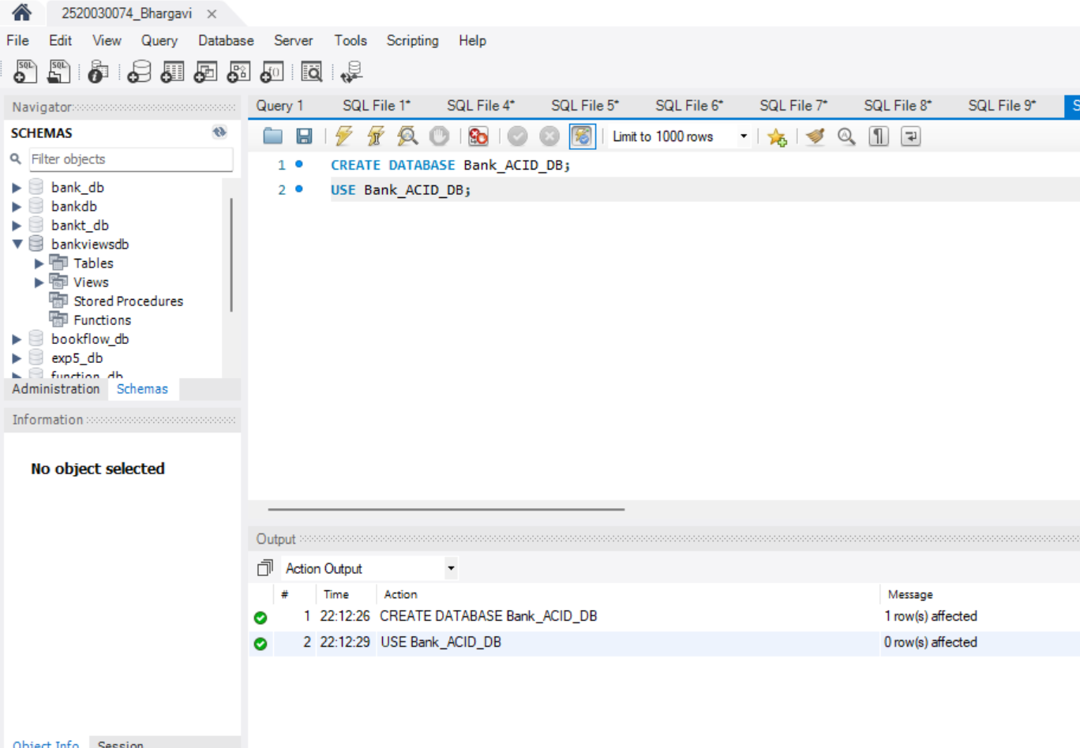
STEP-2: CREATE TABLES
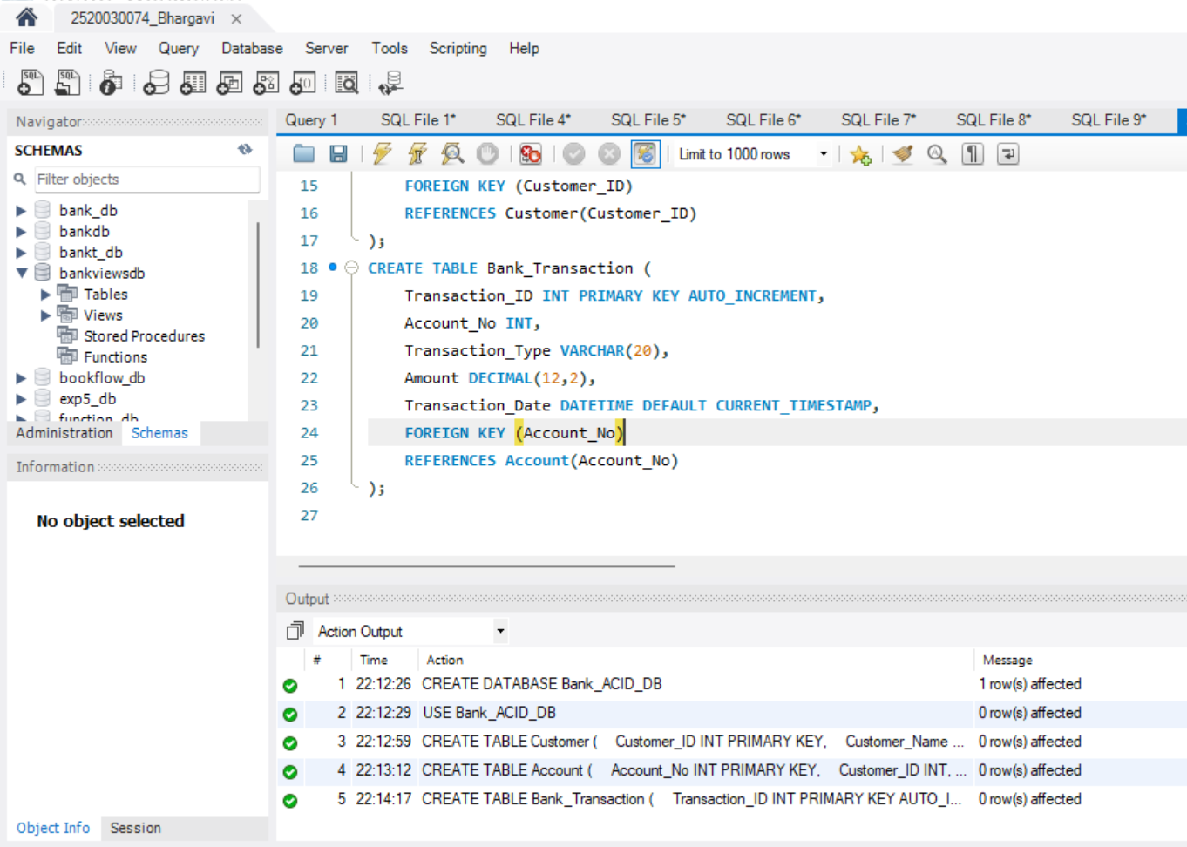
STEP-3: INSERT INTO TABLES
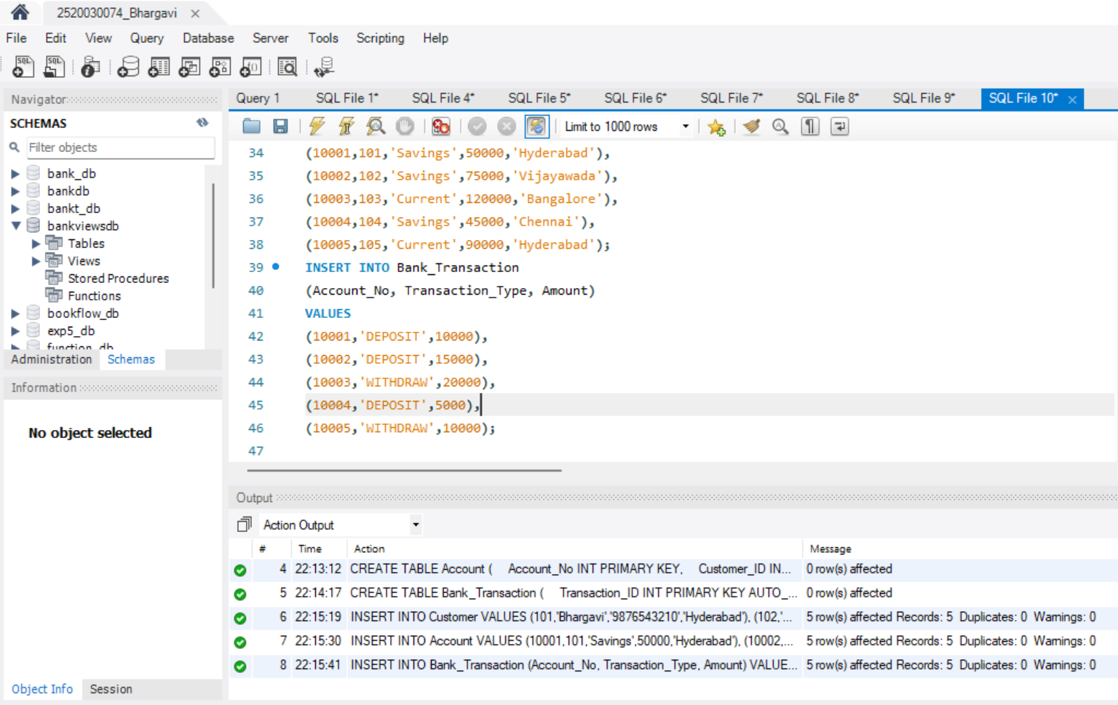
STEP-4: DISPLAY TABLES
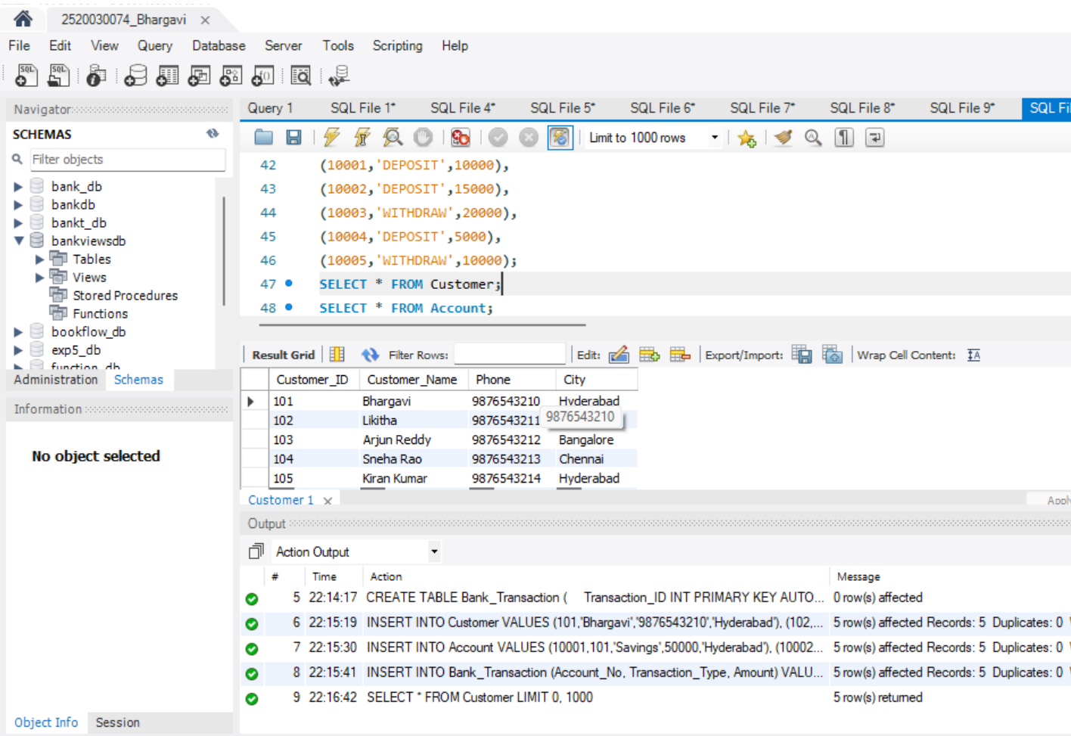
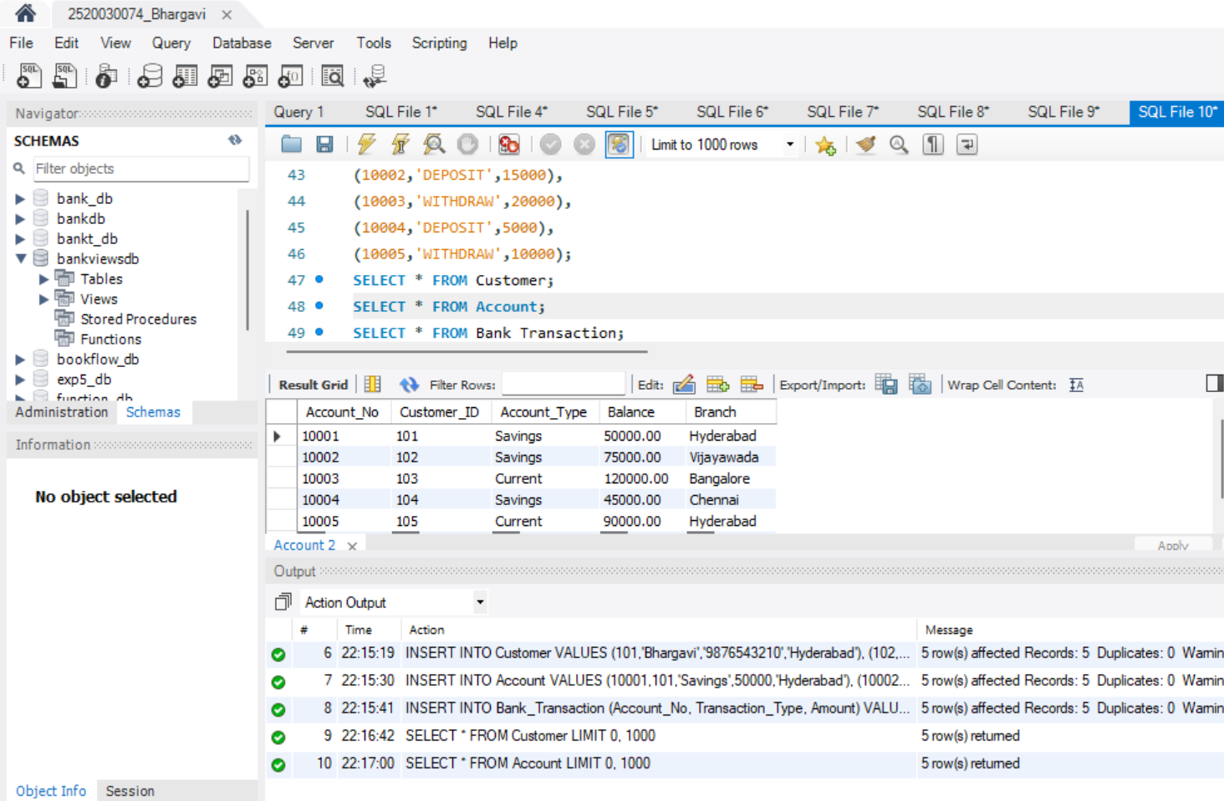
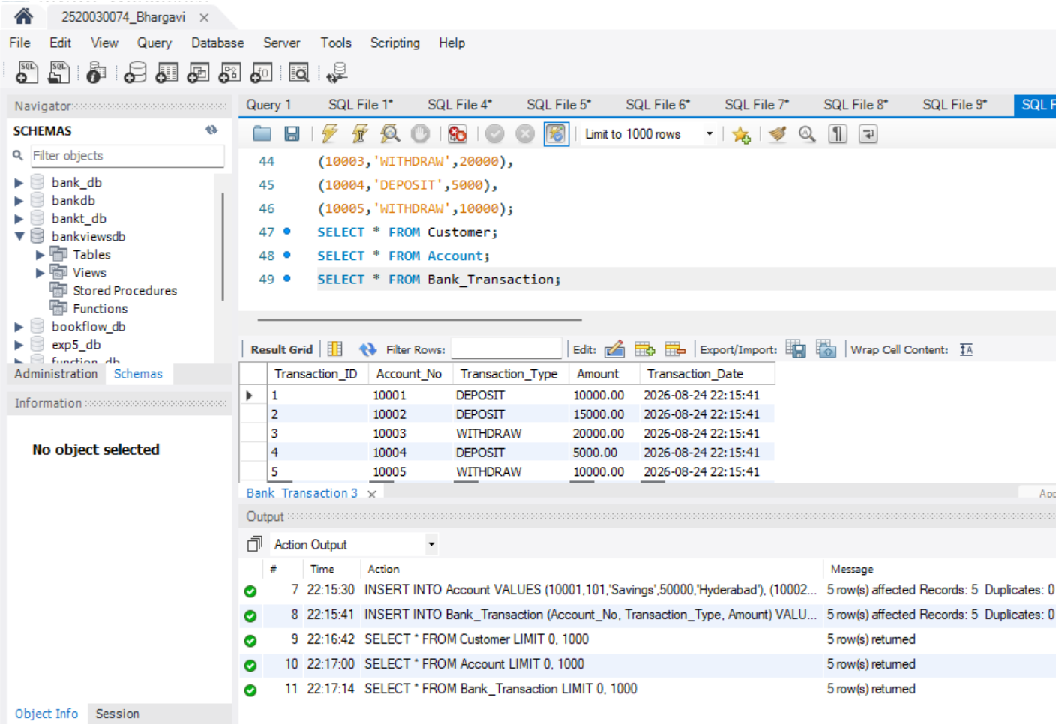
STEP-5: COMMIT
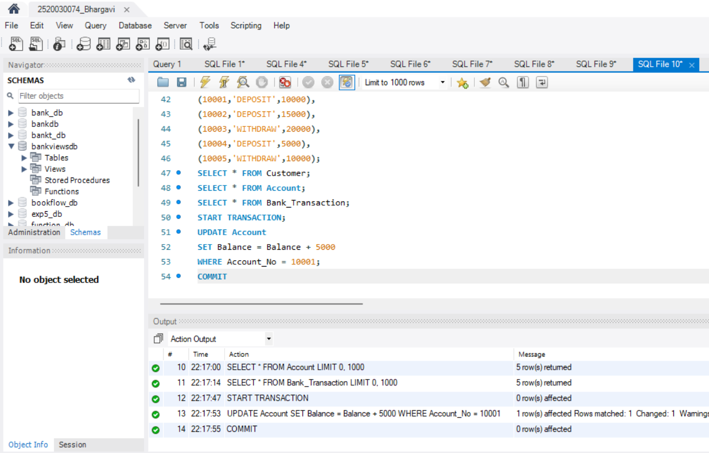
STEP-6: ROLLBACK
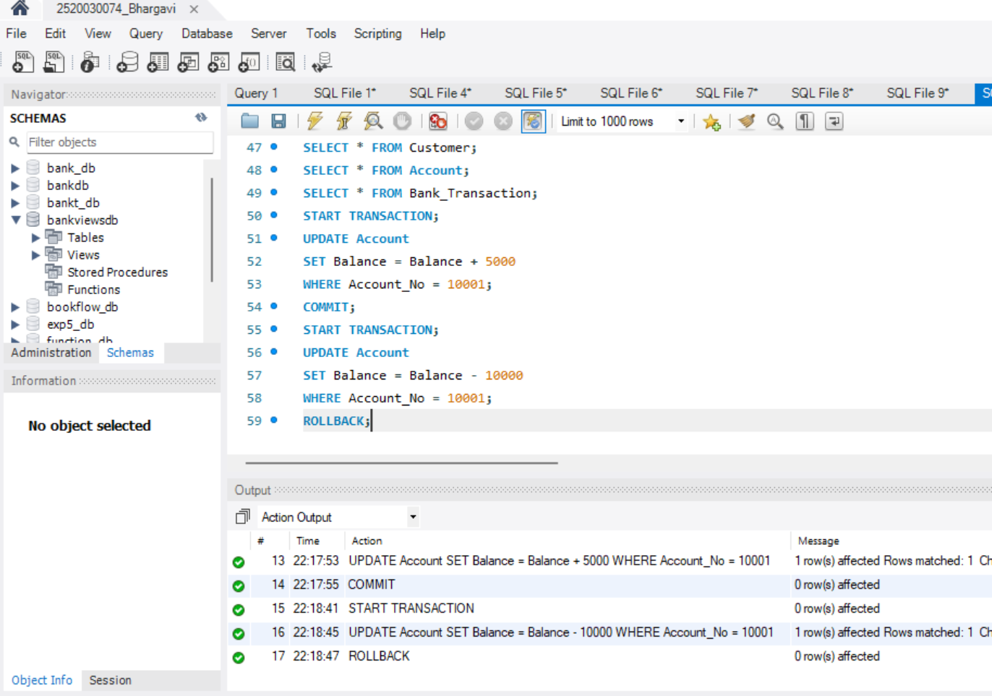
STEP-7: SAVEPOINT
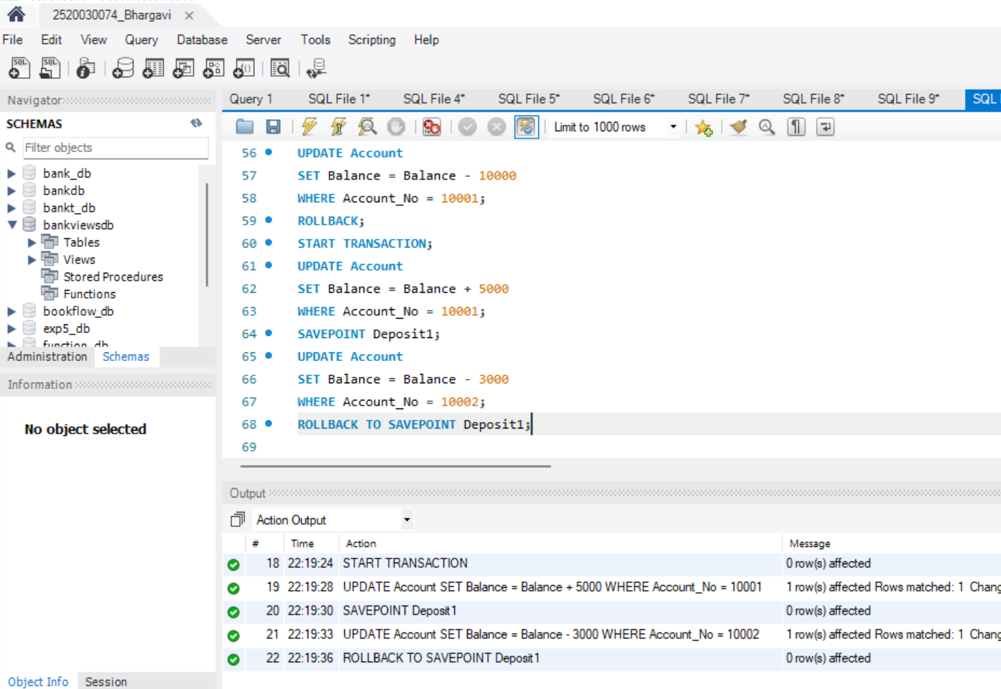
STEP-8: BANK TRANSFER
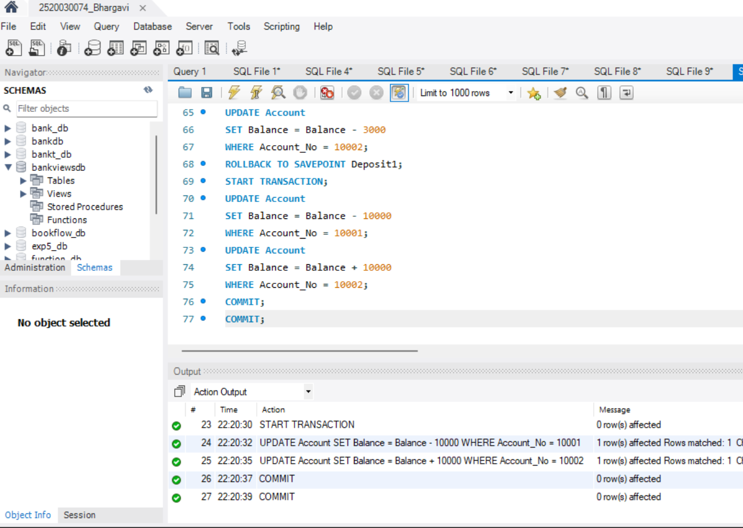
STEP-9: CHECK ISOLATION LEVEL
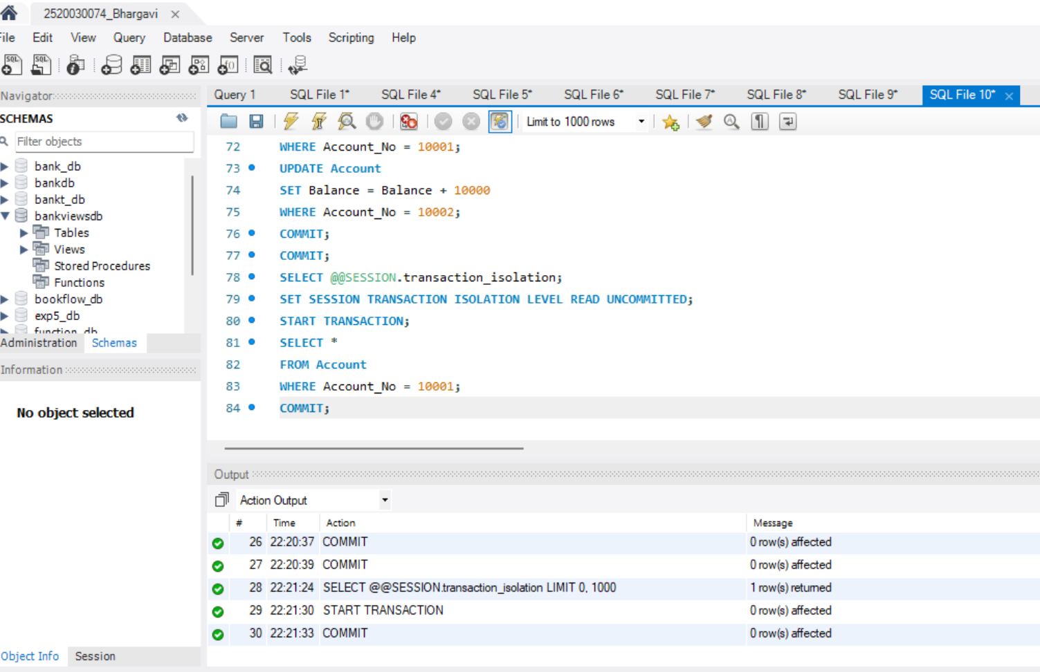
STEP-10: READ COMMITTED
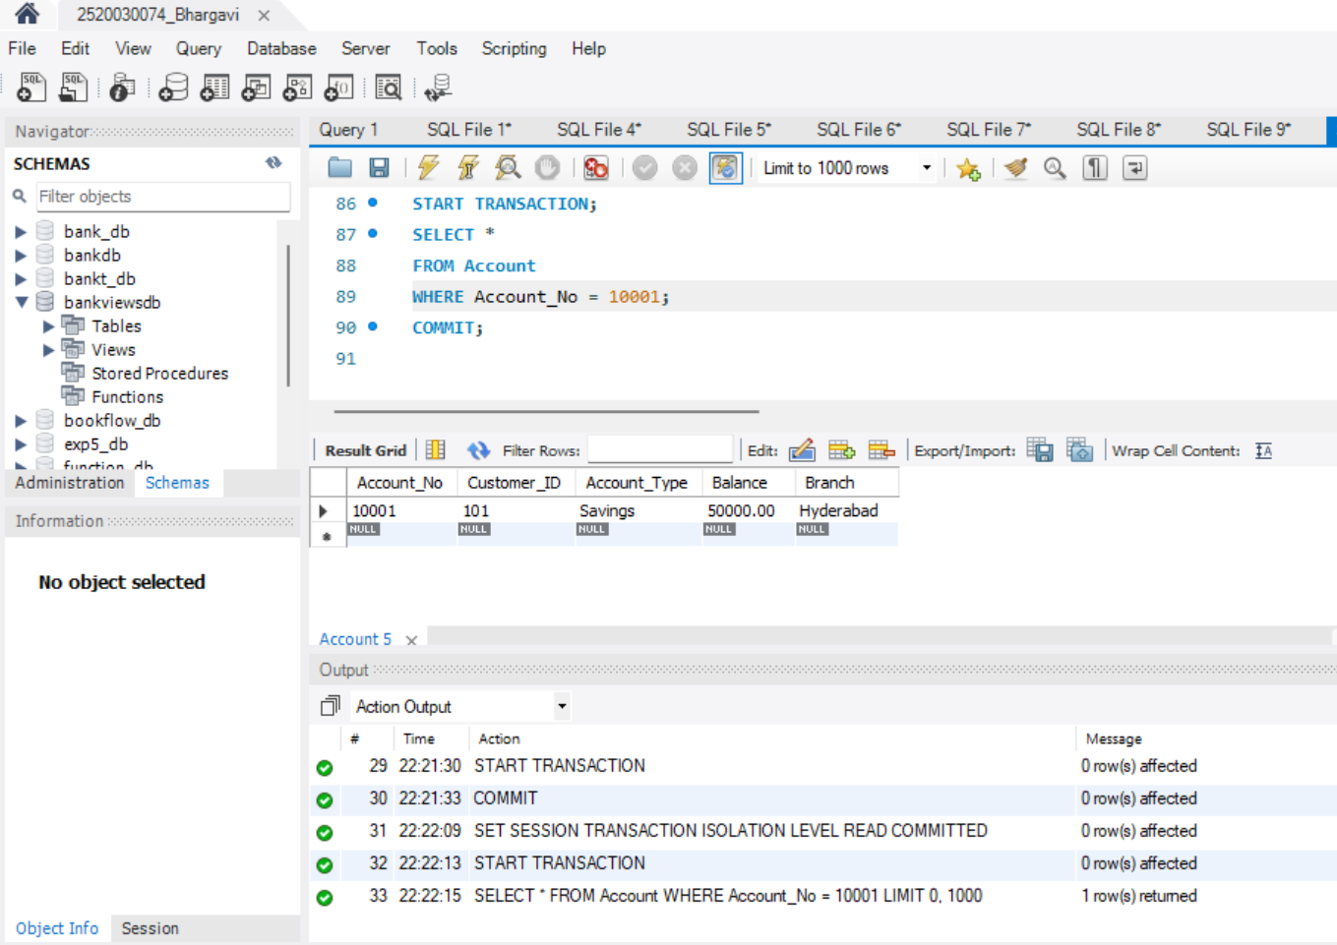
STEP-11: REPEATABLE READ
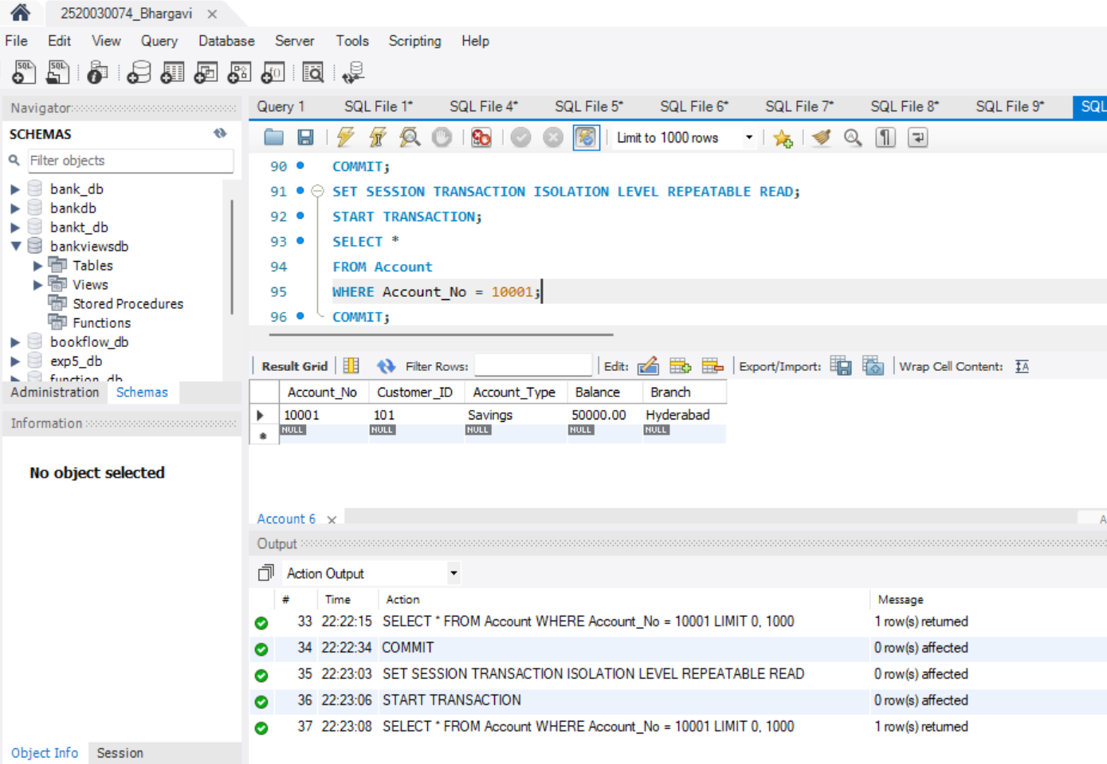
STEP-12: SERIALIZABLE
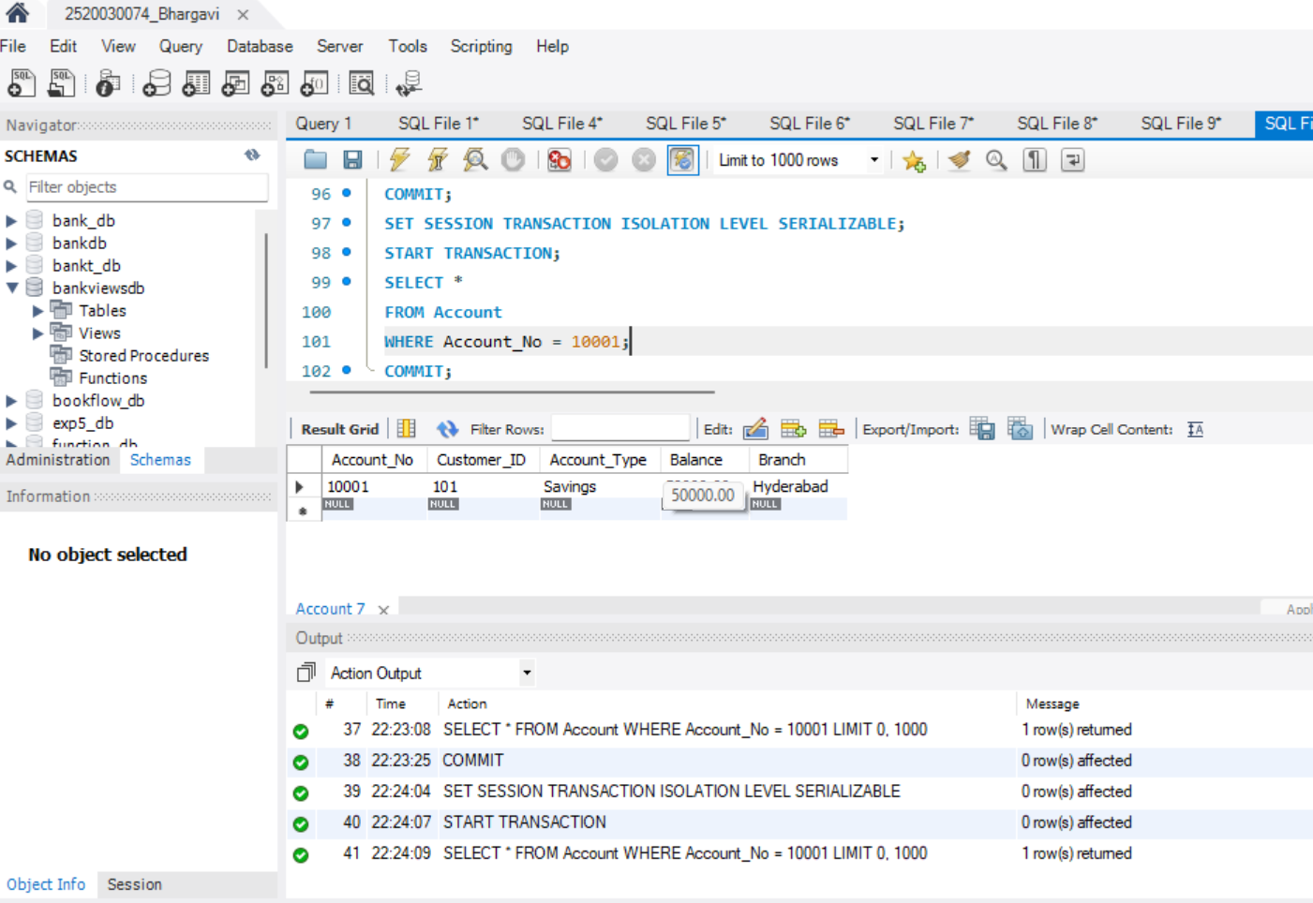
Question 1:
Create a transaction that deposits Rs. 5000 into account
10001 and commit the transaction.
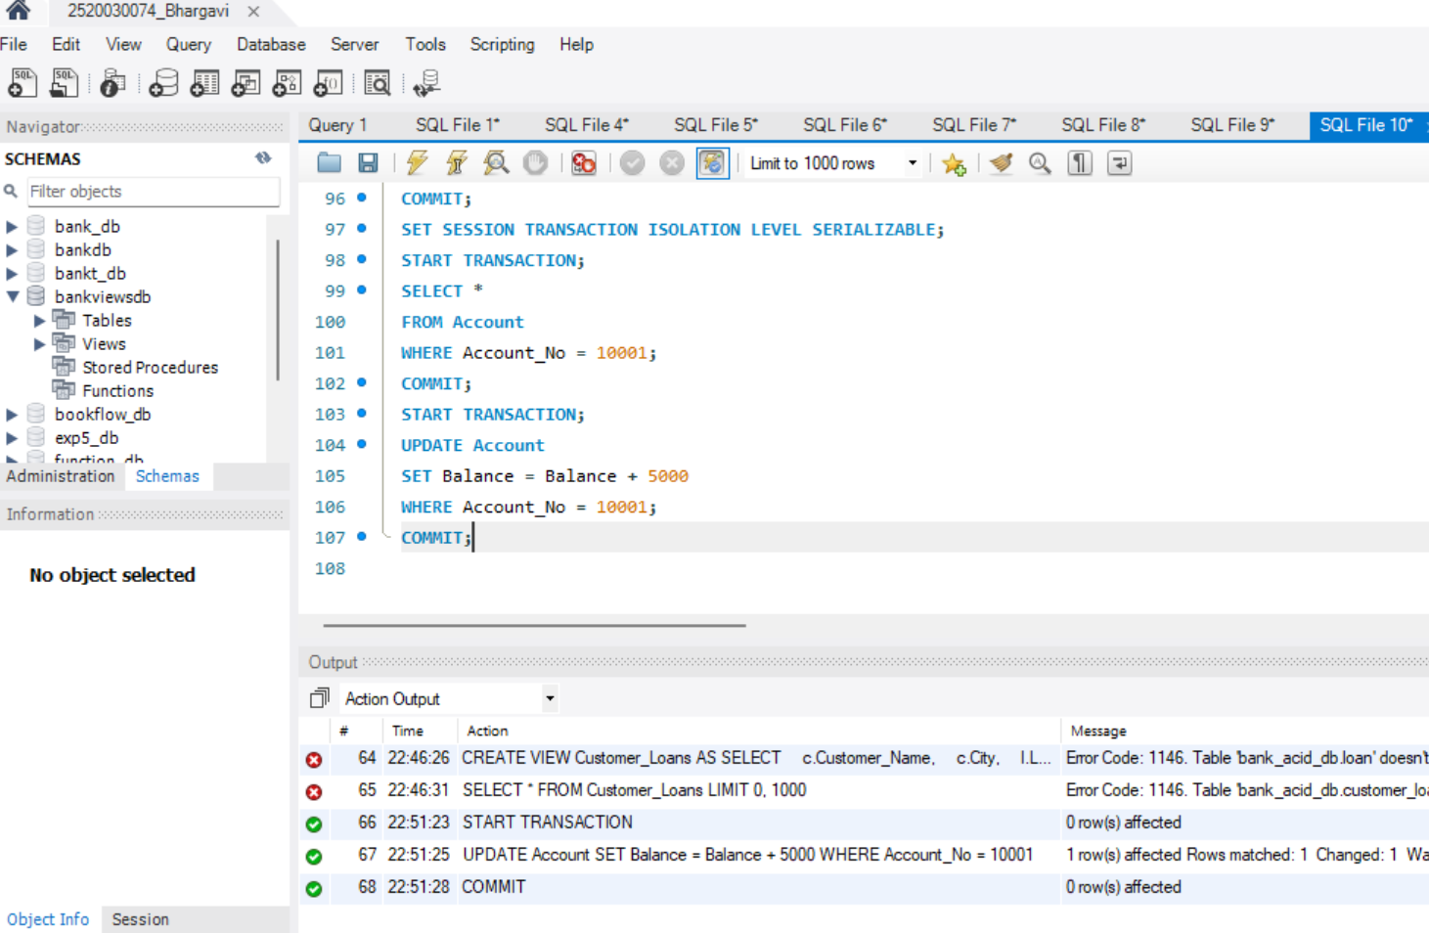
Question 2:
Create a transaction that withdraws Rs. 3000 from account
10002 and commit the transaction.
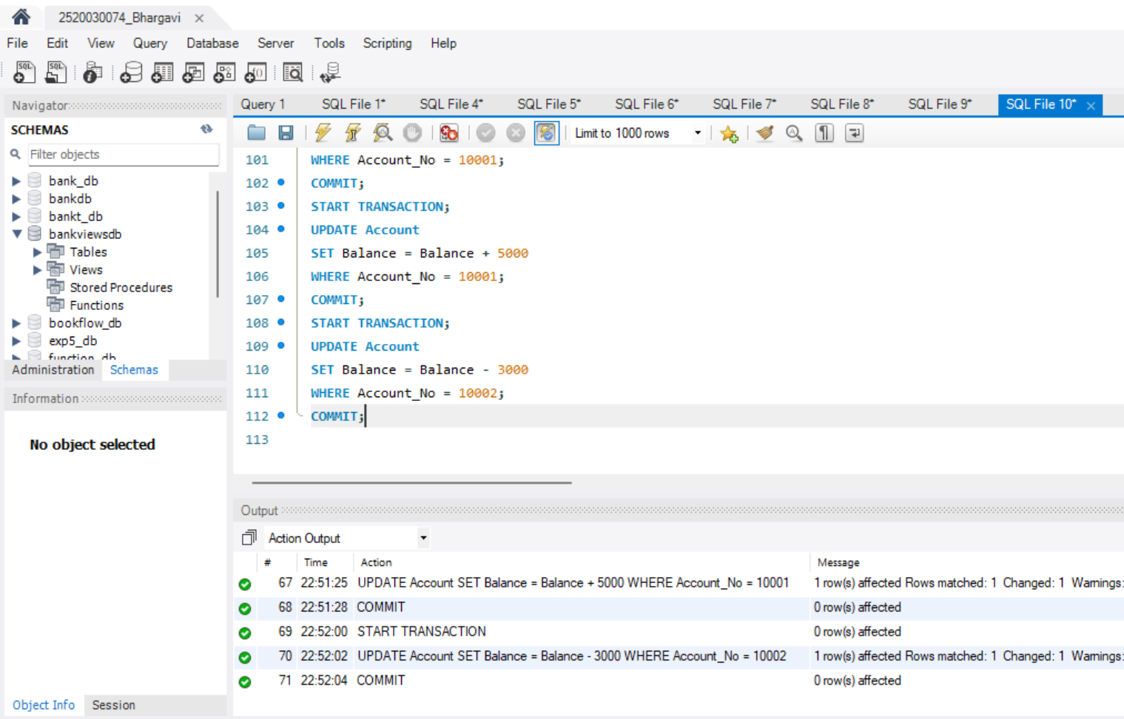
Question 3:
Create a transaction that withdraws Rs. 10000 and then
ROLLBACK the transaction.
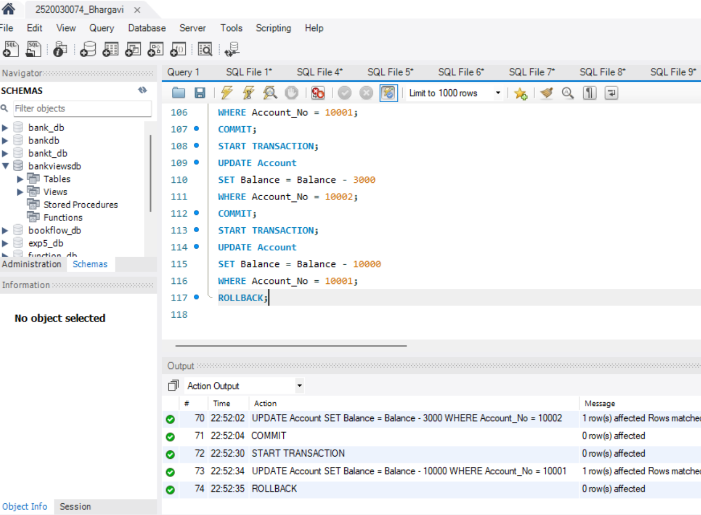
Question 4:
Transfer Rs. 15000 from account 10001 to account 10002
using a transaction.

Requirements:

1. START TRANSACTION
2. Deduct from sender
3. Add to receiver
4. COMMIT
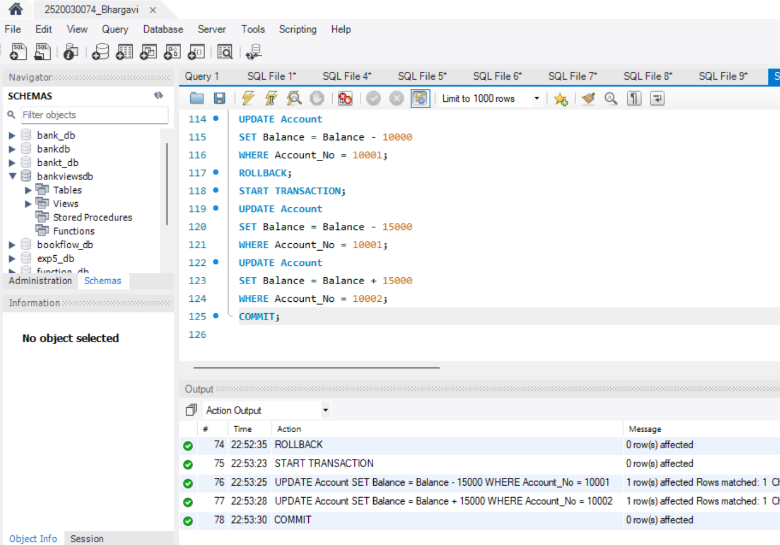
Question 5:
Transfer Rs. 20000 from account 10001 to account 10003.

Use SAVEPOINT after deducting the amount from the sender.
