VIEWS
2520030074
K. BHARGAVI
STEP-1: CREATE DATABASE
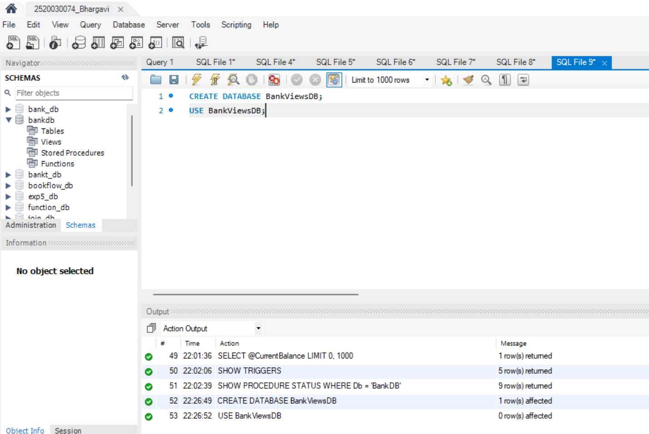
STEP-2: CREATE TABLES
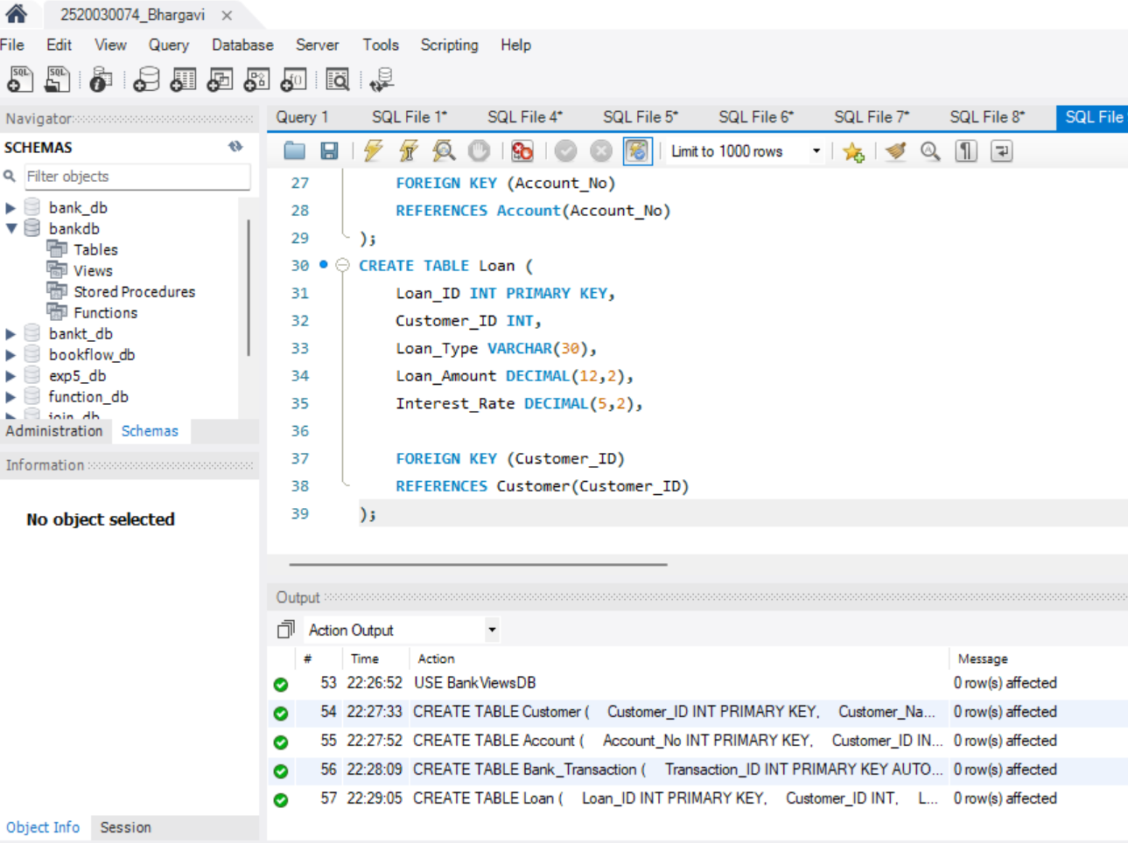
STEP-3: INSERT TABLES
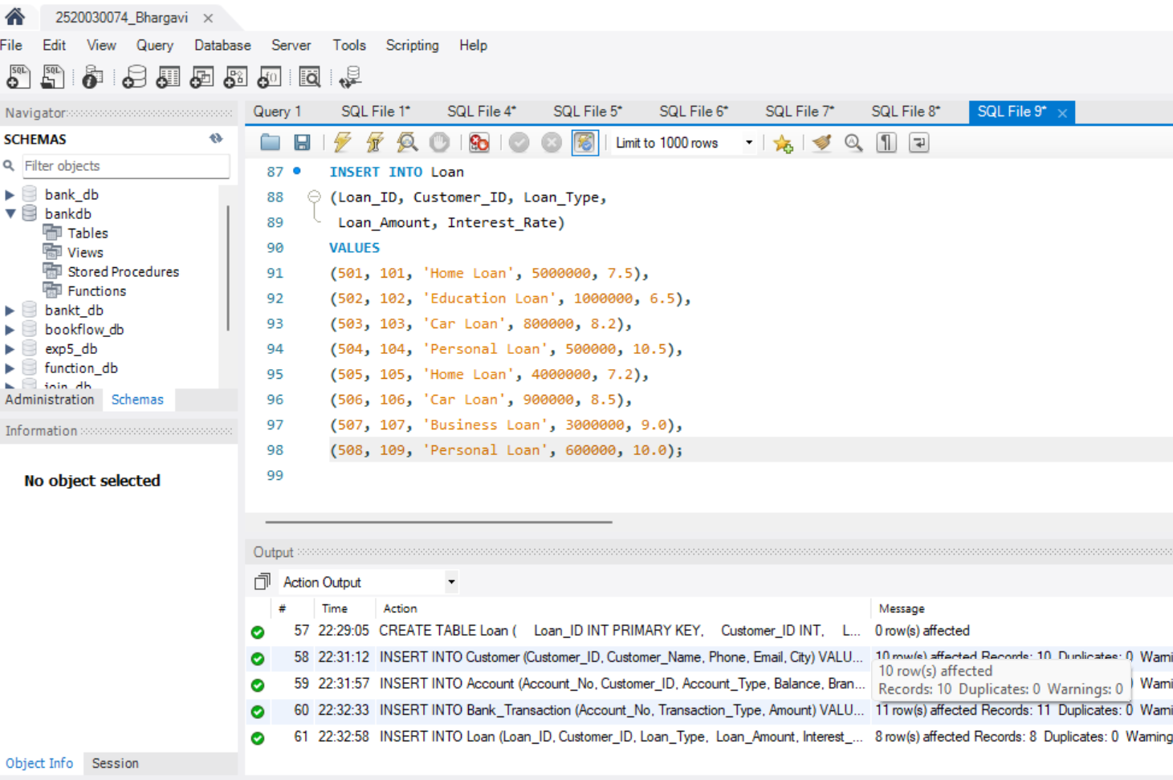
STEP-4: DISPLAY TABLES
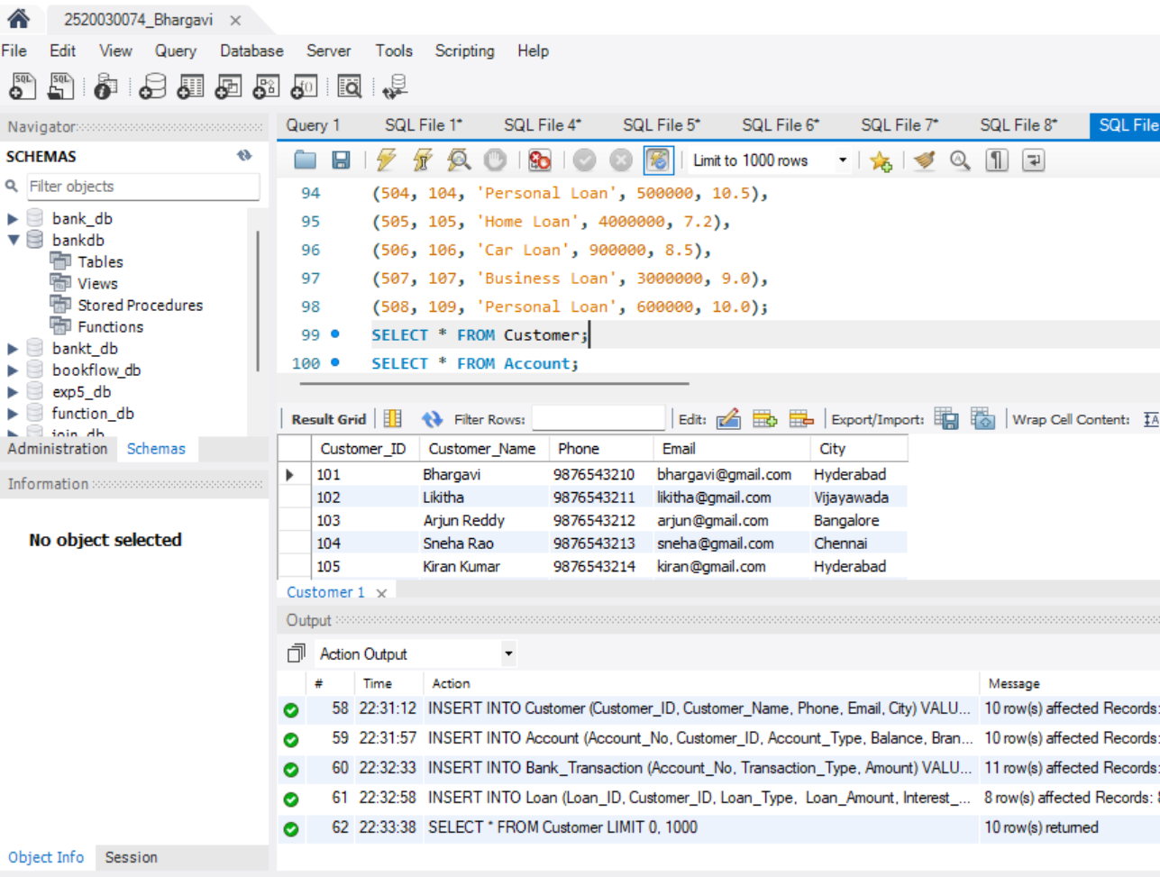
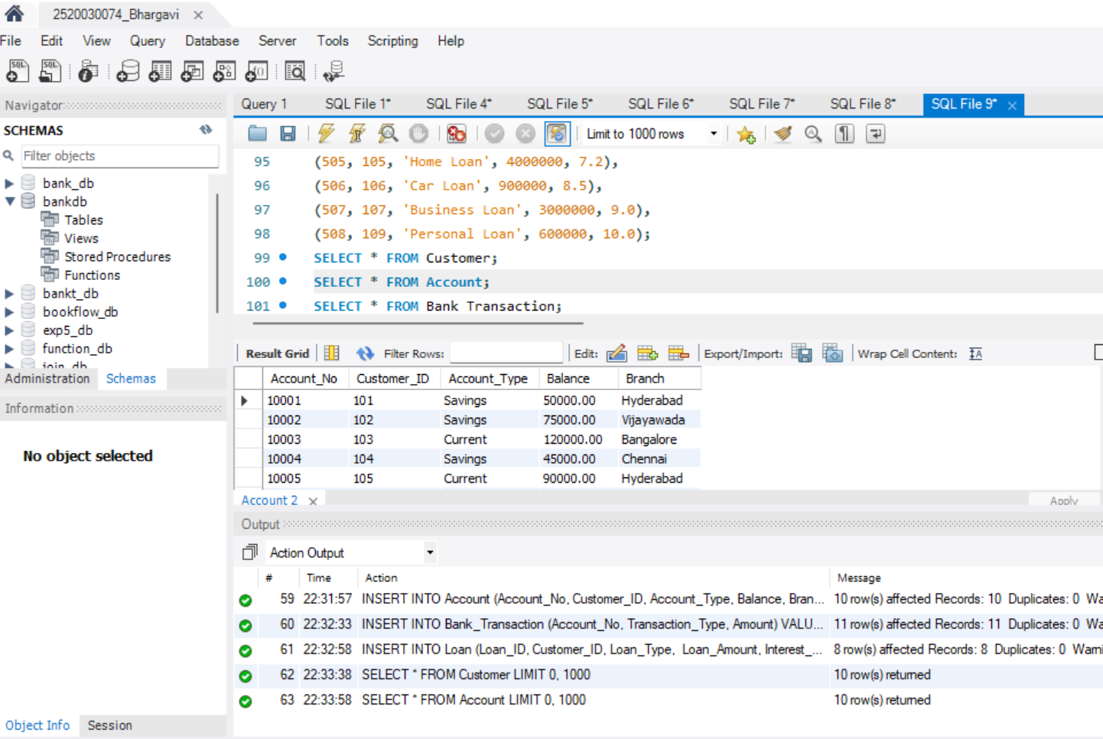
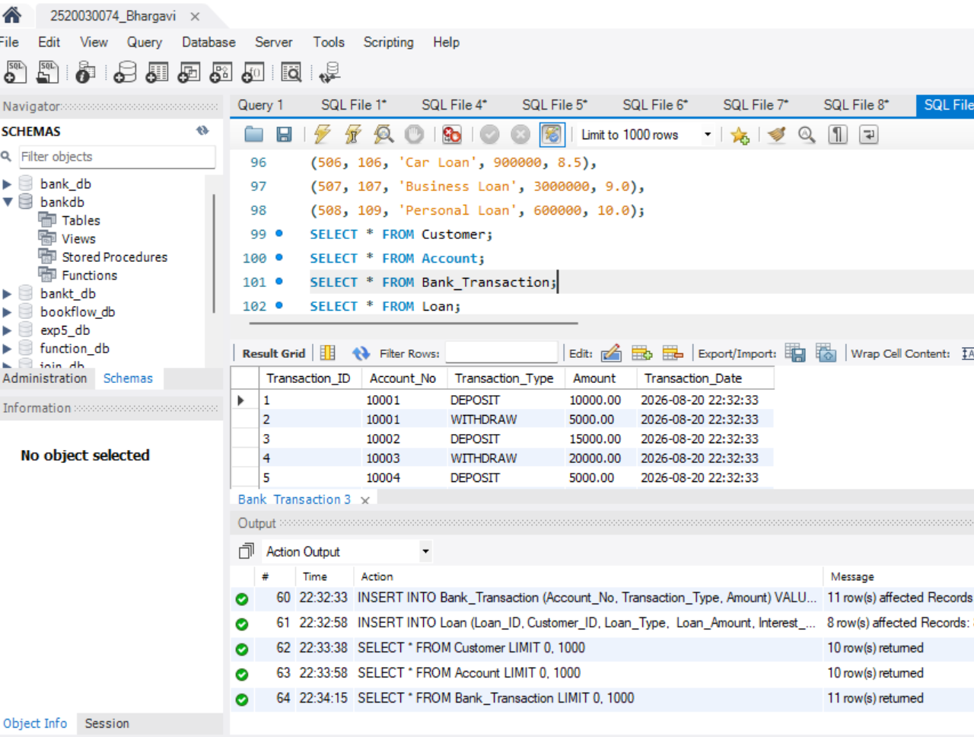
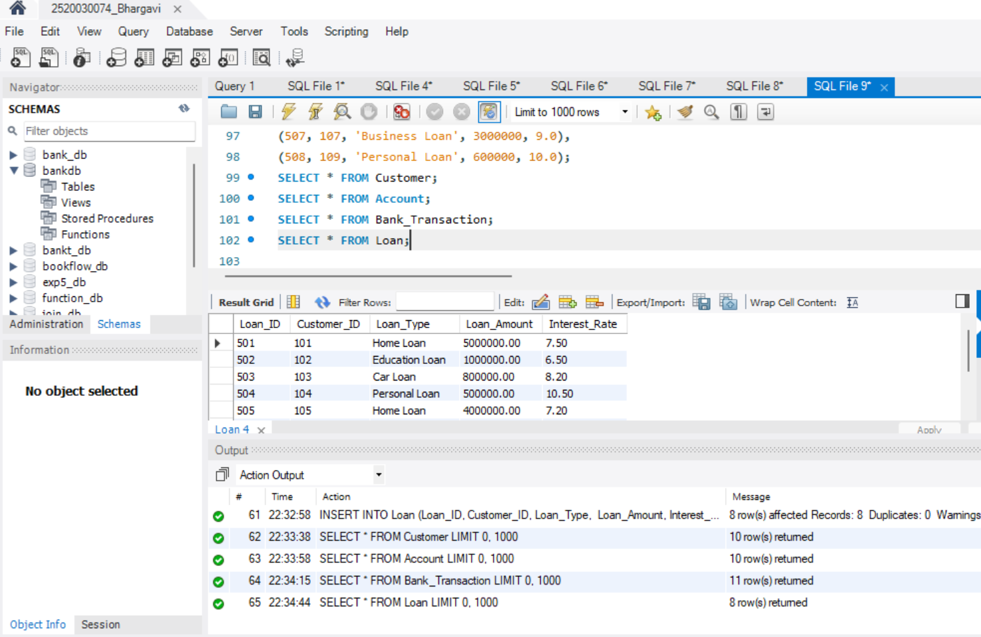
STEP-5: CREATE SIMPLE CUSTOMER VIEW
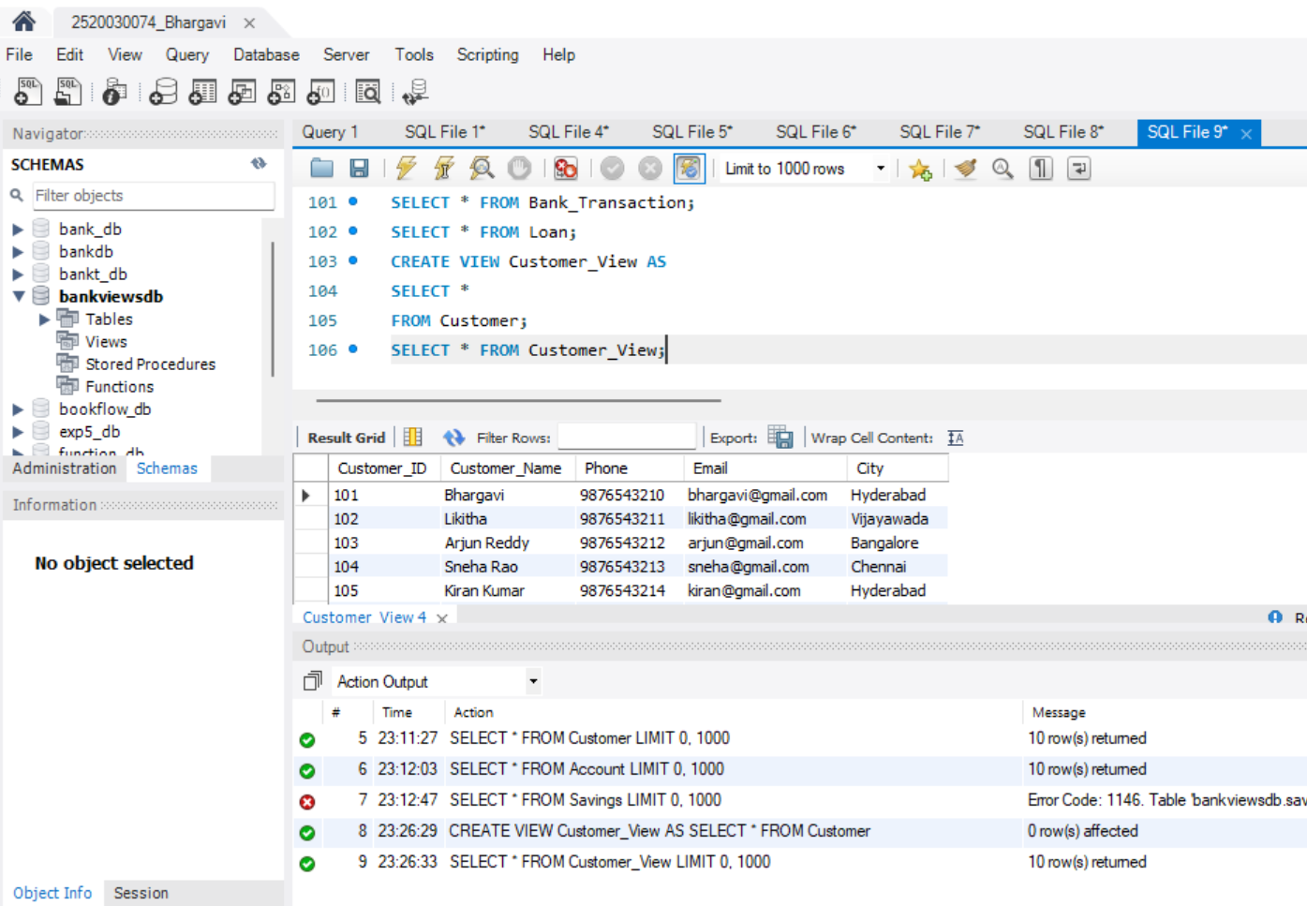
STEP-6: CREATE CUSTOMER BASIC VIEW
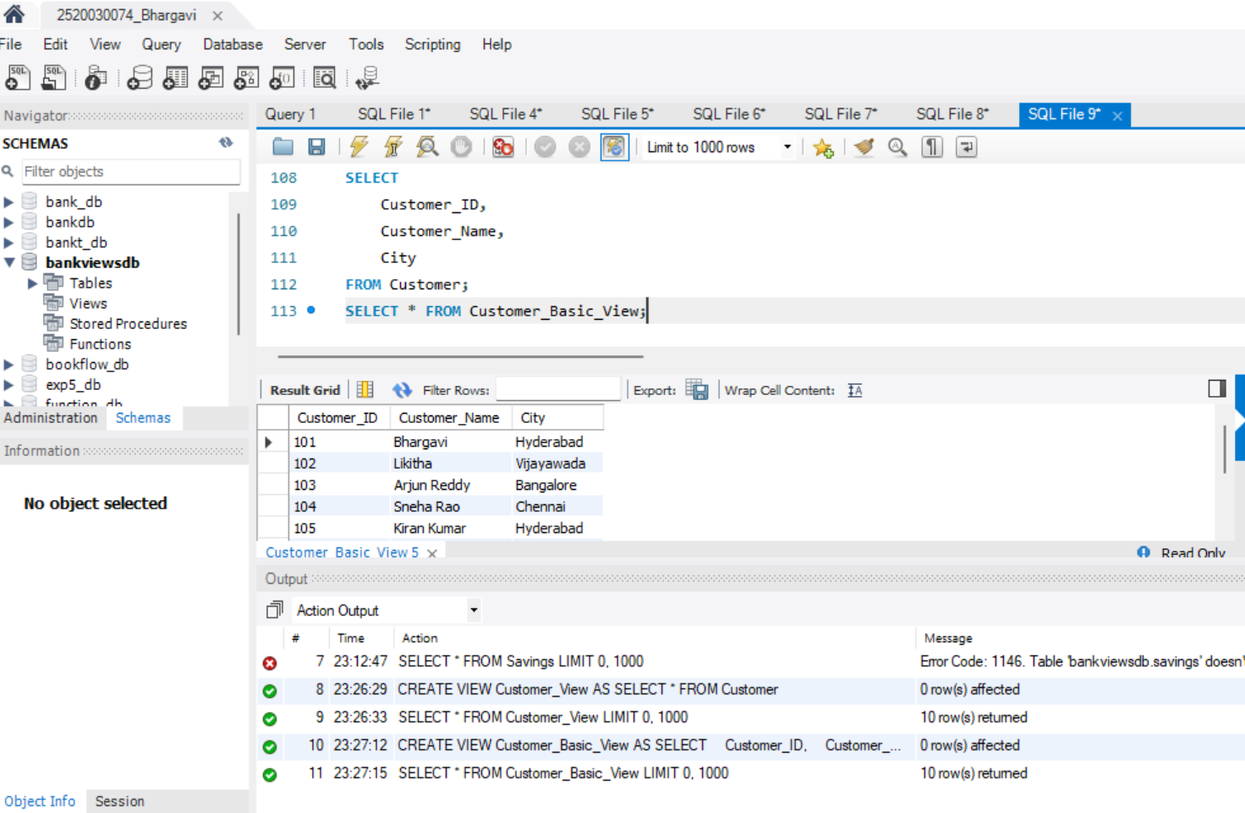
STEP-7: CREATE ACCOUNT VIEW
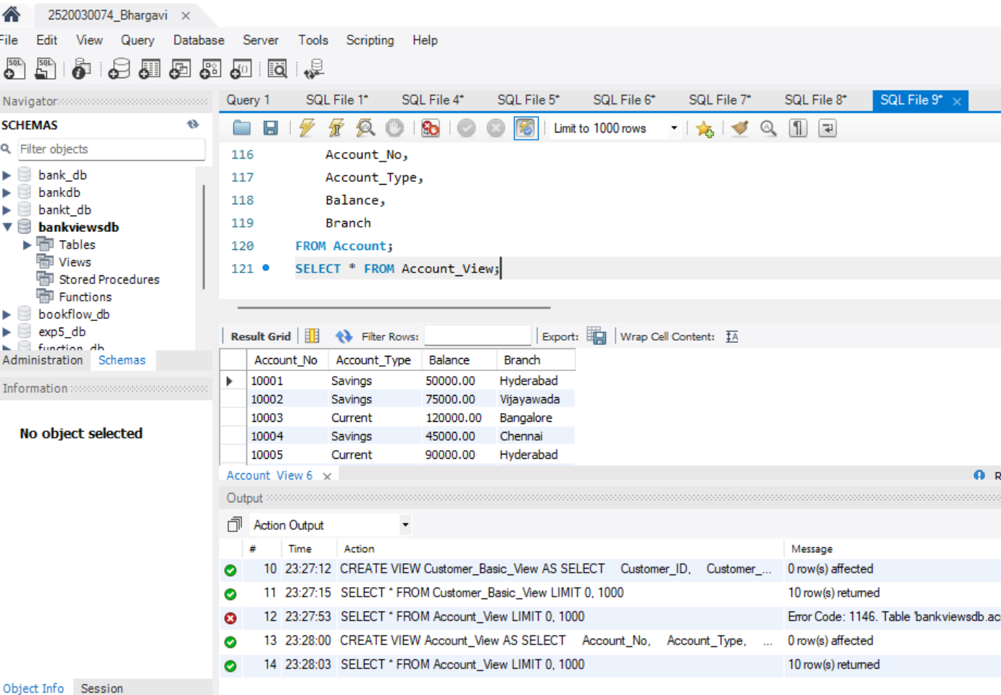
STEP-8: SAVINGS ACCOUNT VIEW
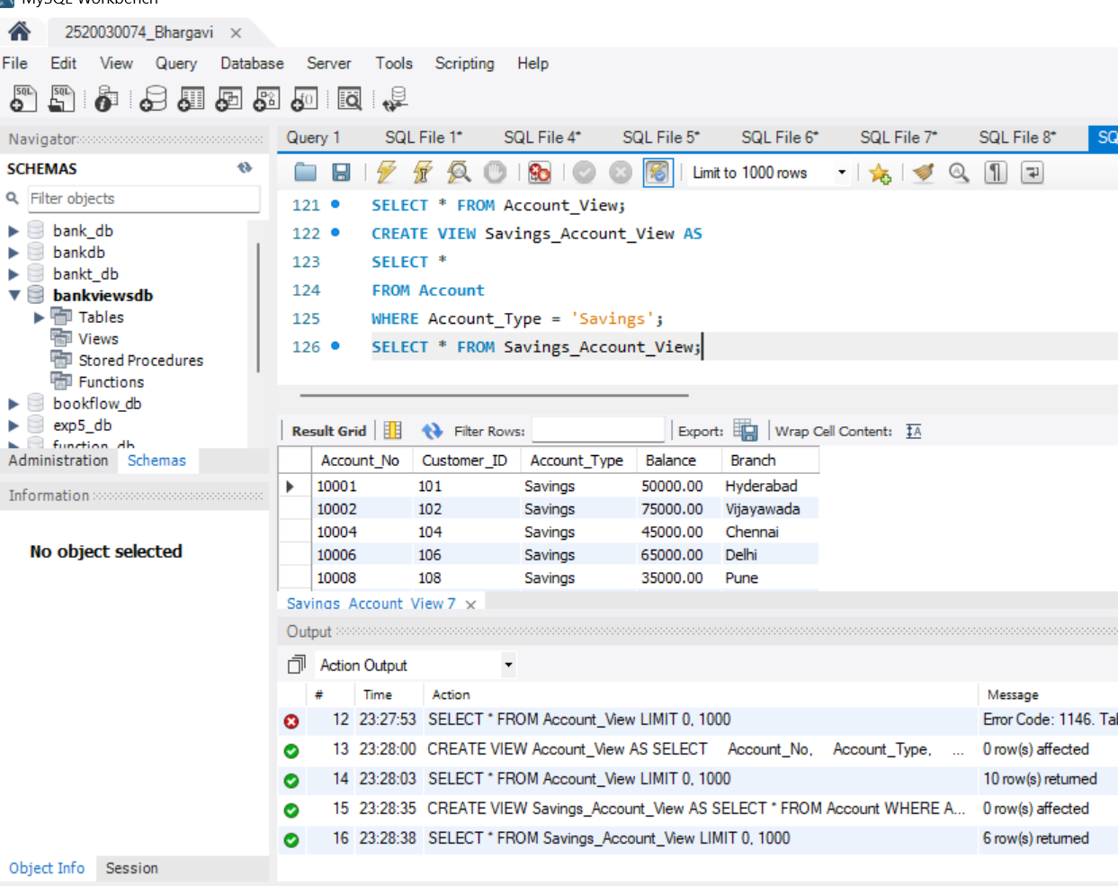
STEP-9: CURRENT ACCOUNT VIEW
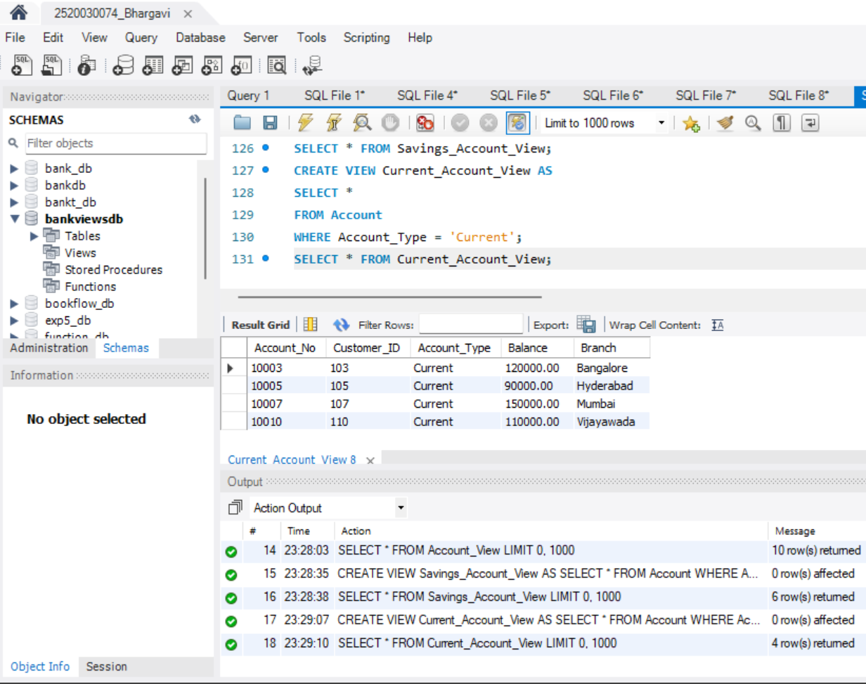
STEP-10: HIGH BALANCE VIEW
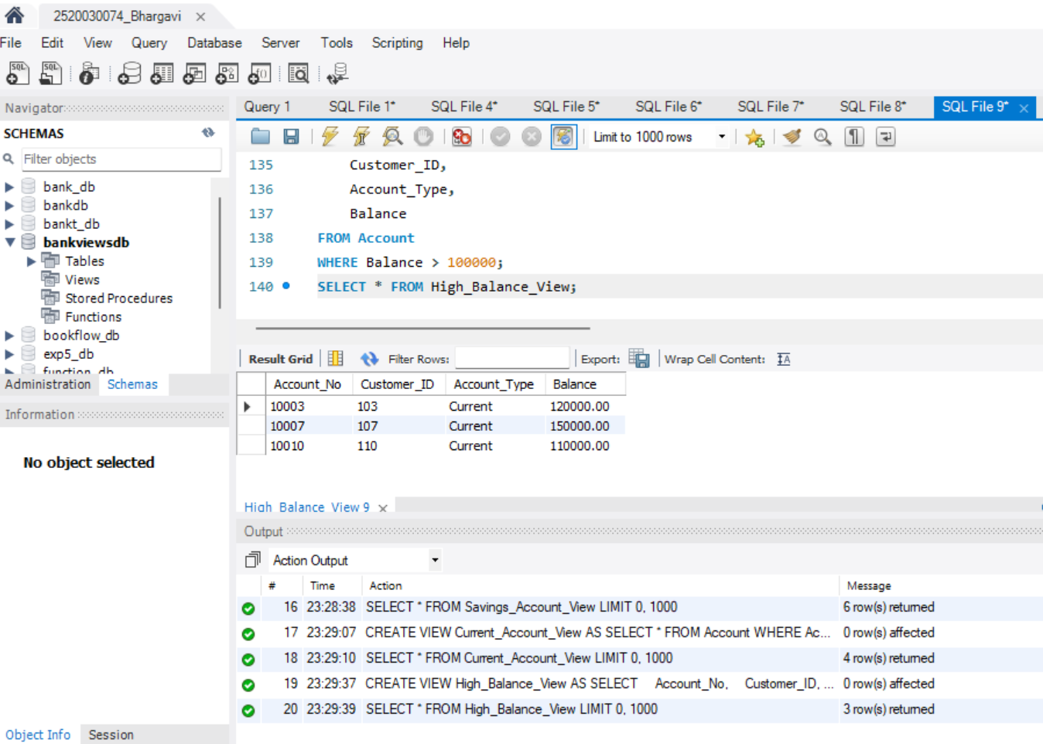
STEP-11: HIGH BALANCE VIEW
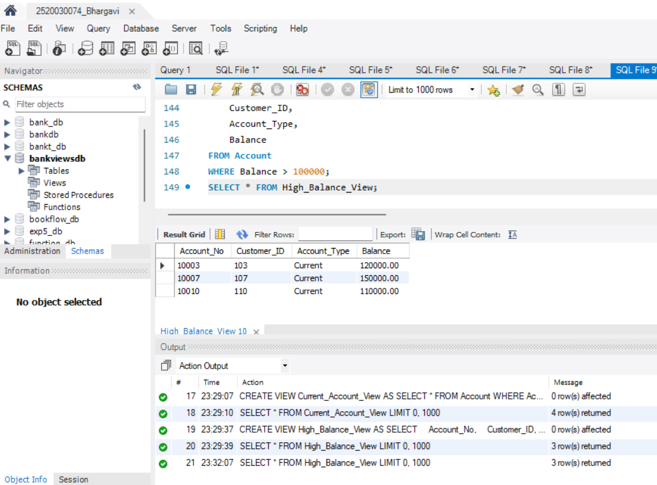
STEP-12: HYDERABAD CUSTOMER ACCOUNT VIEW
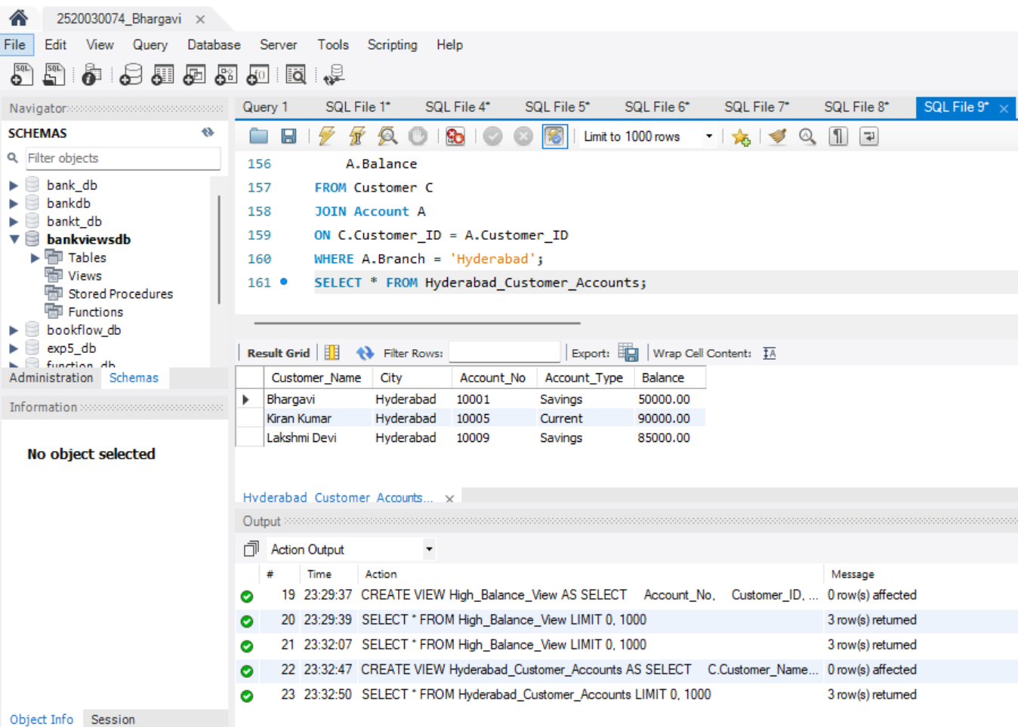
STEP-13: TOTAL BANK BALANCE
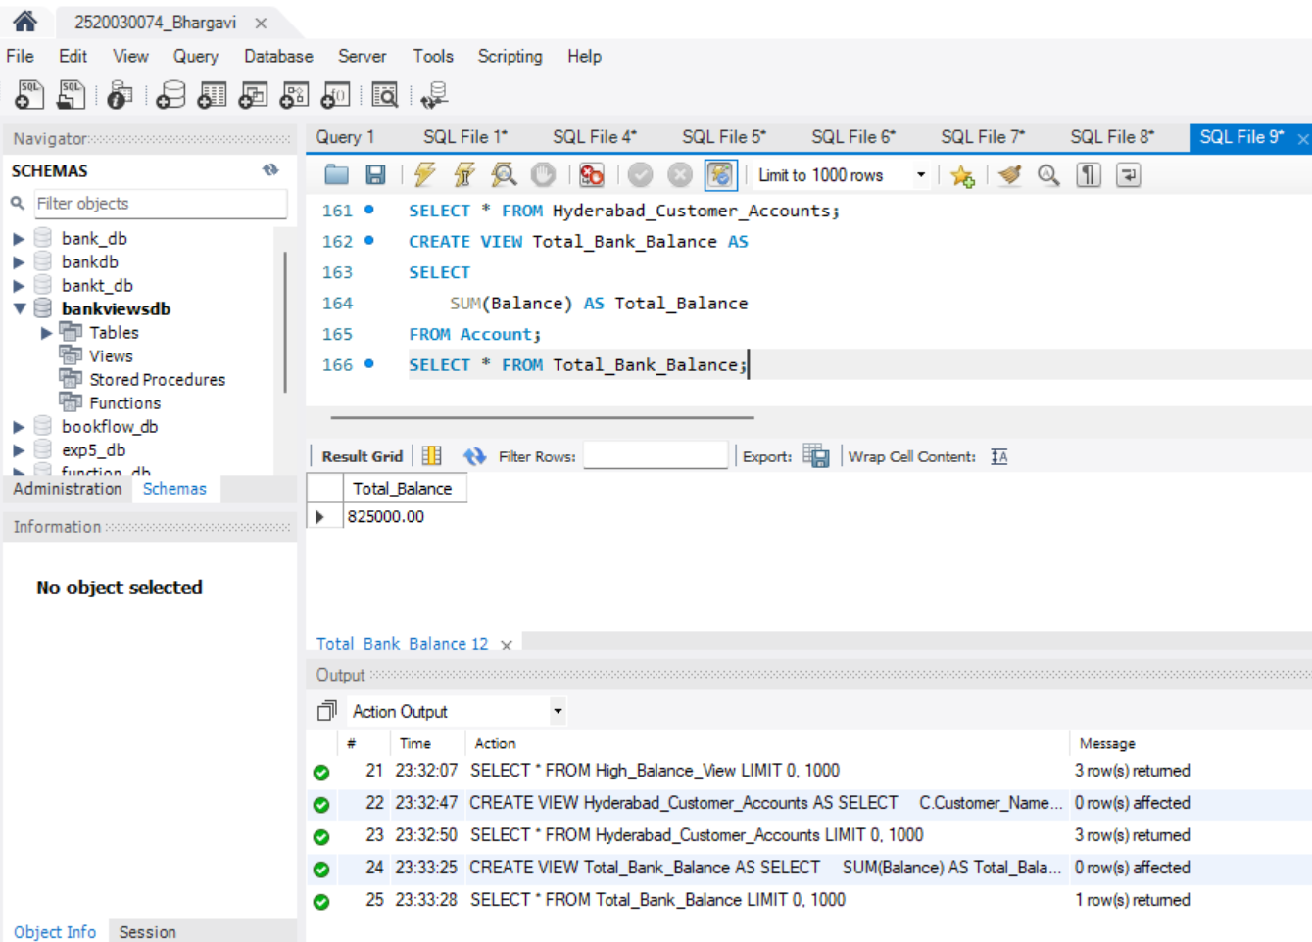
STEP-14: AVERAGE ACCOUNT BALANCE
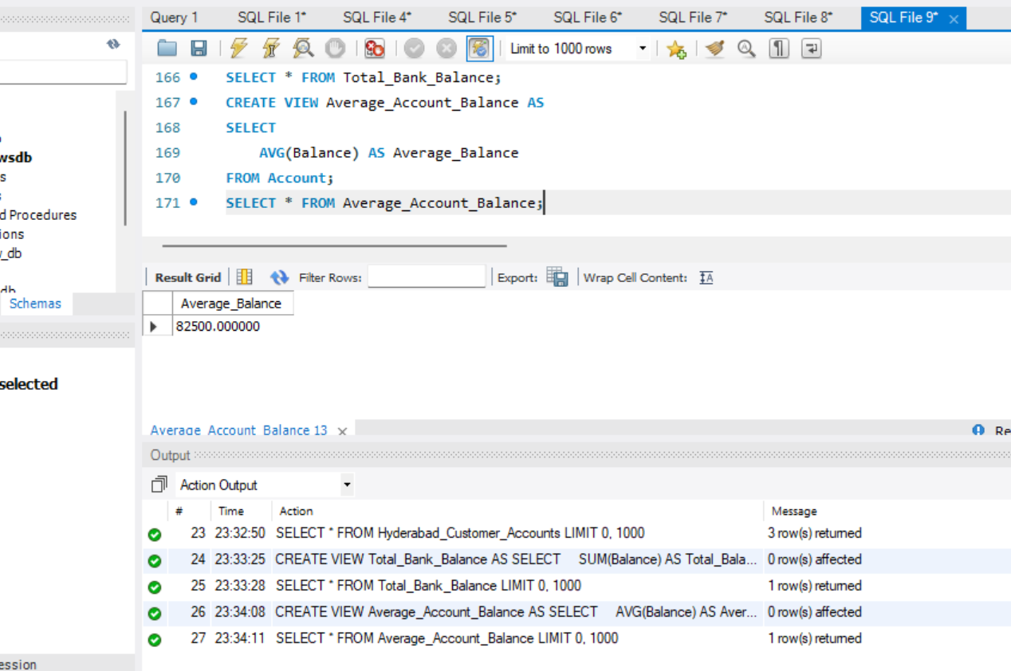
STEP-15: MAXIMUM BALANCE
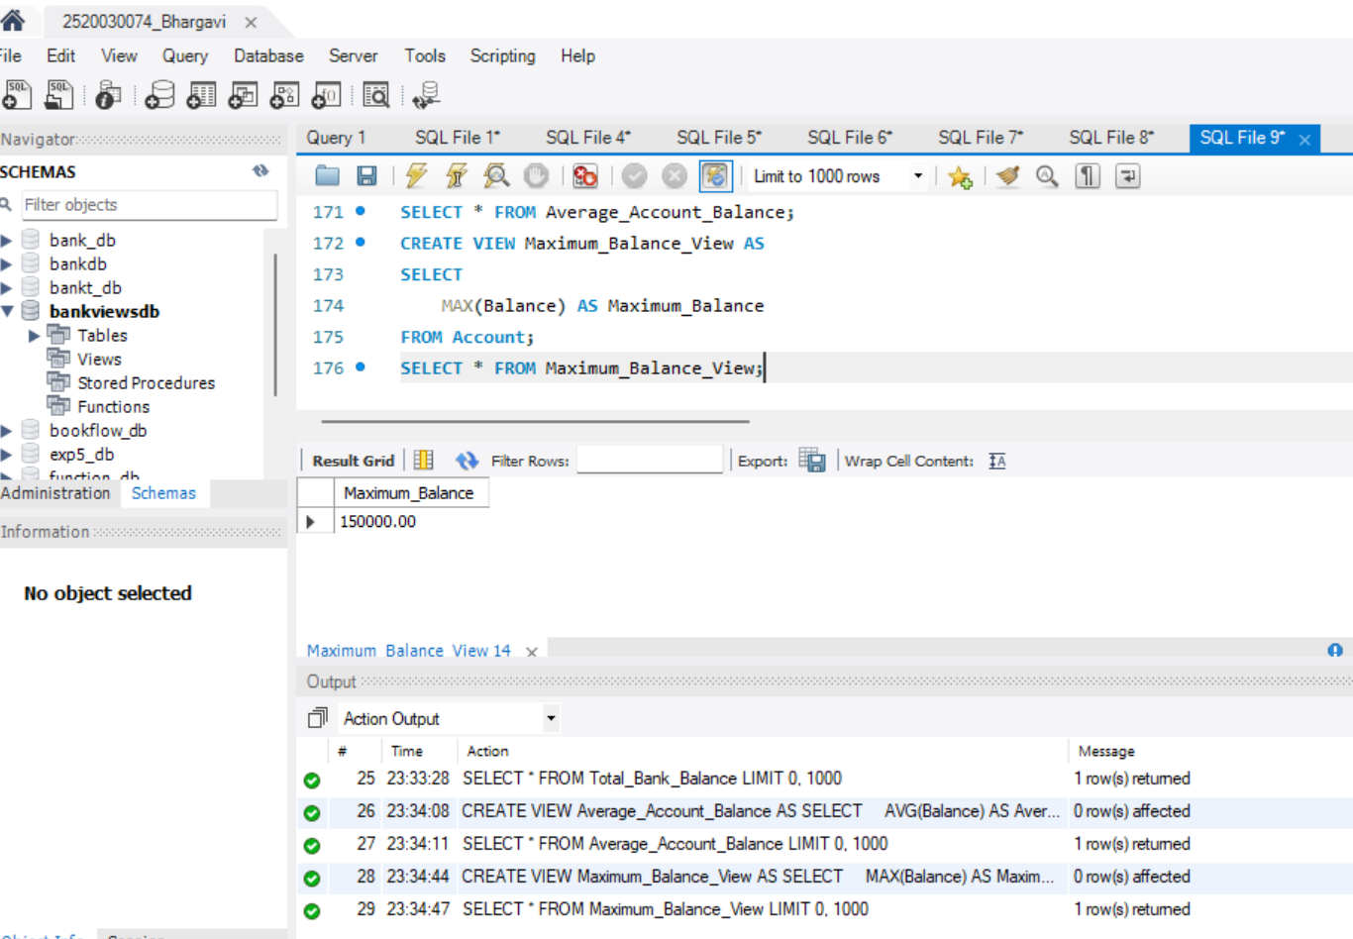
STEP-16: MAXIMUM BALANCE
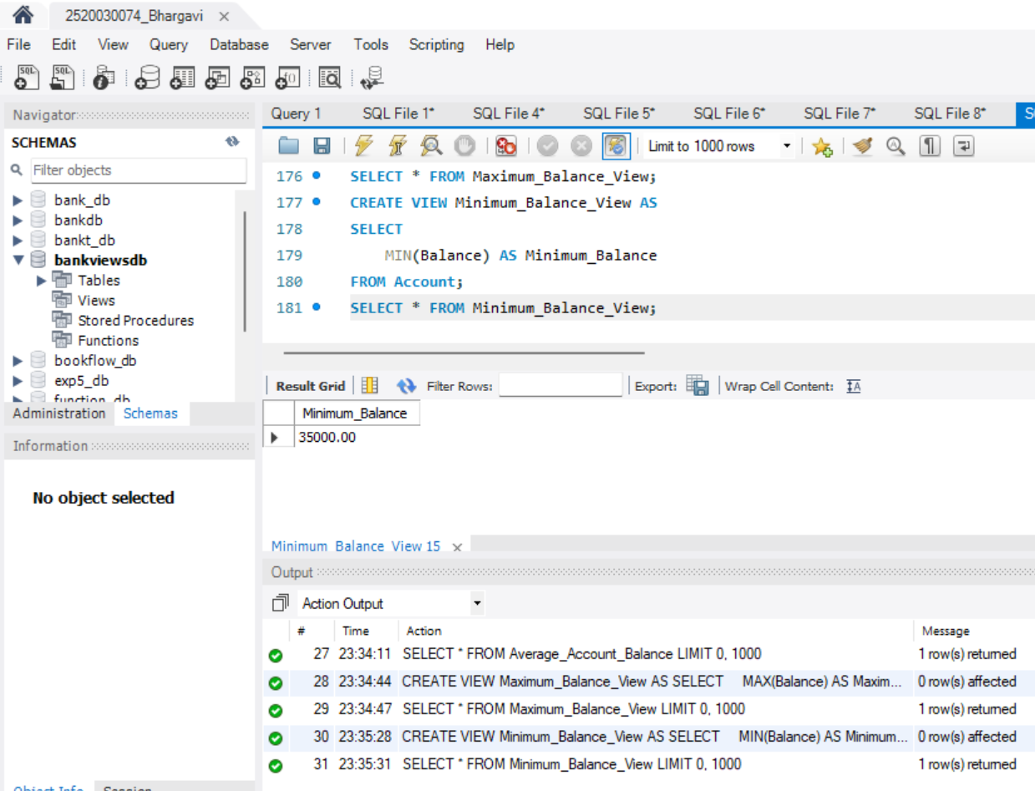
STEP-18: LOAN INTEREST CALCULATION VIEW
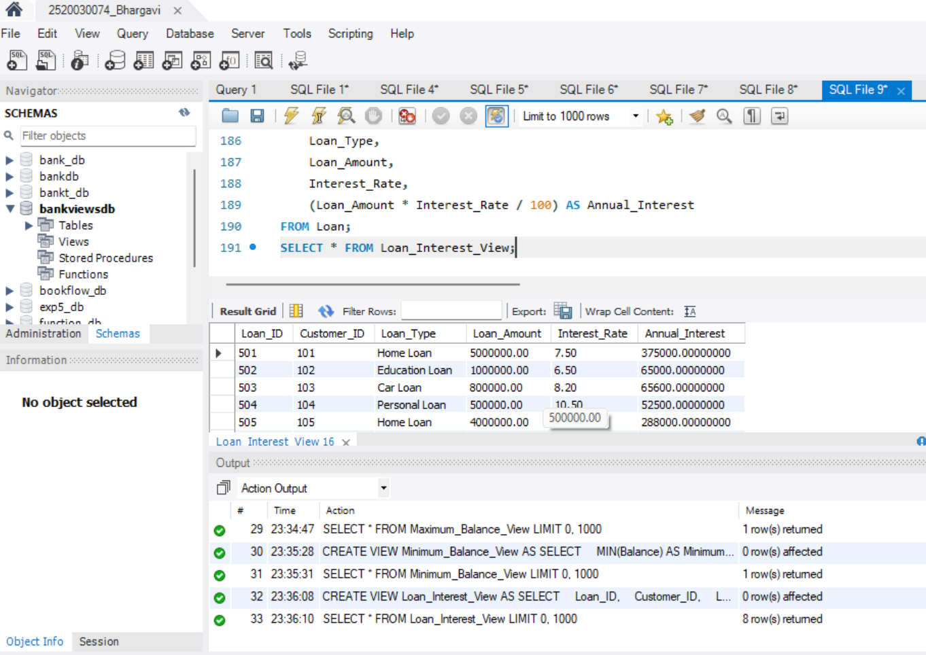
STEP-19: QUERY VIEW USING WHERE
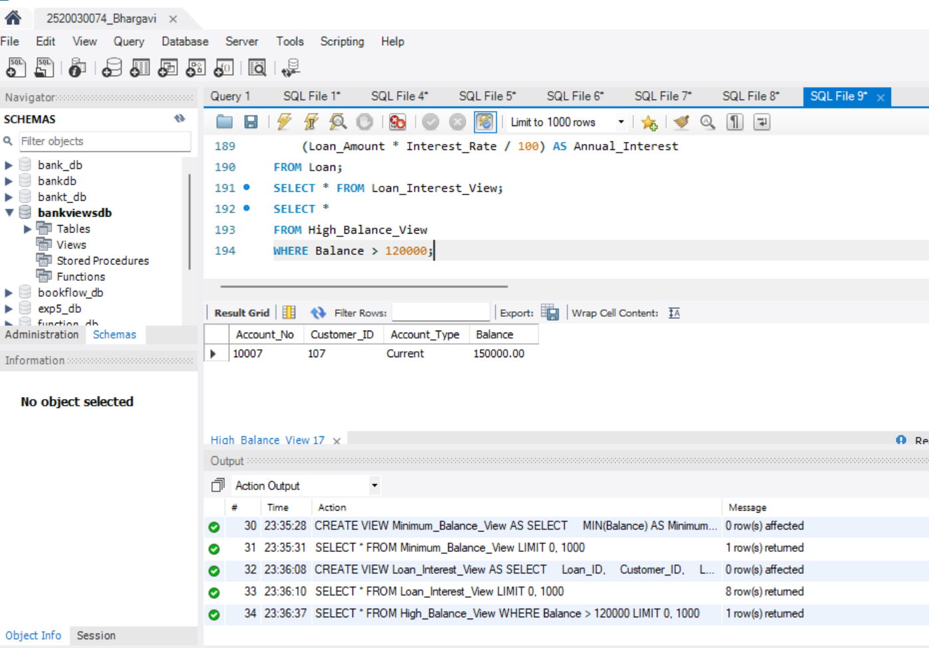
STEP-20: UPDATE THROUGH VIEW
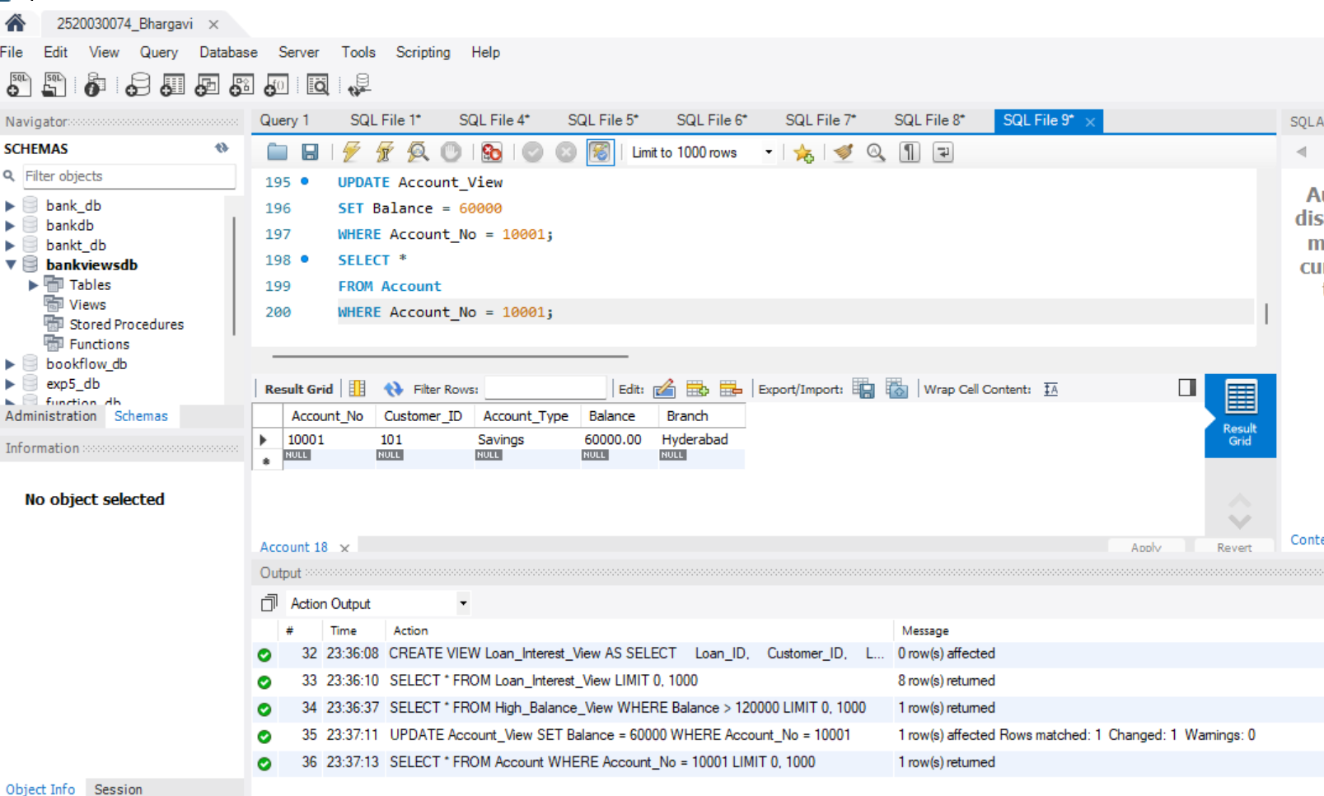
STEP-21: CREATE SIMPLE ACCOUNT VIEW FOR INSERT/DELETE
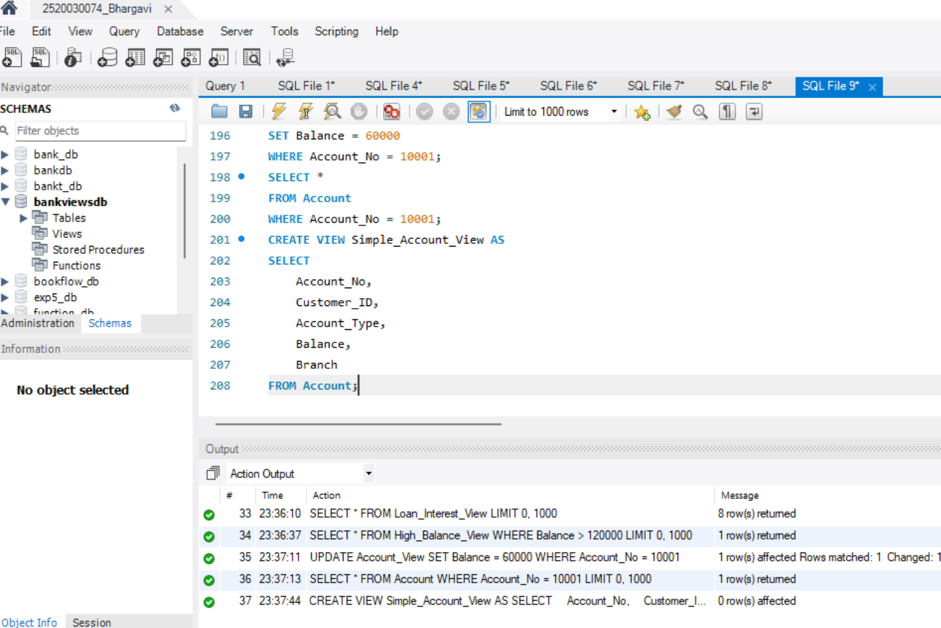
STEP-22: INSERT THROUGH VIEW
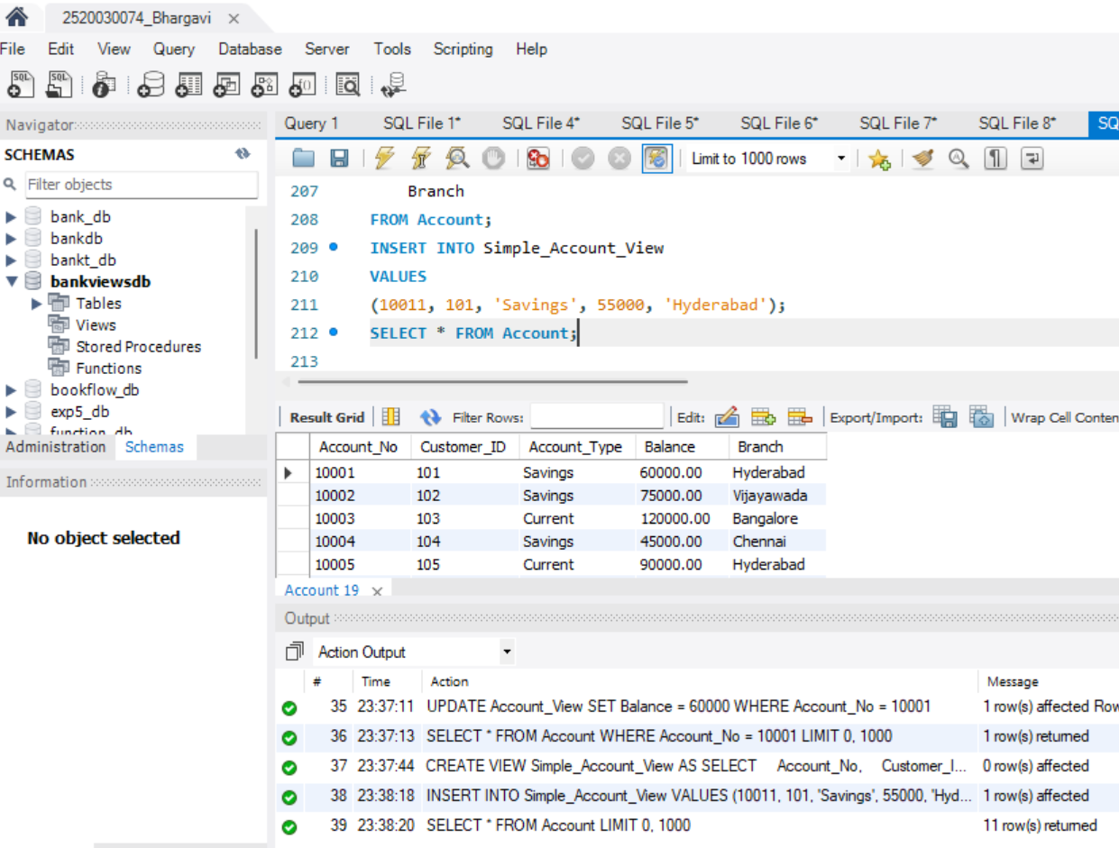
STEP-23: DELETE THROUGH VIEW
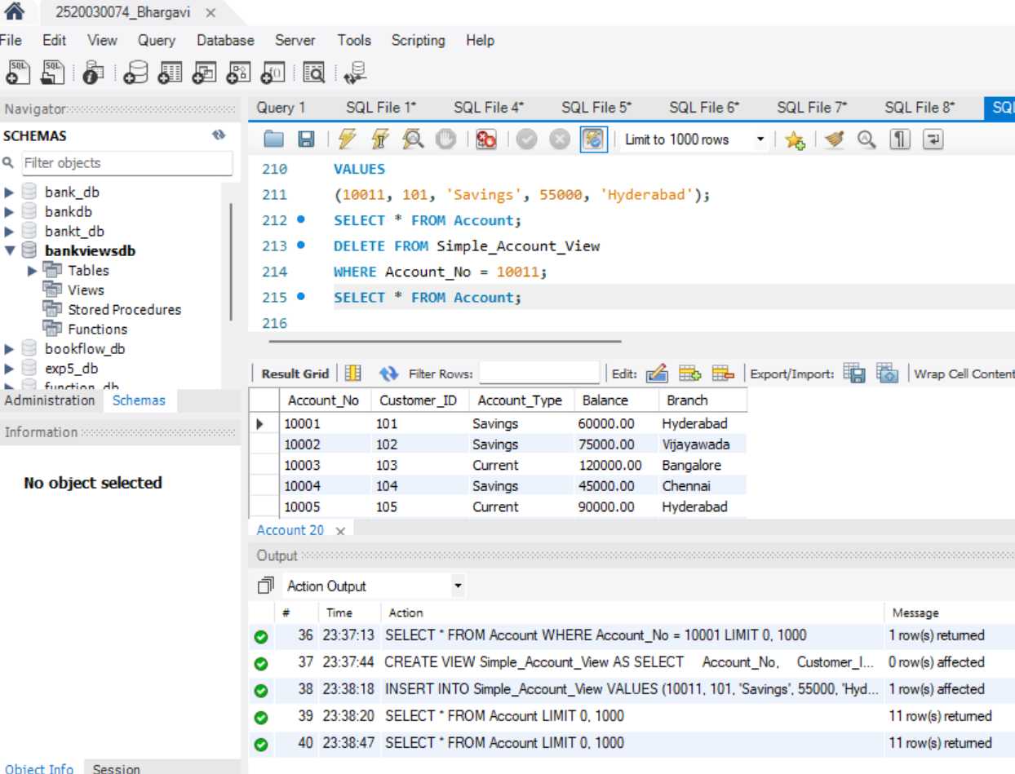
STEP-24: SHOW ALL VIEWS
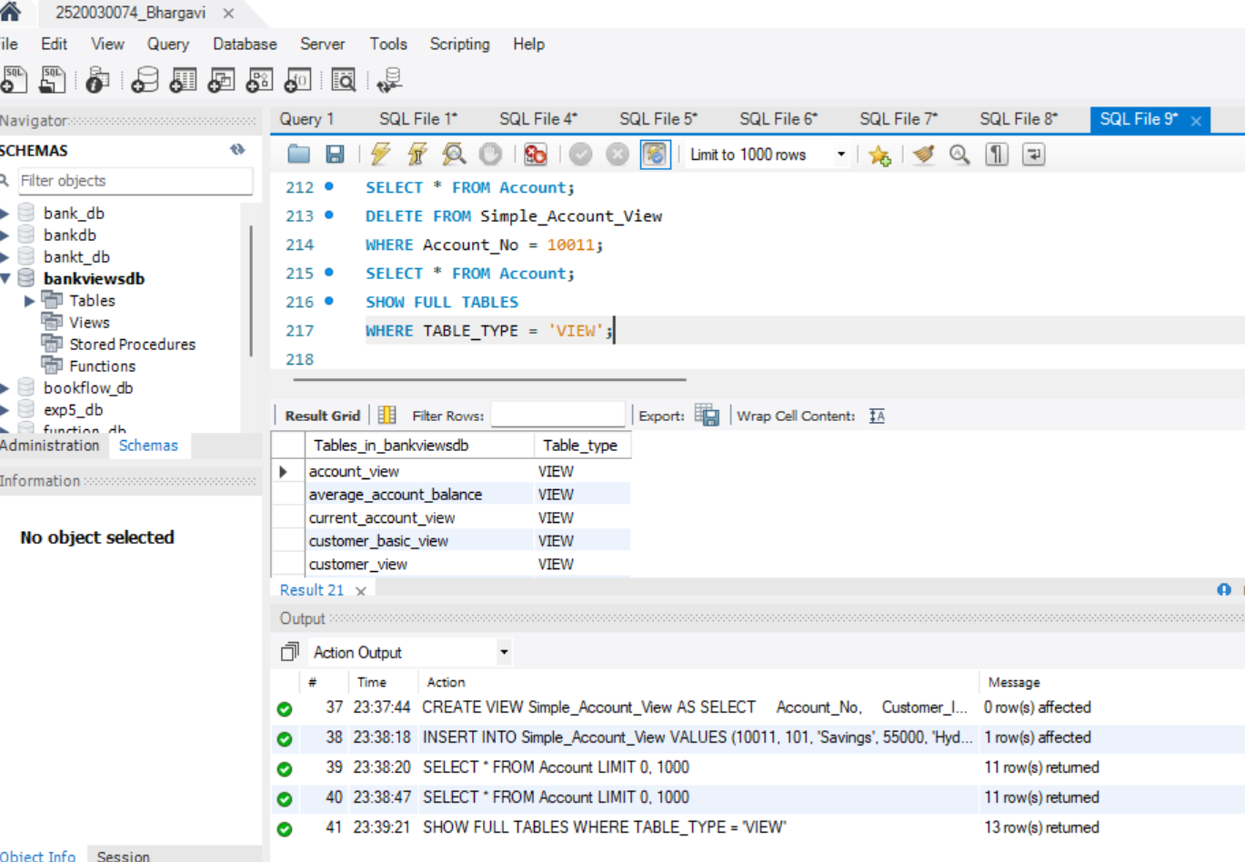
STEP-25: DROP VIEW
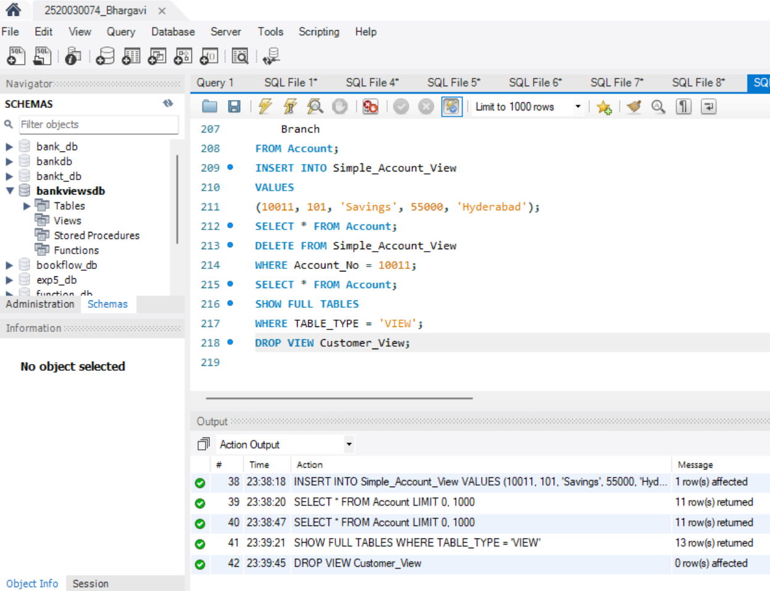
Question 1:
Create a view that displays:

Customer_ID
Customer_Name
Account_No
Account_Type
Balance

for all customers.
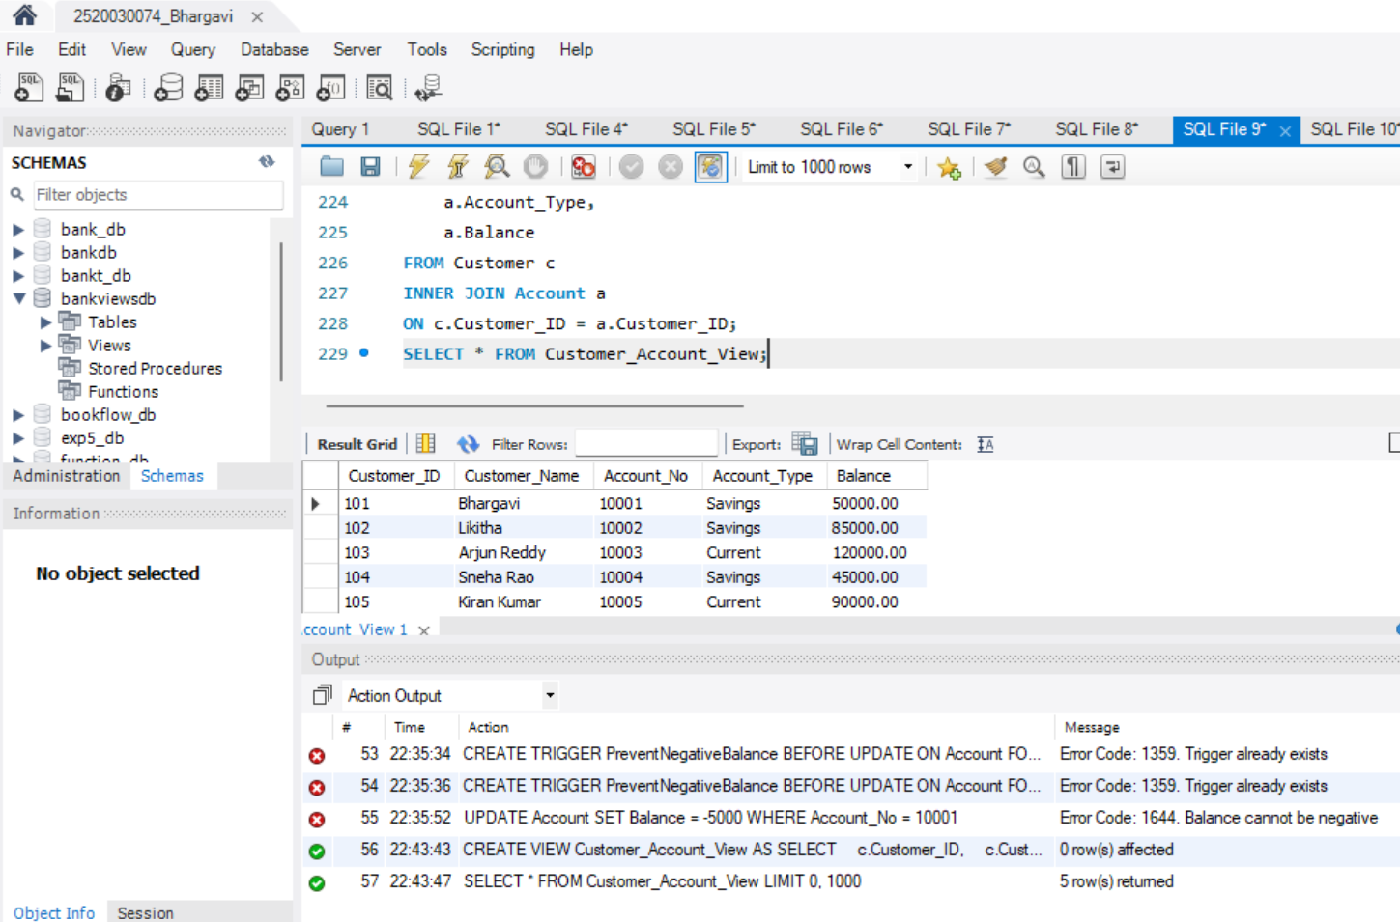
Question 2:
Create a view that displays only Savings Accounts having
balance greater than 50000.
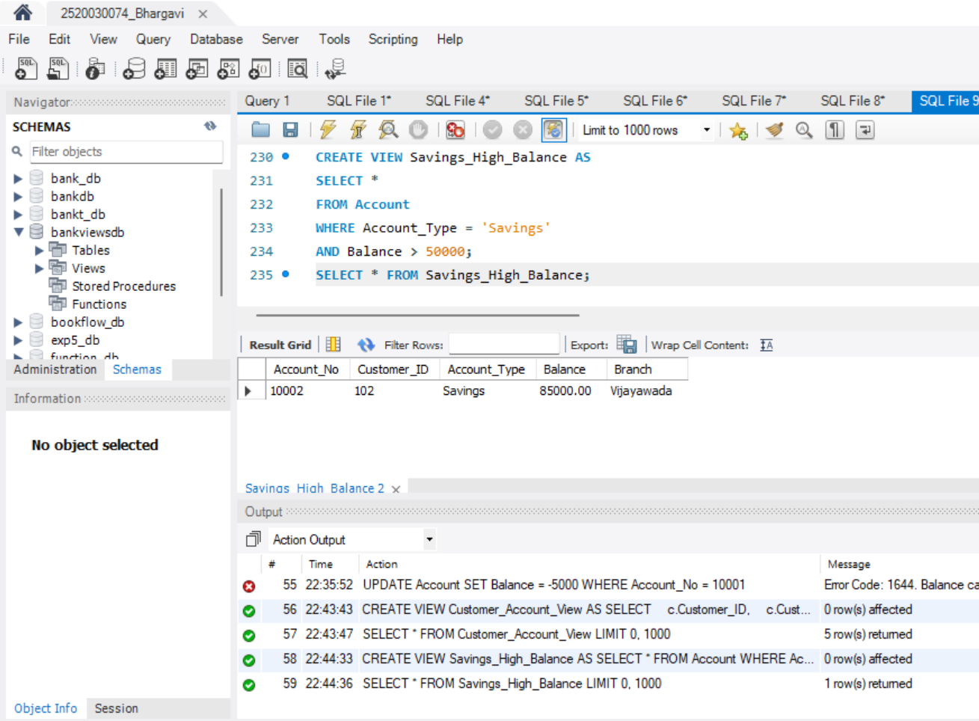
Question 3:
Create a view that displays all Current Accounts from
Hyderabad.
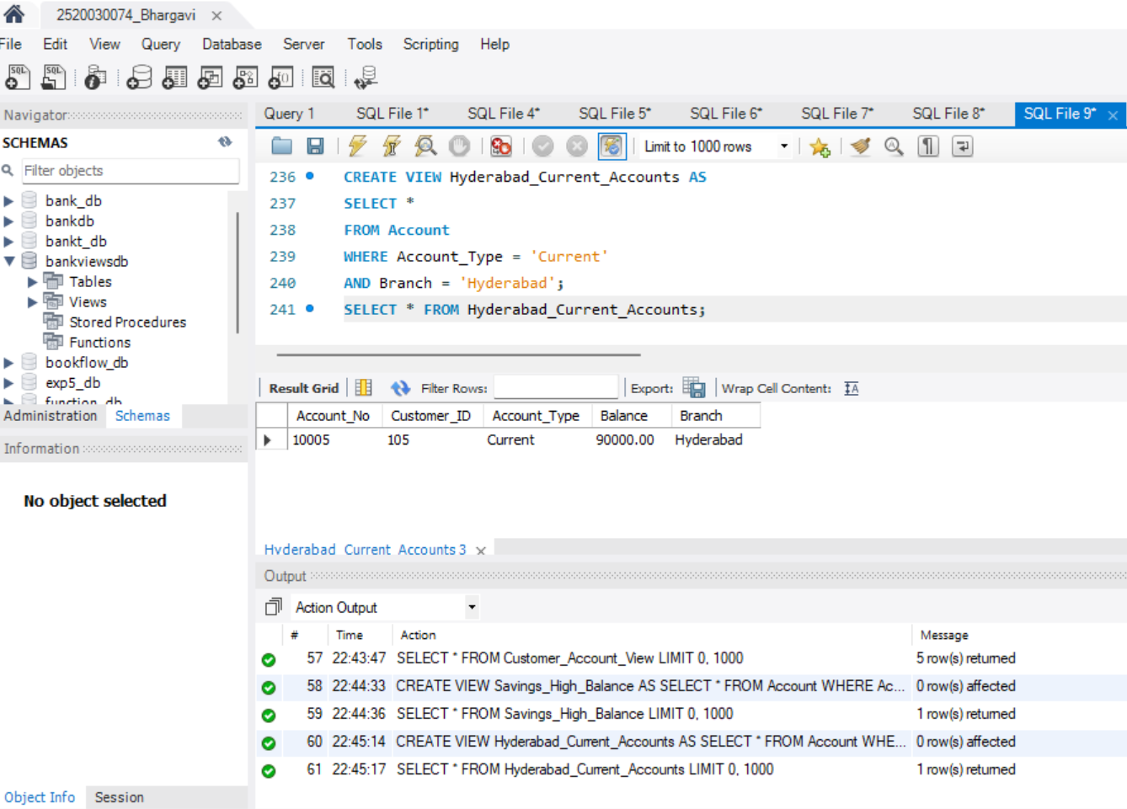
Question 4:
Create a view to display the top balance accounts.

Required columns:

Account_No
Customer_ID
Account_Type
Balance
