Mutual Fund Analytics Capstone Project - Final Report
Bluestock Internship Project
Prepared by: Siddhi Kumbhar
Date : 11th June, 2026

Executive Summary
This project focuses on analyzing mutual fund industry data using Python, SQL, SQLite, and Power BI. The objective was to build an end-to-end analytics solution covering data ingestion, cleaning, exploratory analysis, performance evaluation, risk assessment, and dashboard reporting. The project demonstrates practical data analytics workflows and provides insights into fund performance, investor behavior, SIP trends, and portfolio risk.
This project focuses on analyzing mutual fund industry data using Python, SQL, SQLite, and Power BI. The objective was to build an end-to-end analytics solution covering data ingestion, cleaning, exploratory analysis, performance evaluation, risk assessment, and dashboard reporting. The project demonstrates practical data analytics workflows and provides insights into fund performance, investor behavior, SIP trends, and portfolio risk.
This project focuses on analyzing mutual fund industry data using Python, SQL, SQLite, and Power BI. The objective was to build an end-to-end analytics solution covering data ingestion, cleaning, exploratory analysis, performance evaluation, risk assessment, and dashboard reporting. The project demonstrates practical data analytics workflows and provides insights into fund performance, investor behavior, SIP trends, and portfolio risk.
This project focuses on analyzing mutual fund industry data using Python, SQL, SQLite, and Power BI. The objective was to build an end-to-end analytics solution covering data ingestion, cleaning, exploratory analysis, performance evaluation, risk assessment, and dashboard reporting. The project demonstrates practical data analytics workflows and provides insights into fund performance, investor behavior, SIP trends, and portfolio risk.

Project Objectives
The objectives were to create a data pipeline, clean and validate datasets, build a database schema, perform EDA, calculate performance metrics such as CAGR and Sharpe Ratio, develop advanced risk metrics including VaR and CVaR, and create an interactive Power BI dashboard.
The objectives were to create a data pipeline, clean and validate datasets, build a database schema, perform EDA, calculate performance metrics such as CAGR and Sharpe Ratio, develop advanced risk metrics including VaR and CVaR, and create an interactive Power BI dashboard.
The objectives were to create a data pipeline, clean and validate datasets, build a database schema, perform EDA, calculate performance metrics such as CAGR and Sharpe Ratio, develop advanced risk metrics including VaR and CVaR, and create an interactive Power BI dashboard.
The objectives were to create a data pipeline, clean and validate datasets, build a database schema, perform EDA, calculate performance metrics such as CAGR and Sharpe Ratio, develop advanced risk metrics including VaR and CVaR, and create an interactive Power BI dashboard.

Data Sources
The project used datasets including NAV history, investor transactions, scheme performance, AUM by fund house, SIP inflows, category inflows, folio counts, benchmark indices, and portfolio holdings. These datasets represent key aspects of the mutual fund ecosystem.
The project used datasets including NAV history, investor transactions, scheme performance, AUM by fund house, SIP inflows, category inflows, folio counts, benchmark indices, and portfolio holdings. These datasets represent key aspects of the mutual fund ecosystem.
The project used datasets including NAV history, investor transactions, scheme performance, AUM by fund house, SIP inflows, category inflows, folio counts, benchmark indices, and portfolio holdings. These datasets represent key aspects of the mutual fund ecosystem.
The project used datasets including NAV history, investor transactions, scheme performance, AUM by fund house, SIP inflows, category inflows, folio counts, benchmark indices, and portfolio holdings. These datasets represent key aspects of the mutual fund ecosystem.
Dataset | Description
nav_history | Daily NAV
investor_transactions | Investor activity
scheme_performance | Fund metrics
portfolio_holdings | Sector allocation
monthly_sip_inflows | SIP trends

ETL Design
The ETL process involved extracting CSV data, transforming it through cleaning and validation steps, and loading it into SQLite. Data quality checks included handling missing values, validating numeric fields, standardizing transaction types, and removing duplicates.
The ETL process involved extracting CSV data, transforming it through cleaning and validation steps, and loading it into SQLite. Data quality checks included handling missing values, validating numeric fields, standardizing transaction types, and removing duplicates.
The ETL process involved extracting CSV data, transforming it through cleaning and validation steps, and loading it into SQLite. Data quality checks included handling missing values, validating numeric fields, standardizing transaction types, and removing duplicates.
The ETL process involved extracting CSV data, transforming it through cleaning and validation steps, and loading it into SQLite. Data quality checks included handling missing values, validating numeric fields, standardizing transaction types, and removing duplicates.
Raw CSV
↓
Data Cleaning
↓
SQLite Database
↓
EDA
↓
Performance Analytics
↓
Power BI Dashboard

Database Design
A star schema was designed consisting of dimension tables and fact tables. Relationships were established using AMFI codes and dates to support analytical queries and dashboard reporting.
A star schema was designed consisting of dimension tables and fact tables. Relationships were established using AMFI codes and dates to support analytical queries and dashboard reporting.
A star schema was designed consisting of dimension tables and fact tables. Relationships were established using AMFI codes and dates to support analytical queries and dashboard reporting.
A star schema was designed consisting of dimension tables and fact tables. Relationships were established using AMFI codes and dates to support analytical queries and dashboard reporting.

Exploratory Data Analysis
EDA revealed trends in NAV movement, fund growth, SIP inflows, investor demographics, and geographic distribution. Multiple visualizations were created including line charts, bar charts, heatmaps, correlation matrices, and donut charts.
EDA revealed trends in NAV movement, fund growth, SIP inflows, investor demographics, and geographic distribution. Multiple visualizations were created including line charts, bar charts, heatmaps, correlation matrices, and donut charts.
EDA revealed trends in NAV movement, fund growth, SIP inflows, investor demographics, and geographic distribution. Multiple visualizations were created including line charts, bar charts, heatmaps, correlation matrices, and donut charts.
EDA revealed trends in NAV movement, fund growth, SIP inflows, investor demographics, and geographic distribution. Multiple visualizations were created including line charts, bar charts, heatmaps, correlation matrices, and donut charts.

NAV Trend Analysis
NAV analysis showed long-term growth trends across schemes. Daily NAV patterns highlighted market expansion periods and corrections, helping identify performance stability.
NAV analysis showed long-term growth trends across schemes. Daily NAV patterns highlighted market expansion periods and corrections, helping identify performance stability.
NAV analysis showed long-term growth trends across schemes. Daily NAV patterns highlighted market expansion periods and corrections, helping identify performance stability.
NAV analysis showed long-term growth trends across schemes. Daily NAV patterns highlighted market expansion periods and corrections, helping identify performance stability.
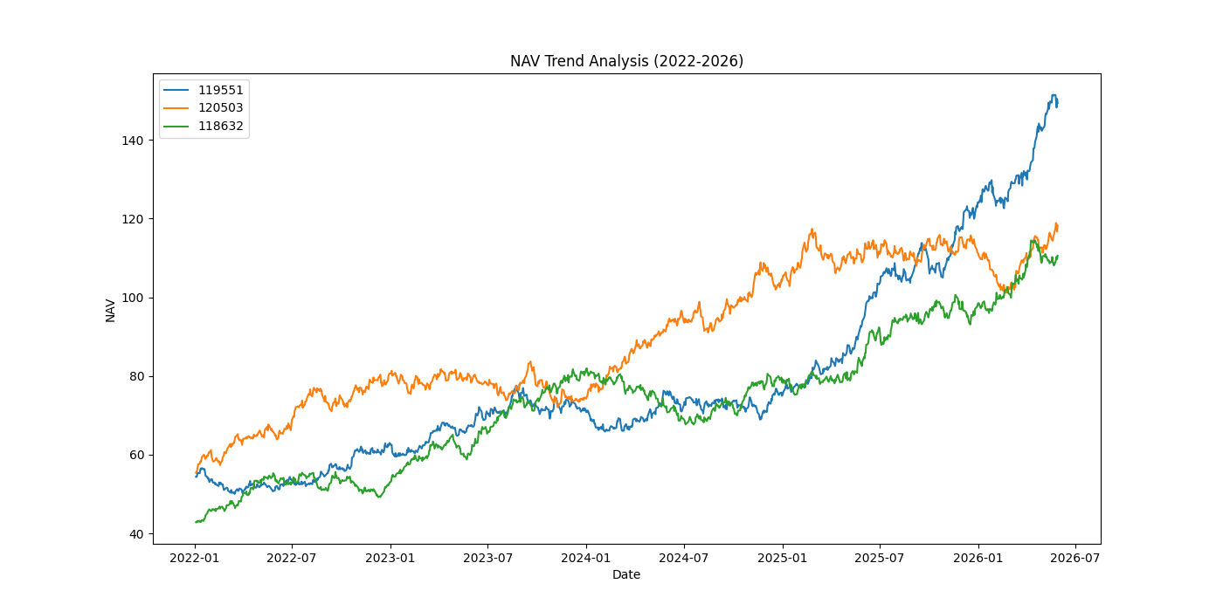
NAV values showed consistent growth across most mutual fund schemes from 2022–2026 with temporary corrections during volatile market periods.

AUM Analysis
AUM trends demonstrated growth in mutual fund participation and highlighted leading fund houses. Comparative analysis helped evaluate market dominance and asset concentration.
AUM trends demonstrated growth in mutual fund participation and highlighted leading fund houses. Comparative analysis helped evaluate market dominance and asset concentration.
AUM trends demonstrated growth in mutual fund participation and highlighted leading fund houses. Comparative analysis helped evaluate market dominance and asset concentration.
AUM trends demonstrated growth in mutual fund participation and highlighted leading fund houses. Comparative analysis helped evaluate market dominance and asset concentration.

Investor Analytics
Investor transaction data was analyzed by state, age group, city tier, and transaction type. Insights indicated variations in investment behavior across demographics and geographies.
Investor transaction data was analyzed by state, age group, city tier, and transaction type. Insights indicated variations in investment behavior across demographics and geographies.
Investor transaction data was analyzed by state, age group, city tier, and transaction type. Insights indicated variations in investment behavior across demographics and geographies.
Investor transaction data was analyzed by state, age group, city tier, and transaction type. Insights indicated variations in investment behavior across demographics and geographies.

Fund Performance Analytics
Daily returns, CAGR, Sharpe Ratio, Sortino Ratio, Alpha, Beta, and Maximum Drawdown were calculated. These metrics provided a comprehensive view of risk-adjusted performance.
Daily returns, CAGR, Sharpe Ratio, Sortino Ratio, Alpha, Beta, and Maximum Drawdown were calculated. These metrics provided a comprehensive view of risk-adjusted performance.
Daily returns, CAGR, Sharpe Ratio, Sortino Ratio, Alpha, Beta, and Maximum Drawdown were calculated. These metrics provided a comprehensive view of risk-adjusted performance.
Daily returns, CAGR, Sharpe Ratio, Sortino Ratio, Alpha, Beta, and Maximum Drawdown were calculated. These metrics provided a comprehensive view of risk-adjusted performance.

Risk Metrics
Historical VaR and CVaR were computed for all schemes. Rolling Sharpe Ratios provided insight into changing performance over time. Risk analysis helped identify funds with higher downside exposure.
Historical VaR and CVaR were computed for all schemes. Rolling Sharpe Ratios provided insight into changing performance over time. Risk analysis helped identify funds with higher downside exposure.
Historical VaR and CVaR were computed for all schemes. Rolling Sharpe Ratios provided insight into changing performance over time. Risk analysis helped identify funds with higher downside exposure.
Historical VaR and CVaR were computed for all schemes. Rolling Sharpe Ratios provided insight into changing performance over time. Risk analysis helped identify funds with higher downside exposure.

Fund Recommender
A simple recommendation engine was developed using Sharpe Ratio rankings and risk grades. The system recommends suitable funds for different investor risk profiles.
A simple recommendation engine was developed using Sharpe Ratio rankings and risk grades. The system recommends suitable funds for different investor risk profiles.
A simple recommendation engine was developed using Sharpe Ratio rankings and risk grades. The system recommends suitable funds for different investor risk profiles.
A simple recommendation engine was developed using Sharpe Ratio rankings and risk grades. The system recommends suitable funds for different investor risk profiles.

Dashboard Development
A multi-page Power BI dashboard was developed covering Industry Overview, Fund Performance, Investor Analytics, and SIP Trends. Interactive slicers and visualizations improved usability.
A multi-page Power BI dashboard was developed covering Industry Overview, Fund Performance, Investor Analytics, and SIP Trends. Interactive slicers and visualizations improved usability.
A multi-page Power BI dashboard was developed covering Industry Overview, Fund Performance, Investor Analytics, and SIP Trends. Interactive slicers and visualizations improved usability.
A multi-page Power BI dashboard was developed covering Industry Overview, Fund Performance, Investor Analytics, and SIP Trends. Interactive slicers and visualizations improved usability.
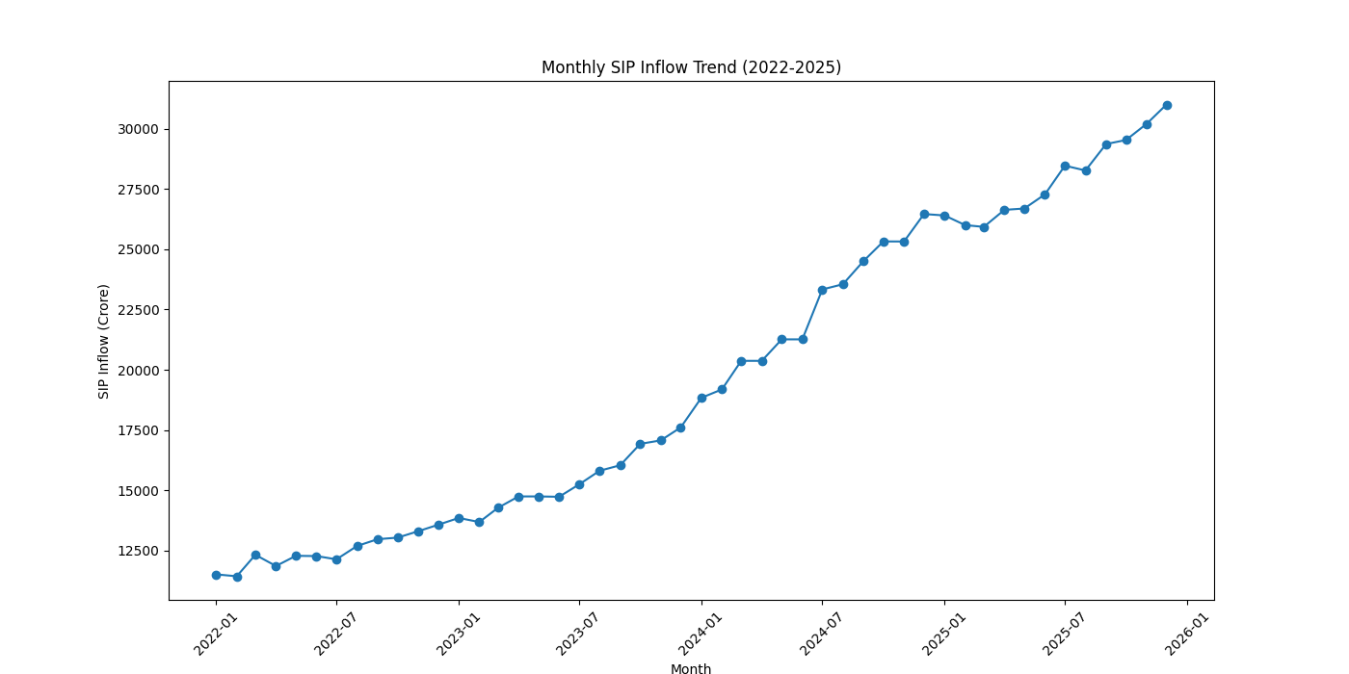
SIP inflows increased steadily, indicating growing retail investor participation.

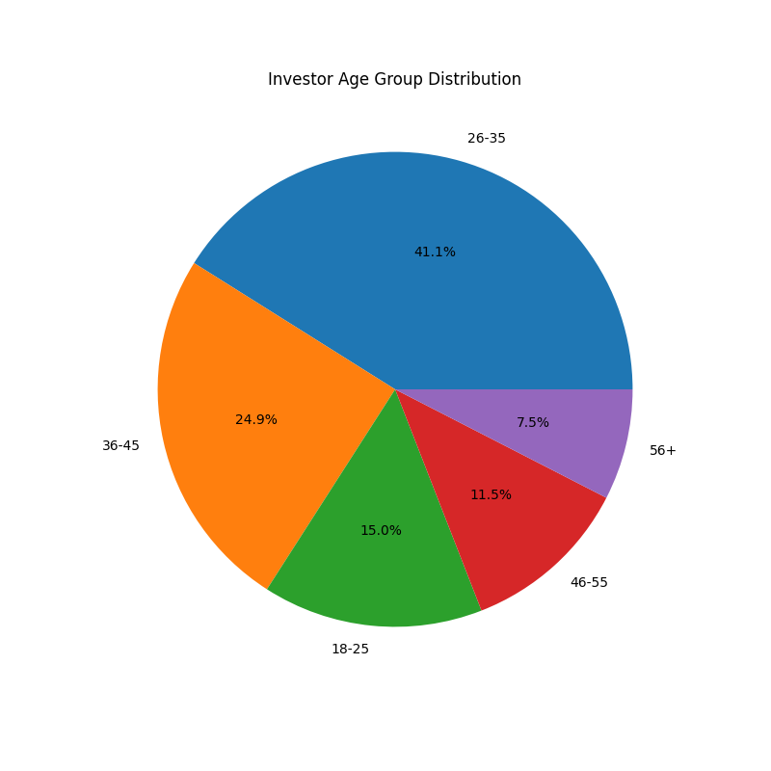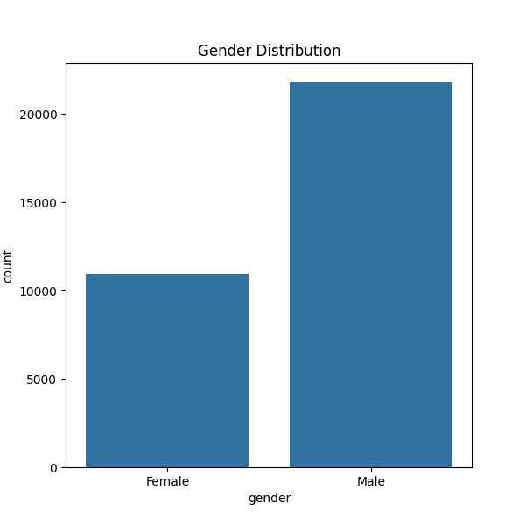
Most investors belong to middle-age groups and investment participation is distributed across genders.

Key Findings
The project identified top-performing funds, investor trends, risk concentrations, and category-level inflow patterns. Results highlighted the importance of diversification and risk-adjusted performance measures.
The project identified top-performing funds, investor trends, risk concentrations, and category-level inflow patterns. Results highlighted the importance of diversification and risk-adjusted performance measures.
The project identified top-performing funds, investor trends, risk concentrations, and category-level inflow patterns. Results highlighted the importance of diversification and risk-adjusted performance measures.
The project identified top-performing funds, investor trends, risk concentrations, and category-level inflow patterns. Results highlighted the importance of diversification and risk-adjusted performance measures.
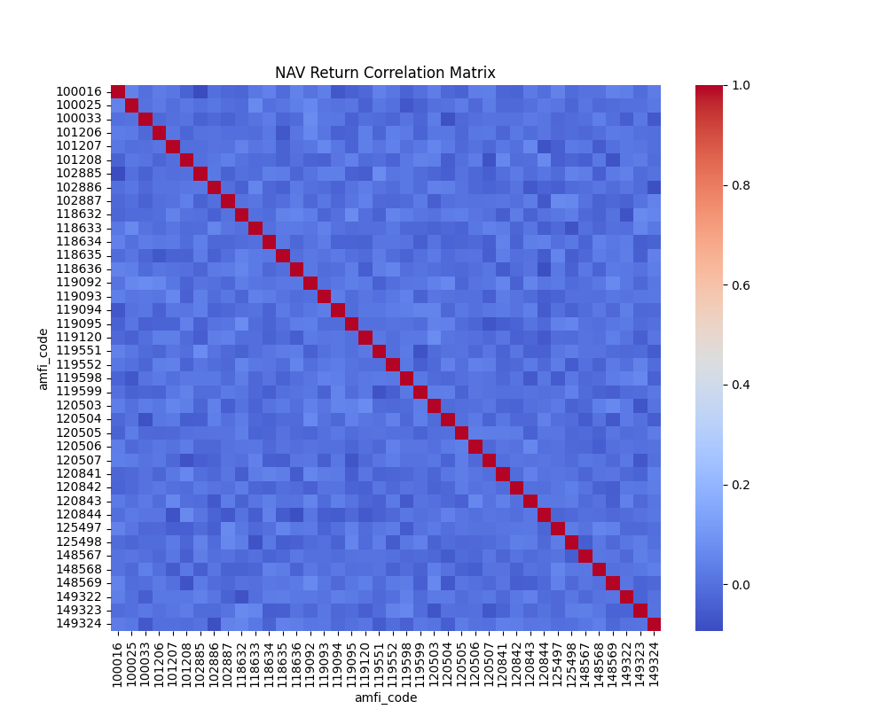
Correlation analysis shows relationships among selected mutual fund schemes.
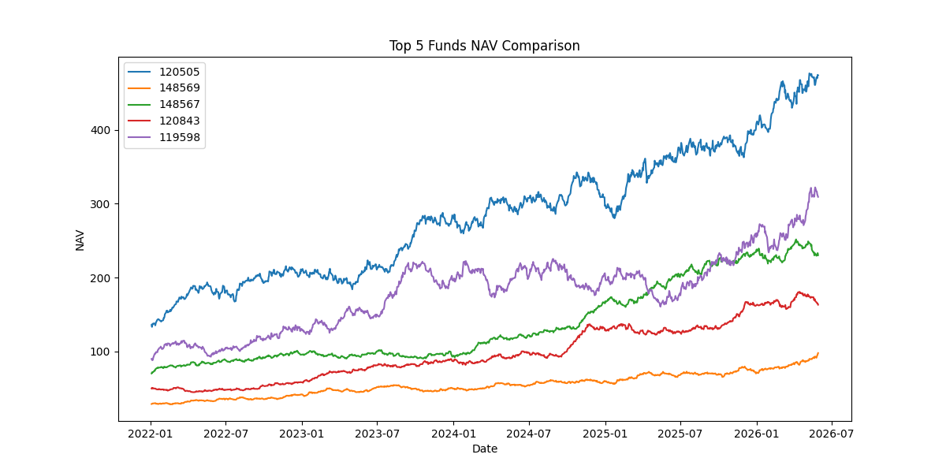
Top-performing funds were compared against benchmark indices to evaluate excess returns.
amfi_code | start_nav | end_nav | cagr | sharpe_ratio | sortino_ratio | max_drawdown | return_rank | sharpe_rank | sortino_rank | drawdown_rank | fund_score
120505 | 135.872 | 473.764 | 0.366495 | 1.180101 | 2.029353 | -0.18189 | 1 | 5 | 5 | 16 | 4.5
148569 | 28.862 | 97.7435 | 0.356564 | 1.23493 | 2.146914 | -0.16397 | 4 | 3 | 3 | 20 | 5.1
148567 | 70.2514 | 230.2708 | 0.345538 | 1.448291 | 2.385644 | -0.11266 | 5 | 1 | 1 | 33 | 5.8
120843 | 49.9131 | 163.2397 | 0.344785 | 1.306744 | 2.36432 | -0.12974 | 6 | 2 | 2 | 28 | 6.2
119598 | 89.8738 | 309.205 | 0.361925 | 0.945308 | 1.675317 | -0.28706 | 2 | 14 | 12 | 5 | 7.9
149323 | 78.4622 | 245.3651 | 0.329805 | 1.132122 | 1.875101 | -0.17248 | 8 | 6 | 6 | 19 | 8.1
149324 | 81.6814 | 279.7511 | 0.360386 | 0.949796 | 1.619793 | -0.31172 | 3 | 13 | 14 | 4 | 8.3
119551 | 54.3856 | 149.3216 | 0.28724 | 1.208267 | 2.140267 | -0.15012 | 10 | 4 | 4 | 24 | 8.4
100033 | 107.3758 | 342.0072 | 0.335925 | 1.093699 | 1.829134 | -0.16217 | 7 | 7 | 8 | 21 | 8.6
118632 | 42.8339 | 110.5554 | 0.2675 | 1.081659 | 1.850133 | -0.17414 | 11 | 8 | 7 | 18 | 10

Top Funds Based on Composite Score
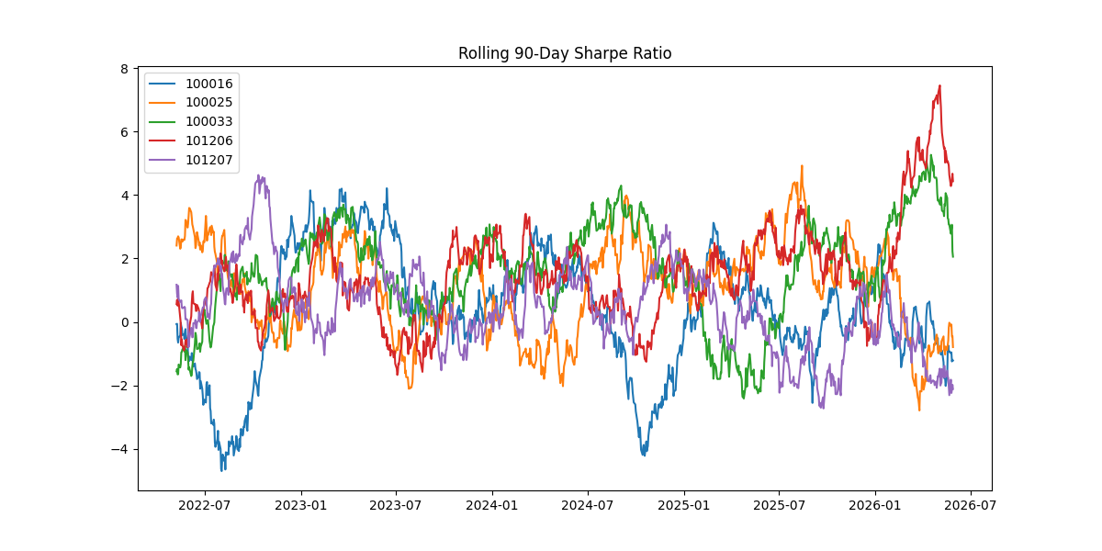
Rolling Sharpe Ratios show changing risk-adjusted performance over time.

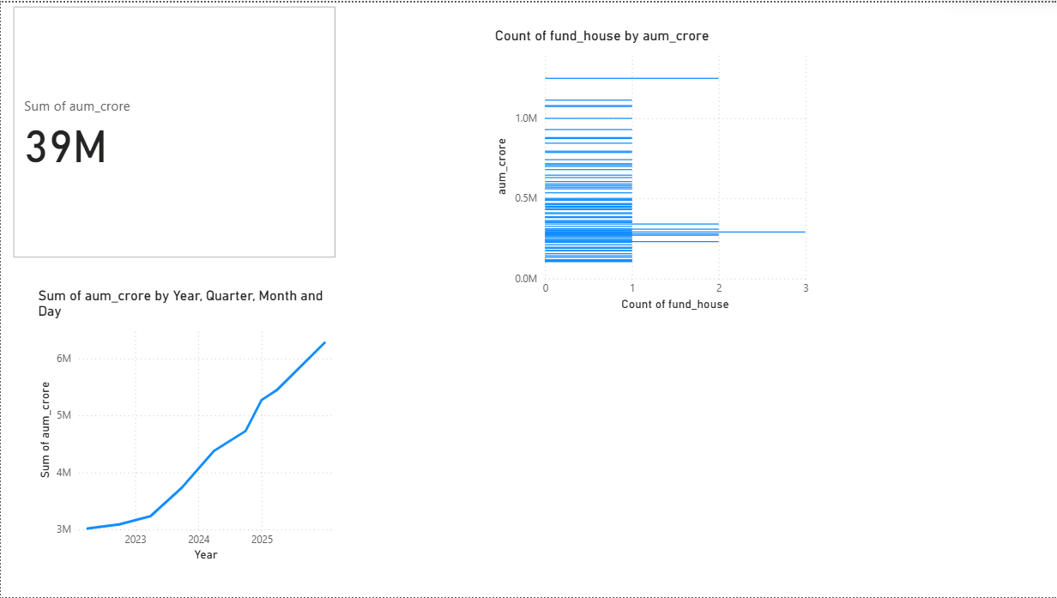
Industry Overview
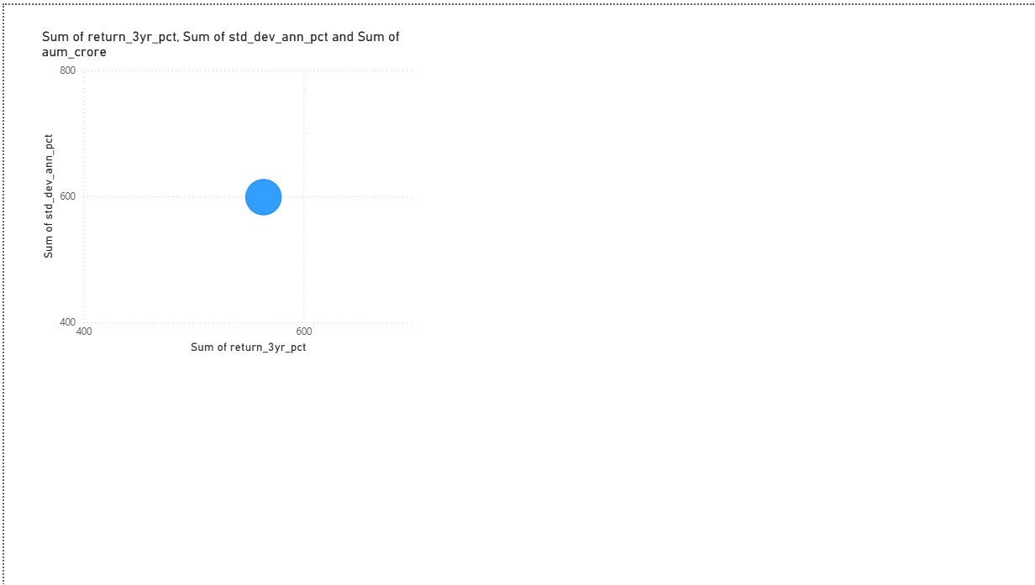
Fund Performance

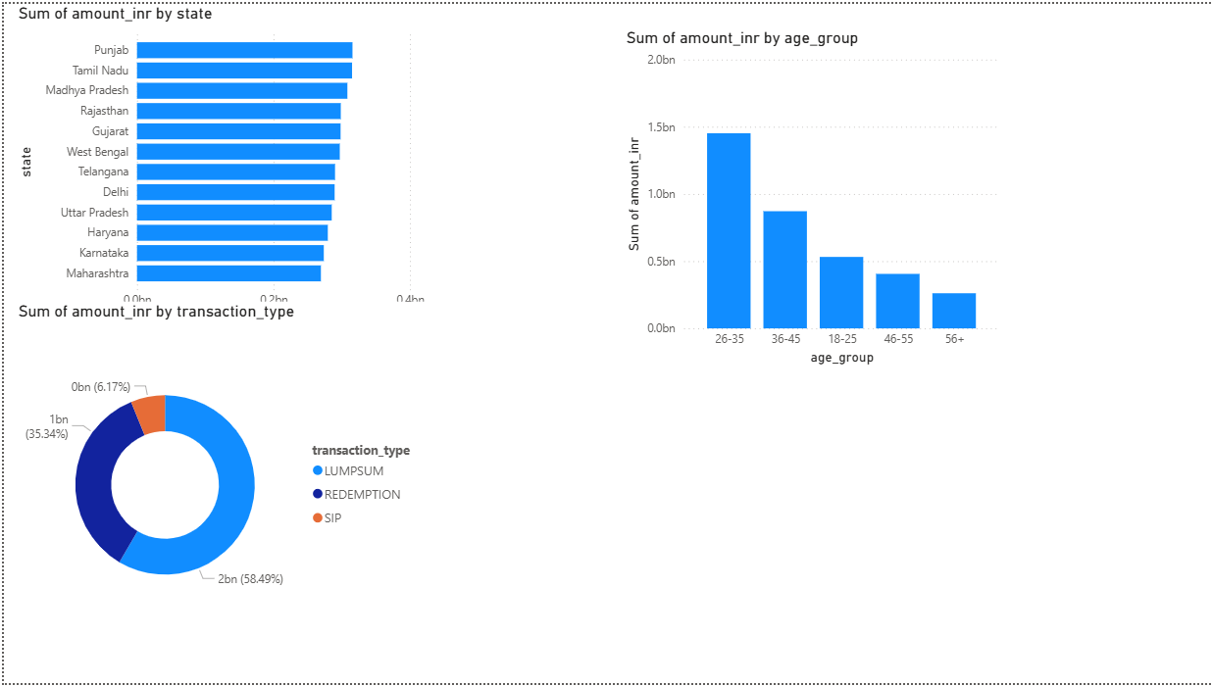
Investor Analytics
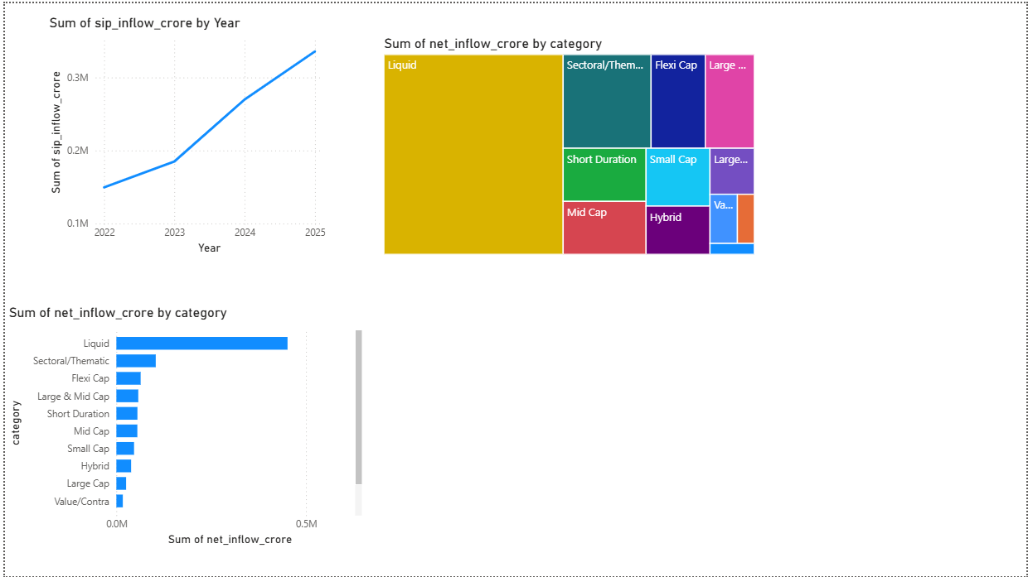
SIP & Market Trends

Limitations
The project relied on available datasets and historical observations. Results may vary with updated market conditions. Additional macroeconomic and real-time data could further enhance analysis.
The project relied on available datasets and historical observations. Results may vary with updated market conditions. Additional macroeconomic and real-time data could further enhance analysis.
The project relied on available datasets and historical observations. Results may vary with updated market conditions. Additional macroeconomic and real-time data could further enhance analysis.
The project relied on available datasets and historical observations. Results may vary with updated market conditions. Additional macroeconomic and real-time data could further enhance analysis.

Recommendations
Future enhancements include predictive modeling, portfolio optimization, machine learning recommendations, real-time data integration, and deployment through cloud-based dashboards.
Future enhancements include predictive modeling, portfolio optimization, machine learning recommendations, real-time data integration, and deployment through cloud-based dashboards.
Future enhancements include predictive modeling, portfolio optimization, machine learning recommendations, real-time data integration, and deployment through cloud-based dashboards.
Future enhancements include predictive modeling, portfolio optimization, machine learning recommendations, real-time data integration, and deployment through cloud-based dashboards.

Conclusion
The project successfully implemented a complete mutual fund analytics workflow from raw data to business insights. It demonstrated practical applications of data analytics, database management, risk assessment, and dashboard reporting.
The project successfully implemented a complete mutual fund analytics workflow from raw data to business insights. It demonstrated practical applications of data analytics, database management, risk assessment, and dashboard reporting.
The project successfully implemented a complete mutual fund analytics workflow from raw data to business insights. It demonstrated practical applications of data analytics, database management, risk assessment, and dashboard reporting.
The project successfully implemented a complete mutual fund analytics workflow from raw data to business insights. It demonstrated practical applications of data analytics, database management, risk assessment, and dashboard reporting.

References
https://www.amfiindia.com
https://www.mfapi.in
https://pandas.pydata.org
https://numpy.org
https://matplotlib.org
https://plotly.com
https://www.sqlite.org
https://powerbi.microsoft.com

GitHub Repository:
https://github.com/kbhrsiddhi1289/mutual-fund-analytics

