Kellen Hunter

08/31/2020

IT FDN 110 A

Module 8 - Assignment 08

URL: https://kbhunter5.github.io/ITFND100-Mod08/

Objects and Custom Classes

# Introduction

Classes are used to create a group of data and define how they work together. The difference between the direct class and an indirect class is, a direct class is accessed from memory an indirect class is accessed from the class’s code. “Self” can be used to manipulate the object you are currently working with. This is useful when there are multiple objects. One issue with fields or attributes is that they are just variables, to help control what data does in them, properties are needed. Properties are used to manage fields or attributes. When using properties you can “hide” the attribute using 2 underscores before its name. Every attribute needs a getter and setter.

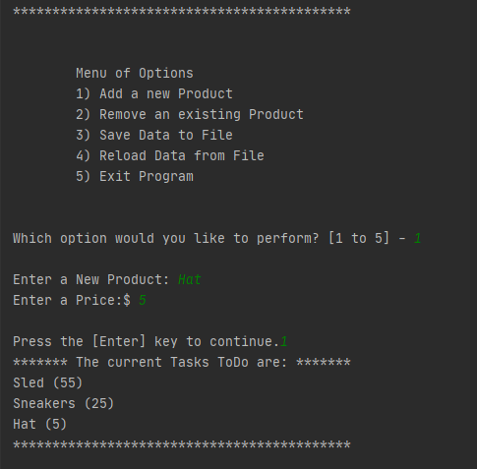

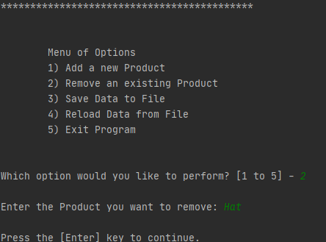

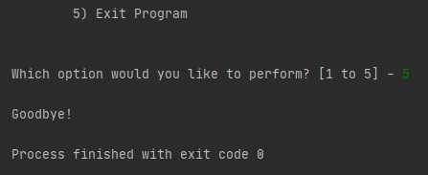

**Input Code in PyCharm**

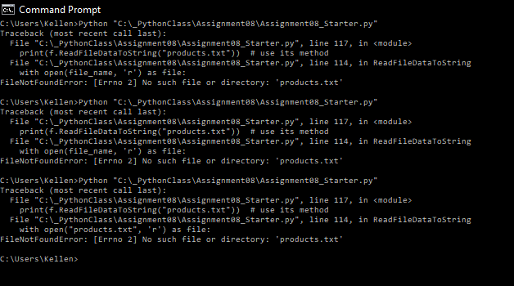

**Picture of code not being able to fine products txt in the Command Prompt.**

**Picture of code working in PyCharm.**

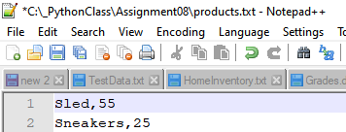

**Picture of product.txt File.**

# Summary

This week’s assignment was hard for me because I wasn’t sure where to input new code from this week and old code from last week. However, I was able to get the script to compile and Products added to the txt file. It will be nice to review other people’s code to see where I could make improvements.

# Sources

Classes:

<https://docs.python.org/3/tutorial/classes.html>

<https://www.oreilly.com/library/view/python-in-a/9781491913833/ch04.html>