Kellen Hunter

08/10/2020

IT FDN 110 A

Module 5 - Assignment 05

# Tuples, Lists and Dictionaries

# Introduction

Values in lists and dictionaries can be added, removed, recalled later for review and saved to an output text file. This can be used to create to do lists like the example shows below. This week’s module also taught me how to comment out and organize my code better. Last week I struggled with indenting and when I did get a compilation error it was hard to see what the issue was because my code was organized so poorly.

# Steps I took to perform this Assignment

First I uploaded some sample data into a dictionary, just so my data would not be blank. Next, I moved onto step 4 which was adding an item to a list. I created two variables, “strTask” and “strPriority” and added in some code to ask the user what task they wanted to add to the list and what the priority was. After the new items were added to the list the added item would display last on the table. I ran into my first issue here. For some reason the list would display multiple times. After a few adjustments I was able to fix my looping issue. Then I moved onto step 5 which was, removing an item. I also created a new variable called “strRemoveTask”. Once the user enters in the name of the task they want to removed it is then removed from the list and the list is displayed. Finally, the user can save the appended list to an output text file named “ToDoList.Txt”.

# Final Result

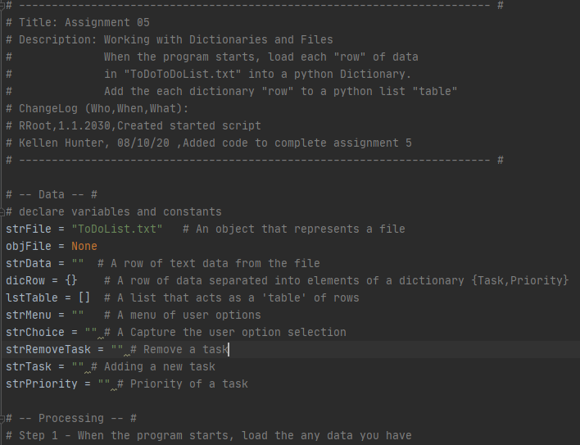

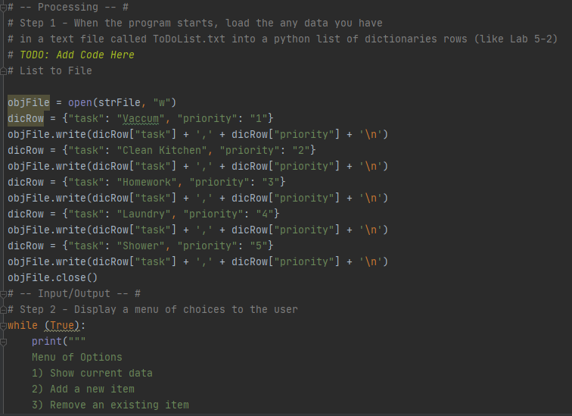

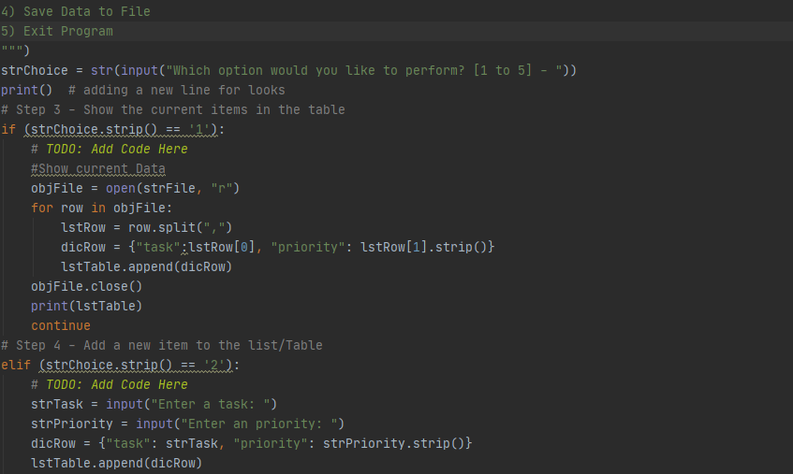

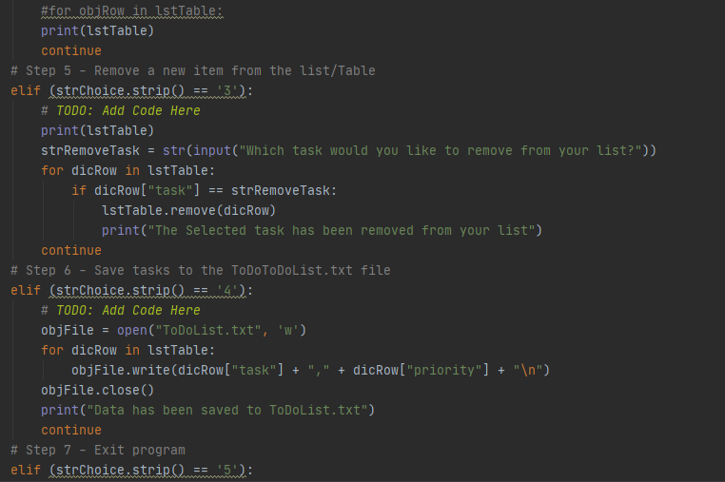

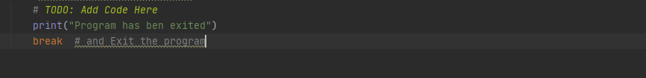

***Fig 1. INPUT- screenshot of code in PyCharm***

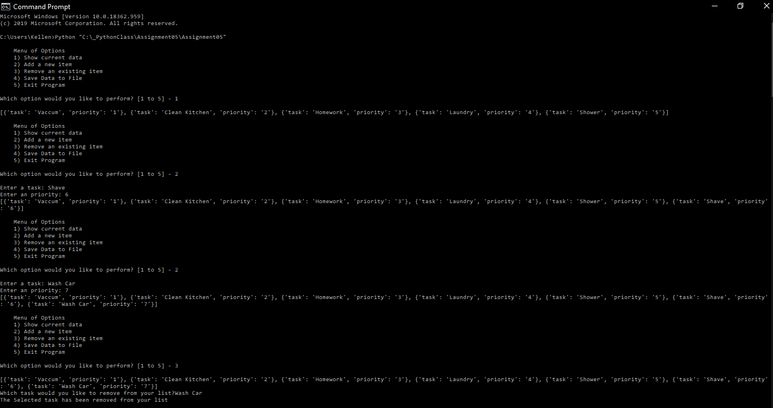

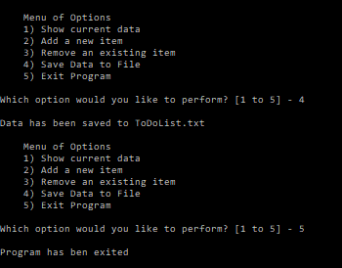

***Fig 2. INPUT- screenshot of code in the Command Prompt***

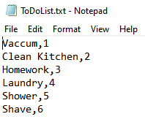

***Fig 3. OUTPUT screenshot of code in the text file.***

# Conclusion

The user is able to view example data, add an item to the list, remove an item, save the data to an output text file and also exit the program. Dictionaries are especially useful because the user can print out keys or values separately. The Txt file can then be opened and printed after the script is ran.