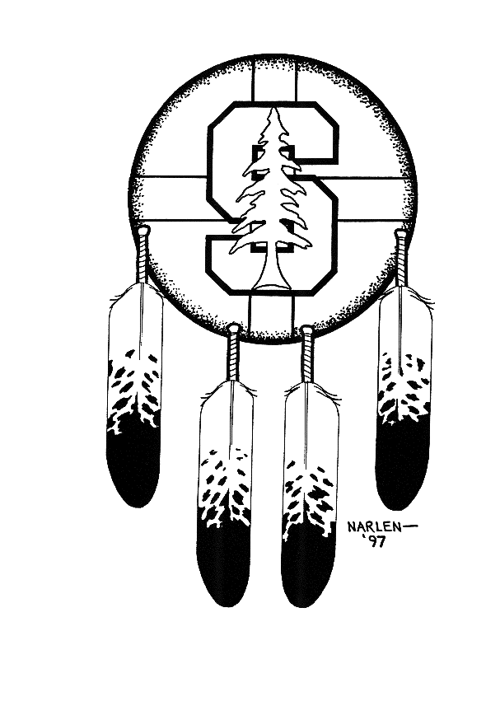 | Stanford Powwow presents the…  2nd Annual  Maurice Morsette Memorial  3-on-3 Basketball Tournament  May 10, 2009 | 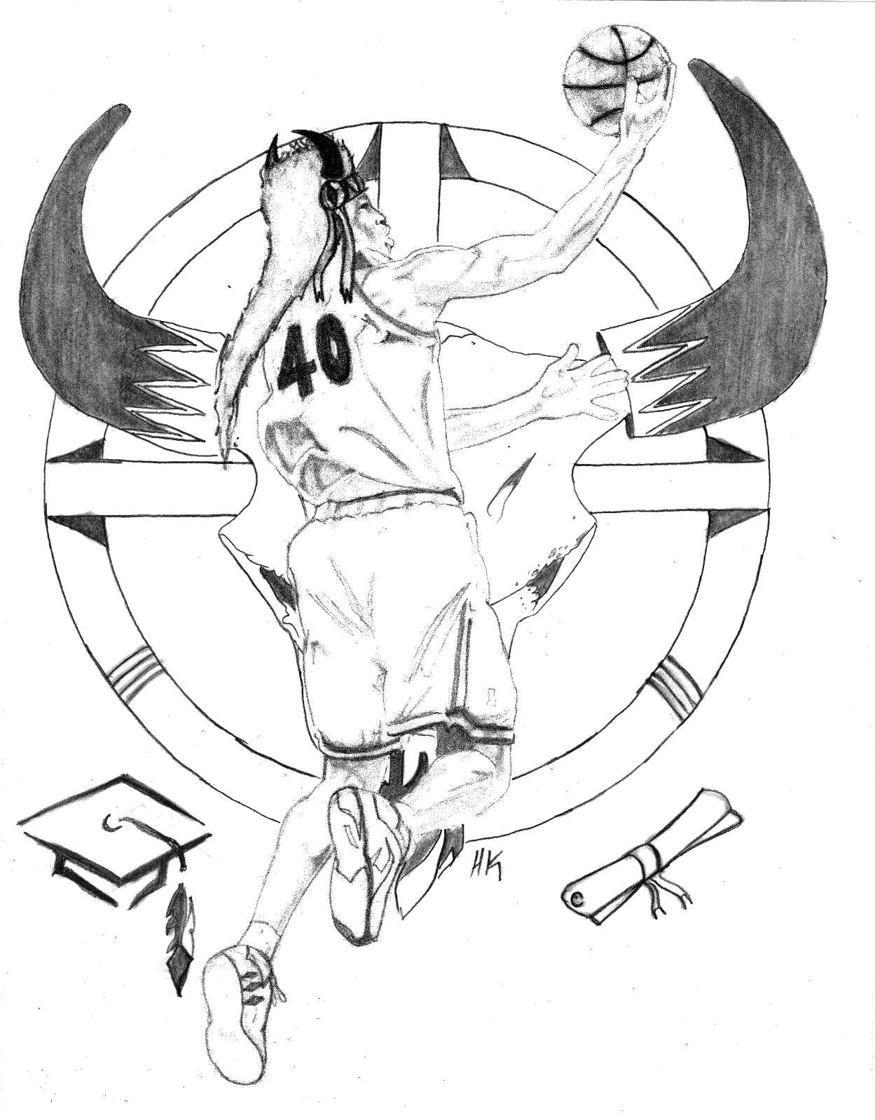

REGISTRATION FORM

Team Name___________________________________

Team Contact: ________________________________

Address: _________________________________________________________

City: __________________________ State: ____________ Zip Code: ______________

Telephone: ( ) ______________ E-Mail Address: __________________________________

TEAM ROSTER

Player Name: Age:____ Signature*:__________________________

Player Name: Age: ____ Signature*:_________________________

Player Name: Age: ____ Signature*:_________________________

Player Name: Age: ____ Signature*:_________________________

*Signature of Participant (Parent or Guardian if under 18)
Waiver: By signing this form and in consideration of your accepting this entry, I, intending to be legally bound, do hereby for myself and heirs, executors, administrators waive and release any and all rights and claims or damages I may accrue against the persons and organizations affiliated with the race for any and all injuries that may be suffered by me or enroute to or from the event. I attest that I am physically fit and sufficiently trained for this competition, my physical condition verified by a licensed MD during the last 6 months. As part of this waiver, I acknowledge that I have read and understand all of the above.

Please return this completed registration form with a check made payable to “Stanford Powwow” for $50 to the address listed below. All proceeds benefit the Stanford Powwow.

Stanford Powwow
Attn: Basketball Tournament Committee
PO Box 20090
Stanford, CA 94309

