
VENDOR APPLICATION REQUIREMENTS
Incomplete/Late Applications (including payments) will NOT be considered. Applications must be sent by the noted postmark date with the following documents and payments to be processed:

- A $25 Application Processing Fee
- Completed Application with appropriate information
- A Booth Fee Check made out to “SAIO Powwow” with designated amount

Postmark Deadline: January 31, 2008
Notification of Acceptance: March 1, 2008

All Booth Committee decisions are final!

Mail completed application to: 37th Annual Stanford Powwow
Attn: Booth Committee
P.O. Box 20090
Stanford, CA 94309

BOOTH FEES
Required Application Fee | $25.00
Single Space Arts/Crafts (10ft wide x 15ft deep) | $400.00*
Double Space Arts/Crafts (20ft wide x 15ft deep) | $800.00*
Single Space Food (10ft wide x 15ft deep) | $900.00**
Non-Profit Informational (10ft wide x 15ft deep) | $100.00
* Arts and Crafts Booth Fee includes a mandatory electricity fee.
Power will be provided for Arts and Crafts Booths.
** Food Booths must bring their OWN generator. Power will not be provided.

VENDOR REQUIREMENTS
- Each vendor must have a current California Seller’s Permit by April 14, 2007. For more information contact the California State Board of Equalization at (408)-277-1231 or (800)-400-7115. Or visit the website http://www.boe.ca.gov
- Each food vendor is required to have a Santa Clara County Health Permit and provide a total of $100 in meals over the three-day weekend to help cater to our Powwow Head Staff.
- All accepted vendors will receive more information along with their acceptance letter in March.

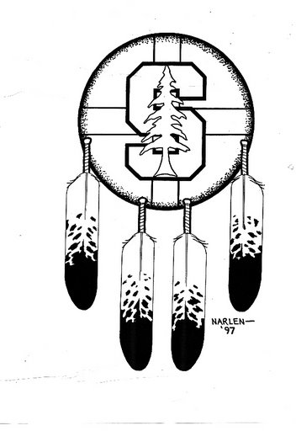
GENERAL INFORMATION

Booth Type (please check one):

[ ] Arts/Crafts Single [ ] Arts/Crafts Double [ ] Food [ ] Information

Booth Payment Enclosed [ ]
Booth Name (as we should list in the program):

Contact Name(s) (for notification purposes):

Mailing Address (for further materials):

Phone Number: | Fax Number:
E-mail Address (and website if available):

Tribal Affiliation(s):

Do you have any special needs? (i.e. wheel chairs, etc, for assessing the booth location assignments on the powwow grounds layout):

VENDOR APPLICATION
Your answer may be a determining factor in your application,
so please feel free to attach extra sheets if necessary.
What ways do you as an artist or vendor contribute to the Native American Community? How would the presence of your booth add to the 37th Annual Stanford Powwow?

What has been your participation in the Stanford Powwow before? Have you ever applied or been a vendor in previous years?

Please attach a separate piece of paper describing the items to be sold/displayed and a price list if applicable.
Arts & Crafts Vendors: Please include several close-up photos and a written description of the artwork that you intend to sell and a price list. Are you an artist selling your own work? [ ] yes [ ] no
Food Vendors: Please send a copy of your menu, including a description of the dishes you serve and a price list.
Information Booths: Please describe the information or the service to be provided and send samples of any information you wish to distribute.
FEES & PERMITS
Please Send 2 Separate Checks/Money Orders for the Application and Booth Fee.
Make payable to “SAIO Powwow”
Application Fee $25- one check/money order payable to “SAIO Powwow”
(All applicants are required to pay. This check will be cashed when received. No refund option is available)
Method of Payment (please check one and list the number):

[ ] Money Order _____________________ [ ] Check __________________________

Booth Fee- one check/money order payable to “SAIO Powwow”
(All applicants are required to send a method of payment that will be applicable to their specific booth type. Checks will not be cashed until all accepted parties are notified. If an applicant is not accepted to this year’s powwow the check will be returned in full)
Booth Type and Fee (please check the appropriate fee):

[ ] $400.00 Arts & Crafts Booth [ ] $900.000 Food Booth
Single Space Single Space
(10 feet wide by 15 feet deep) (10 feet wide by 15 feet deep)

[ ] $800.000 Arts & Crafts Booth [ ] $100.000 Informational Booth
Double Space Single Space
(20 feet wide by 15 feet deep) (10 feet wide by 15 feet deep)

Method of Payment (please check one and list the number):

[ ] Money Order _____________________ [ ] Check __________________________

Permits- if available please photocopy and attach (Info booths are exempt)
CA Sellers Permit-  Needed by:  Arts & Crafts and Food Vendors  California State Board of Equalization  http://www.boe.ca.gov  (408)-277-1231 or (800)-400-7115  Permit #:___________________________  Expiration Date:_____________________ | Environmental Health Permit-  Needed by:  Food Vendors  Santa Clara County  Department of Environmental Health  http://www.sccgov.org/portal/site/scc  (408)-918-3400  Permit #: __________________________

