Kyle Biondich

7/16/2023

[IT FDN 110 A](https://canvas.uw.edu/courses/1655585)

Assignment 02

Python Data Types

# Introduction

Week 2 of the course introduced the different data types that exist in programming and how they are generally used when writing programs. The following paragraphs outline the methods that were used to transform between data types to successfully run each calculation.

# Intended Outcome

The intended outcome for this week is a script file that presents the user with two prompts, each asking for a number. Then the script performs four mathematical operations, summing the numbers, differencing the number, multiplying the numbers, and lastly, dividing the numbers.

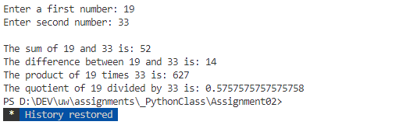

Figure 1: Intended Outcome

**Input Variables**

After the header section, I begin by defining the variables that will capture the numbers that the user is asked to provide.



Figure 2: Capturing Responses

## Converting Strings

I had to google a number of ways that python converts strings into numbers. In my search, I was trying to find the simplest solution, which (Checking if a string can be converted to float in python, n.d.) eventually helped me out. Here python will try to convert the string to an integer, and if that fails, will then try to convert the string to a float. The variables ‘number1’ and ‘number2’ use the conversion to store the values as numbers for the rest of the script.

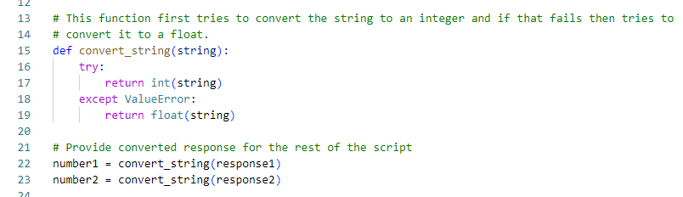 Figure 3: Trying to Convert Strings

# Math Functions

The math functions are defined in Figure 4. I discovered the use of F strings and how they provide a simpler method of writing text and variables together.

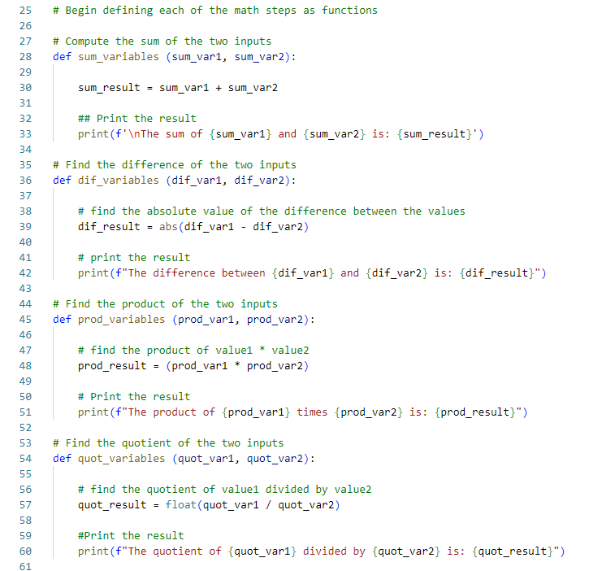

Figure 4: Math Functions

# Defining the Main Function

Lastly, after all the math functions were created, I defined the “Main” function that would call each math function upon initialization. This would pass the values of value1 and value2 to these functions.

I then call the main function, and pass in the values of number1 and number2, which have already been converted to numbers previously.

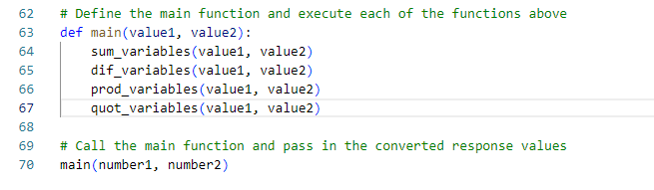

Figure 5: Calling the Main Function

# Summary

In summary, utilizing all the resources provided to the class and the online lecture, this paper outlines all the steps that were taken to create a python script that results in a successful execution of the intended outcome (Figure 1). Following the steps outlined above will allow for the audience to recreate the presented result.

# References

*Checking if a string can be converted to float in python*. (n.d.). Retrieved from Stackoverflow: https://stackoverflow.com/questions/736043/checking-if-a-string-can-be-converted-to-float-in-python