Kyle Biondich

7/30/2023

[IT FDN 110 A](https://canvas.uw.edu/courses/1655585)

Assignment 04

For Loop Inventory

# Introduction

Week 4 of the course introduced data collections and for loops in python. The following paragraphs outline the methods that were used to capture user input from a menu, and either add a new item to a list, read the total list, or write the list to an external file.

# Intended Outcome

The intended outcome for this week is a script file that generates a menu for the user to choose from, and from this menu, capture a list of household items and their estimated values, read the items contained is the list, or write the list to an external file. The script opens or creates a text file then captures user input for an item’s name and estimated value, then appends that info to the end of the text file. After each input from the user, the scripts checks to see if the user entered a specific value to exit the script.

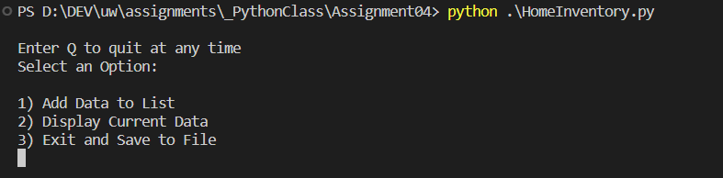

Figure 1: Intended Outcome: HomeIventory.py Menu

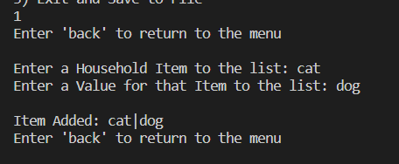

Figure 2: Intended Outcome: HomeIventory.py Menu 1

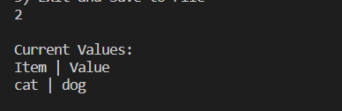

Figure 3: Intended Outcome: HomeIventory.py Menu 2



Figure 4: Intended Outcome: HomeIventory.py Menu 3

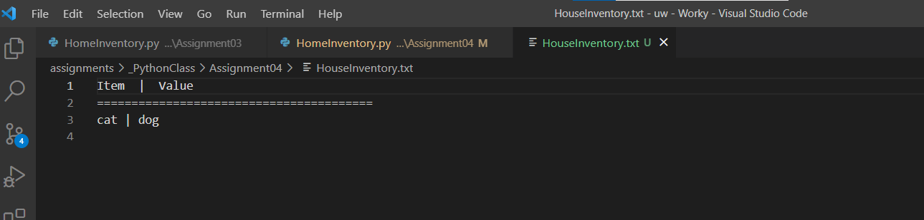

Figure 5: Intended Outcome: HomeIventory.txt Saved File Contents

**Open Inventory File**

After the header section, I define an object ‘objFile’ and call the open function and pass it a file name “Inventory.txt” to open from a relative file location. I provide an argument of “a” to tell the function that it should add to the file by appending any new information.



Figure 2: Open Inventory.txt

## While Looping

A while loop is used to both capture information from the user and add that information to the end of the ‘Inventory.txt’ file.

Prior to the while loop, a print statement is executed after the ‘inventory.txt’ file is open, to inform the user on how to end the script.

On Line 22, the logic for the while loop is started and conditions for each line of the loop is set, in this case, so long as the statements in the loop evaluate to “true”.

Next, a variable ‘houseItem’ is used to store the input from the user and asks that the user pass in a “household item” name.

Next, a ‘break’ is used with an ‘If’ statement to allow for the user to exit out of the loop with a submitted input of ‘exit’, regardless of how ‘exit’ is typed into the input function.

Next, another variable ‘itemValue’ is used to store the input from the user and asks that the user pass in an estimated value of the item.

Another ‘break’ is used with an ‘If’ statement to allow for the user to exit out of the loop with a submitted input of ‘exit’, regardless of how ‘exit’ is typed into the input function.

If ‘exit’ hasn’t been passed into the script at this point, an ‘else’ statement completes the If block and writes the information stored in ‘houseItem’ and ‘itemValue’ to a line at the end of the ‘Inventory.txt’ file.

If ‘exit’ is found from the user, the while loop exits the current loop, and jumps to the end of the script, in this case line 28, and tells the objFile variable to close the ‘Inventory.txt’ file.

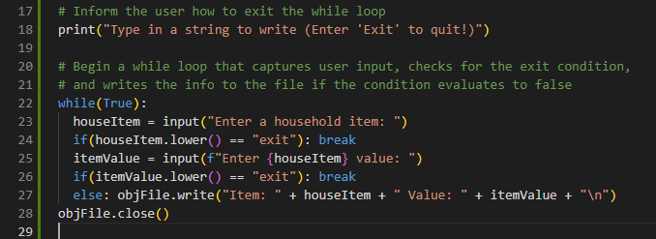Figure 3: While Looping

# Observations

h

# Summary

In summary, utilizing all the resources provided to the class and the online lecture, this paper outlines all the steps that were taken to create a python script that results in a successful execution of the intended outcome (Figure 1). Following the steps outlined above will allow for the audience to recreate the presented result.

# References

thenewboston. (n.d.). *Python Programming Tutorial - 21 - else and elif*. Retrieved from youtube: https://www.youtube.com/watch?app=desktop&v=g1maz1ynR74&feature=youtu.be