Kyle Biondich

8/19/2023

[IT FDN 110 A](https://canvas.uw.edu/courses/1655585)

Assignment 07

[**https://kbiondo.github.io/IntroToProg-Python-Mod07/**](https://kbiondo.github.io/IntroToProg-Python-Mod07/)

Pickling with Errors

# Introduction

Week 7 of the course introduced pickling and error handling in python. The following paragraphs outline the examples I found on the internet and the methods that were used to create a game save state into a state.bin file as well as how the try, exception, and finally block statements work.

# Intended Outcome

T

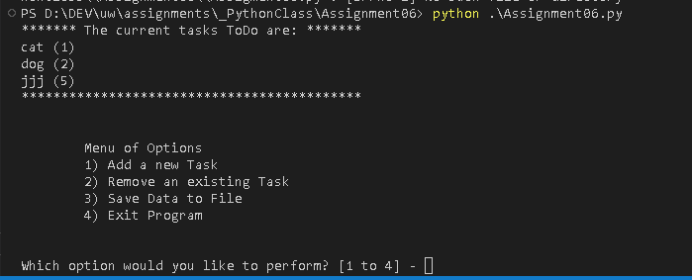

Figure 1: Intended Outcome: Assignment06.py Menu

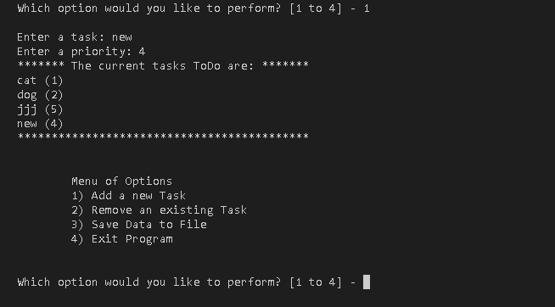

Figure 2: Intended Outcome: Assignment06.py Menu 1

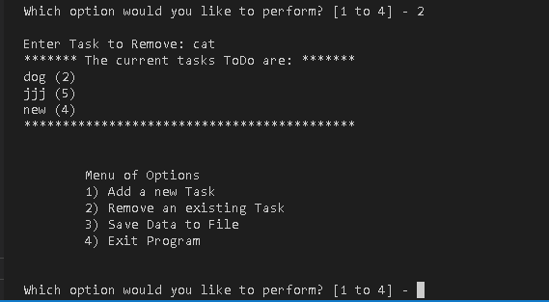

Figure 3: Intended Outcome: Assignment06.py Menu 2

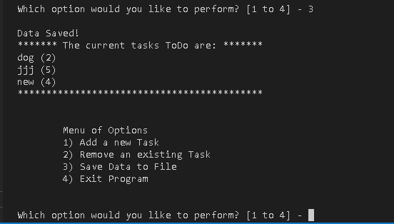

Figure 4: Intended Outcome: Assignment06.py Menu 3

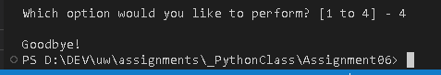

Figure 5: Intended Outcome: Assignment06.py Menu 4

**Declare Variables and constants**

T

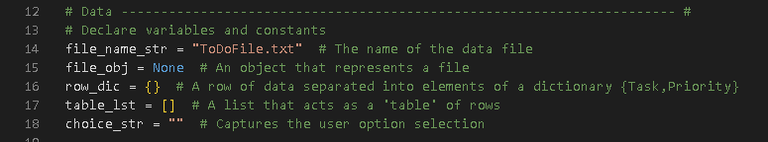

Figure 6: Variables and Constants

## Step 1 – Processing Class – Read Data from file

I

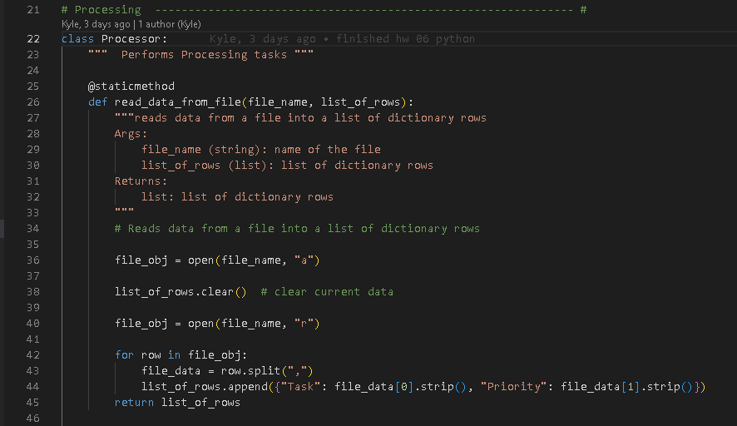

Figure 7: Load a File into a dictionary list

# Step 2 – Add data to list

N

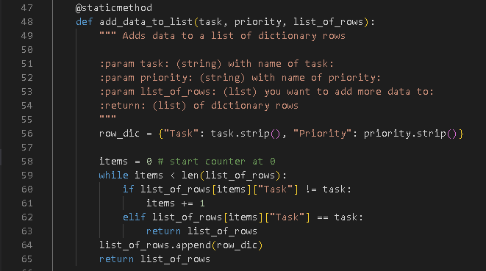

Figure 8: Add data to list

# Step 3 – Remove Data from List

T

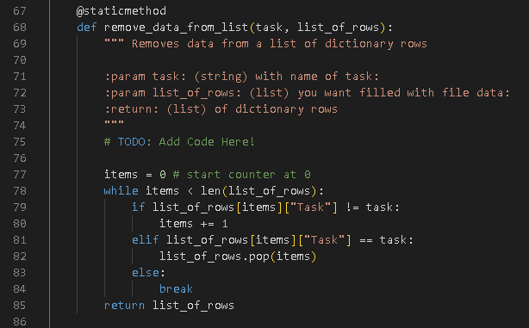

Figure 9: Remove data from list

# Step 4 – Write data to file

T

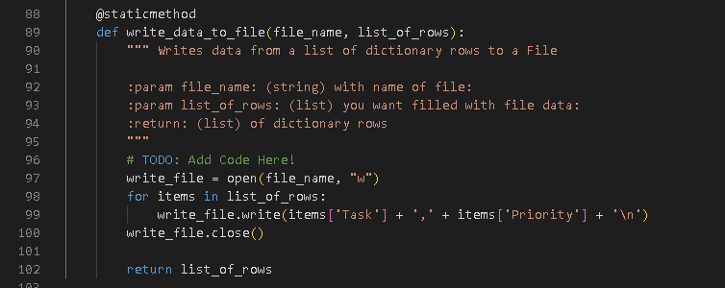

Figure 10: Write list to file

# Step 5 – Class IO

T

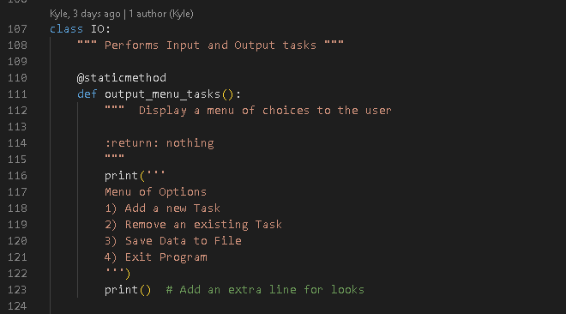

Figure 11: Menu Choices

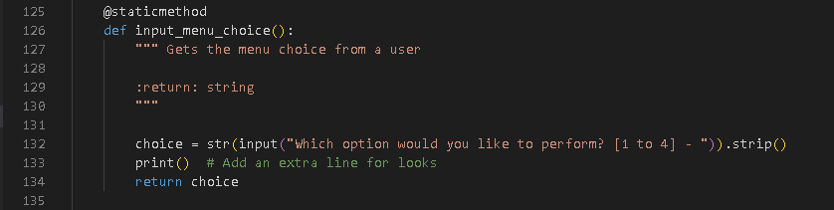

Figure 12: Input Menu Choice

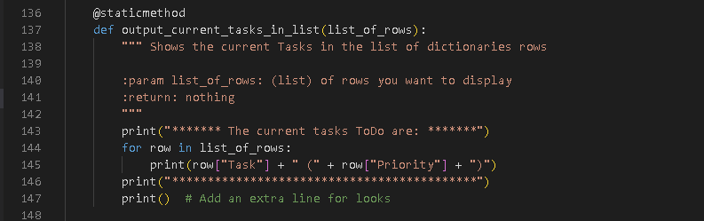

Figure 13: Current tasks in list

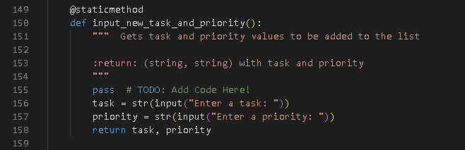

Figure 14: Input new Task and Priority Item

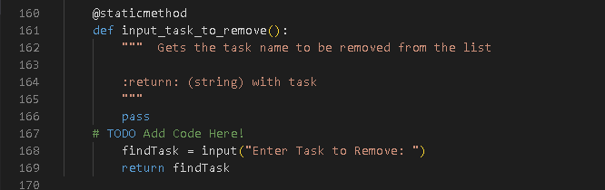

Figure 15: Input task to remove

# Step 6 – Main Body of the Script

T

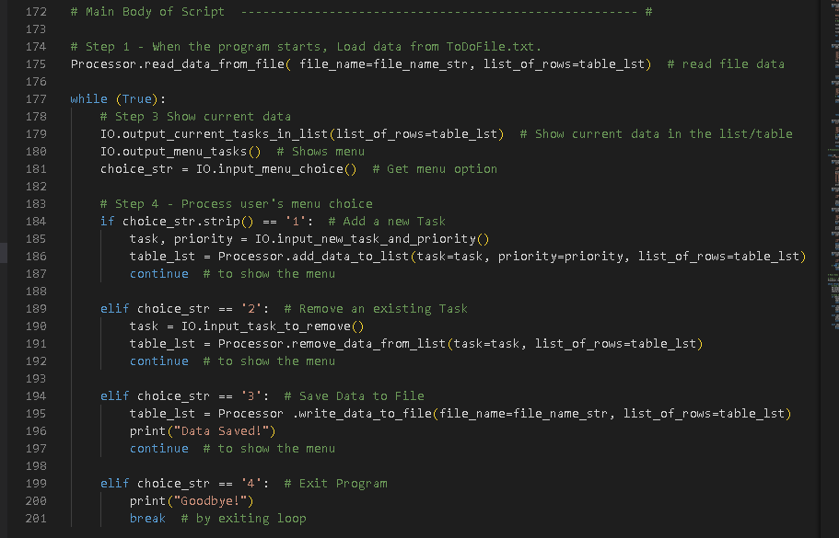

Figure 16: Main body of the Script

# Observations

T.

# Summary

In summary, utilizing all the resources provided to the class and the online lecture, this paper outlines all the steps that were taken to create a python script that results in a successful execution of the intended outcome (Figure 1). Following the steps outlined above will allow for the audience to recreate the presented result.