**Maps and File Input/Output**

General Description: The program accepts names and telephone numbers from the user. It has the modify, deletion and display capabilities. It can also save the data in a text file.

Sample Run.

1. At the start of the program the following is displayed:

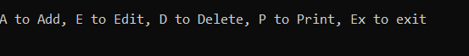

1. If there is already data, the existing phone book,records will be initially displayed.

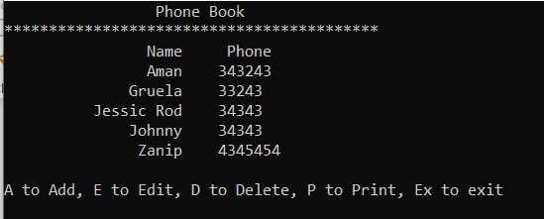

1. If the user, enters A, the program will allow the entry of new records.

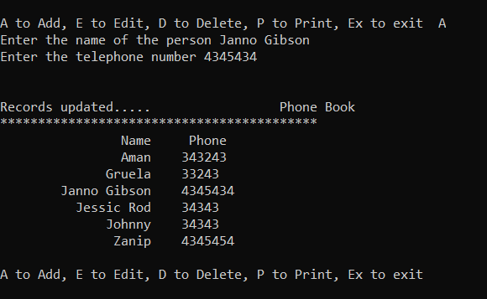

1. There should be validation to ensure no double entry is allowed.
2. If the user, enters E, modification of telephone numbers will be processed.

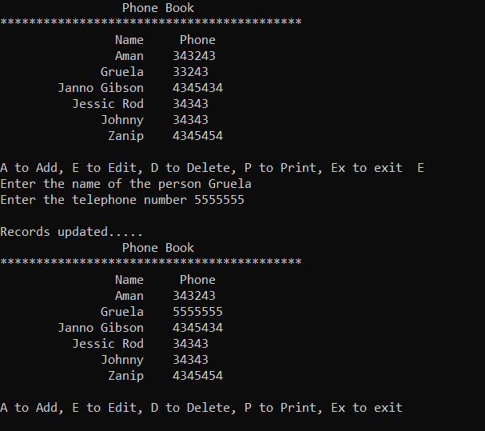

1. If the user, chooses D, deletion of data will be processed.

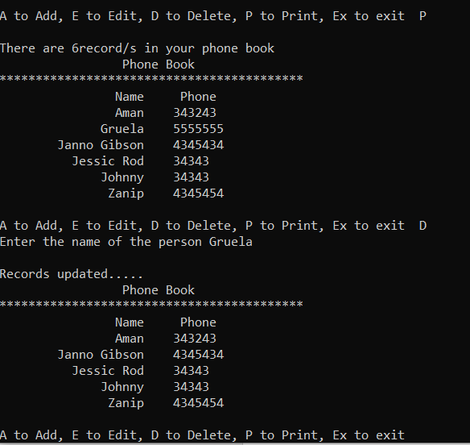

1. Validation should be provided when the user is trying to modify or delete a none- existing data.
2. When the user enters P, it will display the records along with a record count.

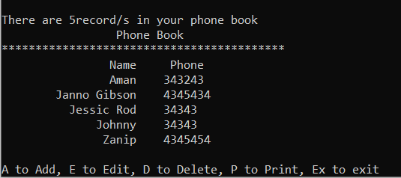

1. When the user enters Ex, the program will end.

**General Specifications**

1. **The program should use Maps.**
2. **The program should be able to save the data in a text file.**
3. **At the start of the program, the program should display the data inside the text file.**
4. **Proper documentation should be followed.**
5. **Program should be running and free from error.**