CSI 2120 – The Resident Matching Service Go Edition
Submitted to
Dr. Robert Laganiere
Submitted by
Nassar Shakir, 300082867
Kobe Blackburn, 300235492
University of Ottawa
Department of Electrical Engineering and Computer Science
Ottawa, Ontario
Submission date
February 26, 2026

Instructions

There are two subdirectories in the zip folder in our submission. The first being “Concurrent” and the other “Single”. These refer of course to the concurrent and single-threaded solutions.
To run the program, the user must first compile all classes then run the command “go run McVitie-Wilson.go” in the terminal. Within each subdirectory contains the csv files for the large datasets and they will run without issue. Ensure that before attempting to run the Go program you are in the desired subdirectory.

Solution and Approach
The recursive offer function is called for each resident once within the main function. First the residents are sorted by id and then they are called on by the offer function.
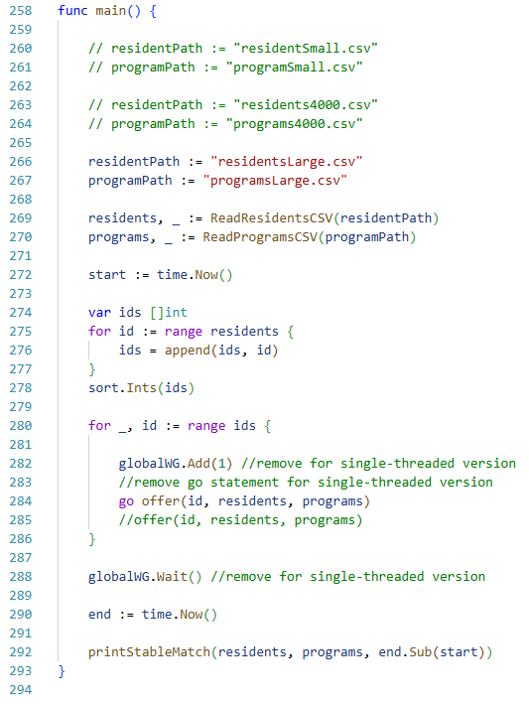
The offer function proposes to programs potential residents. First the function chekcs to see if the resident has been matched in which case it immediately returns. If the resident has not been matched then the program matched are evaluated in order of the resident’s ROL.
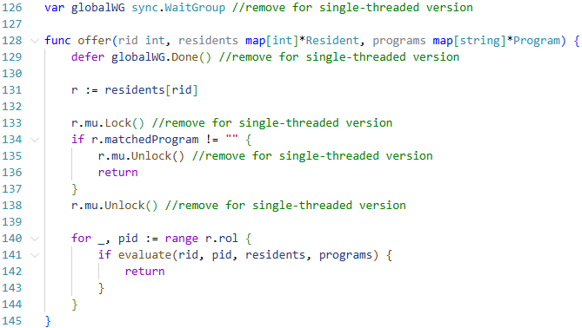

The evaluate function determines whether a program accepts or rejects a resident, or accepts a resident by replacing a previously accepted student’s position thereby rejecting the previous student in favour of the current resident. If the program is full, the least-preferred matched resident will be compared with the current resident. The least-preferred student is displaced and the new resident takes their spot if the new resident is more preferred. Otherwise the student is rejected.
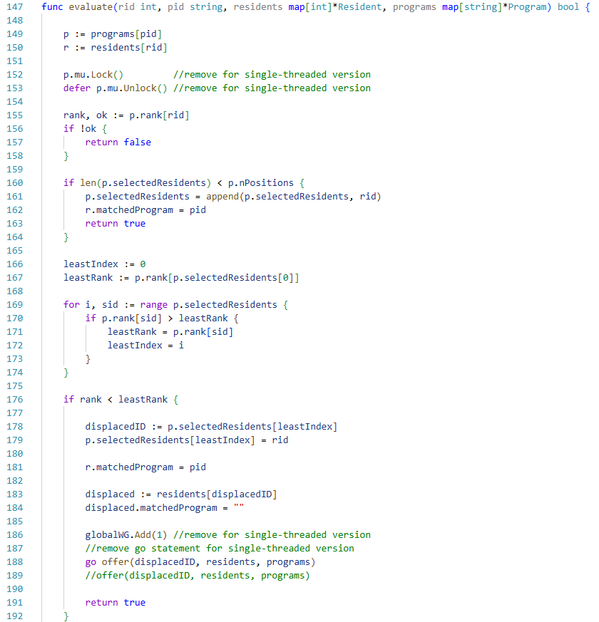

Results

The results of the McVitie-Wilson stable matching algorithm are shown below. It is shown that the concurrent implementation is more than 2x faster than the single-threaded approach. They have the same number of unmatched residents and unfilled positions which confirms the correctness and stability of the program.
 | Number Unmatched | Positions Available | Execution Time
Residents4000 | 334 | 39 | 34 ms
Residents Concurrent | 13027 | 94 | 10 s
Residents Single | 13027 | 94 | 22 s

