COMP 309-005 Data Warehousing and Mining

Assignment 1: Building an OLAP cube

# Objectives

It is required that you research the benefits that a data warehouse brings to a business. This would be reflected in the objectives. Here you will list the anticipated benefits of the cube.

Each “time for action” section: Summarize the steps and provide the screen shots of the intermediate processes and summarize the results.

An OLAP cube is …

# Benefits and ???

Developing

# Time for action – creating an Analysis Services Project

1. Open SQL Server Data Tools for Visual Studio:

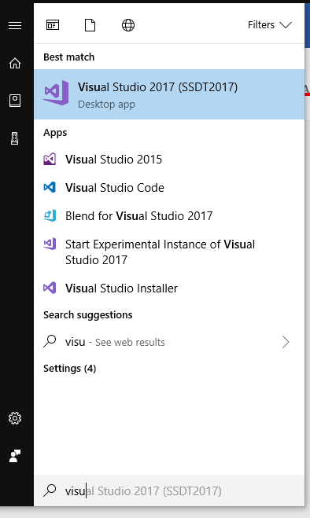

1. Create a new Analysis Services Multidimensional and Data Mining Project from the templates:

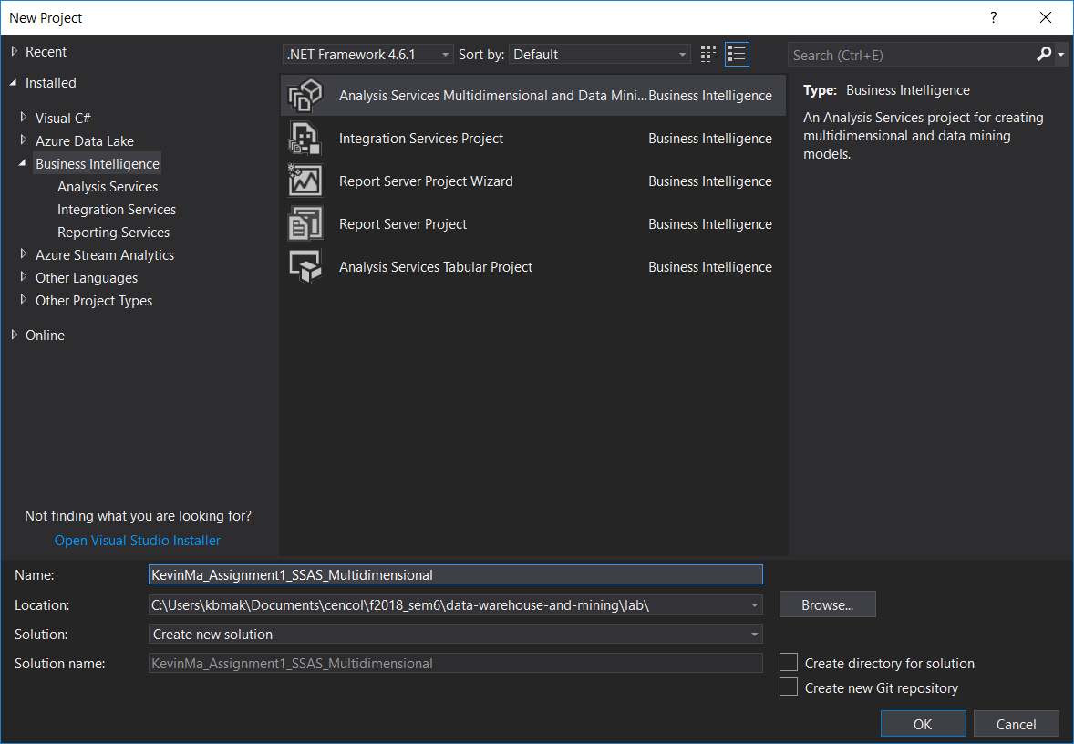

1. Results: A new project was created ☺!

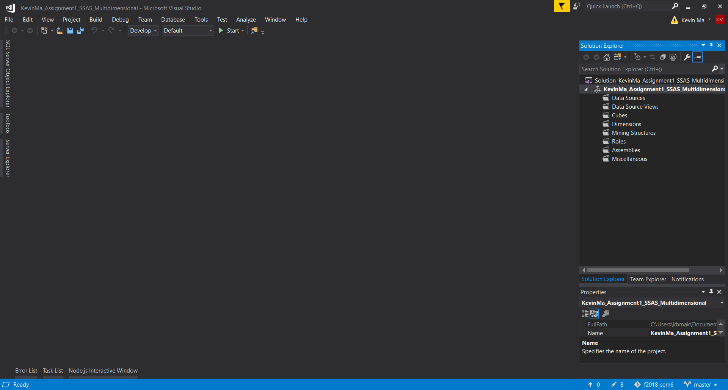

The folders created in the new project represent the following:

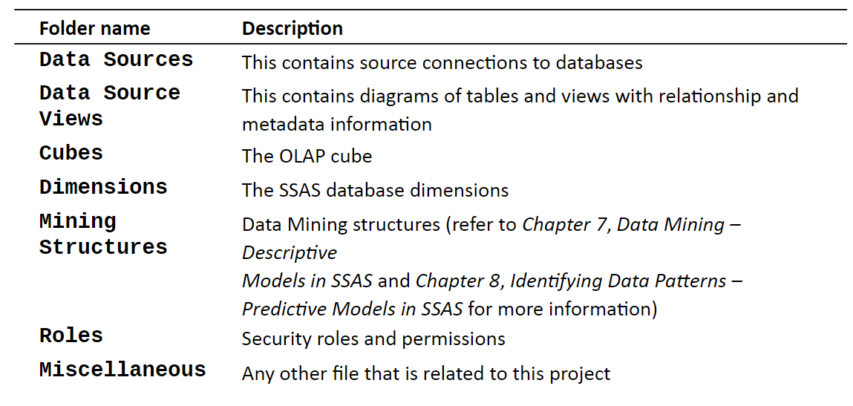

1. Add a Data Connection with the downloaded .mdf database file

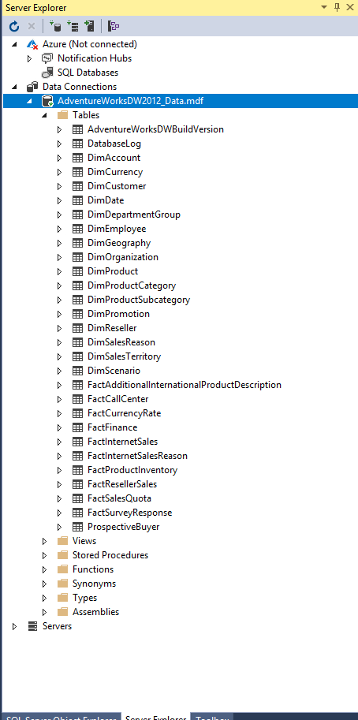

# Time for action – creating the first cube

1. Create a data source connection

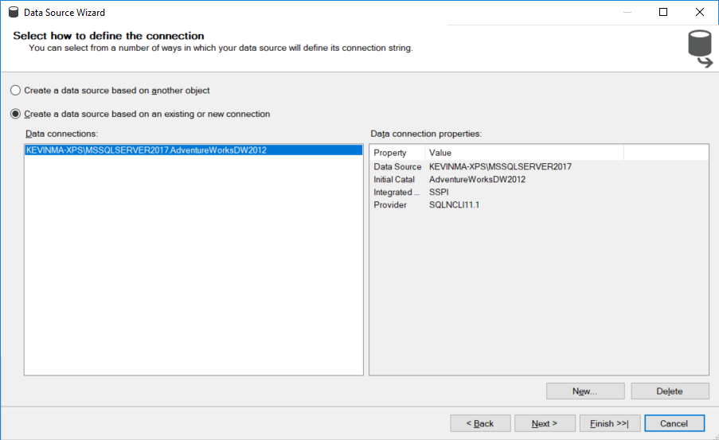

1. 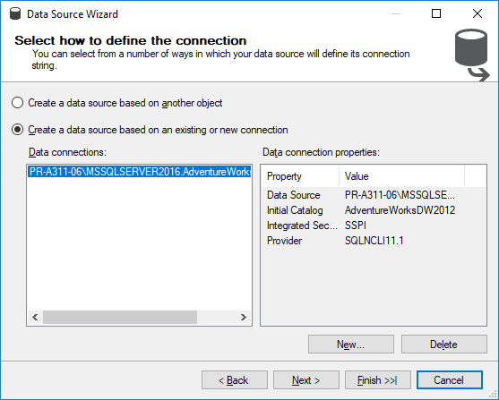
2. 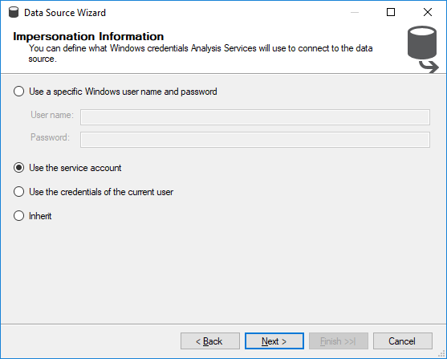
3. 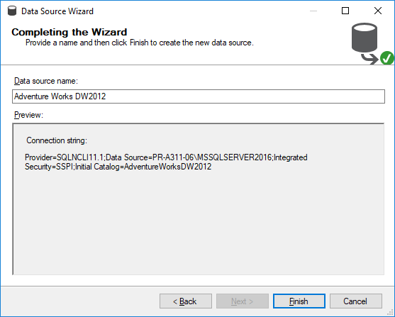
4. A data source connection was created using the Data Source Wizard.
5. Create a New Data Source View
6. 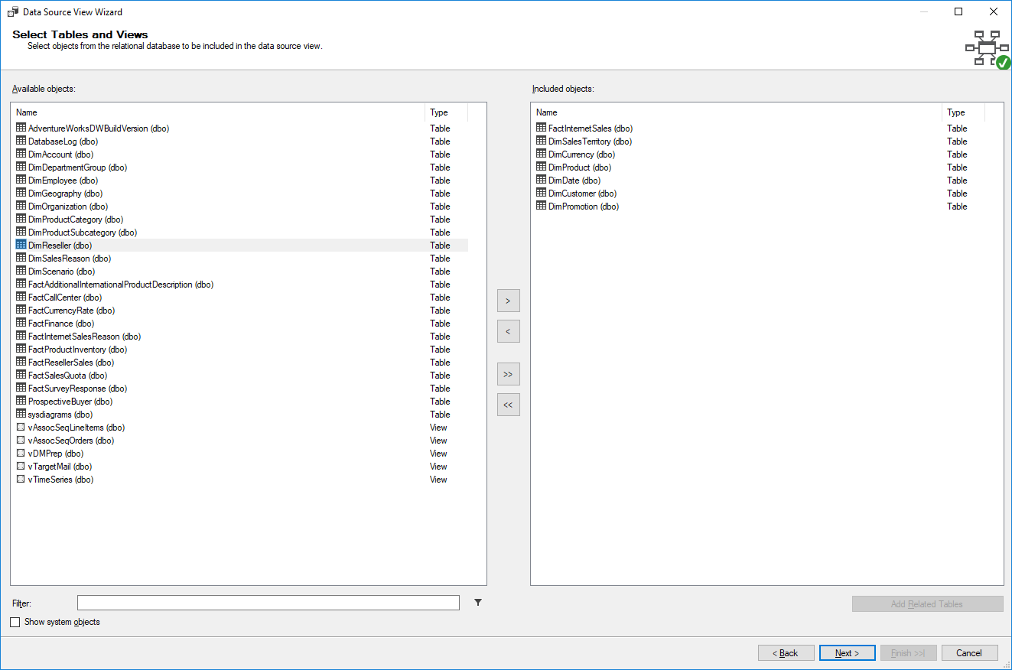
7. 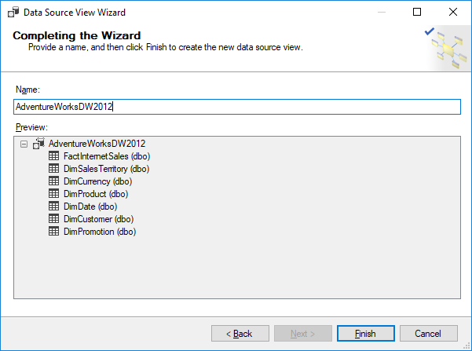
8. A data source view was created using the Data Source View Wizard

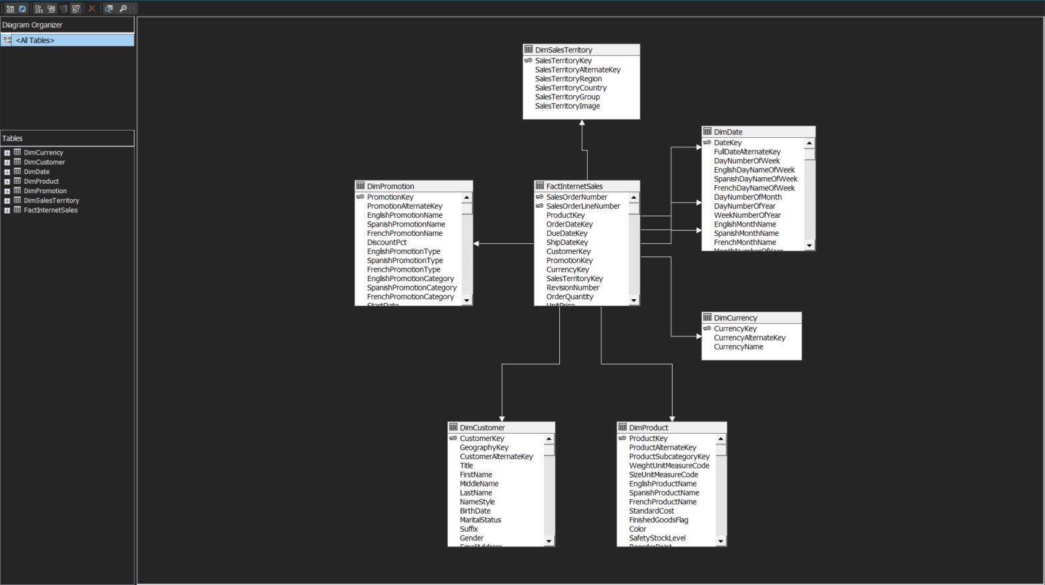

1. Create a Cube using the Cube Wizard
2. 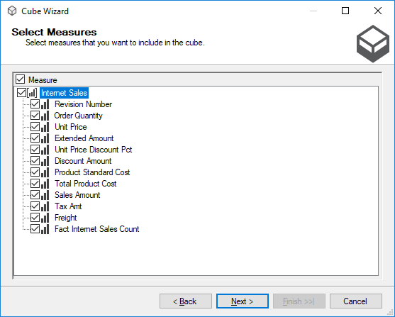
3. 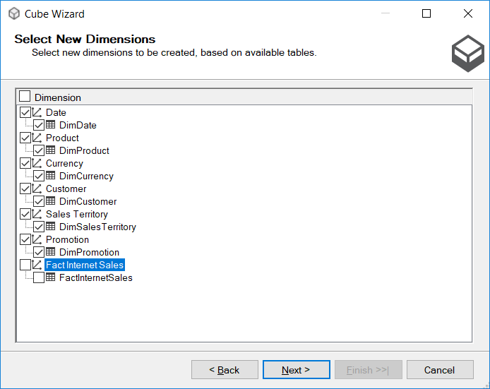
4. 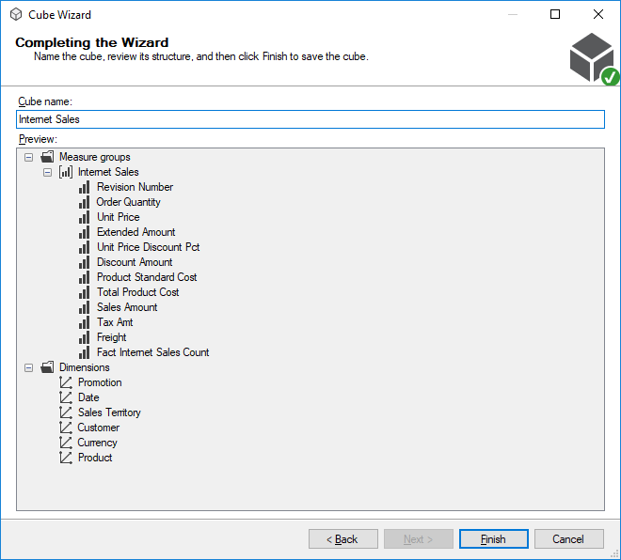
5. 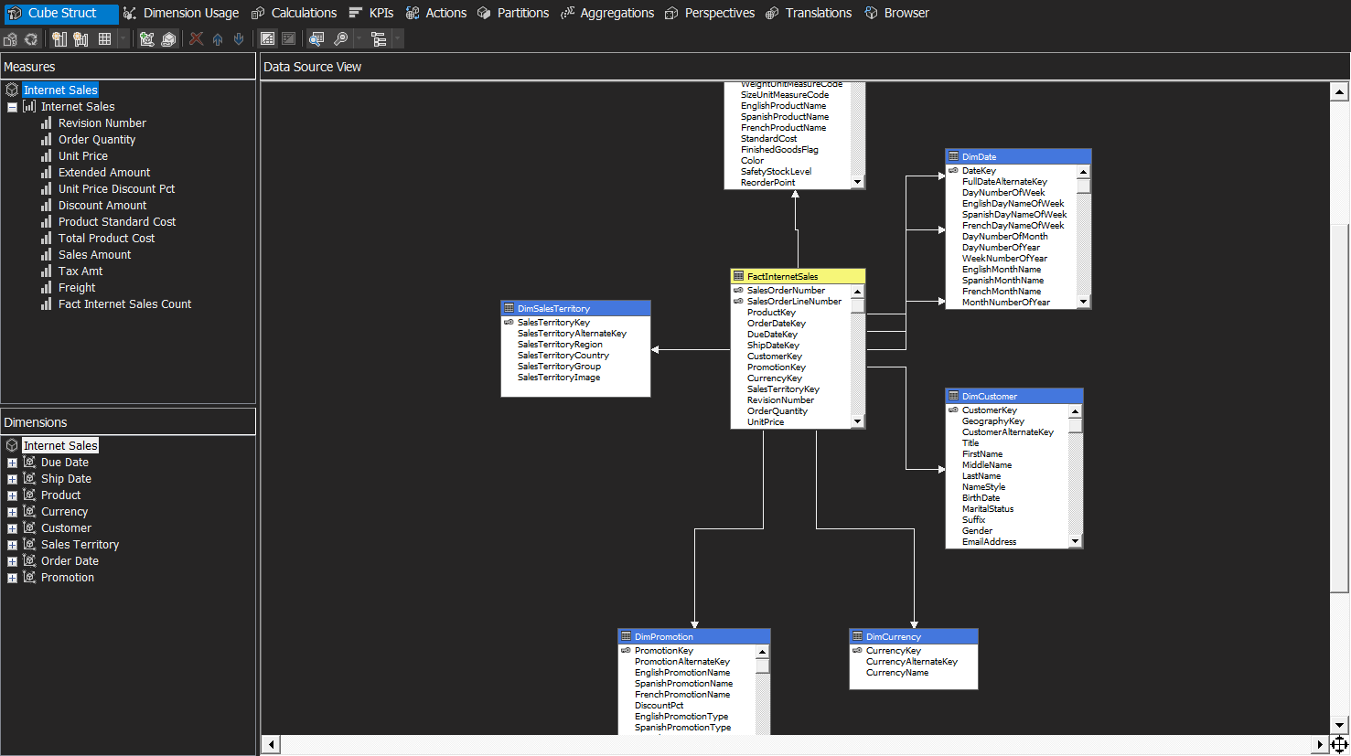
6. A cube has been created using the Cube Wizard ☺!

In this “Time for Action”, we created a connection to a data warehouse using the Data Source Wizard and provided credentials for SSAS (SQL Server Analysis Services) to connect to the underlying database. Following that, we created a data source view using the Data Source View Wizard and the data source we created previously. The data source view will be used to create the base structure for our cube. We then created a cube using the Cube Wizard. Measure groups and dimensions were defined to create the cube. Measure groups are similar to fact tables and each measure group can contain one or more facts. We selected FactInternetSales table as the measure group and it contains measures such as Sales Amount and Order Quantity. Finally, we defined the dimensions to create the cube. There are two different sets of Dimensions we see here. On the right side panel, the dimensions shown are the database dimensions. The dimensions on the left side panel are the cube dimensions. The difference between these two are that we may have some database dimensions that are not used within the cube. We can have multiple cubes within the same project! Or we can have the same database dimension re-used within multiple cubes. We even have dimensions which may be used multiple times within the same cube. We call these role-playing dimensions. For example, there is only one database dimension, Date, but there are three role-playing dimensions in the cube, which are named OrderDate, ShipDate, and DueDate.

# Time for action – viewing the cube in the browser

1. Change from localhost to ComputerName\MsSqlServerInstanceName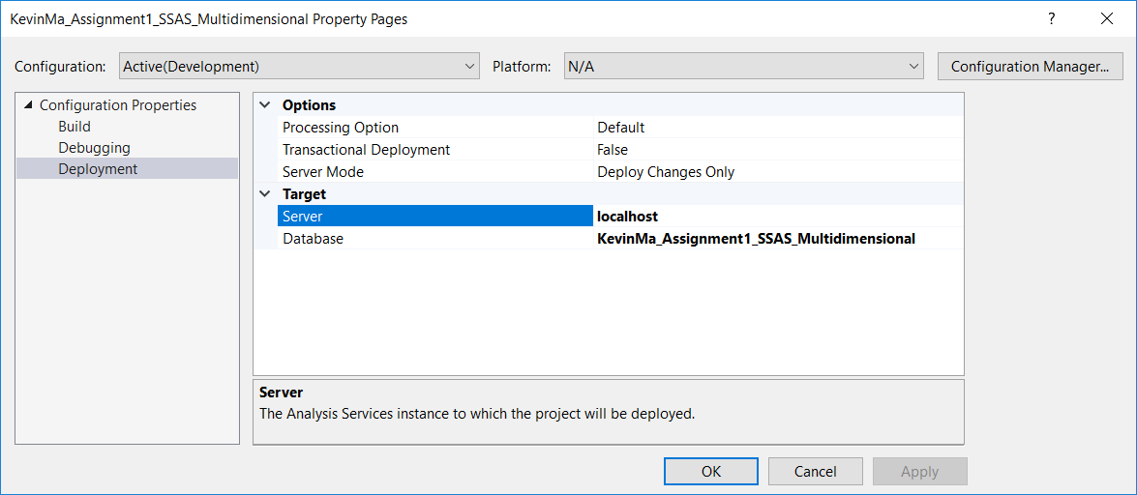

to

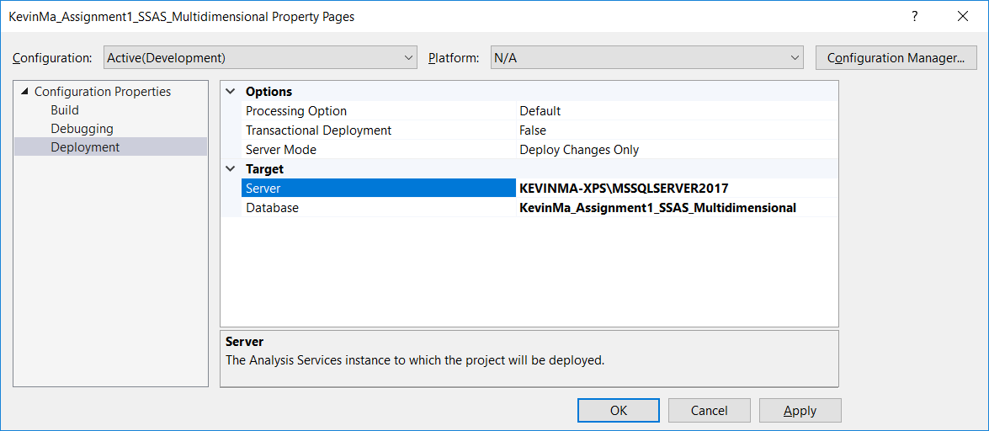

1. Change from service account in data source to

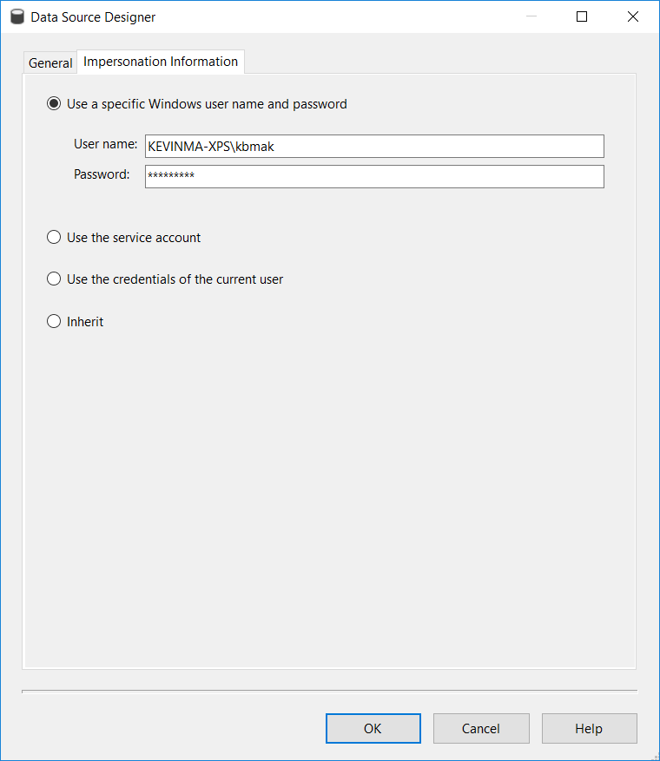

1. 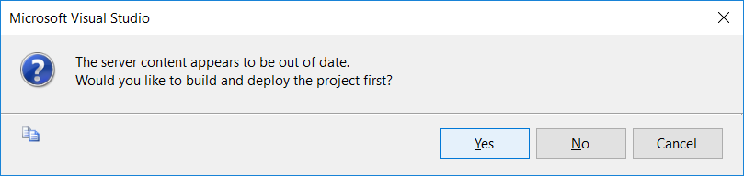
2. 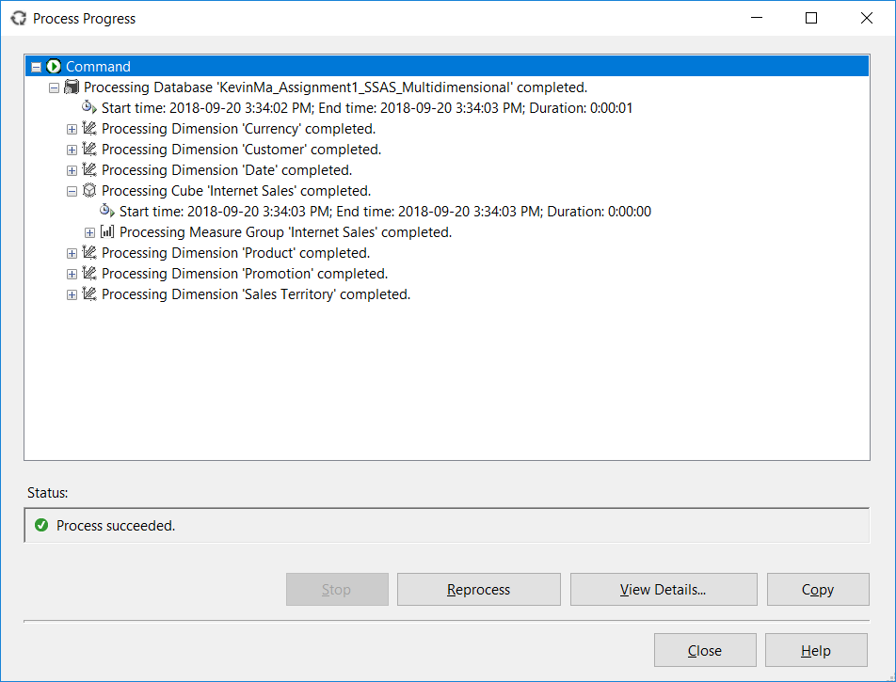
3. Go to Browser tab, which is the last tab in the cube designer
4. To see grand total of Sales Amount and Order Quantity calculated from the cube, drop-and-drag Sales Amount and Order Quantity measures from the Metadata pane on the left side to the pane on the right side and press execute query:

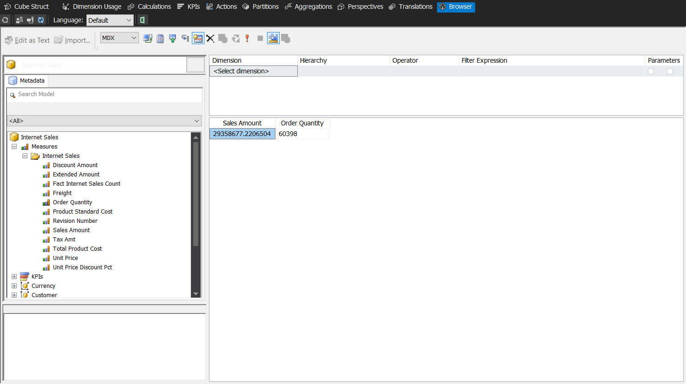

1. Slice and dice the Sales Amount by Sales Territory by dragging the Sales Territory Key dimension from the Metadata pane and re-executing the query on the right:

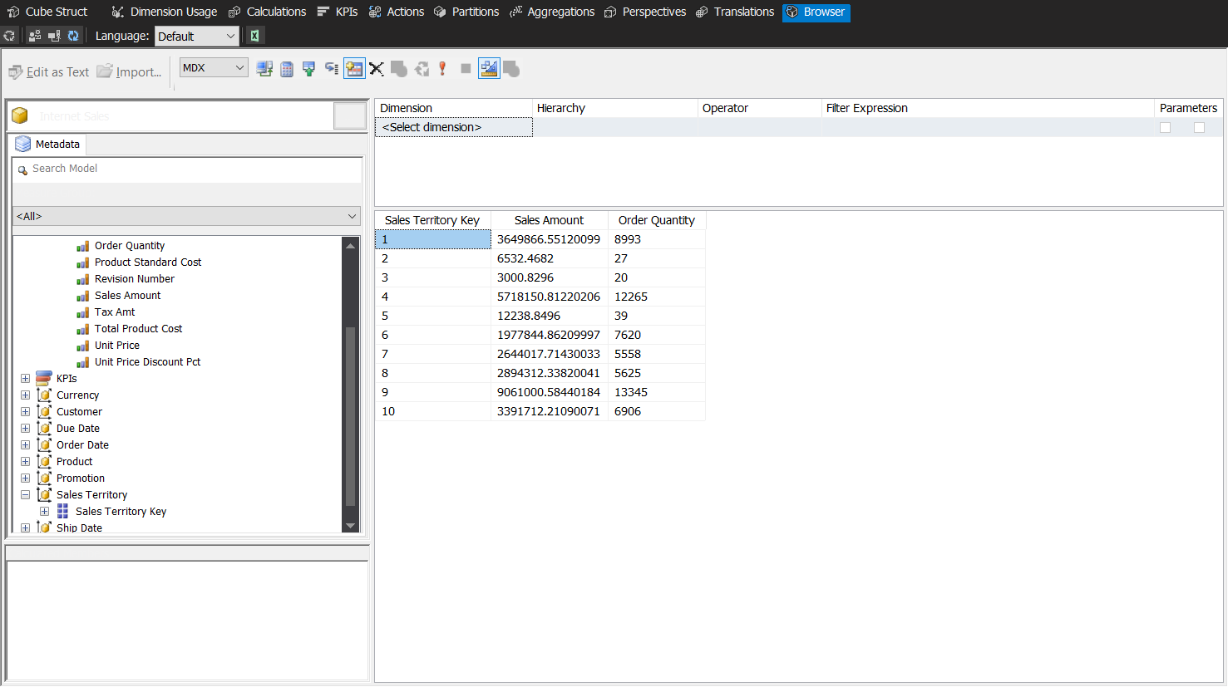

While this may be useful for the SSAS developers, this does not make much sense to the Business Users. So in the next section we will be bringing more descriptive information as additional attributes and better designing the output to make it more useful.

# Time for action – using the Dimension Designer

1. Open the Dimension Designer by double clicking on the Sales Territory dimension in the Solution Explorer

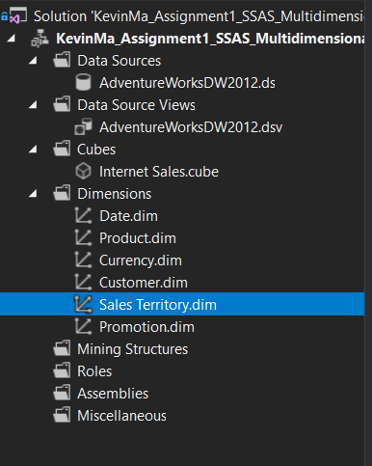

1. Drag-and-drop Sales Territory Region, Sales Territory Group and Sales Territory Country from the Data Source View to the Attributes panel

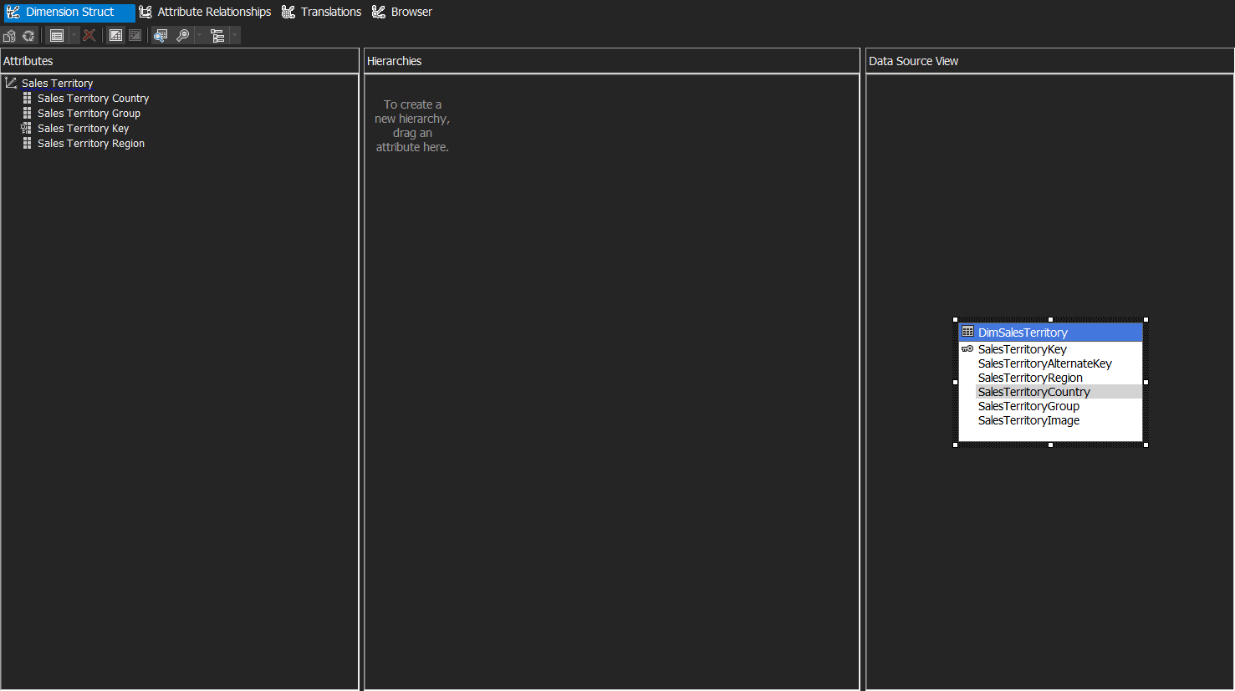

1. Select Sales Territory Key in the Attributes pane, and then in the Properties window, change the AttributeHierarchyVisible property of this attribute to false.

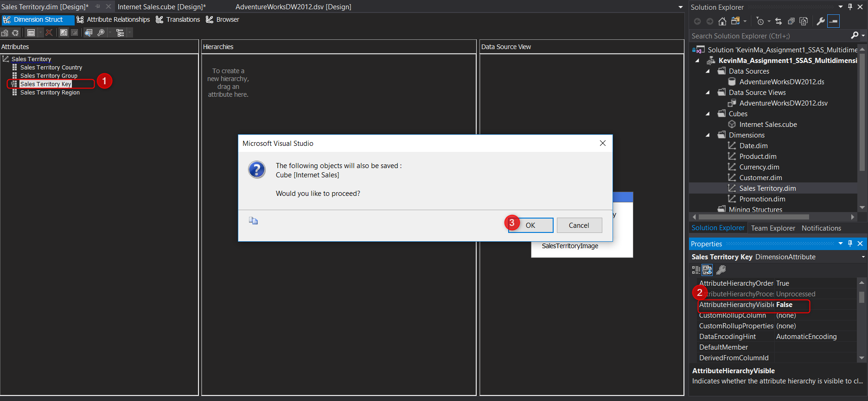

This property:



Some other useful properties of attributes are:

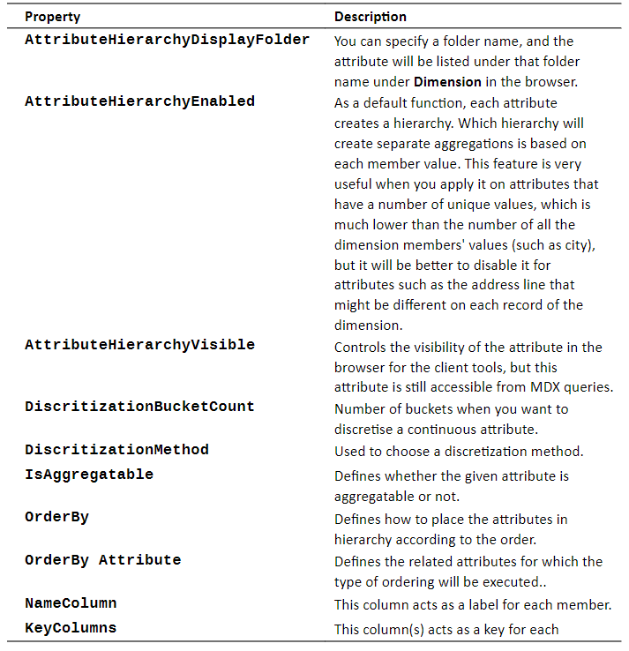

1. Re-process the dimension

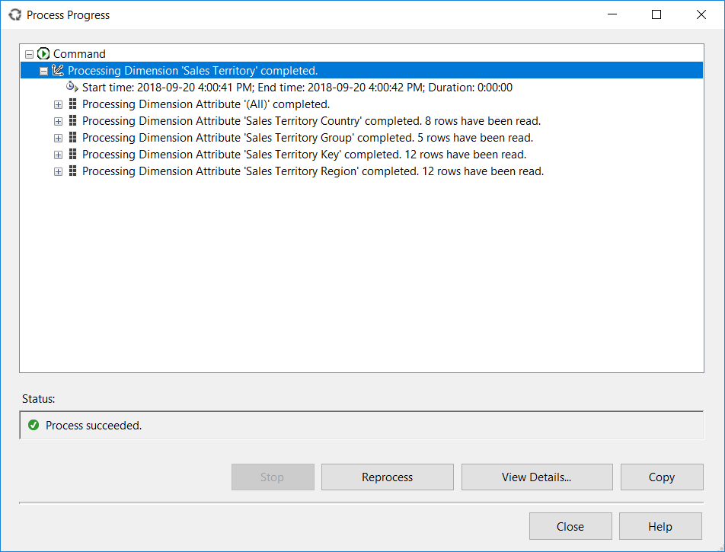

1. Go back to the Browser tab and you should now be able to see the values for the new attribute selected (e.g. Sales Territory Country)

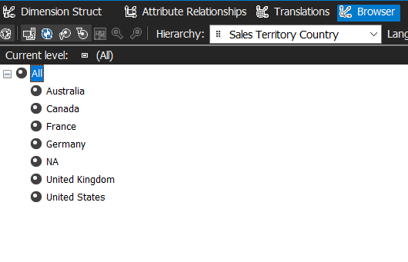

1. To see the changes in the cube, we need to process and deploy again (NOTE: Every time we make a change to the metadata of the SSAS cube, dimension or measures, we need to deploy the changes and process again to see the changes).

# Time for action – change the order of the Month attribute

The date dimension is currently an integer in the format of YYYYMMDD. This is not well formed to a business user, so we want to change this format and add two other attributes for the years and month.

1. Open the Dimension Designer for the Date dimension by double clicking on the Date dimension in the Solution Explorer.
2. Go to the Dimension Structure tab, select DateKey in the attributes pane, and then click on the ellipsis button of the NameColumn property in the Properties window.
3. Change the source column from DateKey to FullDateAlternateKey

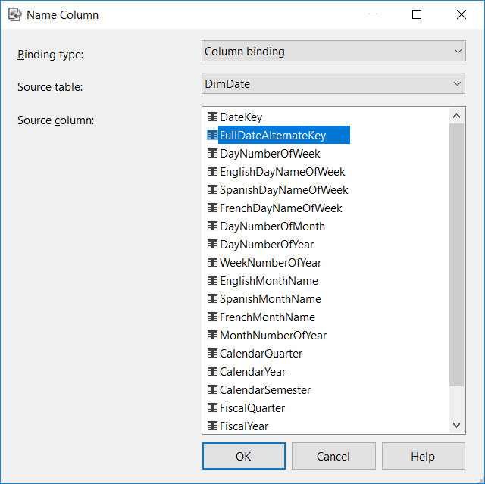

1. Rename the Date Key attribute to Date
2. Drag-and-drop Calendar Year and Month Number of Year from the Data Source View into the Attributes pane
3. Change the NameColumn for the Month Number of Year to show the English month names for the label value and rename the attribute to simply be called Month

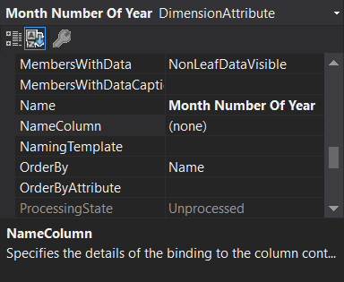 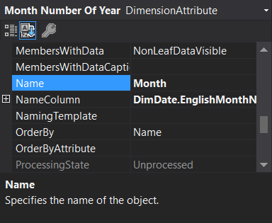

1. After we Process the Project, we can see the changes we made in the Browser Tab

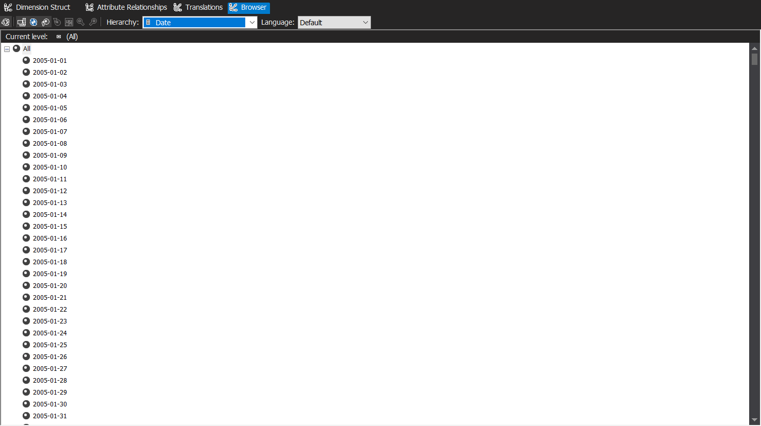

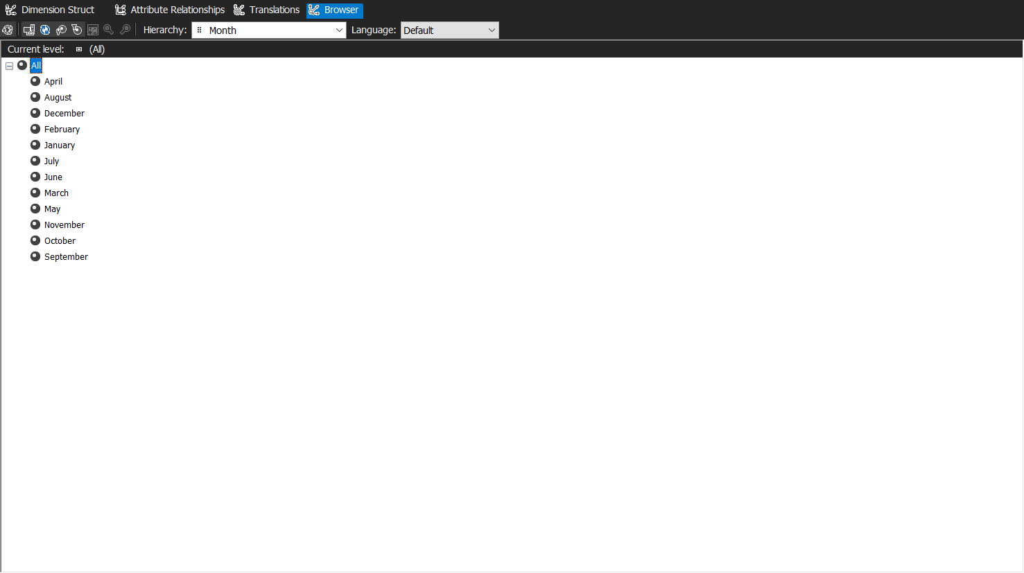

However, the Month names are not in their correct order

1. Go back to the Dimension Structure tab and change the Month attribute’s OrderBy Property to ordering by key instead of name:

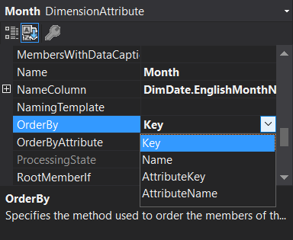

1. After processing the changes, we can see that the month names are in their correct order in the Browser tab

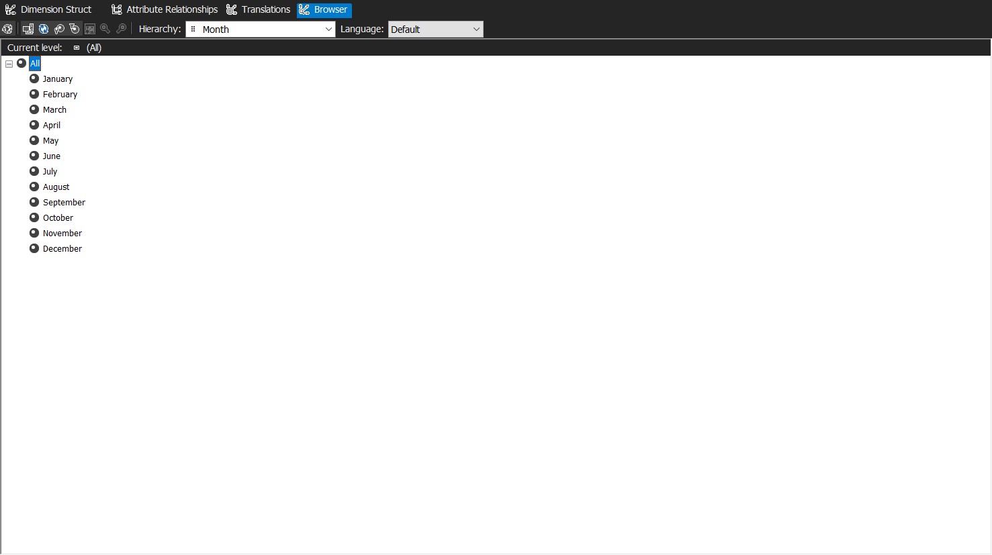

Document about four aspects of building a data warehouse , the advantages to a business, the resources it consumes, etc.

60-70 pages

Spend more time on obj. and conclusions.

Screenshots

Conclusions

Your conclusions would reflect your experience in building the cube. Provide screen shots of the final results, the aggregation of various hierarchies. Provide an overall assessment of the process of building a cube.