# Objectives:

Here you will list the anticipated benefits of the ETL mechanisms. ETL processes

are used in many areas in addition to cleansing and importing data into the data

warehouse. You are expected to research and document its importance to large

computer environments where the daily processes depend on the overnight data

cleansing processes

Each “time for action” section:

Summarize the steps and provide the screen shots of the intermediate processes

and summarize the result

Time for action – creating

# Time for action – creating your first SSIS project

In this project, we will create a SSIS package using SQL Server Data Tools (SSDT) for Integration Services. Shown below are the steps we took to create the SSIS project:

1. Open SSDT/Visual Studio and select Business Intelligence > Integration Services Project under New Project.

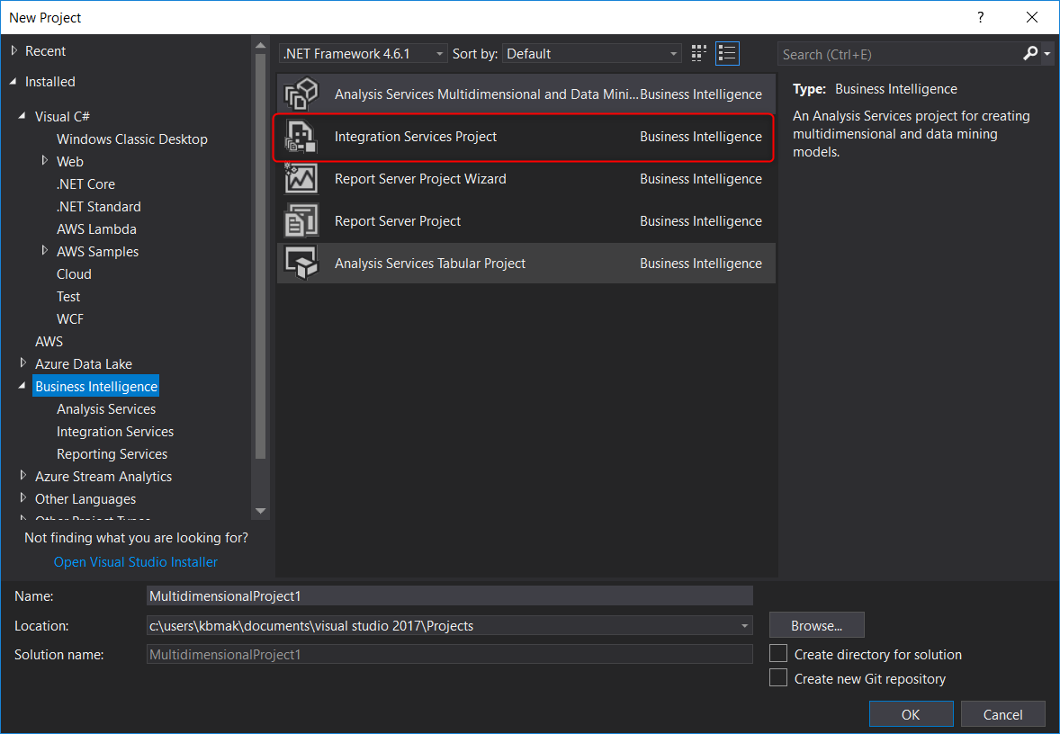

1. That’s it! Now we will have access to the Solution Explorer, Package Designer, and SSIS toolbox.

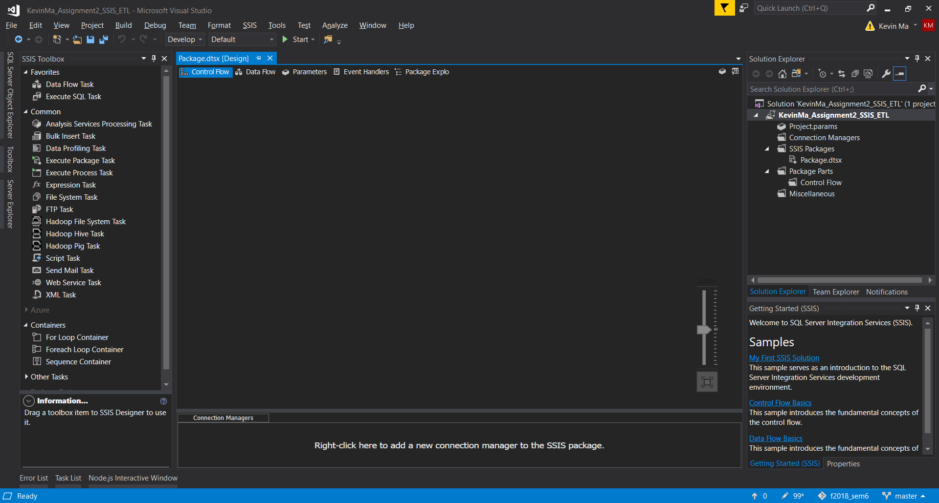

# Time for action – working with Control Flow tasks

# Conclusion:

Your conclusion should reflect your experience performing the ETL exercise: what

was easy, difficult and obscure.