In Class Practice Test - 1

Due Date: Week 6.

Purpose: The purpose of this practice test is to:

1. Develop an interactive Android application with graphics capabilities.

References: Textbook, ppt slides. This material provides the necessary information that you need to complete the exercises.

Be sure to read the following general instructions carefully:

- This practice test must be completed individually by all the students.

- You will have to **implement &** **demonstrate your solution in a scheduled lab session**.

**Exercise 1**

In this exercise you will write a simple app which allows the user to keep track of daily vitamin intake.

Create a new project using usual notations (John_Smith_SecondMidTermPractice).

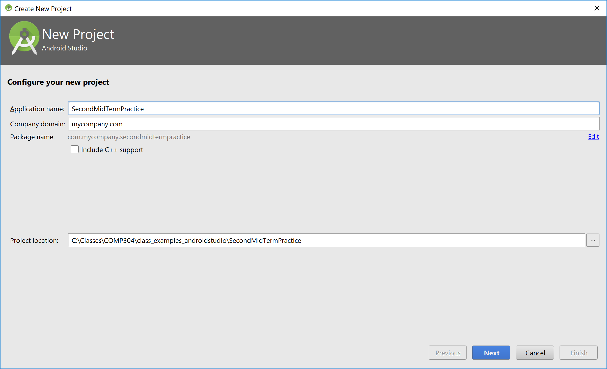

Click next and select the minimum SDK as below:

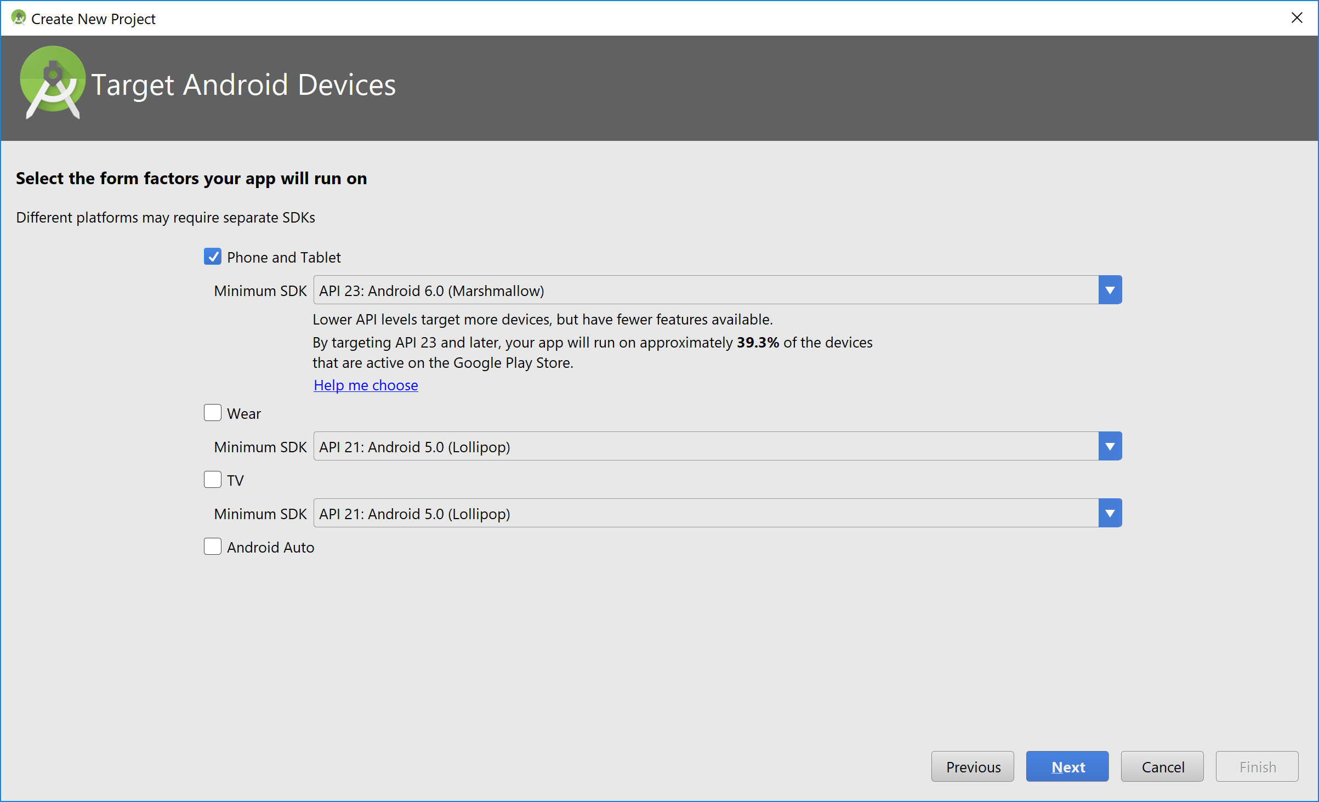

Click next and select EmptyActivity template:

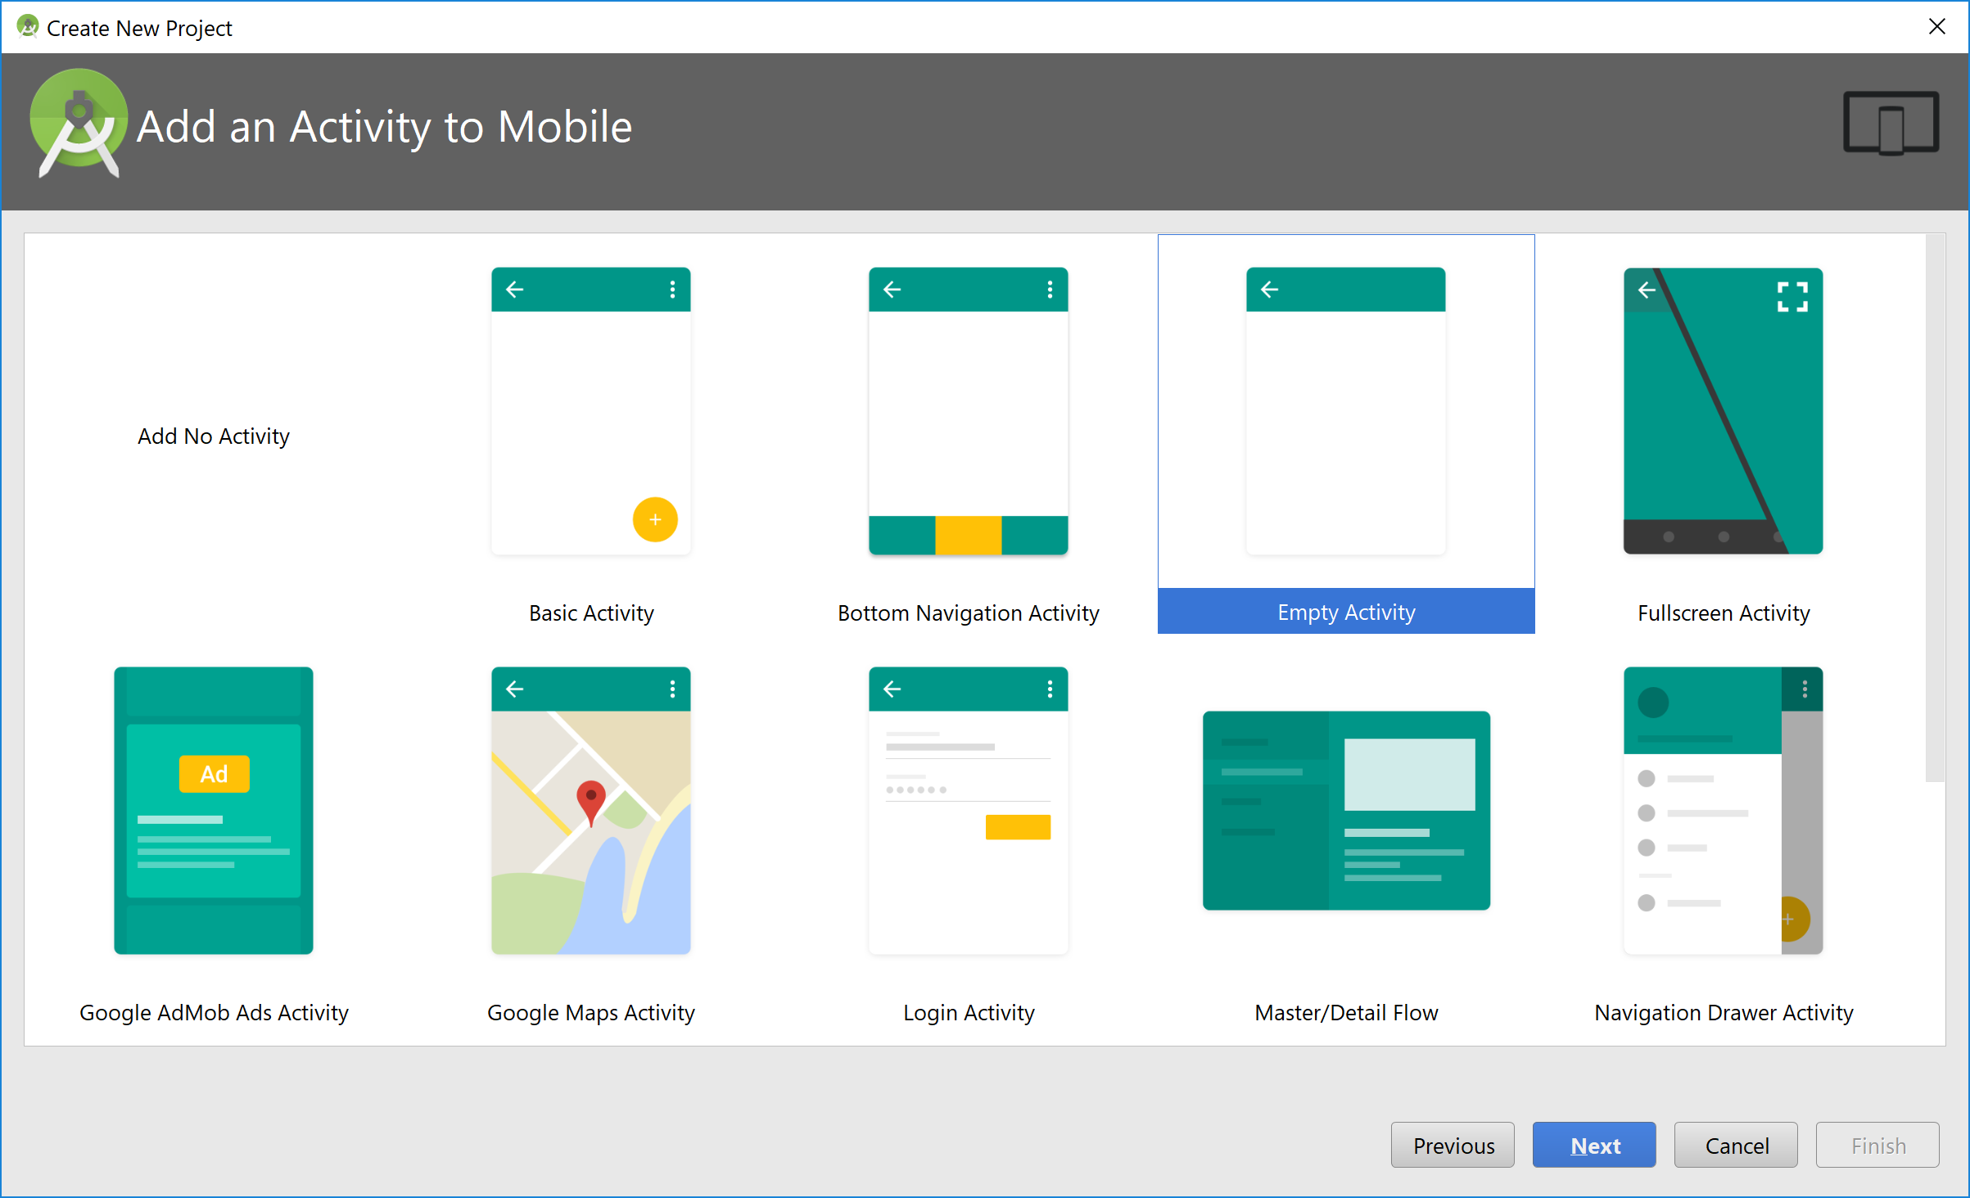

Click next and name the empty activity VitaminActivity:

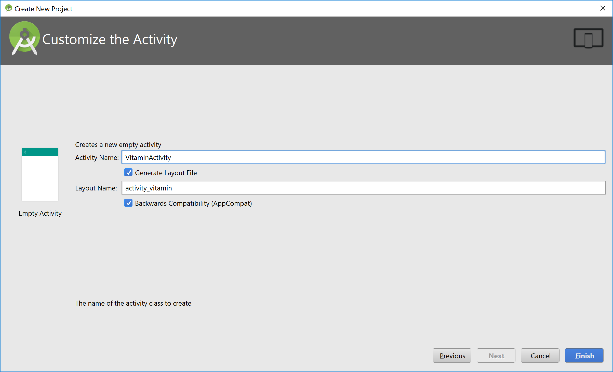

Click Finish.

Create the following UI using a TextView, one ImageView, four Checkbox controls, and one ImageButton:

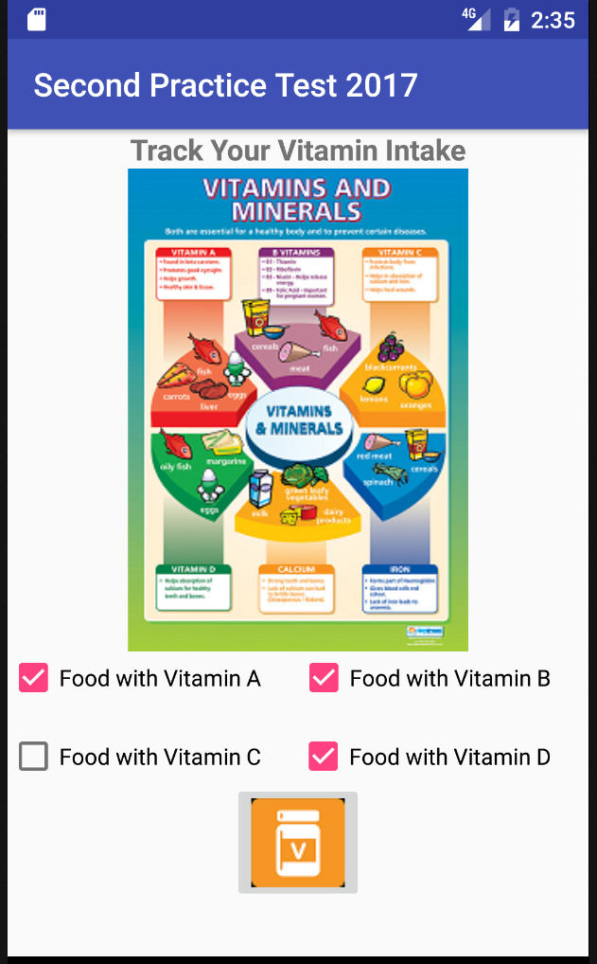

You may use a LinearLayout with vertical orientation as the outer container.

Add a TextView control to display the title (Vitamin Tracker). Add an ImageView to show the vitamin & minerals chart. Use two LinearLayout with horizontal orientations. Use the drag and drop from the Android Studio palette to create the UI. Use the notation shown in the picture below:

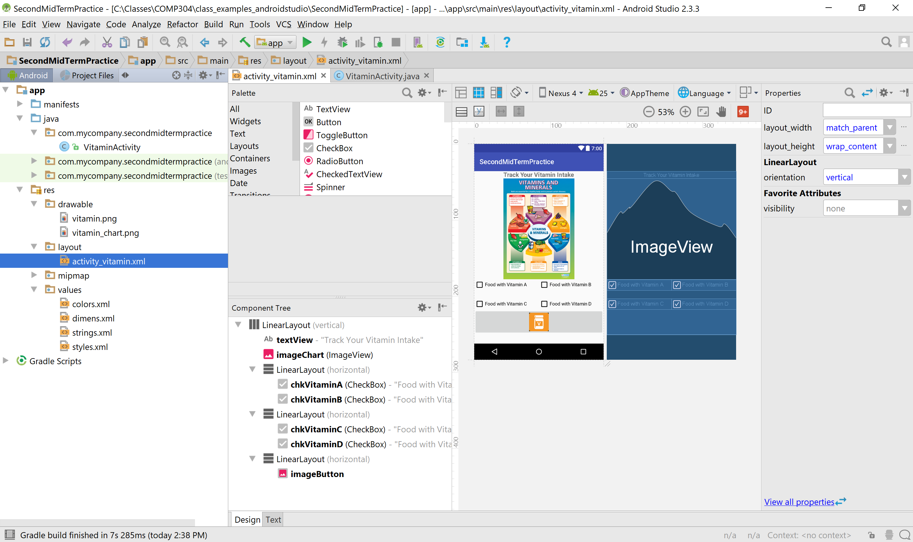

Here is the XML code of my app:

*<?***xml version="1.0" encoding="utf-8"***?>*<**LinearLayout xmlns:android="http://schemas.android.com/apk/res/android"  
  
 xmlns:app="http://schemas.android.com/apk/res-auto"  
 android:layout_width="match_parent"  
 android:layout_height="wrap_content"  
 android:orientation="vertical"**>  
  
  
 <**TextView  
 android:id="@+id/textView"  
 android:layout_width="match_parent"  
 android:layout_height="wrap_content"  
 android:text="Track Your Vitamin Intake"  
 android:textAlignment="center"  
 android:textSize="18sp"  
 android:textStyle="bold"** />  
  
 <**ImageView  
 android:id="@+id/imageChart"  
 android:layout_width="match_parent"  
 android:layout_height="wrap_content"  
 android:adjustViewBounds="false"  
 android:cropToPadding="false"  
 app:srcCompat="@drawable/vitamin_chart"** />  
  
 <**LinearLayout  
 android:layout_width="match_parent"  
 android:layout_height="wrap_content"  
 android:orientation="horizontal"**>  
  
 <**CheckBox  
 android:id="@+id/chkVitaminA"  
 android:layout_width="wrap_content"  
 android:layout_height="wrap_content"  
 android:layout_weight="1"  
 android:checked="false"  
 android:text="Food with Vitamin A"  
 android:onClick="onCheckboxClicked"** />  
  
 <**CheckBox  
 android:id="@+id/chkVitaminB"  
 android:layout_width="wrap_content"  
 android:layout_height="wrap_content"  
 android:layout_weight="1"  
 android:text="Food with Vitamin B"  
 android:onClick="onCheckboxClicked"** />  
  
 </**LinearLayout**>  
  
 <**LinearLayout  
 android:layout_width="match_parent"  
 android:layout_height="wrap_content"  
 android:orientation="horizontal"  
 android:layout_marginTop="50px"** >  
  
 <**CheckBox  
 android:id="@+id/chkVitaminC"  
 android:layout_width="wrap_content"  
 android:layout_height="wrap_content"  
 android:layout_weight="1"  
 android:text="Food with Vitamin C"  
 android:onClick="onCheckboxClicked"** />  
  
 <**CheckBox  
 android:id="@+id/chkVitaminD"  
 android:layout_width="wrap_content"  
 android:layout_height="wrap_content"  
 android:layout_weight="1"  
 android:text="Food with Vitamin D"  
 android:onClick="onCheckboxClicked"** />  
  
 </**LinearLayout**>  
  
 <**LinearLayout  
 android:layout_width="match_parent"  
 android:layout_height="match_parent"  
 android:orientation="horizontal"**>  
  
 <**ImageButton  
 android:id="@+id/imageButton"  
 android:layout_width="wrap_content"  
 android:layout_height="wrap_content"  
 android:layout_centerInParent="true"  
 android:layout_weight="1"  
 android:onClick="showChartActivity"  
 app:srcCompat="@drawable/vitamin"** />  
 </**LinearLayout**>  
  
  
</**LinearLayout**>

Here is the dimens.xml file:

*<?***xml version="1.0" encoding="utf-8"***?>*<**resources**>  
 *<!-- Default screen margins, per the Android Design guidelines. -->* <**dimen name="activity_horizontal_margin"**>16dp</**dimen**>  
 <**dimen name="activity_vertical_margin"**>16dp</**dimen**>  
 <**dimen name="title_font"**>14pt</**dimen**>  
 <**dimen name="chart_font"**>12pt</**dimen**>  
 <**dimen name="img_height"**>600px</**dimen**>  
 <**dimen name="img_width"**>800px</**dimen**>  
 <**dimen name="icon_width"**>100px</**dimen**>  
 <**dimen name="icon_height"**>20px</**dimen**>  
</**resources**>

The strings.xml file:

<**resources**>  
 <**string name="app_name"**>Second Practice Test 2017</**string**>  
 <**string name="chart_name"**>Daily Vitamin Tracker</**string**>  
</**resources**>

Here is the VitaminActivity code:

**package** com.mycompany.secondmidtermpractice;  
  
**import** android.content.Intent;  
**import** android.os.Bundle;  
**import** android.support.v7.app.AppCompatActivity;  
**import** android.view.View;  
**import** android.widget.CheckBox;  
  
  
**public class** VitaminActivity **extends** AppCompatActivity {  
 **private** Intent **intent**;  
  
 **private int**[] **checkedStates** = **new int**[4];  
 @Override  
 **protected void** onCreate(Bundle savedInstanceState) {  
 **super**.onCreate(savedInstanceState);  
 setContentView(R.layout.***activity_vitamin***);  
 }  
  
 **public void** onCheckboxClicked(View view) {  
 *// Is the view now checked?* **boolean** checked = ((CheckBox) view).isChecked();  
  
 *// Check which checkbox was clicked* **switch**(view.getId()) {  
 **case** R.id.***chkVitaminA***:  
 **if** (checked)  
 **checkedStates**[0]=1;  
 **break**;  
 **case** R.id.***chkVitaminB***:  
 **if** (checked)  
 **checkedStates**[1]=1;  
 **break**;  
 **case** R.id.***chkVitaminC***:  
 **if** (checked)  
 **checkedStates**[2]=1;  
 **break**;  
 **case** R.id.***chkVitaminD***:  
 **if** (checked)  
 **checkedStates**[3]=1;  
 **break**;  
 **default**:  
 **break**;  
 }  
 }  
 *//  
 //handling image button* **public void** showChartActivity(View v)  
 {  
 *//put selected items in Extras* **intent** = **new** Intent(**this**, ChartActivity.**class**);  
 **intent**.putExtra(**"checkedStates"**,**checkedStates**);  
 *//* startActivity(**intent**);  
 }  
}

Make sure to change the package name to your package. Note that this code handles onClick event of check boxes and passes information to ChartActivity that you will create now.

Click File/New and select activity. Select empty activity and name it as below:

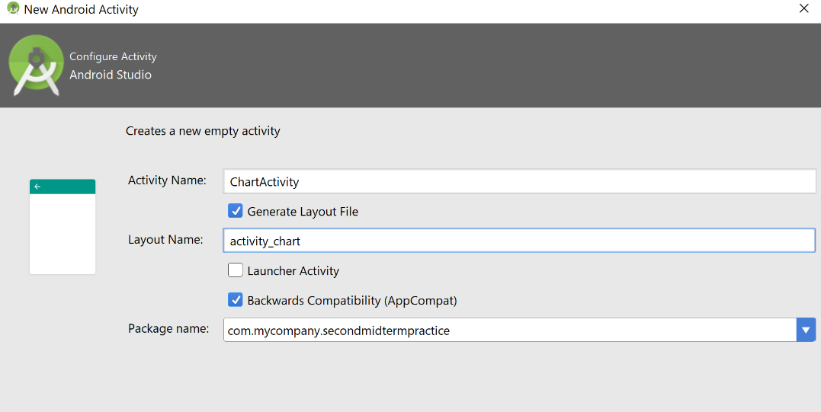

Create the following layout for ChartActivity:

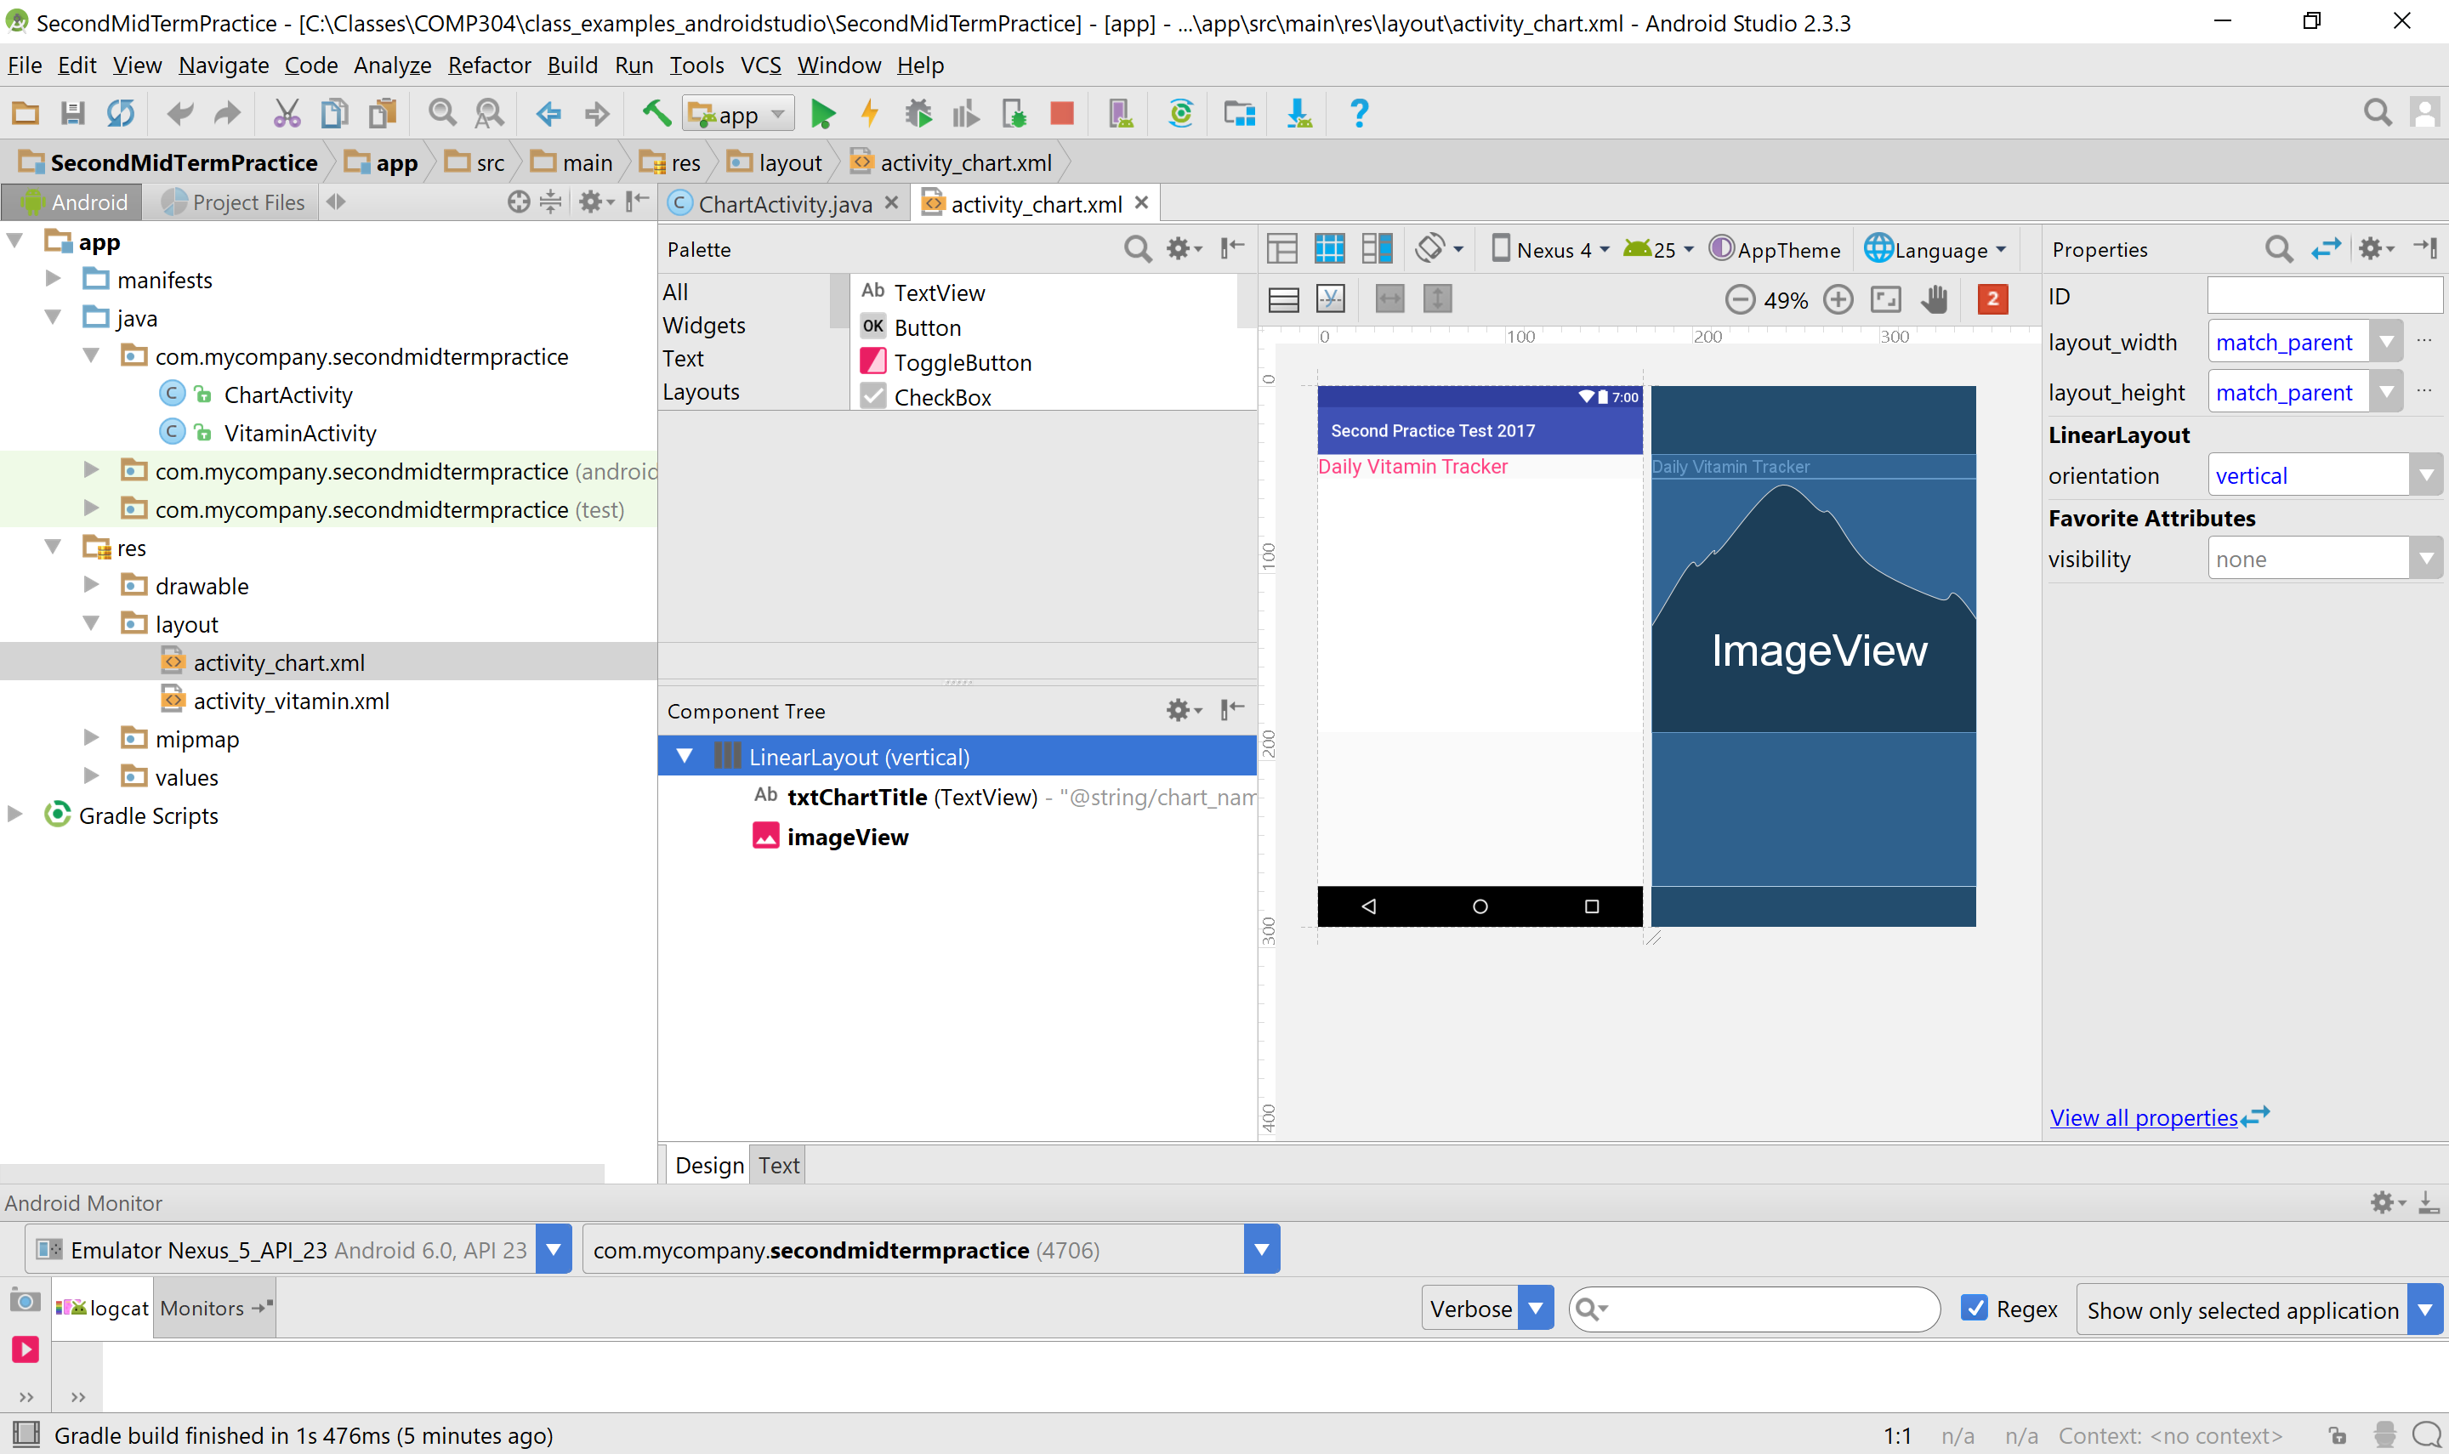

*<?***xml version="1.0" encoding="utf-8"***?>*<**LinearLayout xmlns:android="http://schemas.android.com/apk/res/android"  
 xmlns:app="http://schemas.android.com/apk/res-auto"  
 xmlns:tools="http://schemas.android.com/tools"  
 android:layout_width="match_parent"  
 android:layout_height="match_parent"  
 android:orientation="vertical"  
 tools:context="com.mycompany.secondmidtermpractice.ChartActivity"**>  
  
 <**TextView  
 android:id="@+id/txtChartTitle"  
 android:layout_width="match_parent"  
 android:layout_height="wrap_content"  
 android:text="@string/chart_name"  
 android:textColor="@color/chartTitleColor"  
 android:textSize="24sp"** />  
  
 <**ImageView  
 android:id="@+id/imageView"  
 android:layout_width="@dimen/img_width"  
 android:layout_height="@dimen/img_height"  
 app:srcCompat="@android:color/background_light"** />  
</**LinearLayout**>

Make sure to change the package name to your package name.

Now you have to write the code for ChartActivity class. Here is my code:

**package** com.mycompany.secondmidtermpractice;  
  
**import** android.graphics.Bitmap;  
**import** android.graphics.Canvas;  
**import** android.graphics.Color;  
**import** android.graphics.Paint;  
**import** android.os.Bundle;  
**import** android.support.v7.app.AppCompatActivity;  
**import** android.util.Log;  
**import** android.widget.ImageView;  
  
  
**public class** ChartActivity **extends** AppCompatActivity {  
 **private** ImageView **imageView**;  
 **private** Paint **paint**;  
 **private** Bitmap **bitmap**;  
 **private** Canvas **canvas**;  
 *//* **int barStartY** = 0;  
 **int barY** = 0;  
 **int barHeight** = 100;  
 *//* **int**[] **checkedStates** = **new int**[4];  
 *//* @Override  
 **protected void** onCreate(Bundle savedInstanceState) {  
 **super**.onCreate(savedInstanceState);  
 setContentView(R.layout.***activity_chart***);  
 *//* **this**.getSupportActionBar().setTitle(**"Vitamin Chart"**);  
  
 **checkedStates**=getIntent().getExtras().getIntArray(**"checkedStates"**);  
  
 *// set up the paint* **paint** = **new** Paint();  
 **paint**.setColor(Color.***BLUE***);  
 **paint**.setStrokeWidth(20);  
 *//create the big image view to show memory map* **imageView** = (ImageView)findViewById(R.id.***imageView***);  
 **int** width = (**int**) getResources().getDimension(R.dimen.***img_width***);  
 **int** height = (**int**) getResources().getDimension(R.dimen.***img_height***);  
 *//  
 //prepare drawing environment  
 //create a bitmap as content view for the canvas* **bitmap** = Bitmap.*createBitmap*(width, height, Bitmap.Config.***ARGB_8888***);  
 **canvas** = **new** Canvas(**bitmap**);  
 *//set canvas background* **canvas**.drawColor(Color.***BLACK***);  
 *//set a bitmap as content view for the image* **imageView**.setImageBitmap(**bitmap**);  
 *//render the view to the canvas* **imageView**.draw(**canvas**);  
 *//* **try** {  
 *//compute the width of vitamin A consumption and draw with blue* **double** barWidthOfVitaminA = **checkedStates**[0] * width;  
 **canvas**.drawRect(0, **barY**, (**int**) barWidthOfVitaminA, **barY** + **barHeight**, **paint**);  
 **paint**.setTextSize(100);  
 **paint**.setColor(Color.***CYAN***);  
 **canvas**.drawText(**"A"**, width-100, **barY** + **barHeight**, **paint**);  
 *//compute the width of vitamin B consumption and draw with yellow* **double** barWidthOfVitaminB = **checkedStates**[1] * width;  
 **barY** += **barHeight**;  
 **paint**.setColor(Color.***YELLOW***);  
 **canvas**.drawRect(0, **barY**, (**int**) barWidthOfVitaminB, **barY** + **barHeight**, **paint**);  
 **paint**.setTextSize(100);  
 **paint**.setColor(Color.***CYAN***);  
 **canvas**.drawText(**"B"**, width-100, **barY** + **barHeight**, **paint**);  
 *//compute the width of vitamin C consumtion and draw with magenta* **double** barWidthOfVitaminC = **checkedStates**[2] * width;  
 **barY** += **barHeight**;  
 **paint**.setColor(Color.***MAGENTA***);  
 **canvas**.drawRect(0, **barY**, (**int**) barWidthOfVitaminC, **barY** + **barHeight**, **paint**);  
 *//compute the width of vitamin D consumtion and draw with green* **double** barWidthOfVitaminD = **checkedStates**[3] * width;;  
 **barY** += **barHeight**;  
 **paint**.setColor(Color.***GREEN***);  
 **canvas**.drawRect(0, **barY**, (**int**) barWidthOfVitaminD, **barY** + **barHeight**, **paint**);  
 }  
 **catch**(Exception e)  
 {  
 Log.*d*(**"exception"**,e.getMessage());  
 }  
 **imageView**.invalidate(); *//refreshes the painting* }  
  
}

Note that in this code I only draw the bar for the selected vitamins (not a real percentage of vitamin amount).

Run the application to test the selection of Food:

|  |  |
| --- | --- |
|  |  |