**Lab Assignment #1 – Developing Simple Android Apps**

Due Date: Week 2, Friday lab session.

Purpose: The purpose of this lab assignment is to:

1. Practice the use of Android Studio IDE
2. Practice the use of Android Manifest file
3. Practice the use of Intents in Android apps
4. Practice the use of resources in Android apps

References: Textbook, ppt slides and Android tutorials (**http://developer.android.com/training/basics/firstapp/creating-project.html**). This material provides the necessary information that you need to complete the exercises.

Be sure to read the following general instructions carefully:

- This assignment must be completed individually by all the students.

- You will have to **demonstrate your solution in a scheduled lab session** and upload the solution on eCentennial through the assignment link.

**Exercise 1**

In this exercise you will build a very simple Android application using Android Studio as described here: http://developer.android.com/training/basics/firstapp/creating-project.html.

Make sure you name the project as described in page 2 of this document.

Skip the steps that require the use of command line tools or real devices. This app allows the user to type a message in the text field and click Send button. The message will appear on the second activity as shown below.

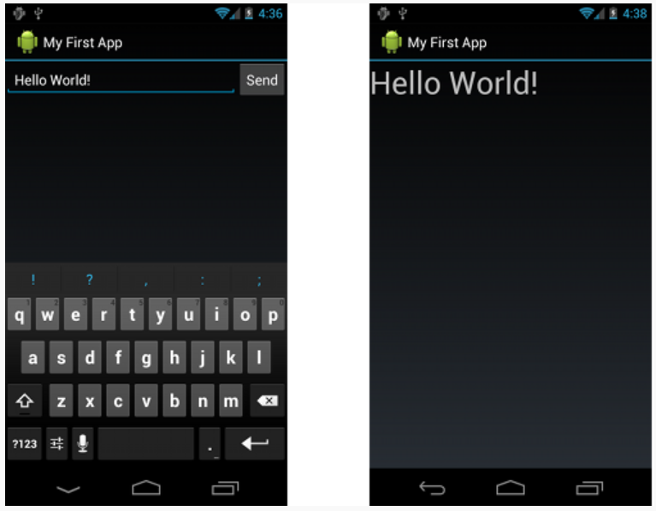

(3 marks)

**Exercise 2**

Write an Android application with two activities. The main activity will use several String variables to hold the following information:

* Your full name
* Your program name
* Your semester
* Course name

Declare the String resources in **strings.xml** file. Add a button to the main activity. Set its text property to “Display”. No need of using EditText controls in the first activity. Display the above information in a second activity whenever the user clicks on the **Display** button.

(4 marks)

**Exercise 3**

Write an Android Application that demonstrates activity life cycle. The main activity should have two button controls to start two other activities, AIActivity and VRActivity. Use a text view control to show the list of life cycle methods that take place when an activity starts. Use two other button controls in the main activity to close AIActivity and VRActivity. Use Toast class methods to display a quick message before activities are finished.

(3 marks)

**Evaluation table:**

|  |  |
| --- | --- |
| **Item** | **Percentage of total mark** |
| **Functionality**:   * Correct implementation of UI * Correct implementation of Event Handling | 80% |
| **Friendliness**:   * Alignments of UI controls * Friendly I/O | 15% |
| Comments, correct naming of variables, methods, classes, etc. | 5% |
| **Total** | 100% |

**Android Module Naming rules:**

You must name your Android Studio module according to the following rule:

**yourfullname_COMP304Labnumber_Exercisenumber**.

Example: **johnsmith_COMP304Lab1_Ex1**

**Submission rules:**

Submit your modules as **zip files** that are named according to the following rule:

**yourfullname_COMP304Labnumber_Exercisenumber.zip**

Example: **johnsmith_COMP304Lab1_Ex1.zip**

**Use 7-Zip file manager to zip your modules (https://www.7-zip.org/).**