COMP307 – Workshop #1

File Upload + CSRF attack

Name: Kevin Ma

Student #: 300867968

Date: October 17, 2018

# Download script from ecentennial

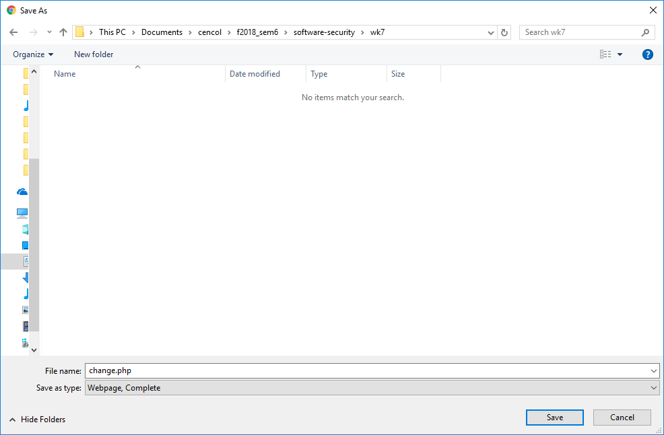

# Modify script so that the src matches host machine’s xampp configurations and correct path

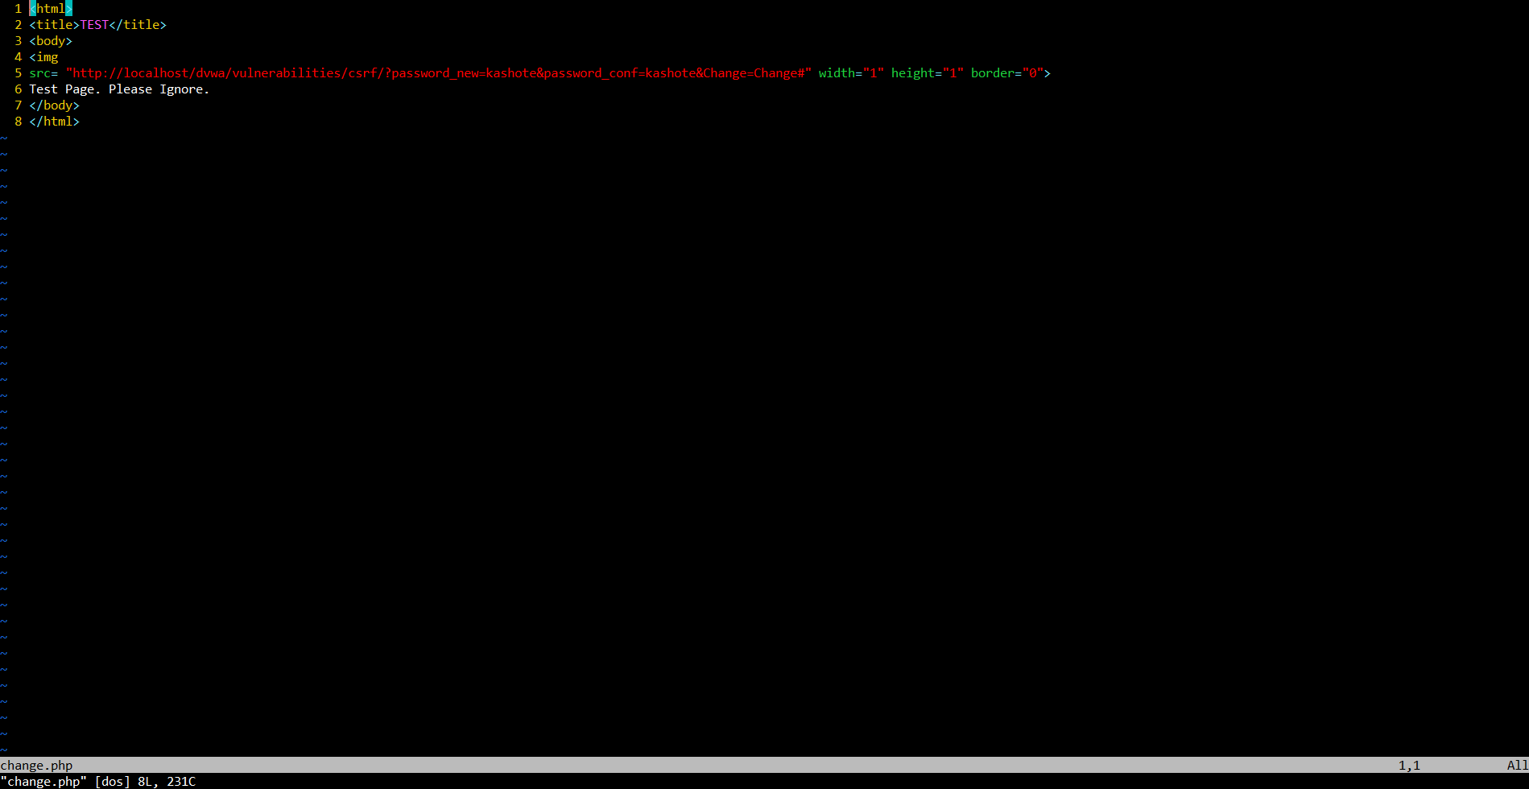

# Upload script to dvwa application

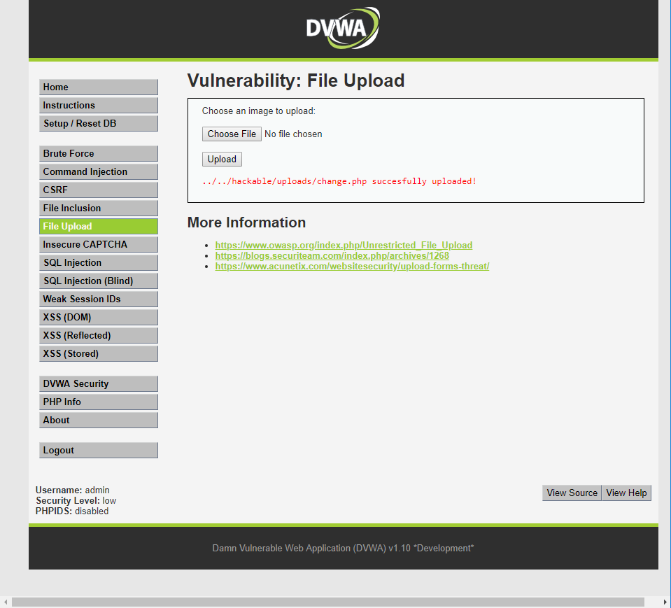

# Navigate to execute the script

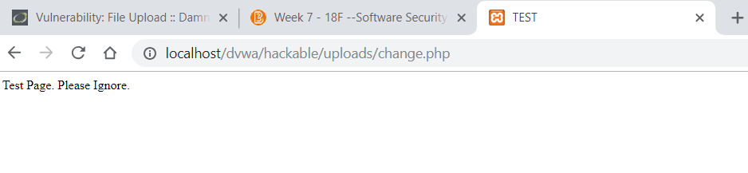

# Logout to confirm password actually got changed

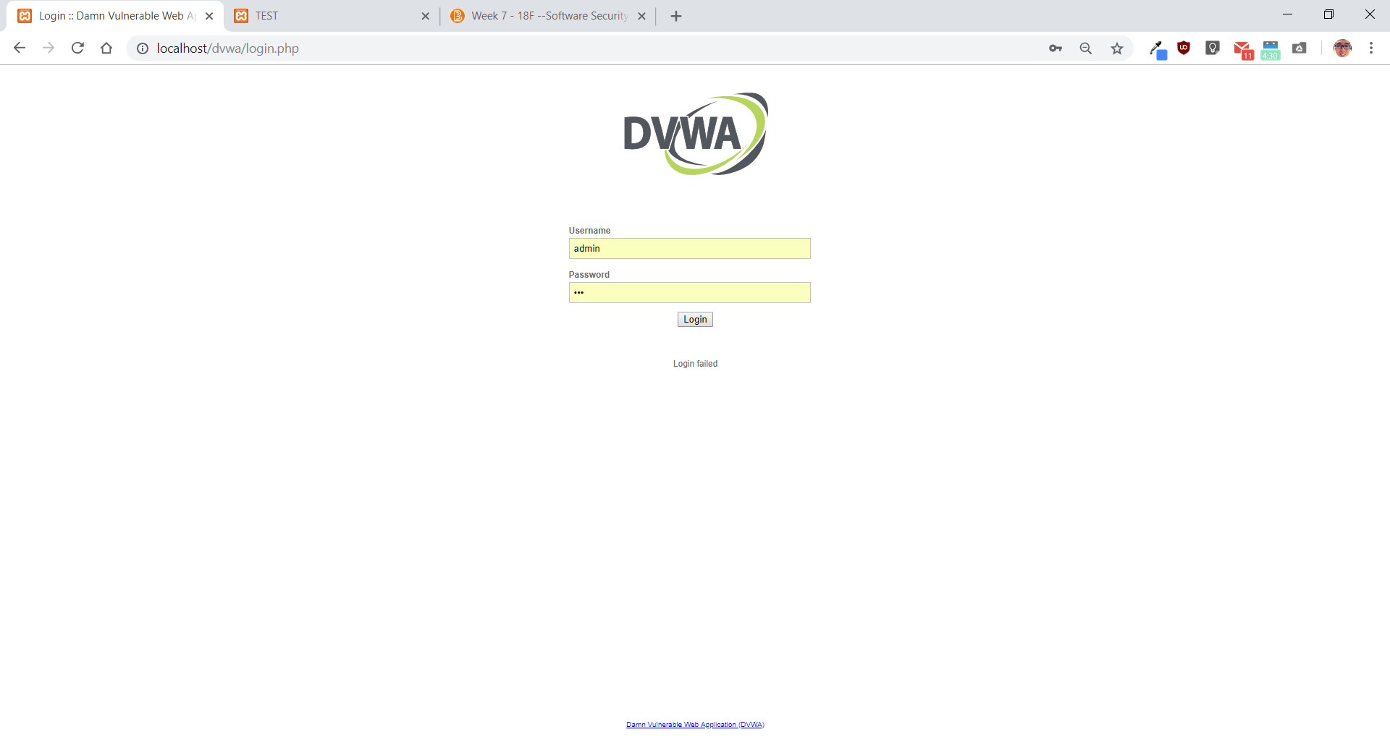

# Login using new password

