Sample - COMP 307-Workshop #1

File upload + CSRF attack –

Name: Bindu Goel-

Date :Oct 16 , 2018

Step 1: Create a file. Download the file from the ecentennial named New Text Document.txt

Step 2: Click on “ Save as” and save the contents as a .php file on the desktop.

Filename: change.php

Save as type: all files

Encoding: ANSI

Step 3: Within the DVWA application in the web browser , Click the upload menu link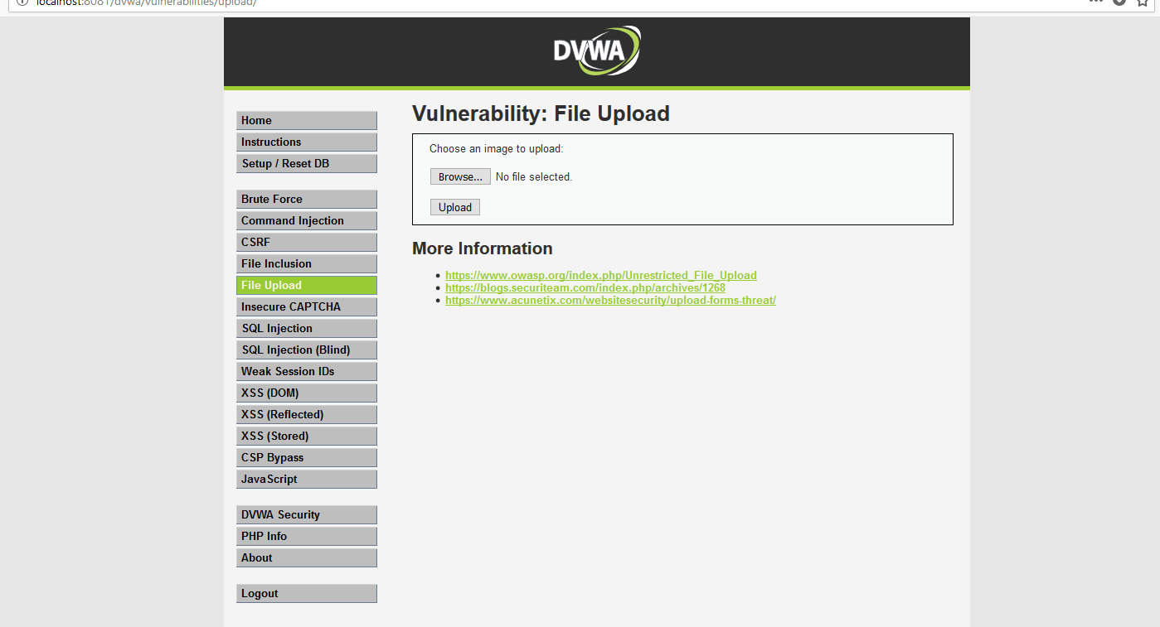

Step 4: Click the Browse button next to the image upload form field

Step 5: Navigate to the location where the change.php was just saved and select change.php and click “open”

Step 6: The file path and change.php name should appear in the image upload form field

Step 7: Upload the file. Click “upload”.

Step 8: A message should appear that says”…/

