**THE MARTIAL ARTS ACADEMY—SCHOOL MANAGEMENT SYSTEM**

**Background**

Grandmaster Taylor has practiced and taught martial arts for more than 30 years. Two months ago, he decided to sell his business, the Martial Arts Academy, and retire with his wife to Tennessee so that he could spend more time enjoying life and pursuing one of his other passions—golf. Before leaving for a warmer climate, Grandmaster Taylor sold the Martial Arts Academy to two of his black-belt instructors, Geoff and Julie.

Currently, the Martial Arts Academy has 35 students of various ranks, ranging from white belts (beginners) to advanced black belts. Each student pays to take a specific number of adult or children classes per week and then can attend any of the classes that are scheduled Monday through Saturday. Classes are led by a black-belt instructor and are 60 minutes long. Based on an individual’s progress, students can schedule a day and time to test for

their next higher rank, or belt, after filling out a testing form, paying a testing fee, and getting permission from one of the black-belt instructors. Kids’ classes are for children ages 6 to 12, while adult classes include people from all walks of life who are 13 years of age or older. The student base is primarily male with about 30 percent females.

Each student signs a contract that also includes personal information such as name, address, phone number, birth date, etc. The contract also includes a liability waiver.

This information is kept in a file folder in a filing cabinet next to the main desk near the front entrance.

As mentioned, students prepay in advance for a specific number of classes a week. Discounts are given for the number of classes a student signs up for a week and the number of months.

|  |  |  |
| --- | --- | --- |
| **Number of Classes a Week** | **Number of Months** | **Cost** |
| 1 | 3 | $120 |
| 2 | $240 |
| 3 | $360 |
| 1 | 6 | $228 |
| 2 | $432 |
| 3 | $612 |

The system is paper-based and simple. Each student has a 3 × 6-inch class card that is kept alphabetically by last name in a file box. When attending a class, students will

take their card from the file box and place it in a tray near the entrance of the dojo or workout area. After each class, one of the black-belt instructors takes all the cards from the tray and writes his or her initials in a blank space that corresponds to the date the student took a particular class. If a student completes eight classes, the instructors will circle their initials and place a paper clip on the card to indicate that the student received eight hours of instruction.

The circled initials and paper clip provide a simple way to help gauge a student’s progress. At the beginning of each class, an instructor will check the cards to determine if any students have earned a “stripe” on their belt for completing eight hours of class instruction. Students who earn a stripe are called to the front of the class where they are congratulated. The instructor places a piece of

black plastic tape around the end of the student’s belt. The number of black stripes on a belt allows the instructors to gauge a student’s progress. In addition to learning and demonstrating knowledge of specific curriculum requirements, 36 class hours (i.e., four stripes) is the minimum number of hours students are required to have before they can test for their next rank or belt. Although this system is simple and effective, it is not perfect. Once in a while an instructor may not circle his or her initials and place a paper clip on the card after a student completes eight classes. Sometimes, the paper clip falls off the card. Eventually, this is corrected by another instructor or when the student brings this to the attention of one of the higher belts.

When students are ready to test for their next rank, they fill out and submit a testing form along with a $20.00 testing fee. Then, one of the black-belt instructors reviews the form and signs it if he or she feels that the student is ready to be tested. Once approved, students are scheduled to test for their next rank or belt. The progression of belts begins with white belt progressing through orange, yellow, green, blue, purple, brown, and black ranks.

**Running the Business**

Just about everyone who enrolls at the Martial Arts Academy aspires to become a black belt. However, this

journey requires a great deal of personal commitment, dedication, and hard work. Although many black belts received their rank within four or five years, the amount of time invested is no guarantee anyone will receive this

**Name**: Kim Jones **Current Rank**: Green Belt

**Date Last Tested**: 12/01

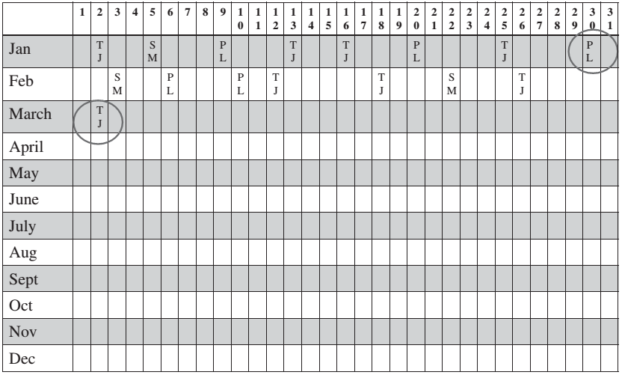

advanced rank. In fact, perhaps 1 out of 100 students who enroll at the Martial Arts Academy will eventually earn a black belt. Geoff and Julie do not want to compromise the high standards set by Grandmaster Taylor by promoting students who are not ready or who do not deserve to be promoted to the next higher rank. Many of the students and instructors who train together consider themselves to be like a second family.

Since Geoff and Julie took over the Martial Arts Academy, their number-one priority has been to stay in business by retaining their current base of students while attracting new students. However, they under- stand the reality of student turnover. They also realize that much of their competition is not from other martial arts schools, but other outside interests. For example, kids and teenagers tend to drop out because of their involvement in other sports such as soccer, baseball, or swimming. Adults and many teenagers often find difficulty maintaining a regular training schedule because of work, family, school, or other personal commitments and responsibilities. There are two other martial arts schools in the area and one martial arts club at the local university. The classes at the Martial Arts Academy are priced competitively.

The Martial Arts Academy also has a small shop where students can purchase school uniforms and shirts, sparring

gear, patches, and, with an instructor’s permission, various martial arts weapons. This retail component has been viewed more as a convenience for the students since people have a greater selection and perhaps better pricing from the larger martial arts stores or online retailers.

**The Need for a School Management System**

Geoff and Julie believe an information system offers an opportunity to help them manage the day-to-day operations more efficiently and effectively. However, their knowledge of technology is limited to using their smart- phones, surfing the Web, using email, and keeping up with friends and several of MAA students on a popular social networking site. Geoff feels that the MAA needs to hire someone to build a custom application system, but neither he nor Julie has the knowledge and skills to develop and maintain their own system. On the other hand, Julie has researched several school management software systems designed specifically for martial arts schools. Some of these software packages

can be purchased and installed on a workstation, while others are subscription-based and hosted by a third party through the Web.

Geoff and Julie are willing to spend the time, money, and resources for this project only if they believe that MAA will receive a reasonable return on this investment. Julie has mentioned that she doesn’t want to buy a computer system and pay consultants “to just auto- mate the existing file card system.” Moreover, Geoff has stated plainly that anything you recommend must pay for itself and provide tangible benefits; otherwise, he will be reluctant to change from the paper-based system.