**Lab Assignment #1**

Due Date: Week 4.

Purpose: The purpose of this assignment is to:

1. Become familiar with **Node.js** and **Express**
2. Become familiar with **MVC** application architecture
3. Develop a **Web Application using Express and MVC architecture**

References: Read the textbook, lecture slides, and class examples. This material provides the necessary information that you need to complete the exercises.

Be sure to read the following general instructions carefully:

- This assignment must be completed individually by all the students.

- You **MUST name** your Visual Studio 2017 project as Yourfullname_COMP308Lab1.

- You **MUST** demonstrate your solution in a scheduled lab session, and submit the project using the assignment link on Dropbox.

**Exercise 1**

Create an Express Web Application which allows the customers to provide feedback for services of your company. You will have to provide a login form (ejs page) to allow the customers to login, a feedback form (ejs page) to allow the customers to enter the feedback, and the Thank You form (ejs page). The login form should accept the user name (user’s email address) and password.

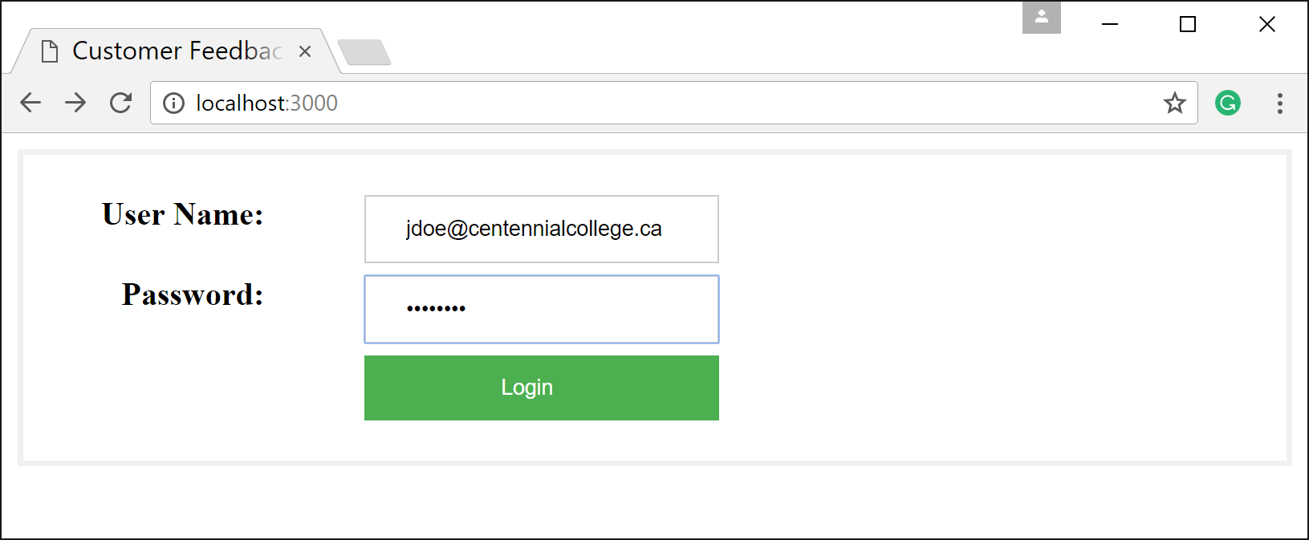

Figure 1. Login page (ejs)

The feedback form should automatically populate the *email* field with the user name value entered in login form and allow the user to enter the *first name*, *last name* and the *comments*. Provide also two other fields in this form that will be **different for each student.** For example, you may create fields for *favorite subject*, *number of languages*, *previous major*, *favorite sport*, *favorite team*, *favorite actor*, *favorite food*, *strongest technical skill*, etc. The Thank You form should simply thank the user for providing the feedback.

Implement a horizontal folder structure for your application similar to SessionTest example.

Apply MVC principles. Design nice and friendly web pages.

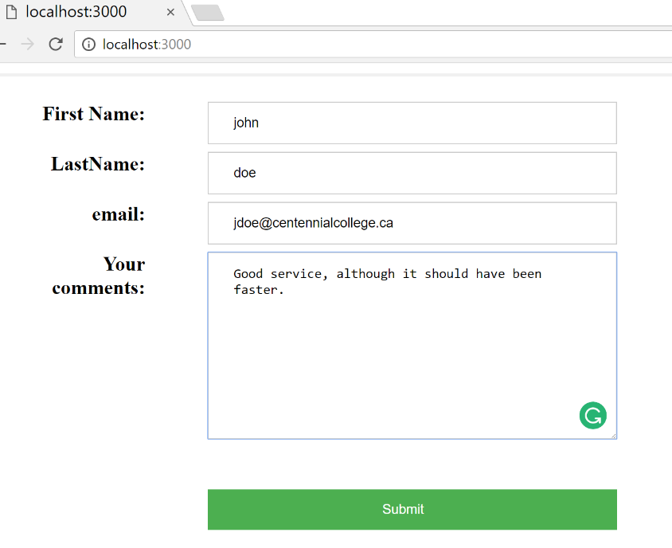

Figure 2. Customer Feedback page (ejs)

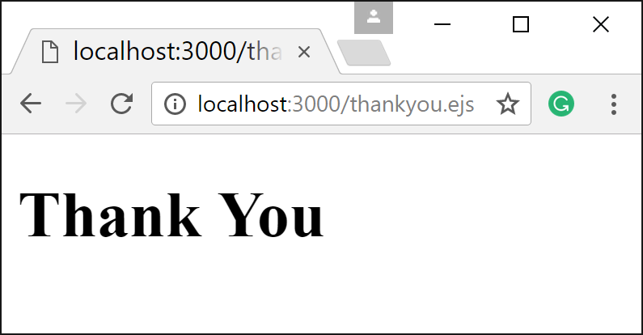

Figure 3. Thank You page (ejs)

**(10 marks)**

**Evaluation:**

|  |  |
| --- | --- |
| **Functionality:** |  |
| UI views (index.ejs, feedback.ejs, thankyou.ejs) | 25% |
| Correct routing code | 20% |
| Correct controllers code | 20% |
| Correct implementation of MVC architecture | 10% |
| Correct server.js, express.js and config files | 15% |
| **Friendliness** | 10% |
| **Total** | **100%** |

Do we need to setup dev vs production environments??