**CASE STUDY TERM PROJECT**

**KLM AIRLINES**

System Integration (COMP 321 - Sec.004)

PART -B

Prof. Mohamed Khan

Prof. Peter Bhola

**Anjith Babu - 300799928**

**Chemcee Cherian - 300793352**

**Eunmi Han- 300790610**

**KwangSik Kim - 300818301**

**Table of Contents**

INTRODUCTION 3

Background 3

Salesforce Introduction 4

KLM CRM Solution -Salesforce 6

Workflows and Use Cases 7

Handling Feedback and Cases – Service module 7

Use Case Diagram 7

Use Case Description 8

Flow chart for the use case 10

Managing Opportunities and Cases – Sales module 17

Use Case Diagram 17

Use Case Description 17

Flow chart for the use case 20

Creating a Campaign – Service module 22

Use Case Diagram 22

Use Case Description 23

Flow chart for the use case 26

Creating Orders 31

Use Case Diagram 31

Use Case Description 31

Flow chart for the use case 33

References 37

# INTRODUCTION

## Background

KLM Royal Dutch Airlines (now merged with Air France) is an international airline that operates worldwide. KLM was founded in 1919 and it is the oldest airline in the world. The airlines operates scheduled passenger and cargo services to approximately 130 destinations worldwide. It has a reputation of being one of the safest airlines in the world. At the beginning of KLM, it had four core activities such as passenger transport, cargo transport, engineering and maintenance, and charter/low cost flights, and since its first flight took place successfully in 1920, KLM had been expending business.

Since May 2004, Air France and KLM Royal Dutch Airlines merged together and became the largest airline group in Europe. Both airlines retained its individual identity, brand and trade name. Together they carry more than 77 million passengers every year. Air France and KLM are part of the SkyTeam airline alliance. They offer a frequent flyer program called Flying Blue.

KLM came to the realization that it could differentiate from other airline companies by providing superior custom service experience at every interaction point with its customers. They found every interaction to be an opportunity to bond with the customers or prospects. The main aim was to infuse CRM as a business opportunity with extensive investment into the Information and Communication Technology, and make the customer relationship as intimate as possible.

A first major CRM project was set up in 1997. They hired several consultants and started an extensive study on what opportunities CRM could offer KLM and the ICT capabilities required to make it happen. The primary objectives of the CRM implementation were:

* Implementing better customer identification and recognition capabilities.
* Improvement of data gathering, integration and use.
* Creating new strategic and well architected ICT

KLM hoped to deal with all the customer interactions more systematically based on the customer intelligence available. Unfortunately, at the time, this was too much data for the organization to digest and the ICT-driven CRM project did not take off. One of the reasons were high forecasted technology costs and the lack of support for the initiative on the business side.

In 2002 Paul Gregorowitsch was appointed as the Executive VP Commercial of KLM and brought back CRM back into the company. He envisioned three building blocks for KLM namely, 1. Customer, 2.CRM and 3. e-Business. The mission of the new Customer Relationship Management team was “to make every customer interaction an opportunity to enhance the customer’s buying and travelling experience, and to increase and sustain profitability”. The overall objectives were

* Differentiate services to customers in efficient and cost effective way.
* Make KLM a truly customer centric organization.
* Turn around the negative trend in the declining yields.

The project was name CIAO (Customer Insight, Analysis and Opportunities). This project would introduce CRM into the marketing communication to allow the company to deliver the right offer to the right customer at the right time via the right channel. They achieved all the objectives via :

* Identification of customer value segments.
* Better understanding of customer needs and preferences.
* Monitoring of customer responses.
* Applying experiences to future campaigns.
* Better steering of customer buying and travelling behavior.
* Creation of target marketing and sales campaigns for specific customer segments.

The success of CIAO project was important for generating the momentum necessary for further deployment of CRM in KLM. Gradually the CRM project would move beyond Marketing and the Commercial Division into other parts of the organization.Fig 1 shows KLM architecture of passenger business where CRM adoption began. The vision and mission statement of CRM were translated into the following goals

* More personalized and consistent service delivery across all interaction points.
* More customer profitability based steering.
* More customer-centric organization.

Each goal was further translated into sub-goals used to actually drive the different CRM projects that would constitute the program.

As a result of all these, in 2004 KLM won the Gartner CRM excellence award.

## Salesforce Introduction

Salesforce is a cloud based CRM solution. Salesforce consists of three main modules Sales Cloud, Service Cloud and Marketing Cloud (Social CRM).

**Sales Cloud**:-

* It stores customer data including activity history, key contacts, customer communications, and internal account discussions.
* Details of all the deals with customers— stage, products and competition.
* Understand how prospects are engaging and use real time sale alerts to manage sales.
* Automates the sales performance, marketing and sales data for KLM.

**Service Cloud:**-

* Provide facilities for customers to do live chat with a service agent.
* Provide customer service team the tools to manage cases via social media channels.
* Provide options to share videos, screen sharing and on-screen guided assistance.

**Sales Cloud**:-

* Creates personalized customer-focused experiences at scale.
* Provide email marketing.
* Collaborates across teams with approval workflow processes.
* Track when a customer opens KLM app, how much time they spend interacting, and details about their location.
* Track and send mobile messages.
* Social media marketing - listen and analyse the social messages and profiles of the customers.

Salesforce implementation helped KLM to achieve following things:-

* Opportunities to build more meaningful and lasting relationships with customers
* Logging, managing, analysing all customer activity through a web-based Salesforce software.
* Connections with customers across sales, customer service, marketing, communities, analytics, apps and more using its Customer Success Platform.

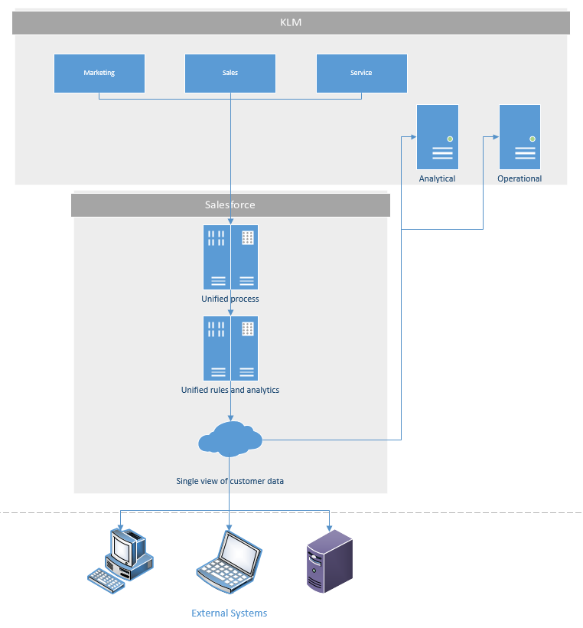

[KLM] CRM architecture

## KLM CRM Solution -Salesforce

Salesforce is a cloud based CRM solution. Salesforce consists of three main modules Sales Cloud, Service Cloud and Marketing Cloud (Social CRM).

**Handling feedback and cases-Service Cloud and Social CRM:**

* Provide facilities for customers to do live chat with a service agent.
* Provide customer service team the tools to manage cases via social media channels.
* Provide options to share videos, screen sharing and on-screen guided assistance.

We chose the feedback and handling section of service cloud to demonstrate the working the service cloud

**Managing opportunities and cases-Sales Cloud:**

* Provide facilities for KLM manager to create new opportunities based on new business and existing business.
* Provide shareable functionalities to business users and sponsors to collaborate and cooperate with each other.
* Provide various type of notification to schedule or log events related the opportunity.
* Provide reports to monitor status of the opportunity.

We chose the managing opportunities and collaborating section of sales cloud to demonstrate the working of the sales cloud

**Managing Campaigns – Social CRM**

* Helps in adding news campaign and coordinate all activities

**Managing Orders – Service Cloud**

* Helps in managing orders and sales of the company

# Workflows and Use Cases

## Handling Feedback and Cases – Service module

### Use Case Diagram

E:\Linux\Centennial -USB\#WINTER-SEM-5\System Integration\Final Project\PART B\usecaseV3.png

### Use Case Description

|  |  |  |  |  |  |
| --- | --- | --- | --- | --- | --- |
| **No.** | **Actor** | **Goal Use Case** | **<Include>** | **Priority** | **Brief Description** |
| UC01 | Customer | Post feedback or complaint | * View complaint or feedback | High | Customer post feedback or complaint in the website or in the social media |
| UC02 | Developer | View open or assigned cases | * Open a new case | High | Developer view opened cases to work on it. |
| UC03 | KLM Staff | View Complaints or feedback | * Open a new case * Create report * Post reply to feedback | High | KLM staff uses view complaints or feedback to see list of feedbacks from clients and then use this to open new cases. |

|  |  |
| --- | --- |
| **Use case name** | Post feedback or complaint |
| **Use case ID** | UC01 |
| **Super use case** | - |
| **Actor(s)** | Customer |
| **Brief description** | Customer uses the social media or the KLM website to post feedback regarding the experience with KLM |
| **Preconditions** | 1. Customer login to website or social media 2. Customer goes to KLM portal |
| **Post-conditions** | 1. KLM Staff view the feedback |
| **Flow of events** | 1. Customer post feedback on the website 2. KLM staff view the feedback or complaint then open a case if it is an issue otherwise post a feedback to the client. |
| **Alternative flows and exceptions** | KLM follows up on customer response directly |
| **Priority** | High |
| **Non-behavioural requirements** | Internet connection, no response from customer |
| **Assumptions** | KLM will be able to increase customer interest by offering proper following-ups. |
| **Issues** | None |
| **Source** | None |

|  |  |
| --- | --- |
| **Use case name** | View open or assigned cases |
| **Use case ID** | UC02 |
| **Super use case** | - |
| **Actor(s)** | Developer |
| **Brief description** | Developer has access to view issues that are opened to him. He or She then has to work on this use cases to solve it. |
| **Preconditions** | 1. KLM staff creates new cases |
| **Post-conditions** | 2. Developer change the status of the opened case as closed or fixed. |
| **Flow of events** | * + - 1. KLM staff view the feedback from client   2. KLM staff open a new case for the developer to check   1. Developer view his opened cases 2. Developer changes the status of the opened case as closed or open. |
| **Alternative flows and exceptions** | KLM staff follow up with developer |
| **Priority** | High |
| **Non-behavioural requirements** | Internet connection, no response from the developer, developer takes more time to fix the issue |
| **Assumptions** | KLM will be able to increase customer interest by offering proper following-ups. |
| **Issues** | None |
| **Source** | None |

### Flow chart for the use case

E:\Linux\Centennial -USB\#WINTER-SEM-5\System Integration\Final Project\PART B\flow chart-casesV2.png

**Fig 1**

[The letters in the diagram indicate the picture of salesforce section it belongs to]

**A**

Client post feedback on the web.

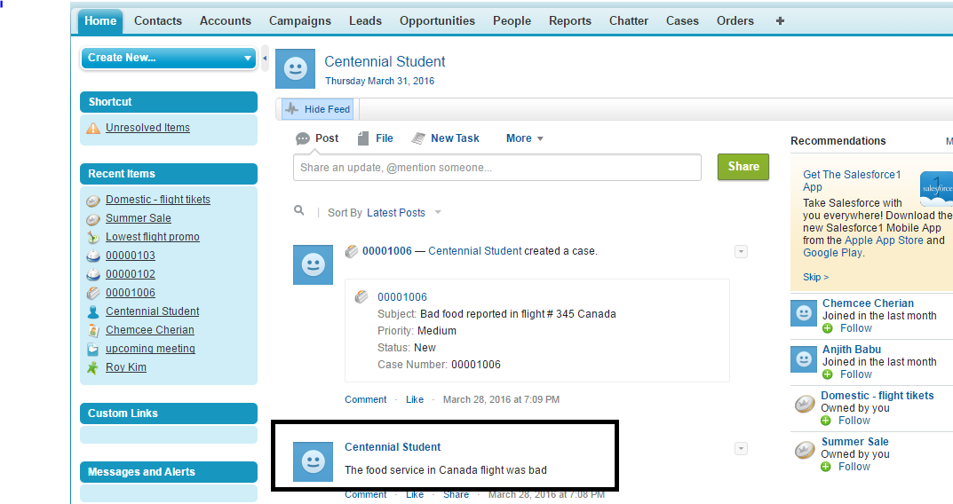

**B**

KLM customer care staff responds to the feed with a reply. All feeds are monitored by the staff.

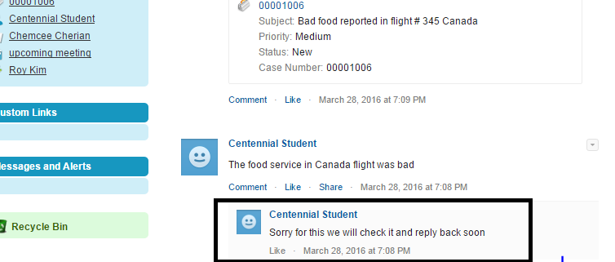

**C**

KLM staff then creates a case regarding the issue.

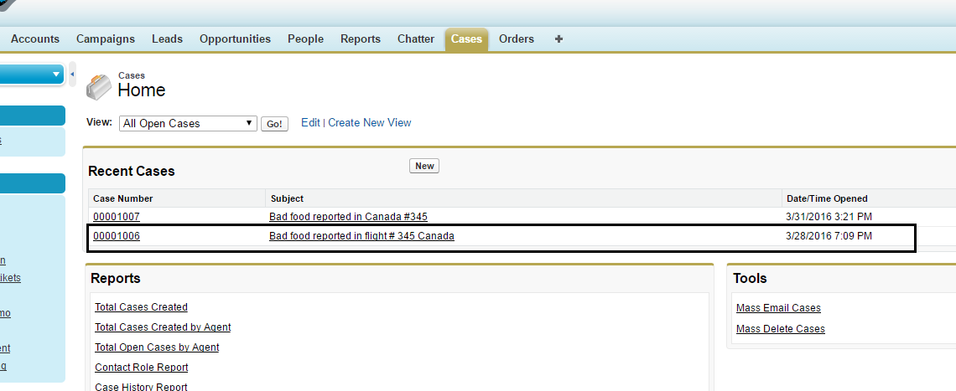

**D**

The issue is assigned to a contact person, who can see all the cases assigned to him. Here the contact person is the developer to which the case is assigned.

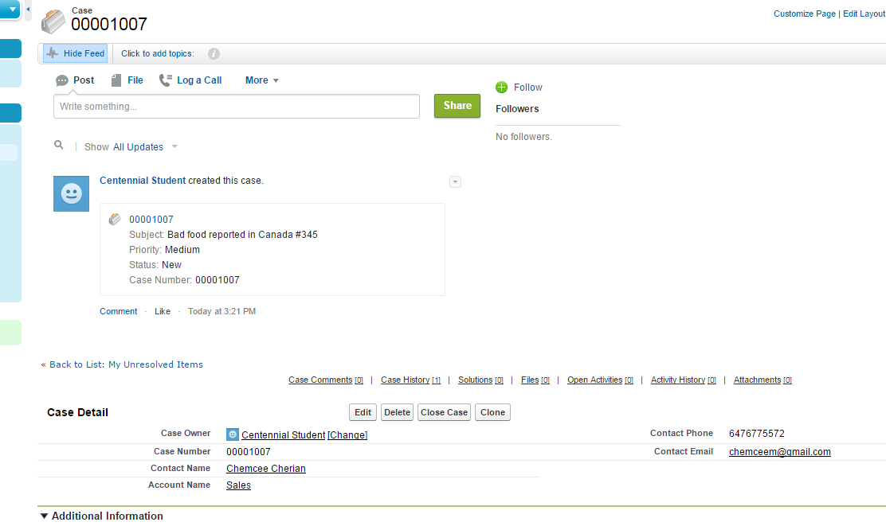

**E**

Finally when the contact person is done fixing the issue, it is reported back to the staff who created the case. The KLM staff then creates a report and dashboard regarding the issue.

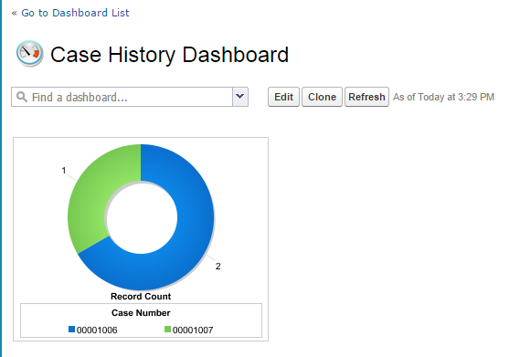

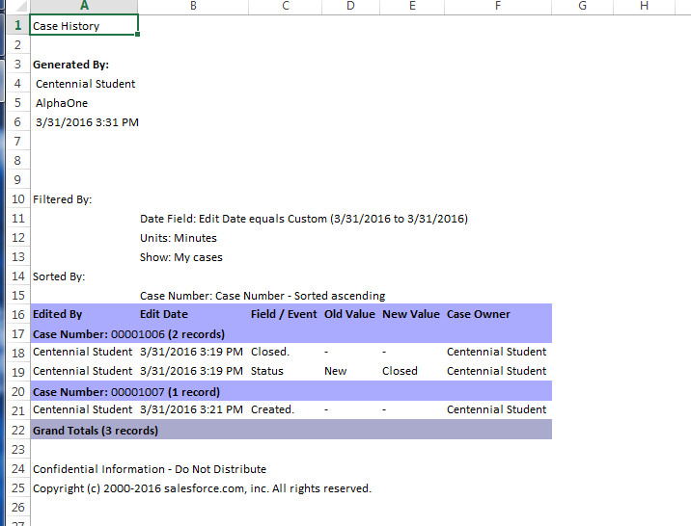

**F**

Finally after creating the report and analysing it with the lead of the team. The staff will close the case and post reply to the client feed.

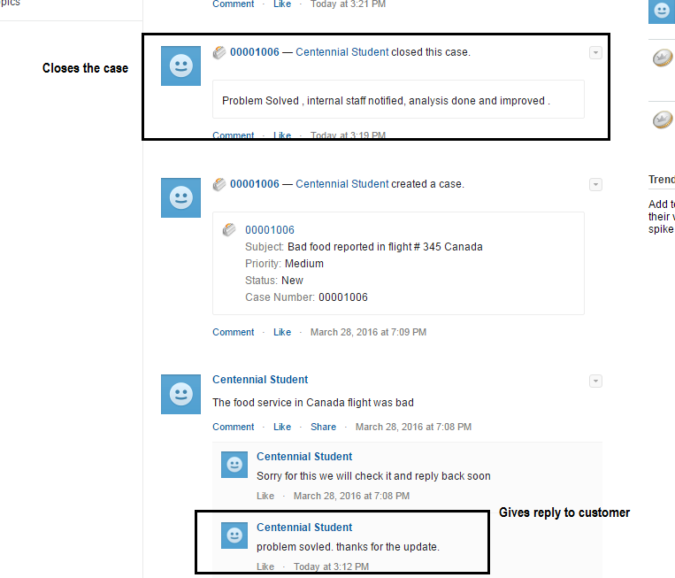

## Managing Opportunities and Cases – Sales module

### Use Case Diagram

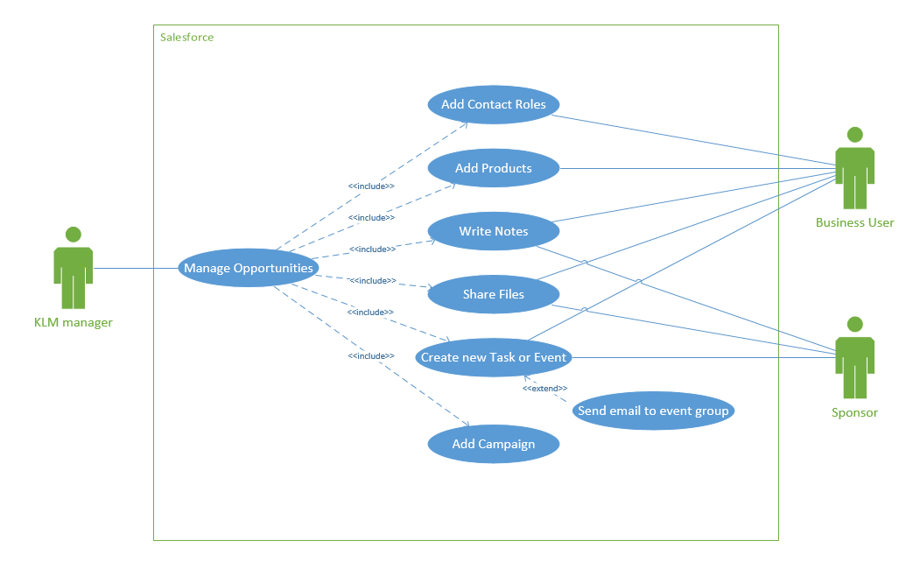

### Use Case Description

|  |  |  |  |  |  |
| --- | --- | --- | --- | --- | --- |
| **No.** | **Actor** | **Goal Use Case** | **<Include>** | **Priority** | **Brief Description** |
| UC04 | KLM manager | Manage Opportunities | * Add Contact Roles * Add Products * Write Notes * Share Files * Create new Task or Event * Add Campaign | High | KLM manager create or update or delete opportunities. |
| UC05 | Business User,  Sponsor | Create new Task or Event |  | High | Business User and Sponsor create a new task or event related to the opportunity to collaborate with each other |

|  |  |
| --- | --- |
| **Use case name** | Manage Opportunities |
| **Use case ID** | UC04 |
| **Super use case** | - |
| **Actor(s)** | KLM manager |
| **Brief description** | KLM manager create or update or delete opportunities. |
| **Preconditions** | 1. KLM manager login to salesforce |
| **Post-conditions** | 1. Status of the opportunities are changed depending on KLM manager’s action |
| **Flow of events** | 1. KLM manager login to salesforce 2. Create or Update or Delete opportunities as the KLM manager decided after discussion in team meeting. |
| **Alternative flows and exceptions** | Decision is made not to change anything on the opportunity. |
| **Priority** | High |
| **Non-behavioural requirements** | Internet connection |
| **Assumptions** | KLM manager will be able to manage an opportunity to lead a business to success. |
| **Issues** | None |
| **Source** | None |

|  |  |
| --- | --- |
| **Use case name** | Create new Task or Event |
| **Use case ID** | UC05 |
| **Super use case** | - |
| **Actor(s)** | Business User, Sponsor |
| **Brief description** | Business User and Sponsor of KLM create a new task or event related to the opportunity to collaborate with each other. |
| **Preconditions** | 1. Business User Sponsor login to salesforce |
| **Post-conditions** | 2. A new task or event is created for all team members |
| **Flow of events** | * + - 1. Business User or Sponsor login to salesforce       2. Business User or Sponsor create a task or event       3. All team members including manager, business user and sponsor check the new task and then, work on it accordingly. |
| **Alternative flows and exceptions** | Business User or Sponsor contact and work directly without logging on salesforce |
| **Priority** | High |
| **Non-behavioural requirements** | Internet connection, no task and event made from business user and sponsor |
| **Assumptions** | All team members of KLM will be able to collaborate by using the shared takes and events. |
| **Issues** | None |
| **Source** | None |

### Flow chart for the use case

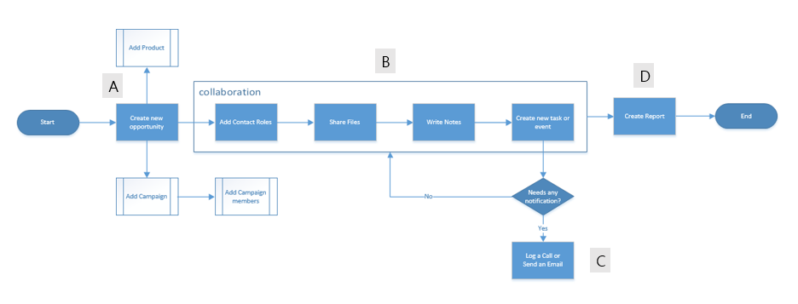

**Fig 1**

[The letters in the diagram indicate the picture of salesforce section it belongs to]

**A**

KLM manager creates an opportunity.

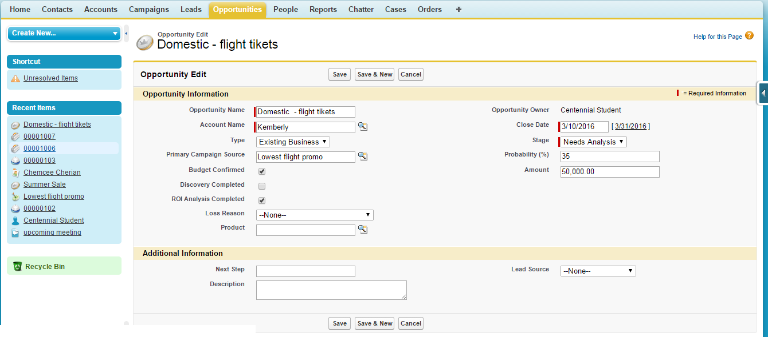

**B**

KLM members collaborate to achieve a goal of the opportunity by communicating and sharing information.

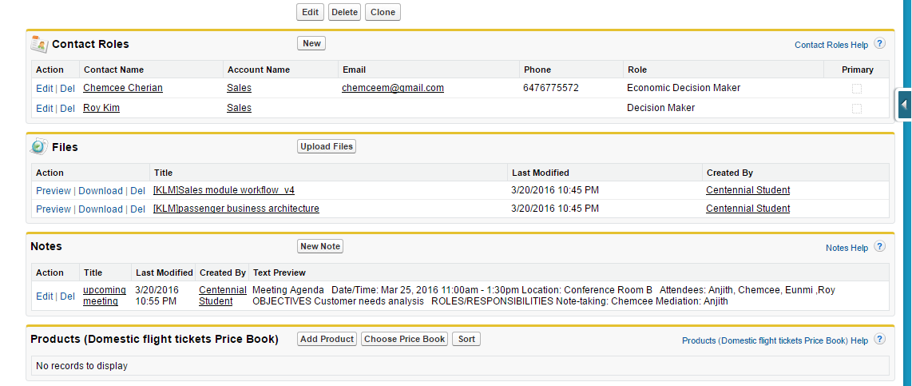

**C**

Send an email to group members or log a call if needed.

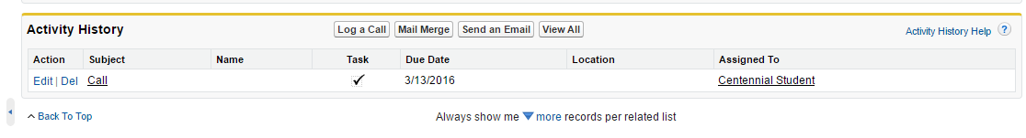

**D**

Finally, if KML staff wants to analyse opportunities regarding opportunities pipeline or status of opportunities, the KLM staff then can create a report and dashboard.

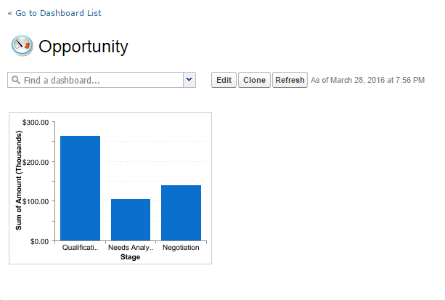

## Creating a Campaign – Service module

### Use Case Diagram

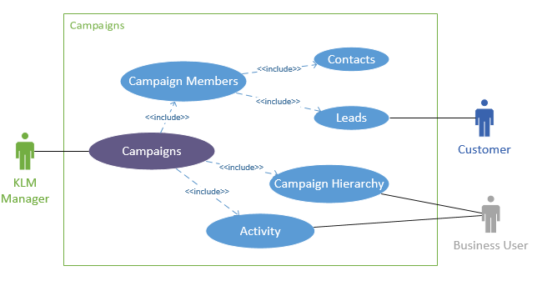

### Use Case Description

|  |  |  |  |  |  |
| --- | --- | --- | --- | --- | --- |
| **No.** | **Actor** | **Goal Use Case** | **<Include>** | **Priority** | **Brief Description** |
| UC06 | KLM manger | Create a campaign | * Add Campaign * Add members to campaign | High | KLM manager create or update or delete campaign. |
| UC07 | Business User | Create new Activity and involve in campaign |  | High | Business User create a new activity about campaign and be involved in campaign to collaborate with each other |
| UC08 | Customer | Customer is participated in campaign |  | High |  |

|  |  |
| --- | --- |
| **Use case name** | Create a campaign |
| **Use case ID** | UC06 |
| **Super use case** | - |
| **Actor(s)** | KLM manager |
| **Brief description** | KLM manager create or update or delete campaign. |
| **Preconditions** | 1. KLM manager login to salesforce |
| **Post-conditions** | 1. Campaign should be posted through team meeting. |
| **Flow of events** | 1. KLM manager login to salesforce 2. Create or Update or Delete campaign as the KLM manager decided after discussion in team meeting. |
| **Alternative flows and exceptions** | Decision is made not to change anything on the campaign. |
| **Priority** | High |
| **Non-behavioural requirements** | Internet connection |
| **Assumptions** | KLM manager will be able to manage an campaign to lead a business to success. |
| **Issues** | None |
| **Source** | None |

|  |  |
| --- | --- |
| **Use case name** | Create new Activity and involve in campaign. |
| **Use case ID** | UC07 |
| **Super use case** | - |
| **Actor(s)** | Business User |
| **Brief description** | Business User of KLM is related to the campaign to collaborate with each other. |
| **Preconditions** | 1. Business User login to salesforce |
| **Post-conditions** | 1. A new campaign is created for all team members |
| **Flow of events** | 1. Business User login to salesforce 2. Business user choose the campaign that created and involve that campaign 3. All team members including manager, business user check the new task and then, work on it accordingly. |
| **Alternative flows and exceptions** | Business User contact and work directly without logging on salesforce |
| **Priority** | High |
| **Non-behavioural requirements** | Internet connection, no task and event made from business user |
| **Assumptions** | All team members of KLM will be able to collaborate by using the shared takes and events. |
| **Issues** | None |
| **Source** | None |

|  |  |
| --- | --- |
| **Use case name** | Customer is participated in campaign. |
| **Use case ID** | UC08 |
| **Super use case** | - |
| **Actor(s)** | Customer |
| **Brief description** | Customer gets campaigns and participate campaign, |
| **Preconditions** | 1. Customer login to their social network |
| **Post-conditions** | 1. Customer gets all campaigns |
| **Flow of events** | 1. Customer login to their social network 2. Customer gets campaigns from KLM 3. Customer choose campaigns and participate |
| **Alternative flows and exceptions** | Customer gets campaigns without logging on their social network |
| **Priority** | High |
| **Non-behavioural requirements** | Internet connection, no task and event made from business user and sponsor |
| **Assumptions** | Customer gets good offer from KML |
| **Issues** | None |
| **Source** | None |

### Flow chart for the use case

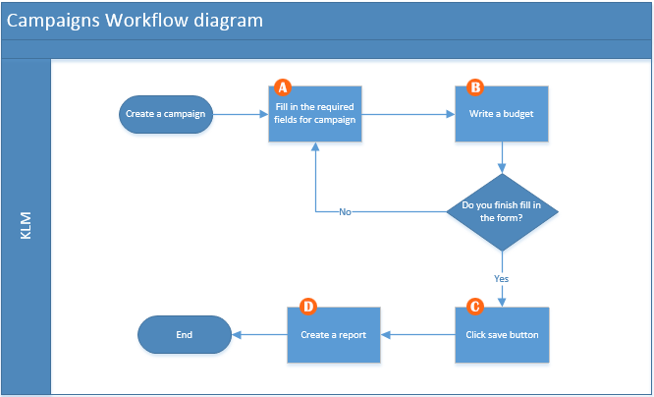

**A**

KLM manager creates a campaign.

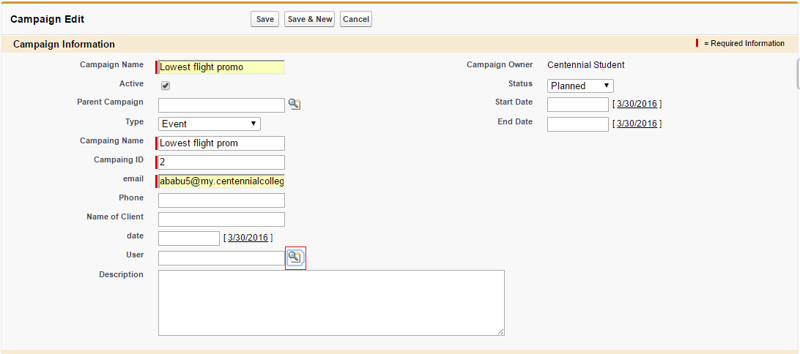

**B**

Manager fill in the budget part.

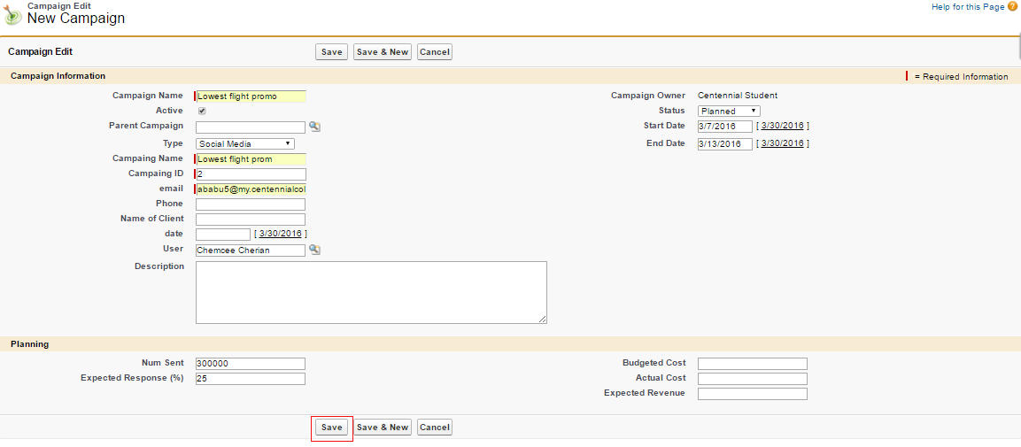

**C**

Click save button for the creating campaign and see the campaign that you made

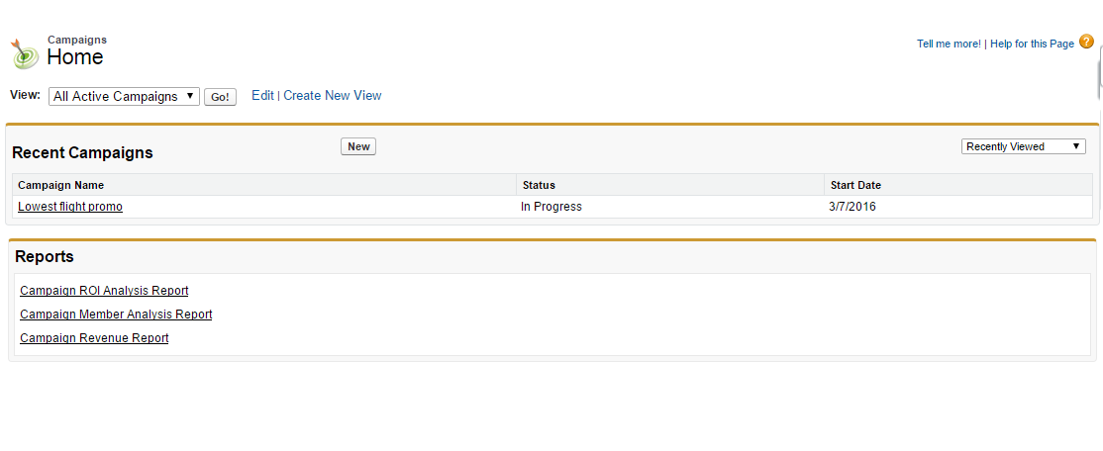

**D**

Finally, if KML staff wants to analyse report regarding campaign, the KLM staff then can create a report and dashboard.

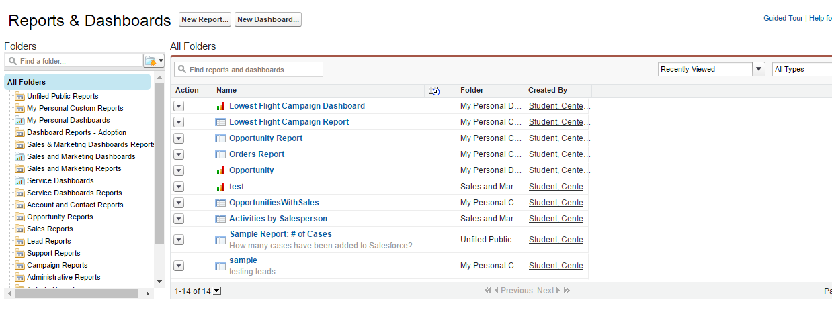

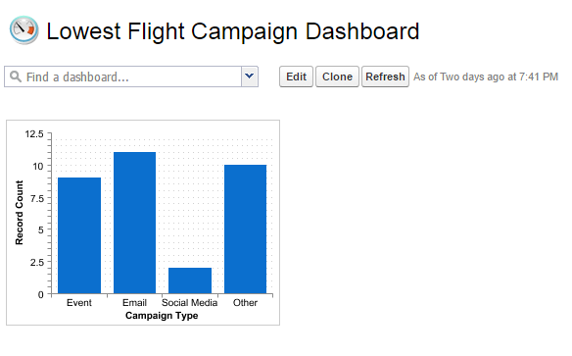

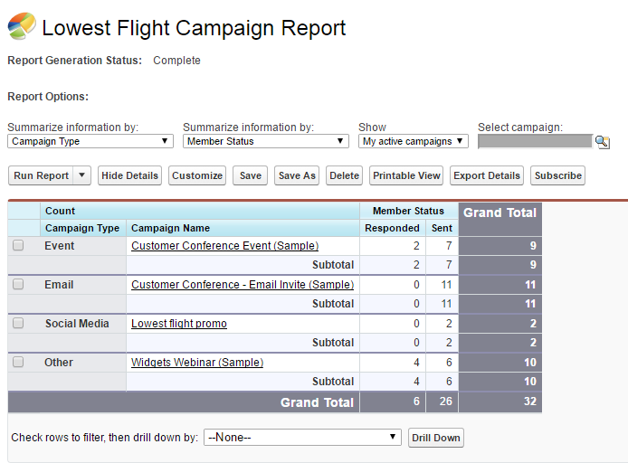

# Creating Orders

### Use Case Diagram

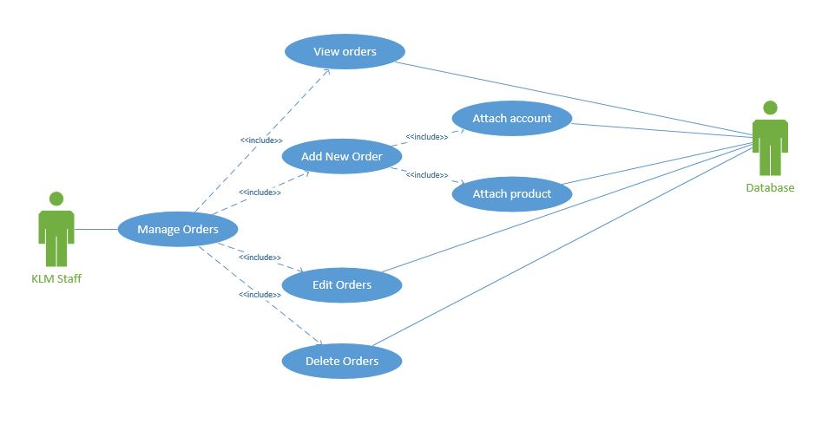

### Use Case Description

|  |  |  |  |  |  |
| --- | --- | --- | --- | --- | --- |
| **No.** | **Actor** | **Goal Use Case** | **<Include>** | **Priority** | **Brief Description** |
| UC09 | KLM Staff | Manage Orders | * Add New Order * View Orders * Edit Ordrs * Delete Orders | High | KLM staff creates or edits or deletes or view the orders |

|  |  |
| --- | --- |
| **Use case name** | Manage Orders |
| **Use case ID** | UC09 |
| **Super use case** | - |
| **Actor(s)** | KLM Staff |
| **Brief description** | KLM staff creates or edits or deletes or view the orders. |
| **Preconditions** | KLM Staff login to salesforce  KLM staff has the authorization to view and edit orders |
| **Post-conditions** | Orders are changed or new orders are added or orders are deleted depending on KLM staff’s action |
| **Flow of events** | 1. KLM staff login to salesforce 2. Create or Update or Delete orders according to KLM staff’s decision. 3. All the changes are updated to the database |
| **Alternative flows and exceptions** | Decision is made not to change anything on the order. |
| **Priority** | High |
| **Non-behavioural requirements** | Internet connection |
| **Assumptions** | KLM staff will be able to manage an order to lead a business to success. |
| **Issues** | None |
| **Source** | None |

### Flow chart for the use case

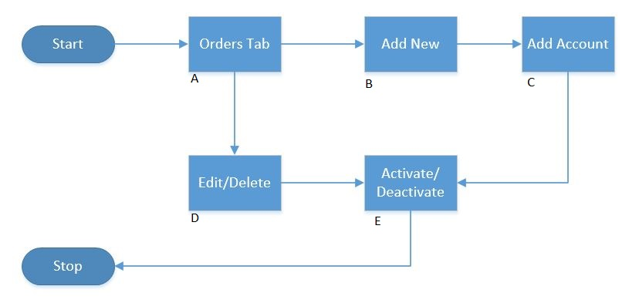

**Fig 1**

[The letters in the diagram indicate the picture of salesforce section it belongs to]

**A**

KLM Staff Enters the orders page

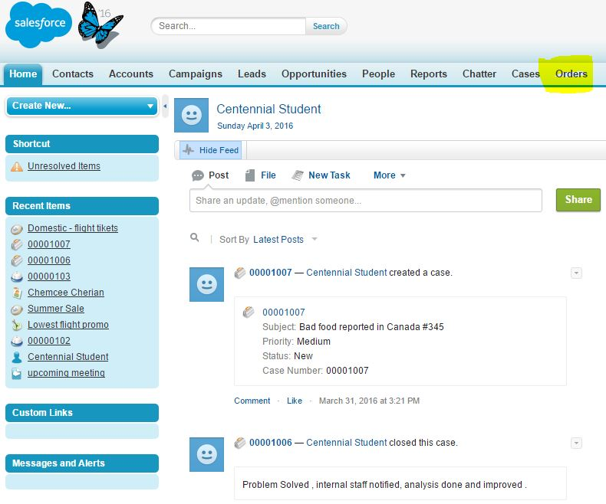

**B**

KLM Staff creates a new order.

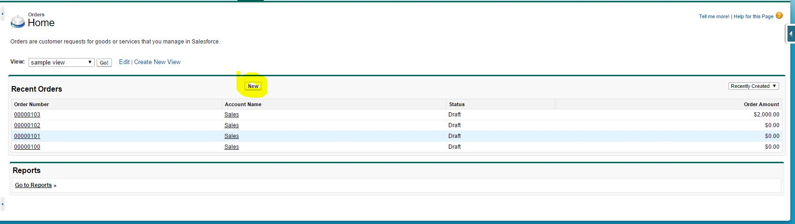

**C**

KLM staff adds an account to the order

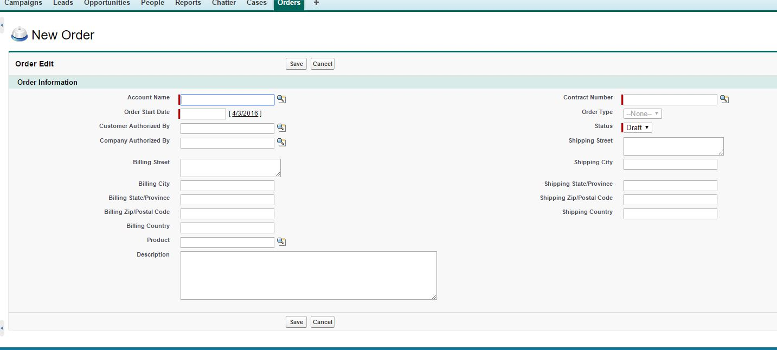

**D**

KLM staff edits or deletes the order

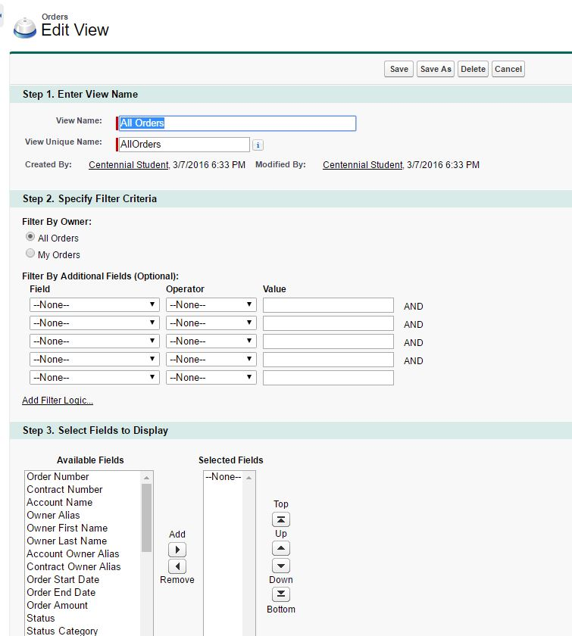

**D**

KLM staff saves the order

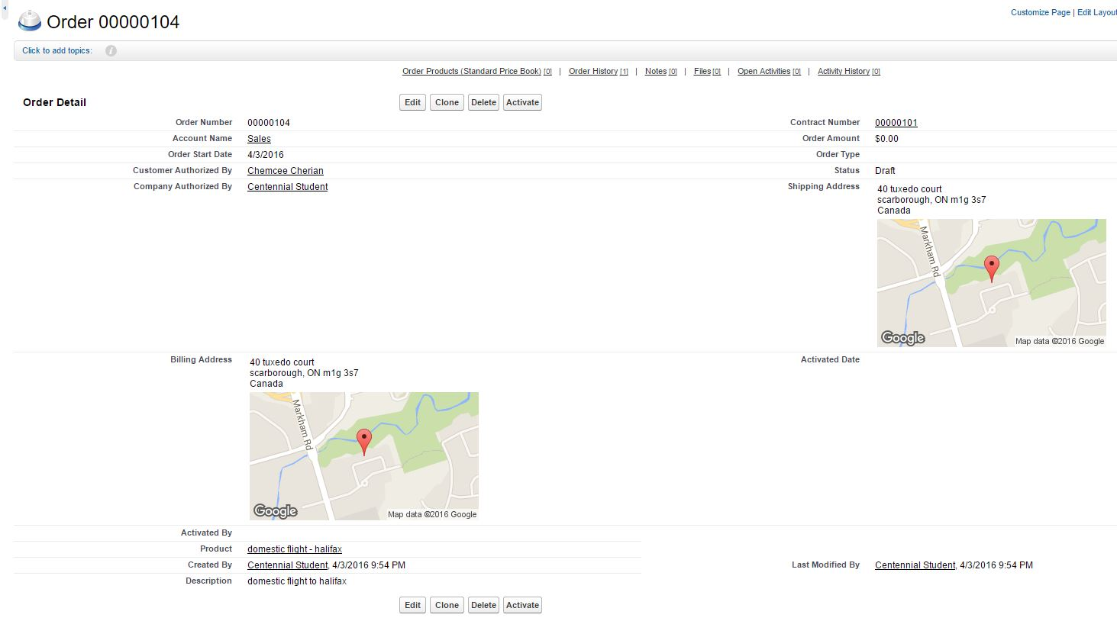

# 

# References

Stijn Viaene., Bjorn Cumps . (2005). CRM EXCELLENCE AT KLM ROYAL DUTCH AIRLINES:

Retrieved 23 Jan, 2016, from <http://mis.ucd.ie/courses/KLMCRMcase.pdf>

Mark Riseley. (2004). KLM Demonstrates the Power of Persuasion to Drive CRM Success:

Retrieved 25 Jan, 2016, from <http://www.gartner.com/2_events/crmawards/2004/docs/KLM.pdf>

Nuria Rojas. CRM Software Review Salesforce.com:

Retrieved 22 Feb, 2016, from <http://www.crmsoftware360.com/salesforce-review.htm>