Test 1 – COMP392-002 – Mar. 8th

Kevin Ma

# Created squash court with ceiling, three walls and a floor + Camera peeking inside the “squash” court

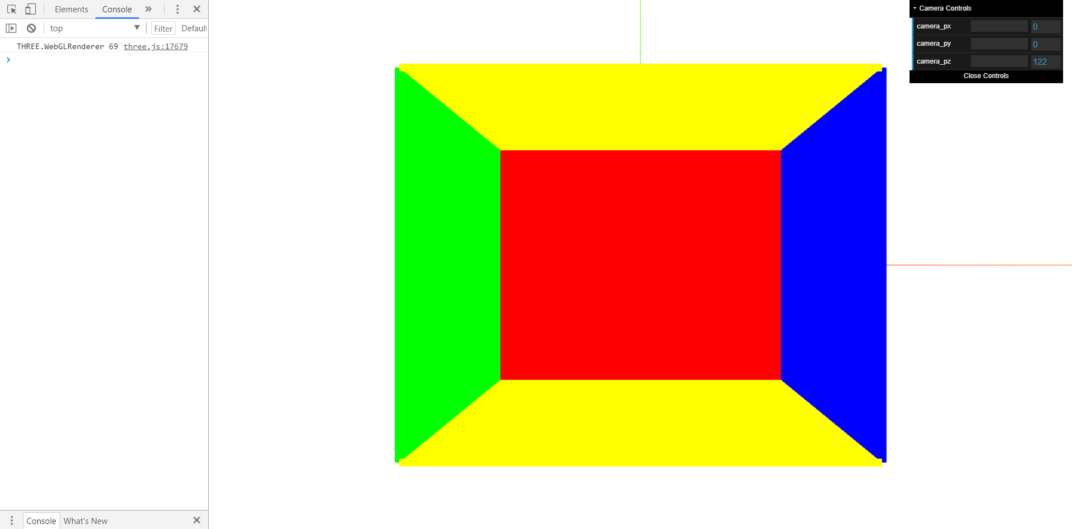

# Added point lights, spheres, ambient lights and dat.GUI controls

