Class Work – COMP 392 – 002 – Jan. 25th

Kevin Ma

Table of Contents

Download and extract to desktop the code: 1

Download the code from Jos Dirksen’s Github Repository 1

Serving the files using Python 2

Download Python 2

Serving the files using NodeJS 3

# Download and extract to desktop the code:

## Download the code from Jos Dirksen’s GitHub Repository

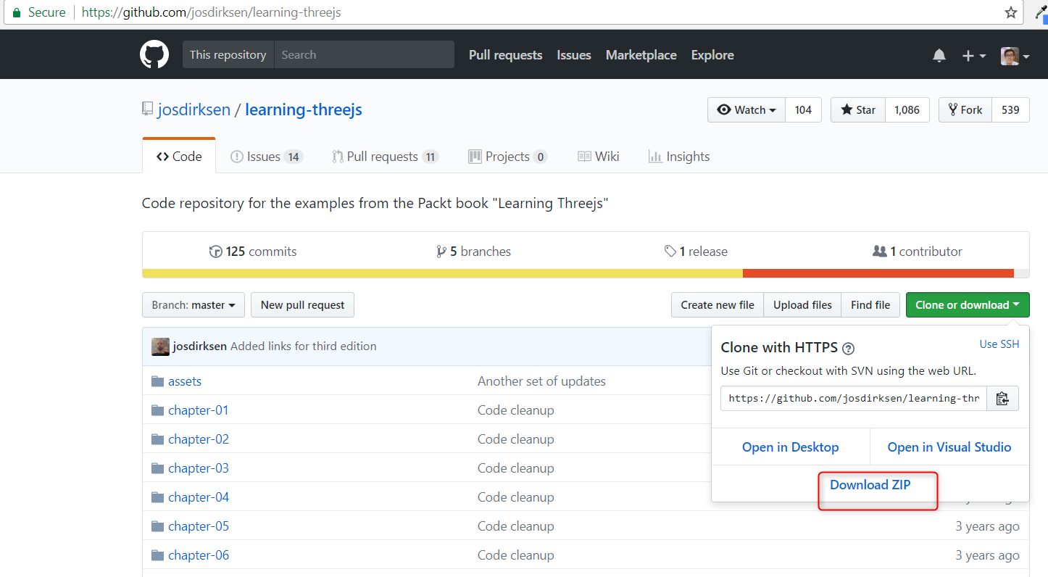

## Extract the code to the desktop

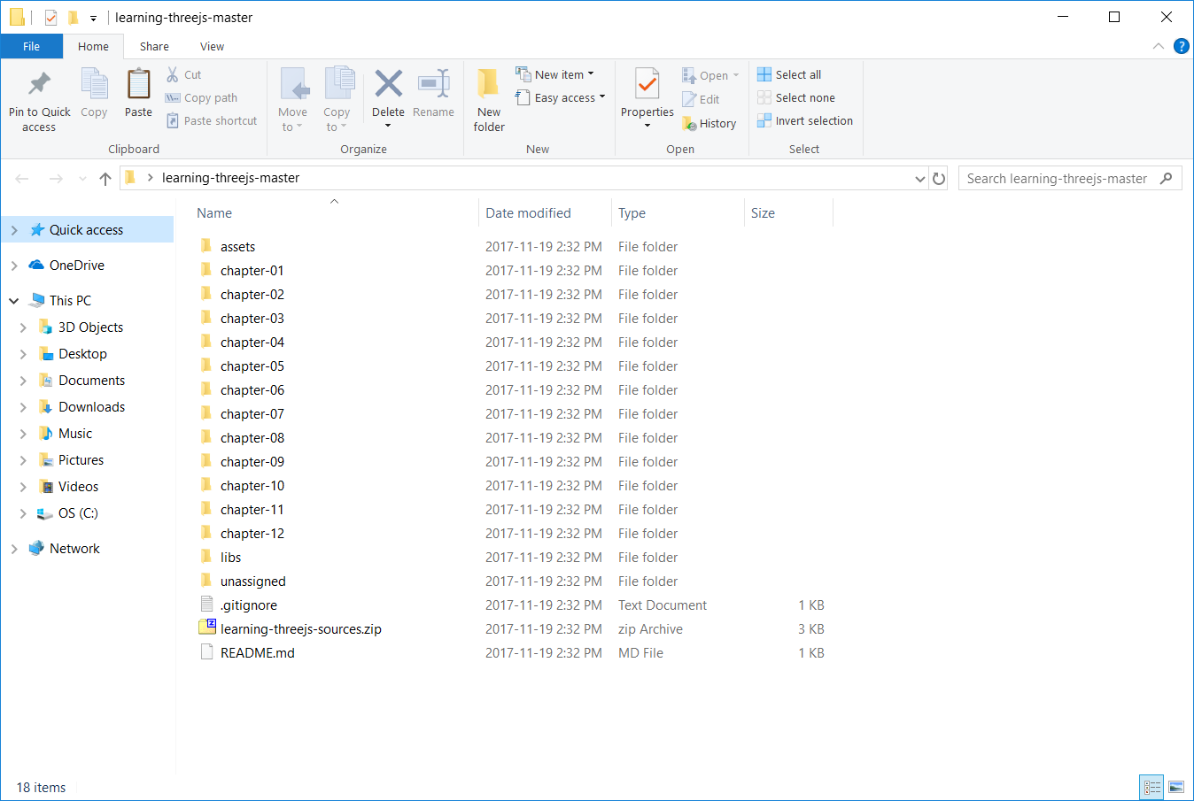

# Serving the files using Python local server

## Download Python

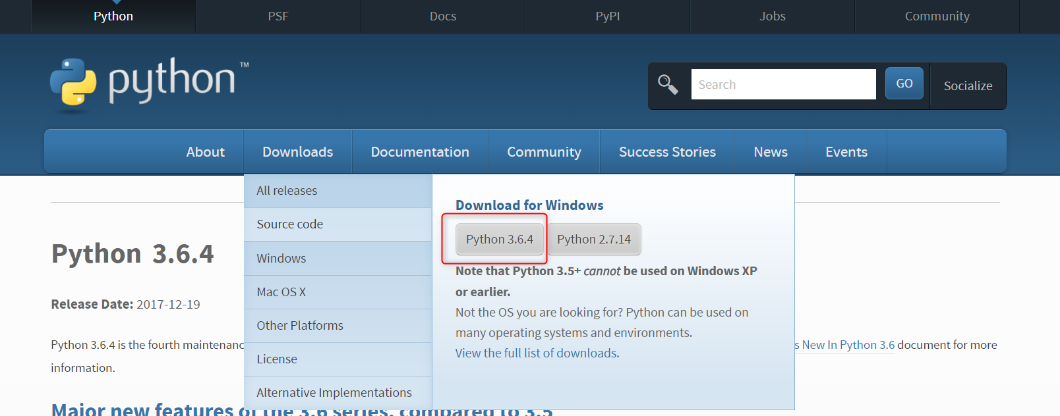

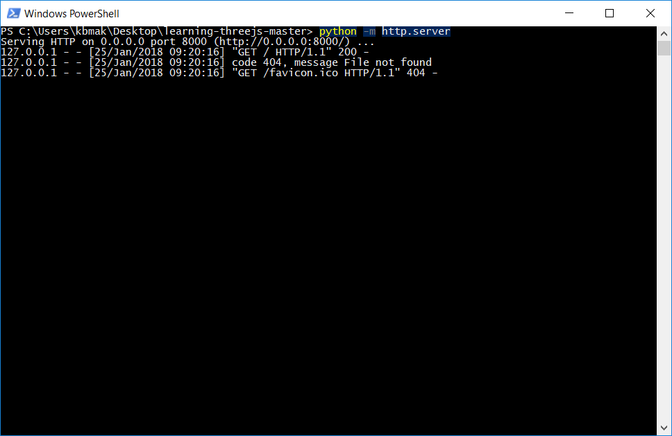

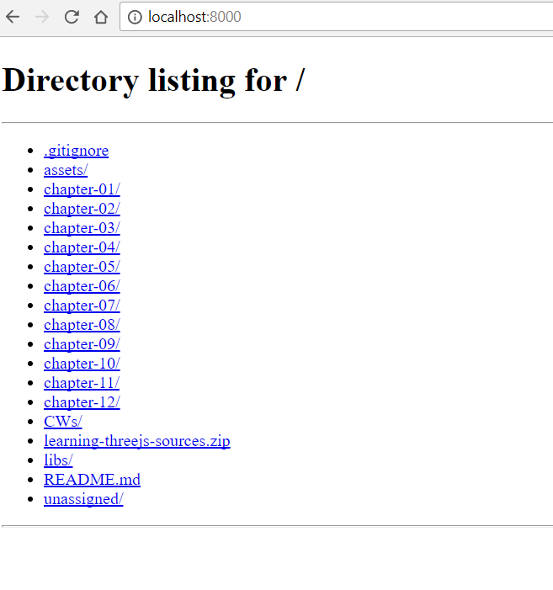

# Serving the files using NodeJS local server

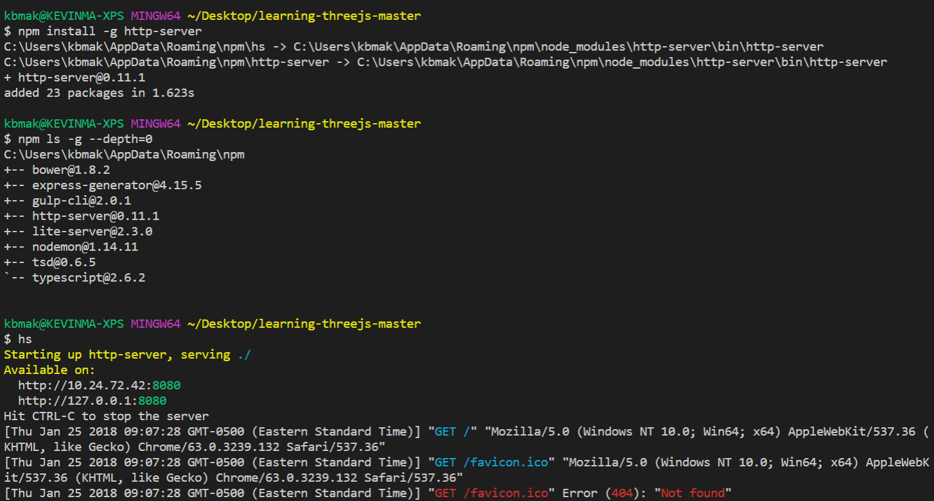

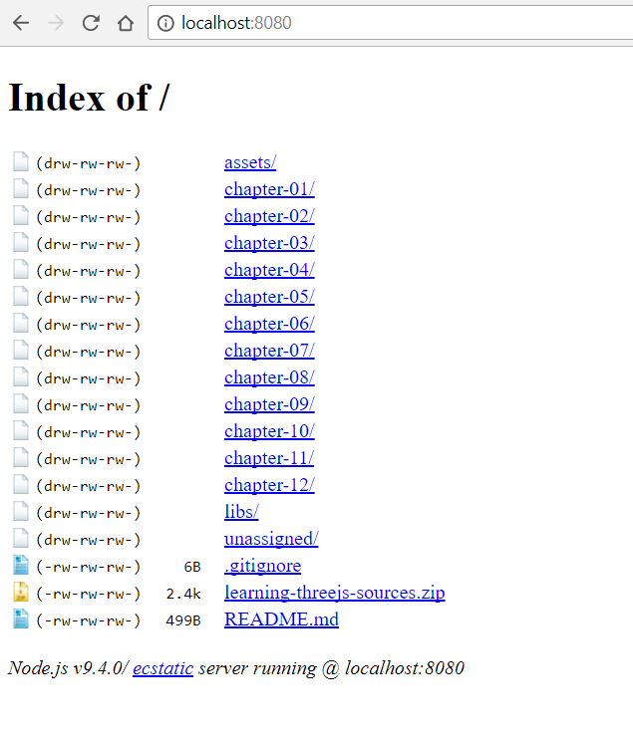

# Start working with Chapter01 files

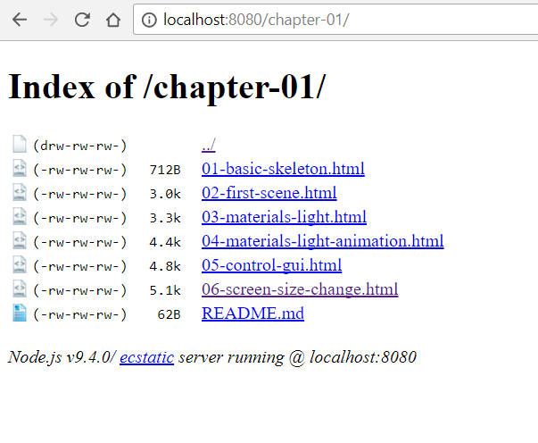

# Creating my 3js template

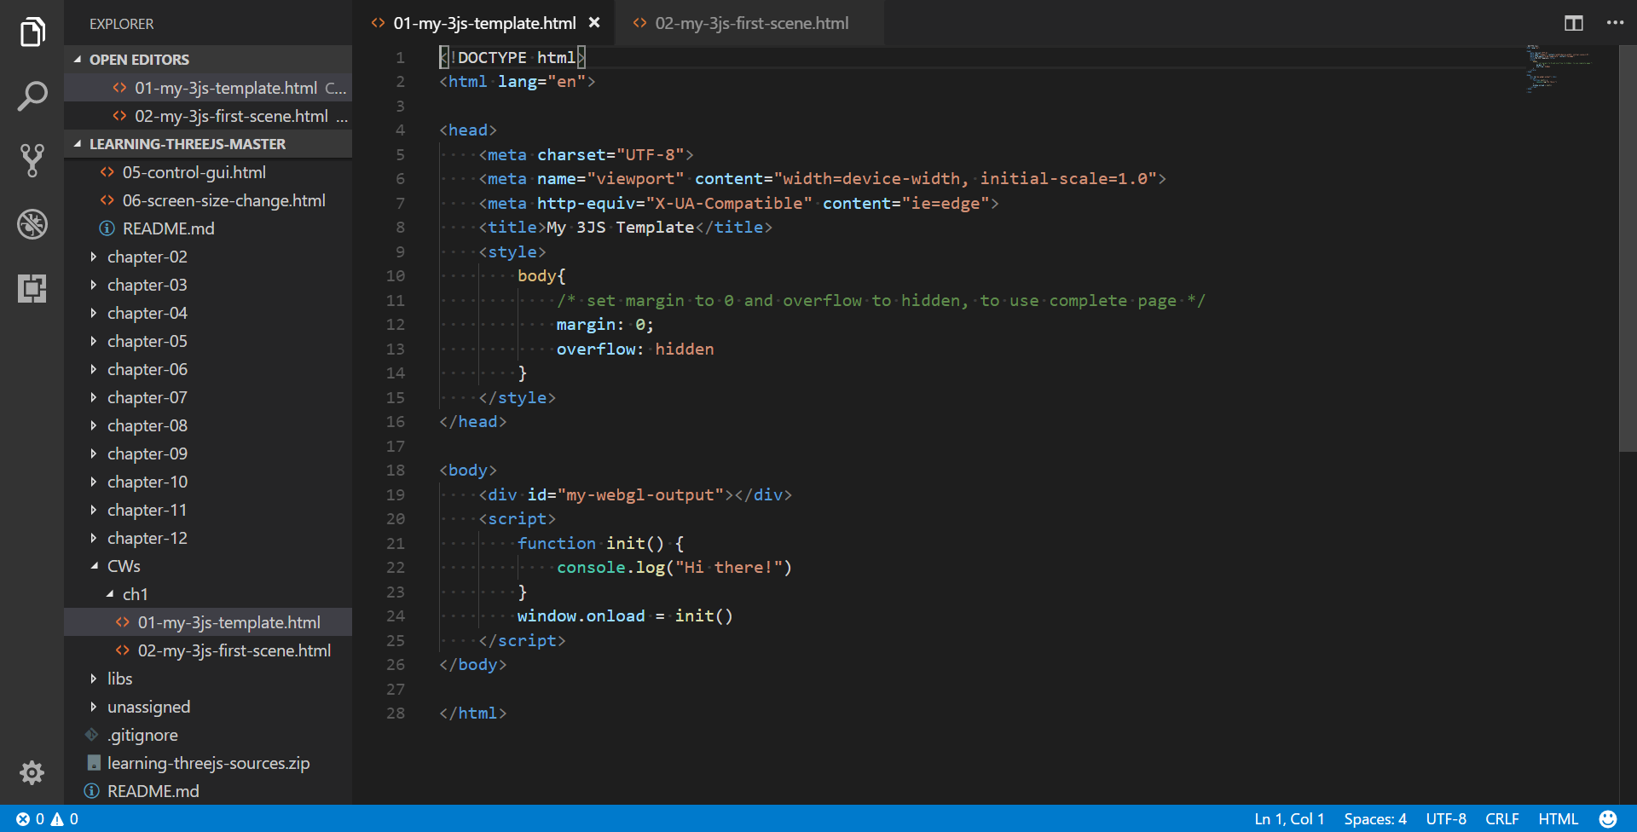

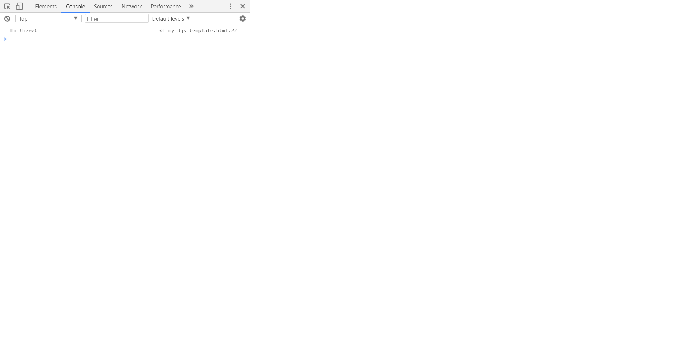

# Creating my 3js first scene