COMP392 – 002

Environment Setup

Contents

Setup the environment: 2

Donwload the code from github: 2

Google ‘Jos Dirksen’: 2

Extract Code: 3

Make Google Chrome the default browser: 3

Set up a local server: 3

Using Python: 4

In Google Chrome open the address **localhost:8000:** 5

Using NodeJS: 5

Open nodejs command line (install nodejs if necessary): 5

You should see this: 6

Download and extract as as above and go to the extracted folder: 6

Try to run hs: 6

If you get the above message, http-server is not installed so you need to install it first via ‘**npm install –g http-server**’: 7

Run **hs** again. Now you should see this: 7

Now open the localhost:8081 in Chrome: 7

In the command box you should see something similar to this: 8

# Setup the environment:

## Donwload the code from github:

### Google ‘Jos Dirksen’:

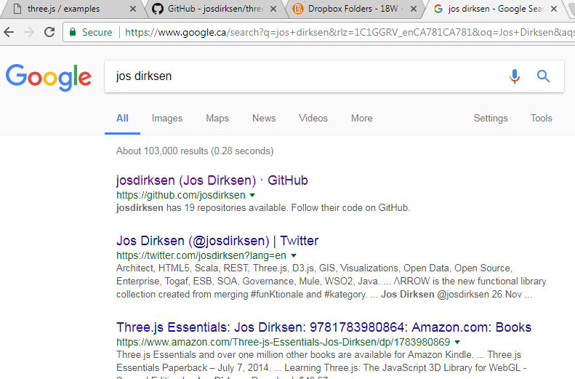

## Extract Code:

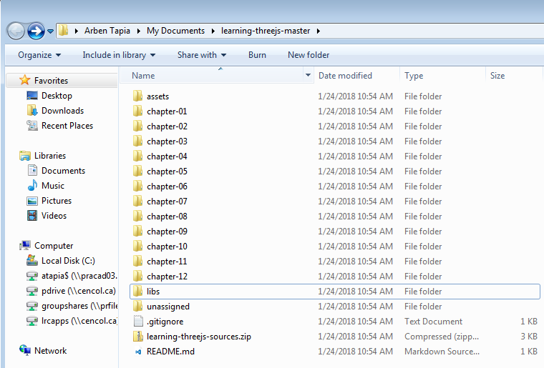

## Make Google Chrome the default browser:

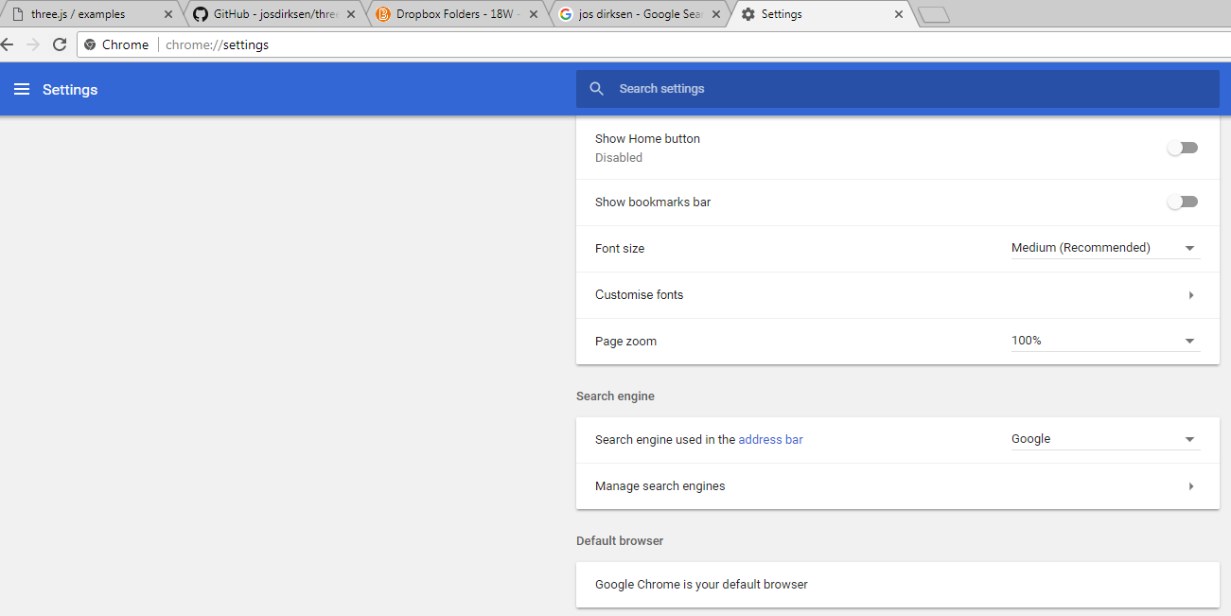

## Set up a local server:

There are many to do this.

### Using Python:

In the command line yype ‘dir \’ and you will see this:

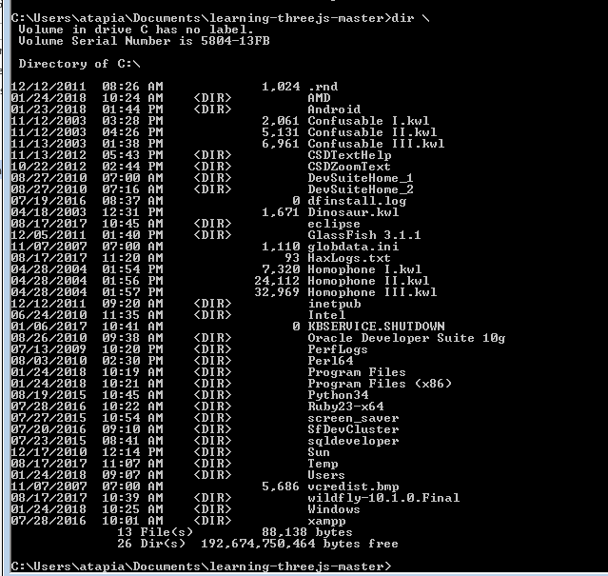

If you see Python.. in the list you have python installed, otherwise please install the latest python for your platform:



In this case I have Python 3.4 installed in directory c:\Python34

Run the following command: **\Python34\python.exe -m http.server**

C:\Users\atapia\Documents\learning-threejs-master**>\Python34\python.exe -m http.server**

Serving HTTP on 0.0.0.0 port 8000 ...

## In Google Chrome open the address **localhost:8000:**

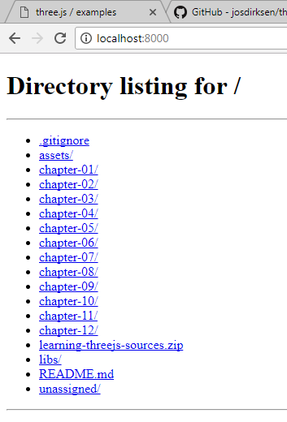

## Using NodeJS:

### Open nodejs command line (install nodejs if necessary):

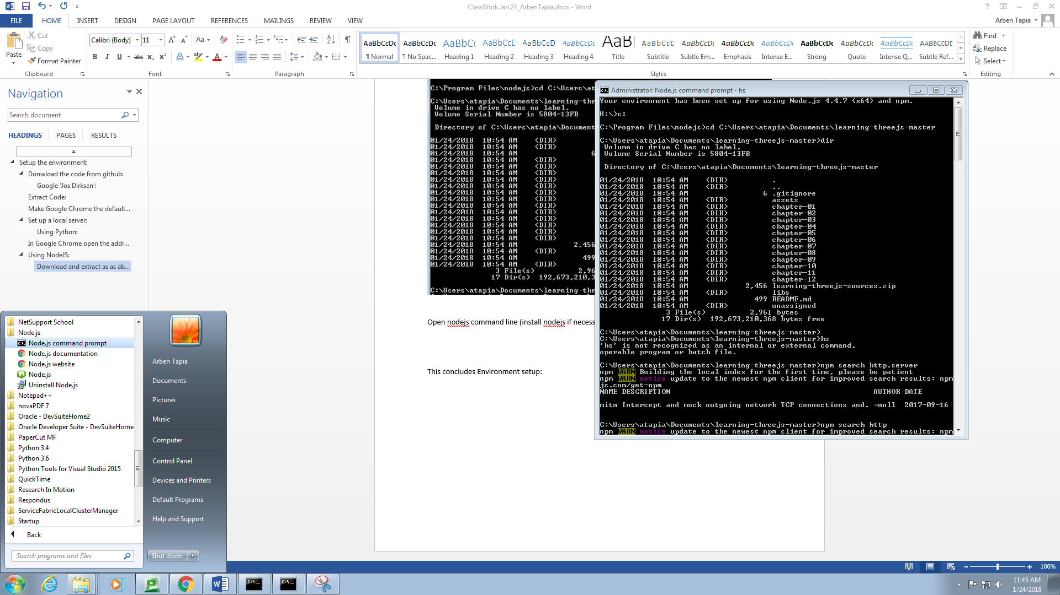

### You should see this:



### Download and extract as as above and go to the extracted folder:

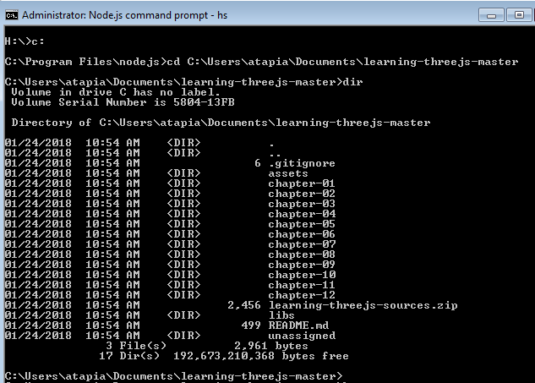

### Try to run hs:



### If you get the above message, http-server is not installed so you need to install it first via ‘**npm install –g http-server**’:



### Run **hs** again. Now you should see this:

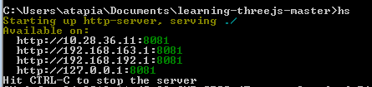

### Now open the localhost:8081 in Chrome:

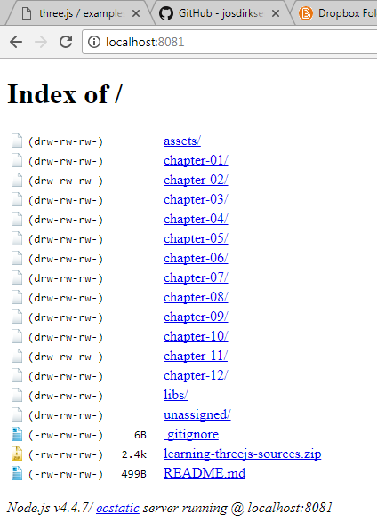

### In the command box you should see something similar to this:

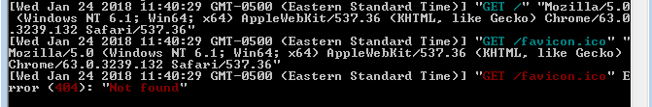

This concludes Environment setup: