Class Work – Feb 8th – COMP392 – 002

Kevin Ma

Contents

Setup environment + add 06…html file (AsciiEffect): 2

Create Ch2 subfolder of ClassWork’s folder: 2

Copy of 05…html from Ch1 to Ch2 and rename to 02-second-scene-and-some-refactoring-and-extra-light-types-KM.html: 3

Do some refactoring (move everything inside init() function so only init is a global function): 3

Add an AmbientLight in the scene: 4

Code: 4

Result: 5

Add a dat.GUI control for the ambientLight color and wire it up: 6

Code: 6

Result: 7

# Setup environment + add 06…html file (AsciiEffect):

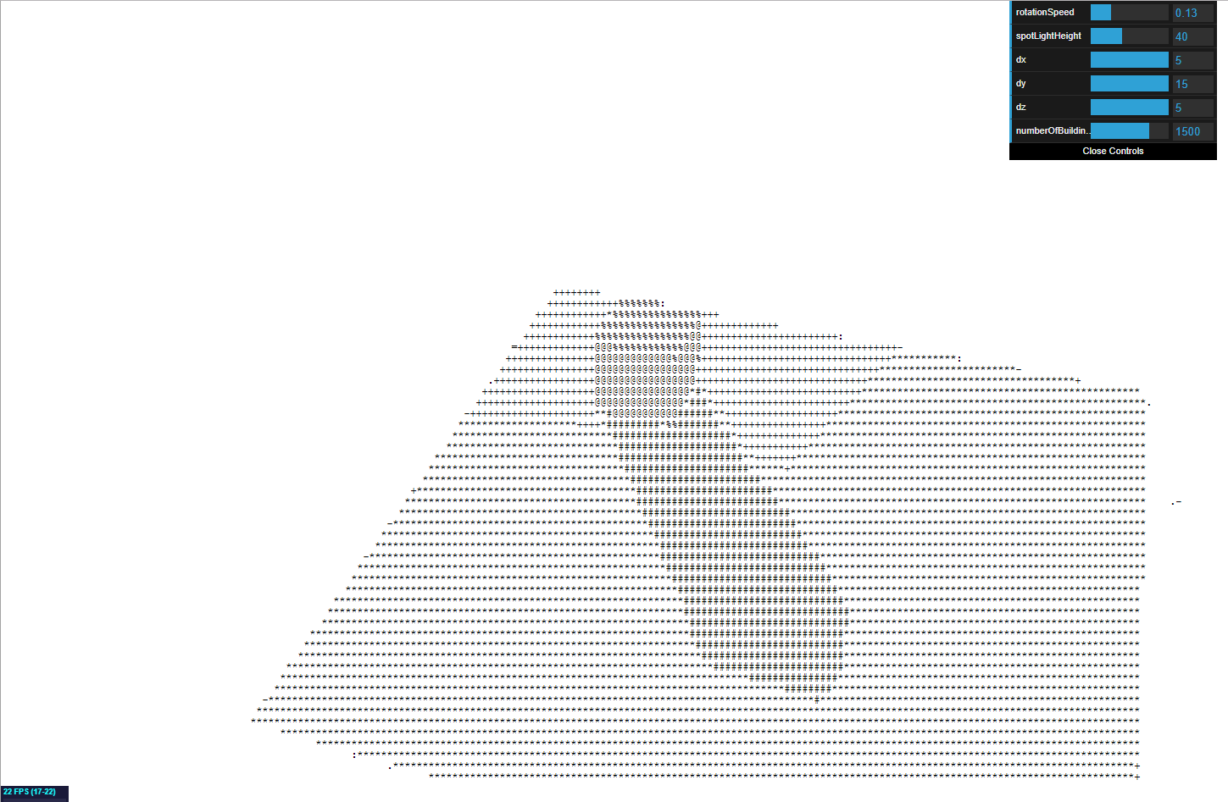

# Create Ch2 subfolder of ClassWork’s folder:

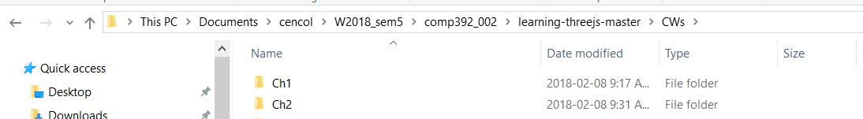

# Copy of 05…html from Ch1 to Ch2 and rename to 02-second-scene-and-some-refactoring-and-extra-light-types-KM.html:

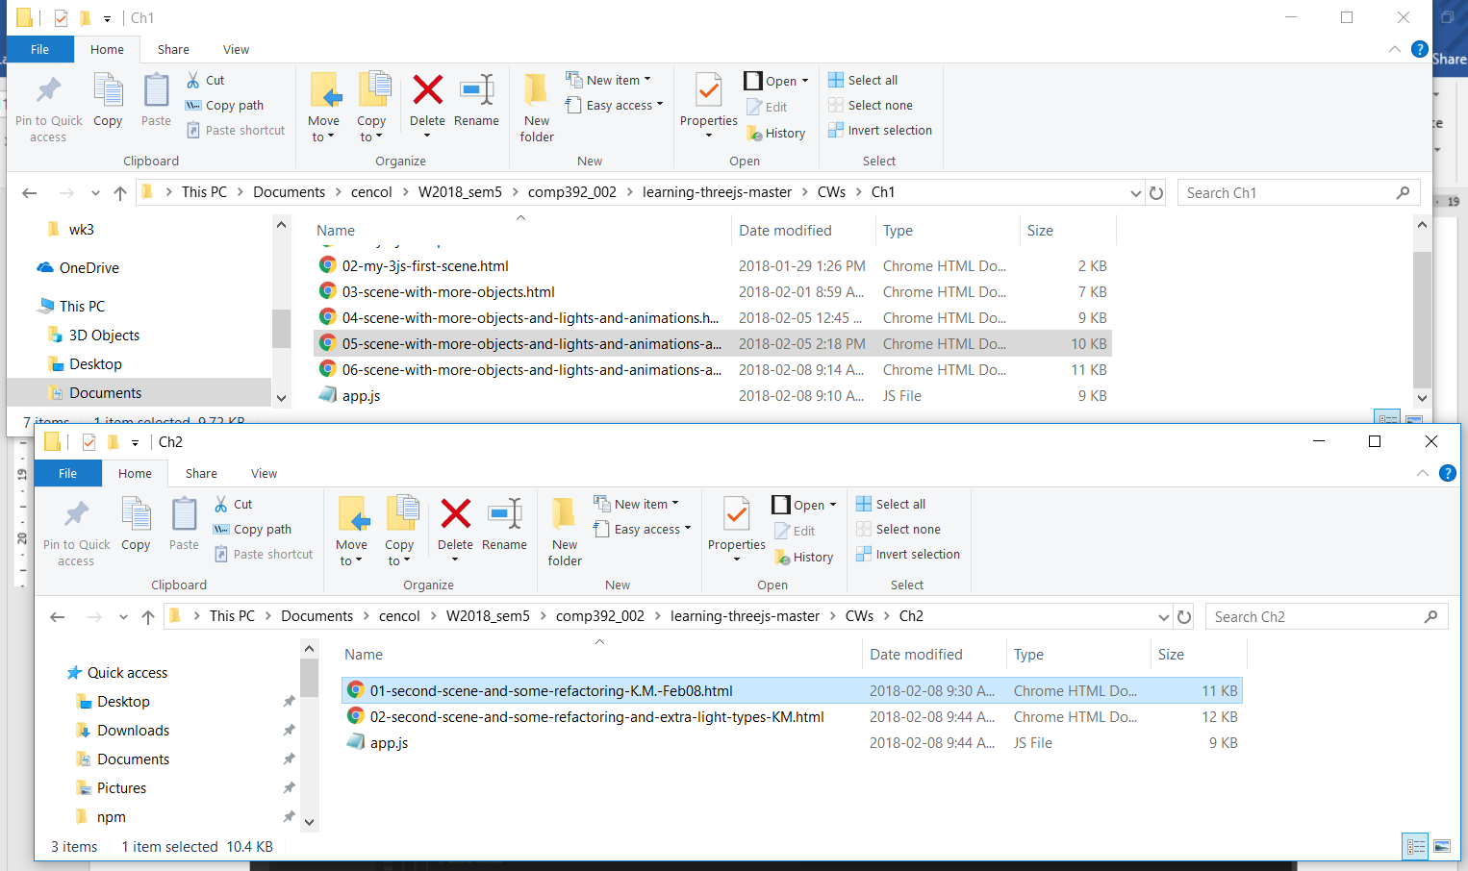

# Do some refactoring (move everything inside init() function so only init is a global function):

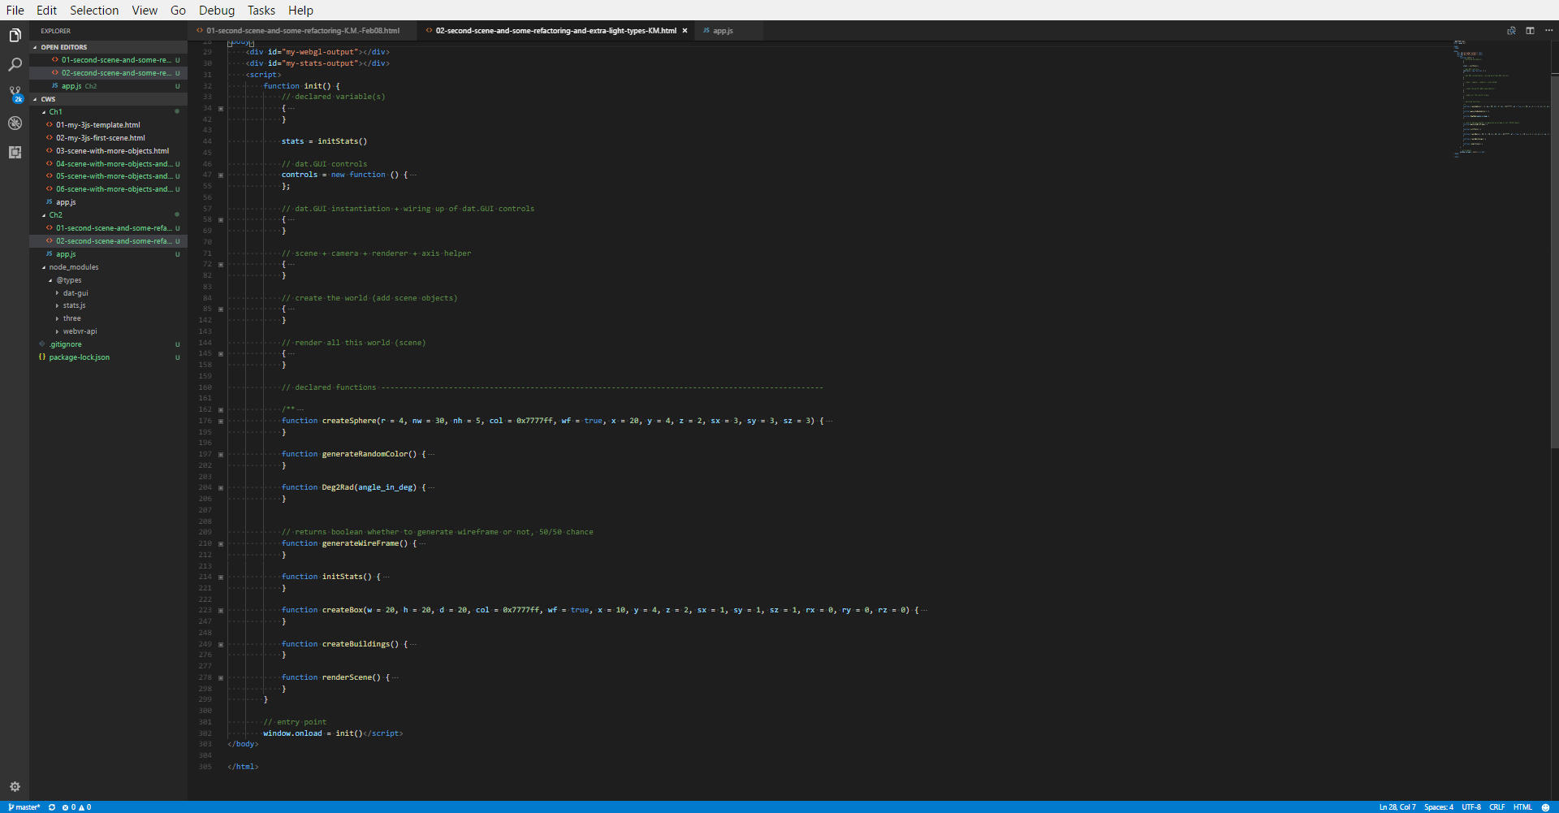

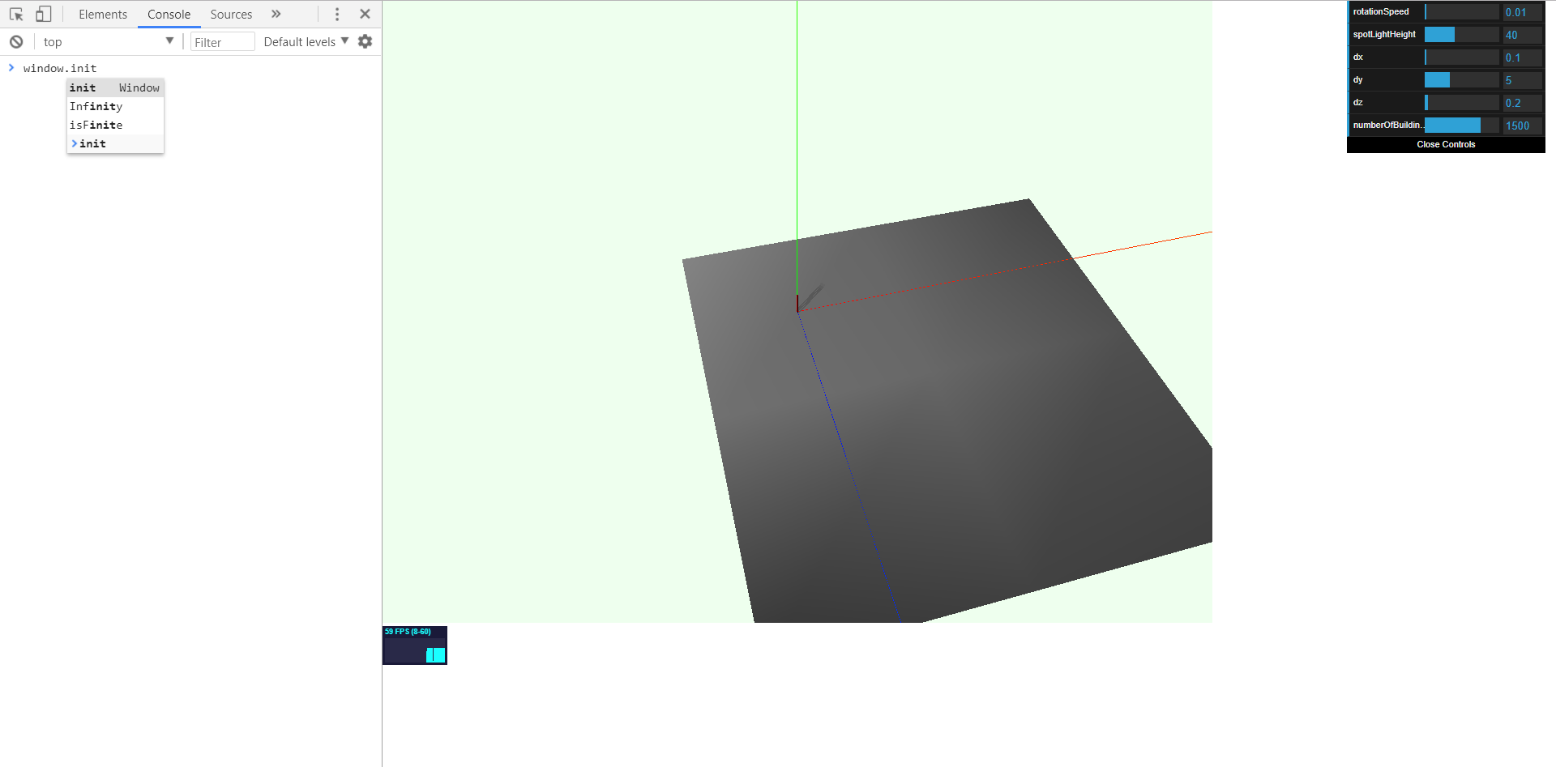

# Add an AmbientLight in the scene:

## Code:

// add an ambient light

{

ambientLight = new THREE.AmbientLight(0x0c0c0c);

scene.add(ambientLight);

}

## Result:

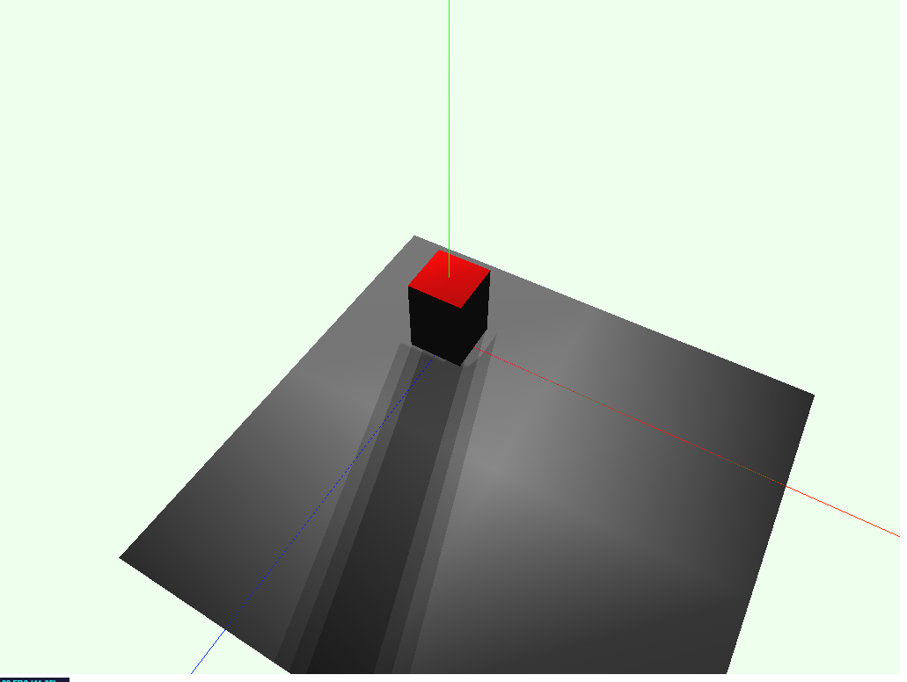

# Add a dat.GUI control for the ambientLight color and wire it up:

## Code:

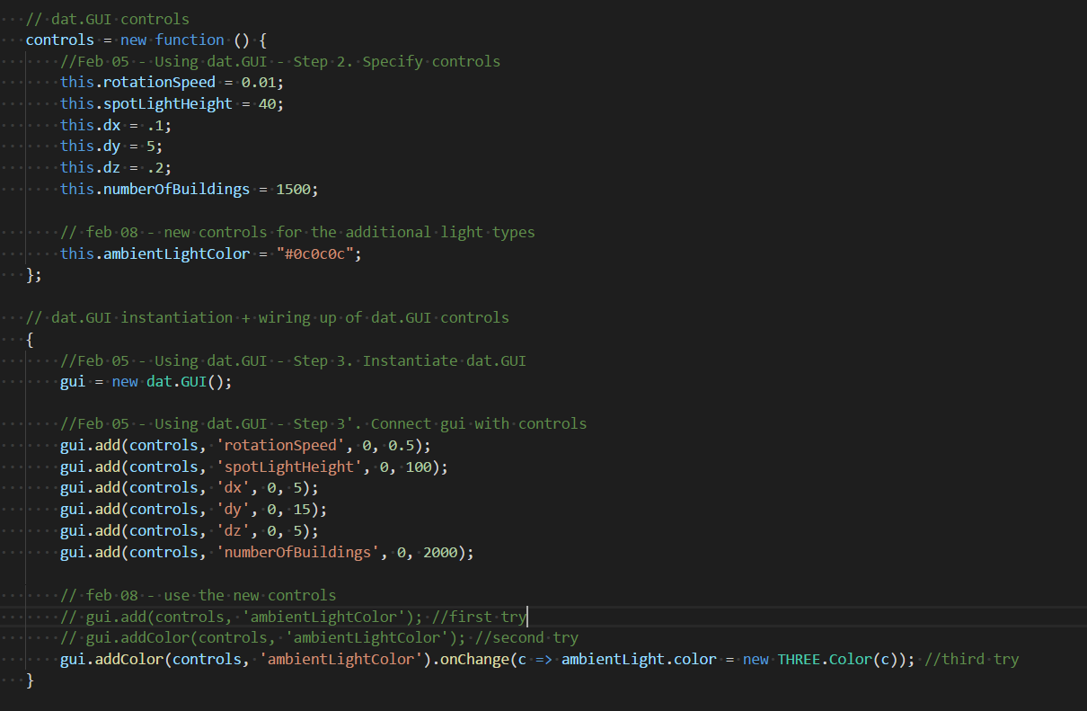

## Result:

