Class Work – COMP 392 – 002 – Feb. 12th

Kevin Ma

Contents

Environment Setup 1

Copy the last file (Ch2/02-… .html) to Ch2/03-… .html. And ‘…and-fog…’ in the title: 3

Results of FogControls, FogExp2Controls and OverrideMaterial control 4

# Environment Setup

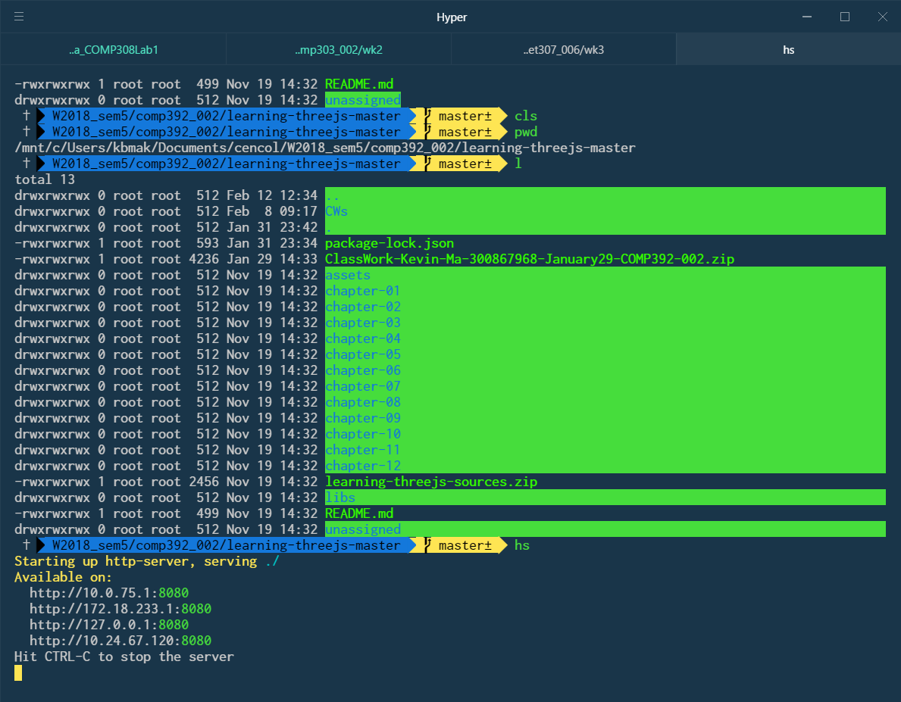

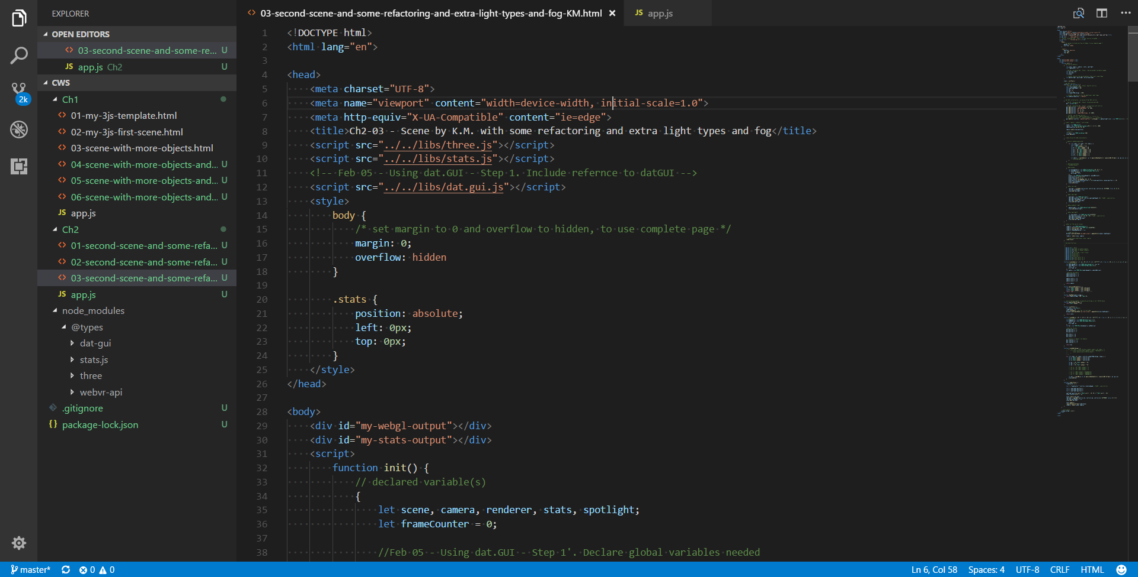

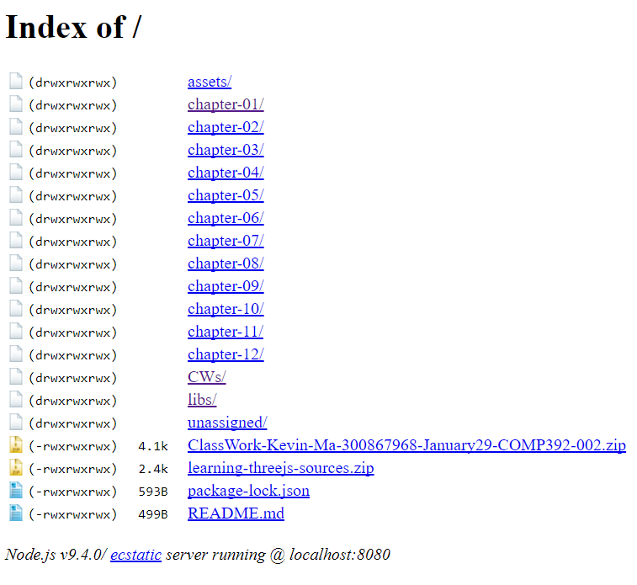

# Copy the last file (Ch2/02-… .html) to Ch2/03-… .html. And ‘…and-fog…’ in the title:

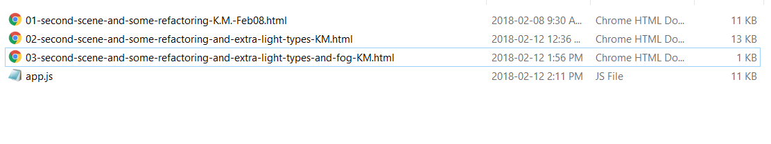

# Results of FogControls, FogExp2Controls and OverrideMaterial control

