Class Work – COMP392-002 – Feb. 15th

Kevin Ma

Contents

Setup Env. in: CWs -> Ch2 folder copy 03…html to 04…html 1

Change title to …Custom Geometry: 1

Exercise 2 - Tetrahedron: 4

# Setup Env. in: CWs -> Ch2 folder copy 03…html to 04…html

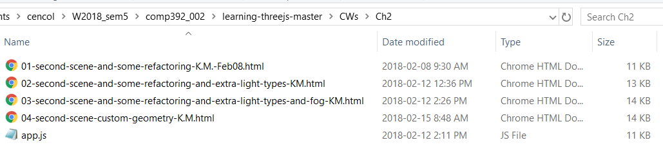

# Change title to …Custom Geometry:

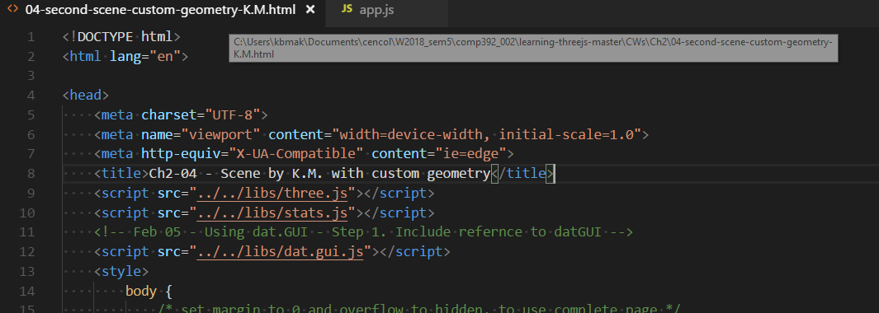

Create a triangle custom geometry

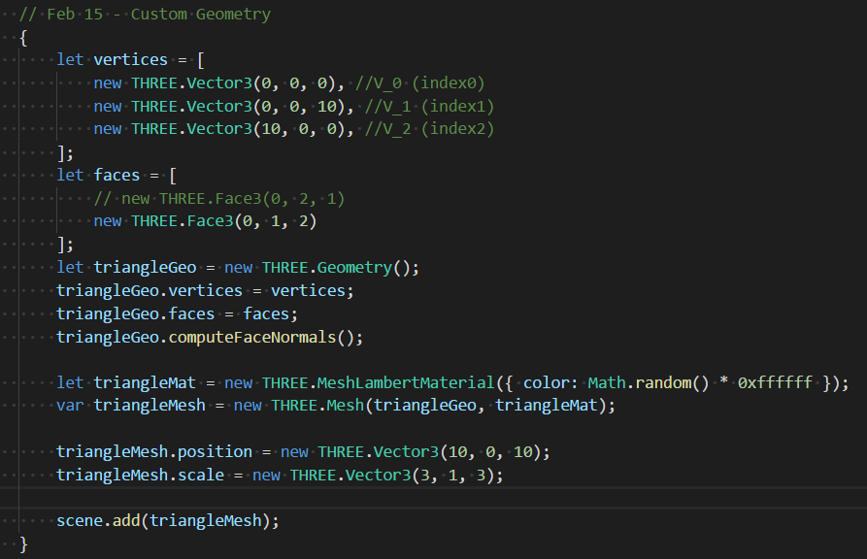

Try it (if you don’t see it use dat.GUI controls:

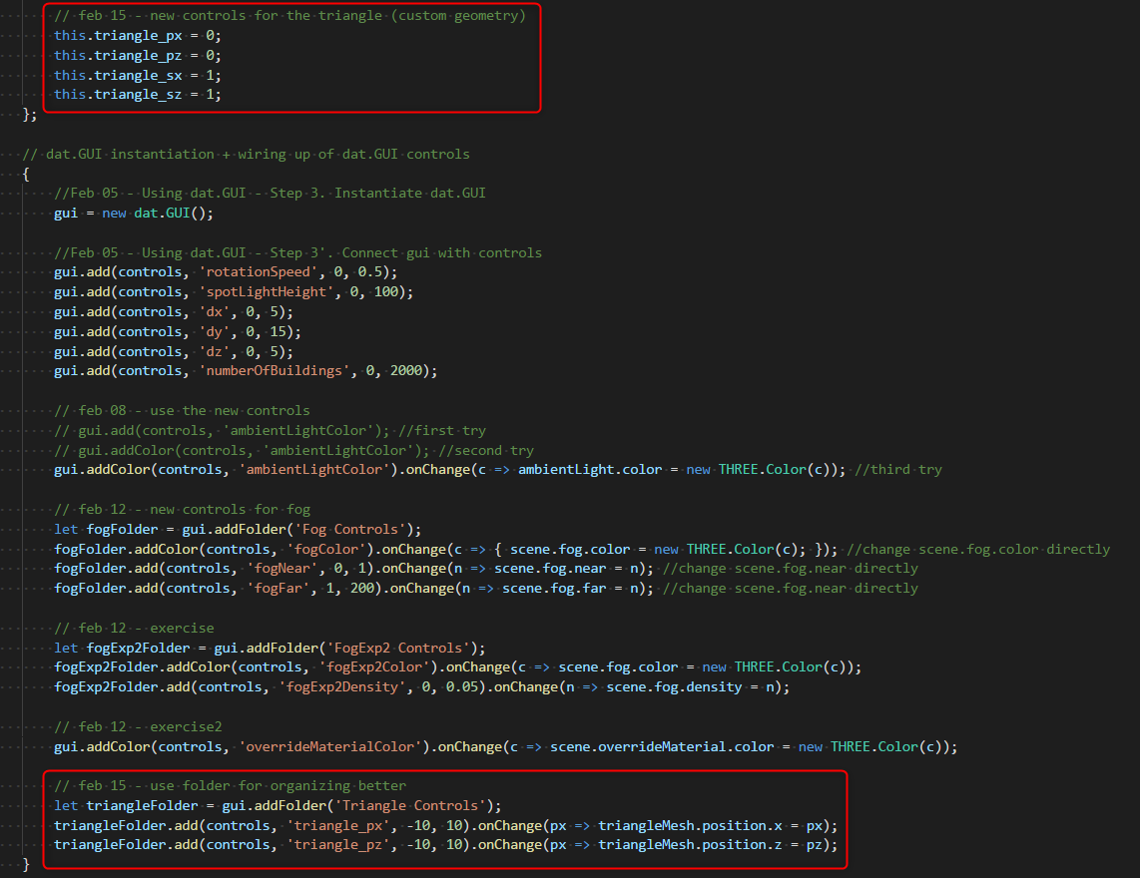

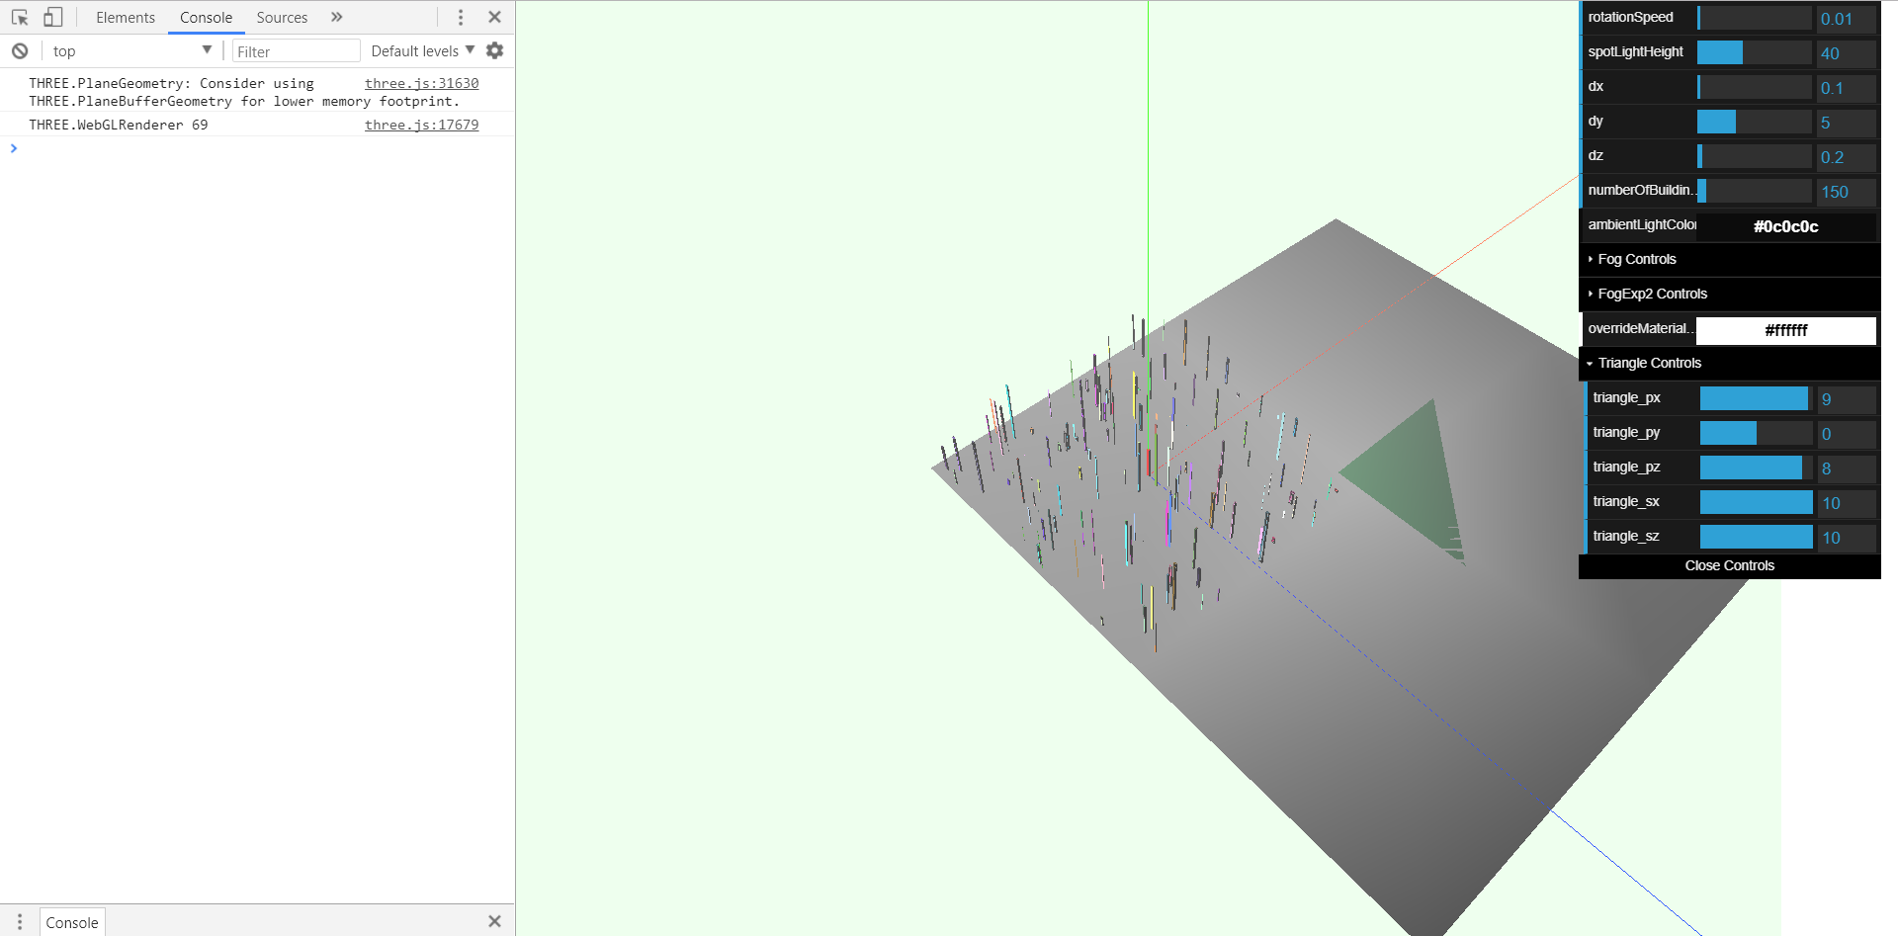

# Exercise 2 - Tetrahedron:

