Home Work – COMP392-002 – Mar. 5th

Kevin Ma

Contents

Completing requirements of Homework – COMP392 2

Adding continuous spinning controls for the main tetrahedron and the randomly generated tetrahedrons 4

Demonstration of the controls 6

Camera 6

Original 6

Using Controls 6

Horizontal Plane 7

Original 7

Using Controls 7

Ambient Light 8

Original 8

Using Controls 8

SpotLight 9

Original 9

Using Controls 9

Point Light 10

Original 10

Using Controls 10

Regular Tetrahedron 11

Original 11

Using Controls 11

Random tetrahedrons 12

Original 12

Using Controls 13

# Completing requirements of Homework – COMP392

* . creating a scene with the usual items (**1 pts**):
  + . camera,
  + . horizontal plane,
  + . ambient light,
  + . spot light,
  + . point light
* . as well as:
  + . a regular tetrahedron using Custom Geometry (tetrahedron with all the sides equal)
  + (**5 pts**).
* . Name the solution html file **HomeWork_COMP392***_<fn_ln>.***html** (where you should substitute your first name, last name for <fn_ln> as usual in class works) (**0.5 pts**).
* . For all the objects above set up a dat.GUI folder with respective parameters for quick experiments. As a minimum have a color attribute for each item. For the tetrahedron have also position, scale, rotation attributes as well as visible and wireframe boolean attributes. (**2 pts**)
* . Refactor the tetrahedron creation in its own function and use it to populate a rectangular area of the plane with tetrahedrons in random positions, rotations and scales (as we have done in class with rectangular polyhedron “buildings”) (**1.5 pts**)

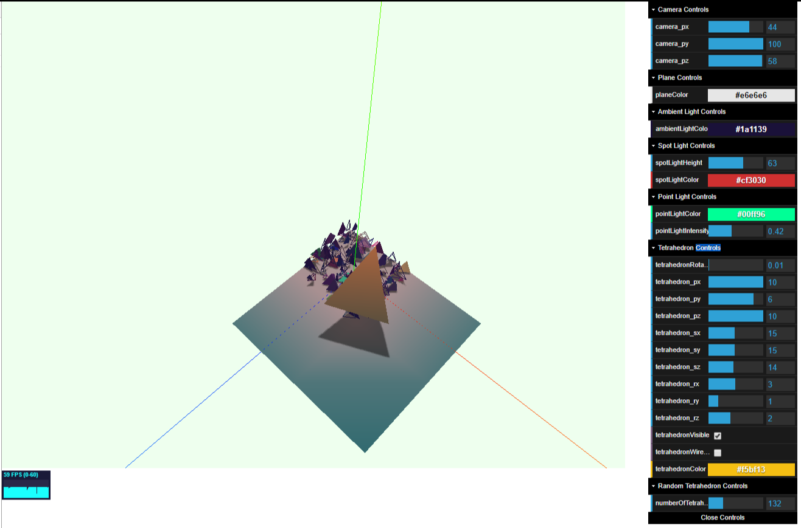

# Adding continuous spinning controls for the main tetrahedron and the randomly generated tetrahedrons

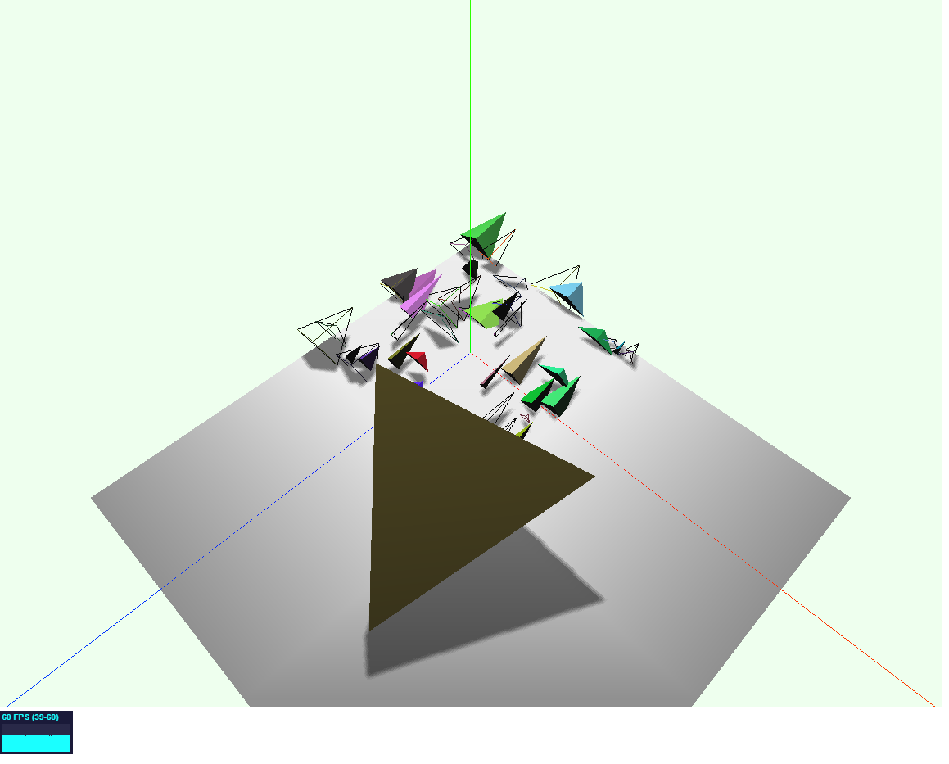

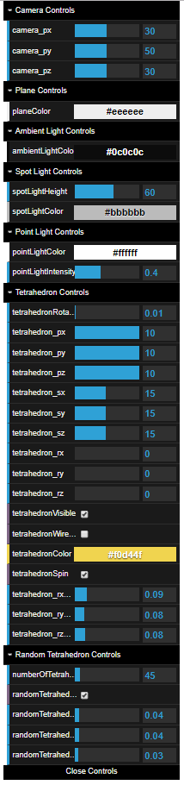

# Demonstration of the controls

## Camera

### Original

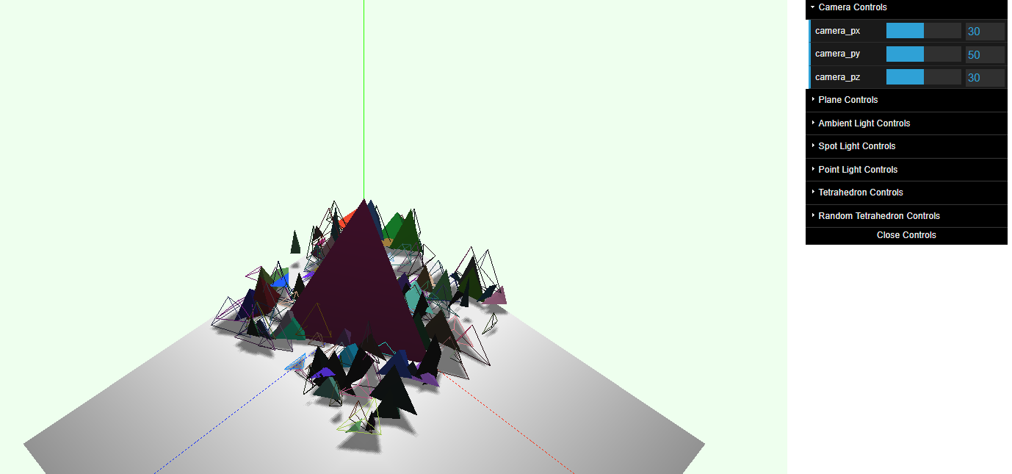

### Using Controls

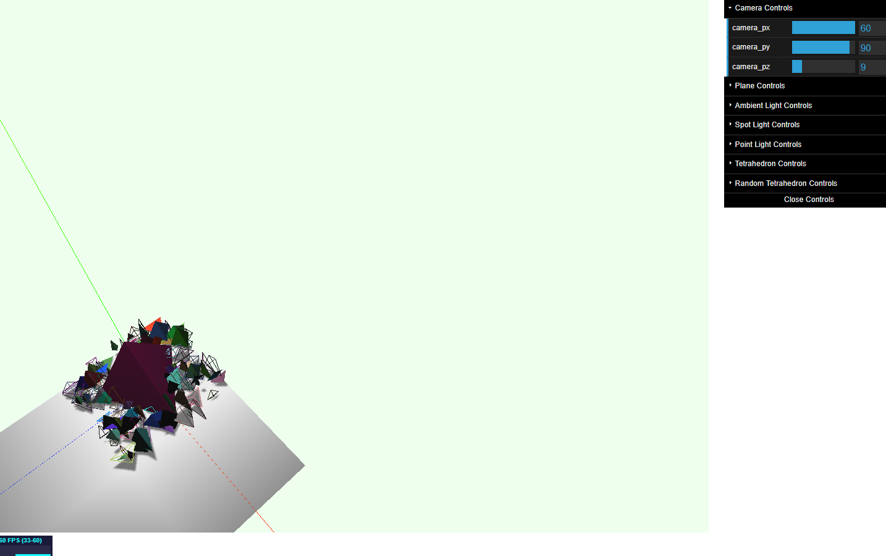

## Horizontal Plane

### Original

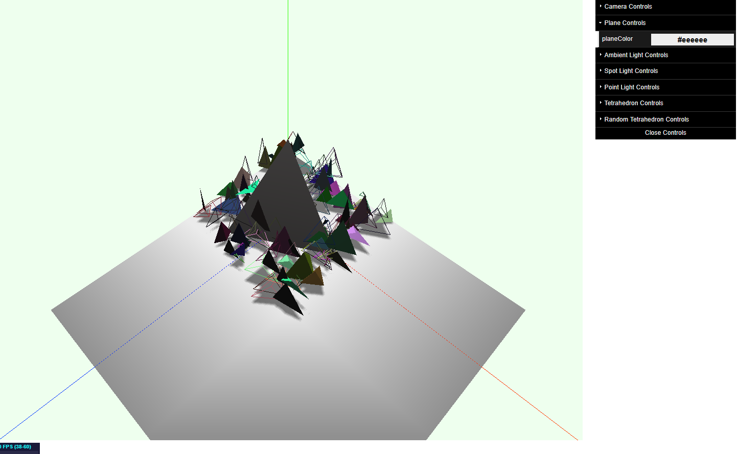

### Using Controls

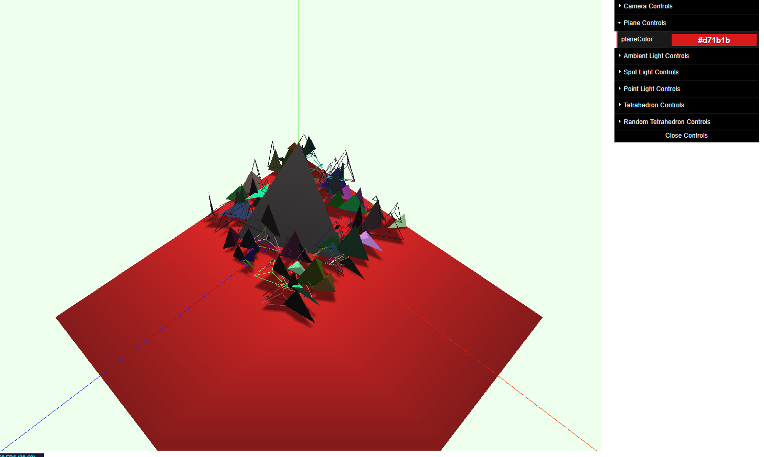

## Ambient Light

### Original

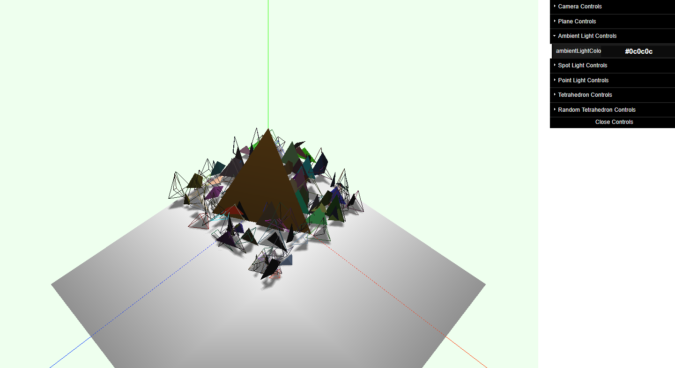

### Using Controls

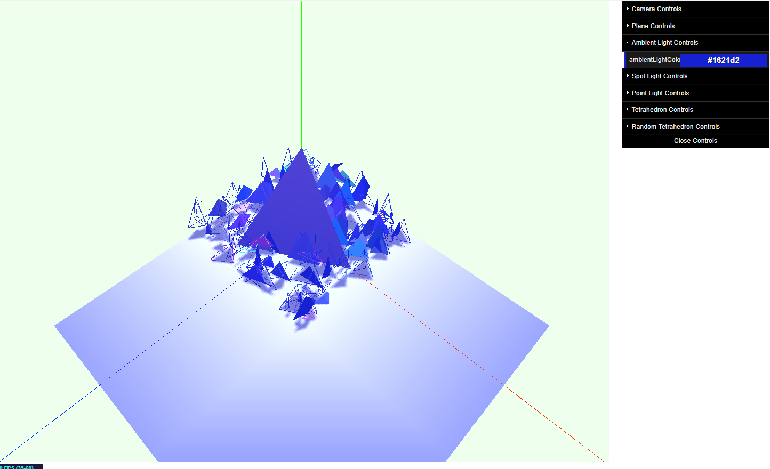

## SpotLight

### Original

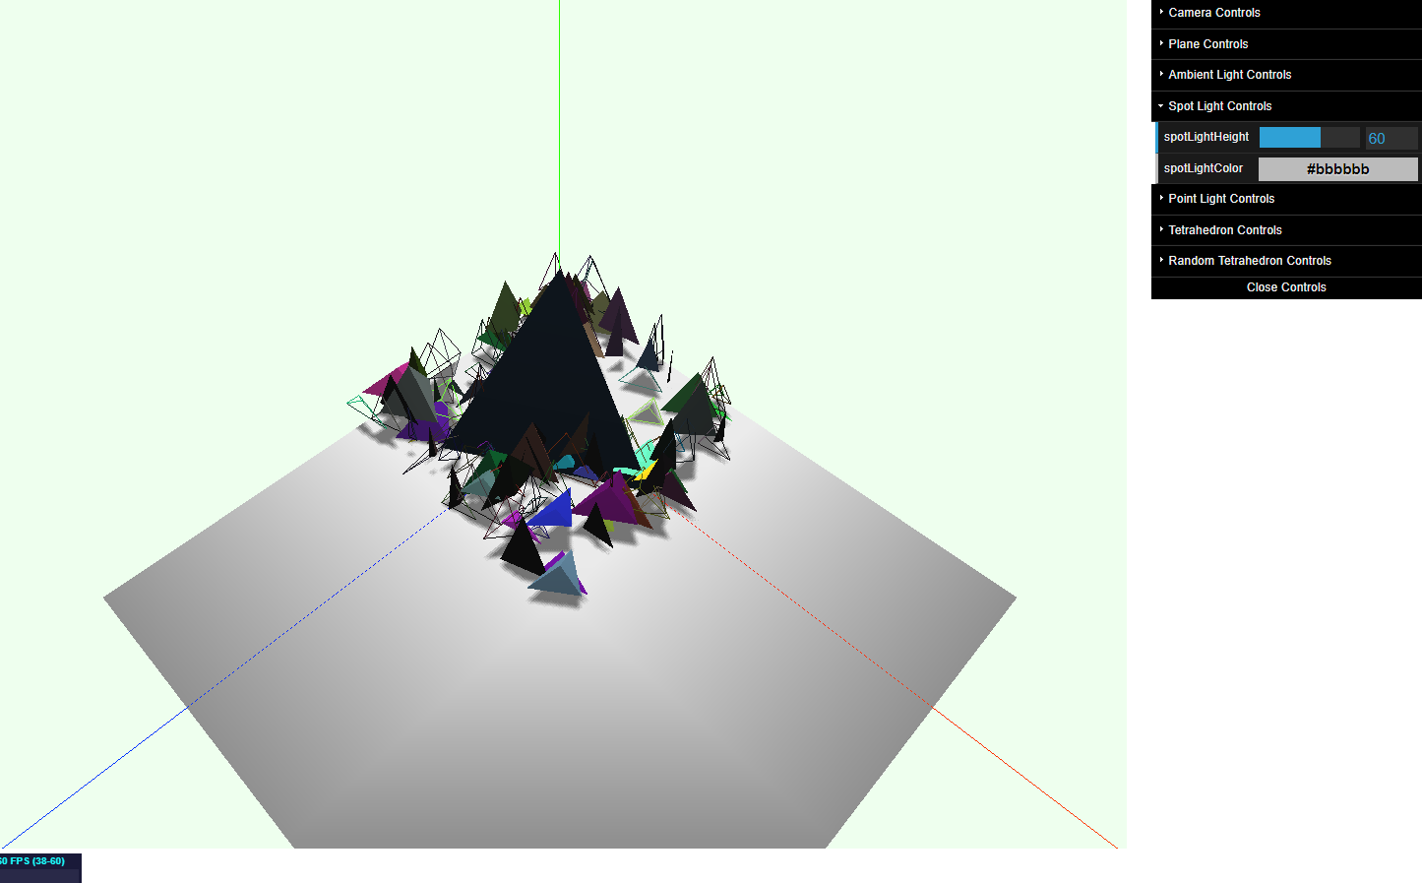

### Using Controls

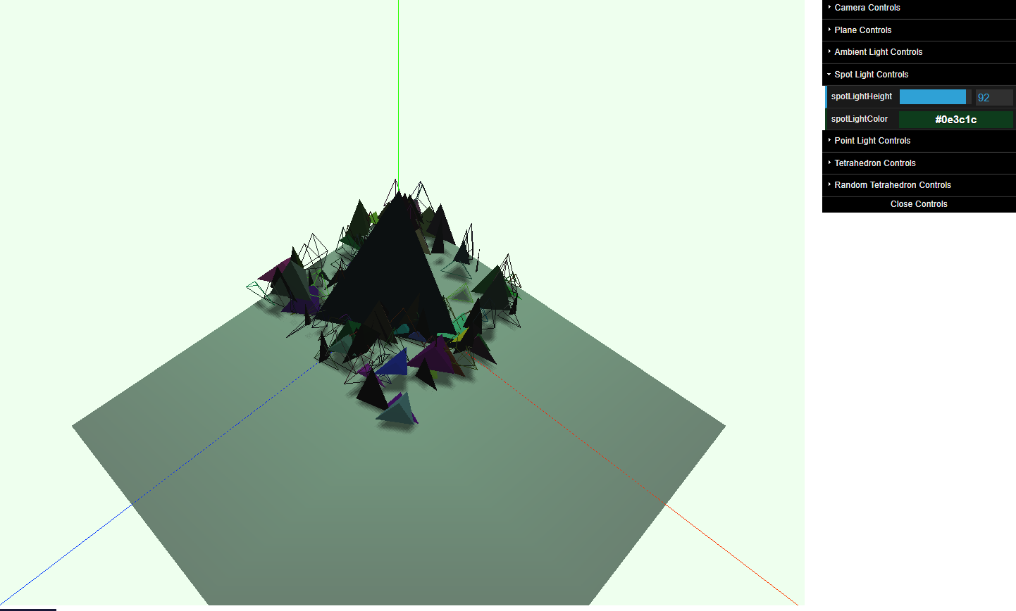

## Point Light

### Original

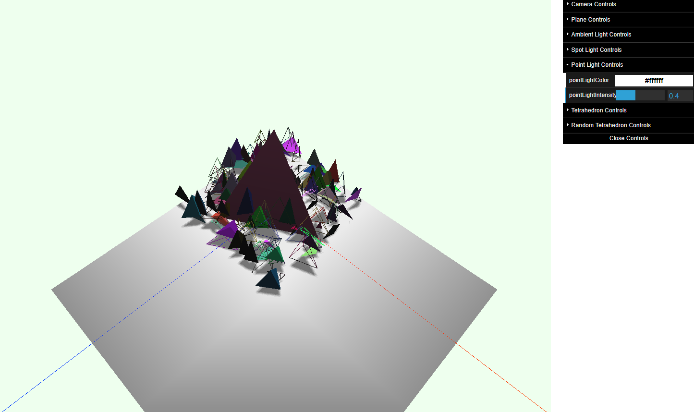

### Using Controls

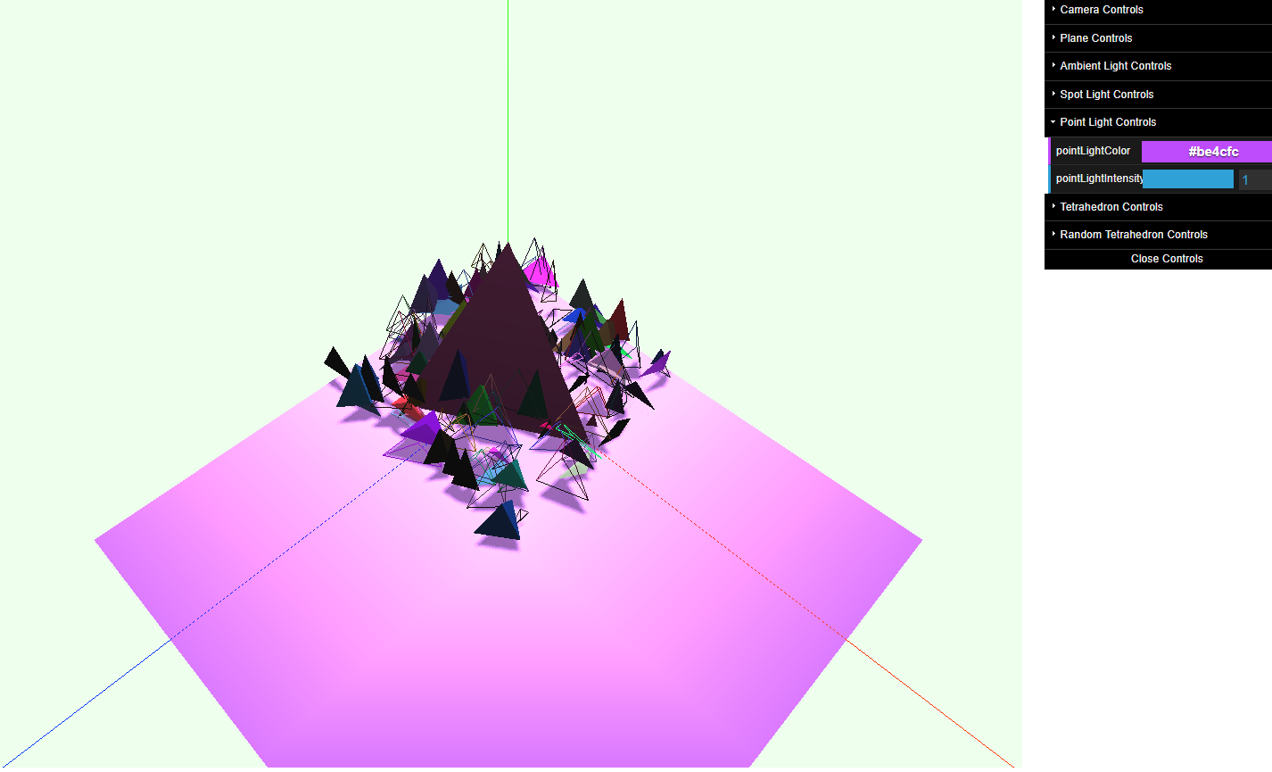

## Regular Tetrahedron

### Original

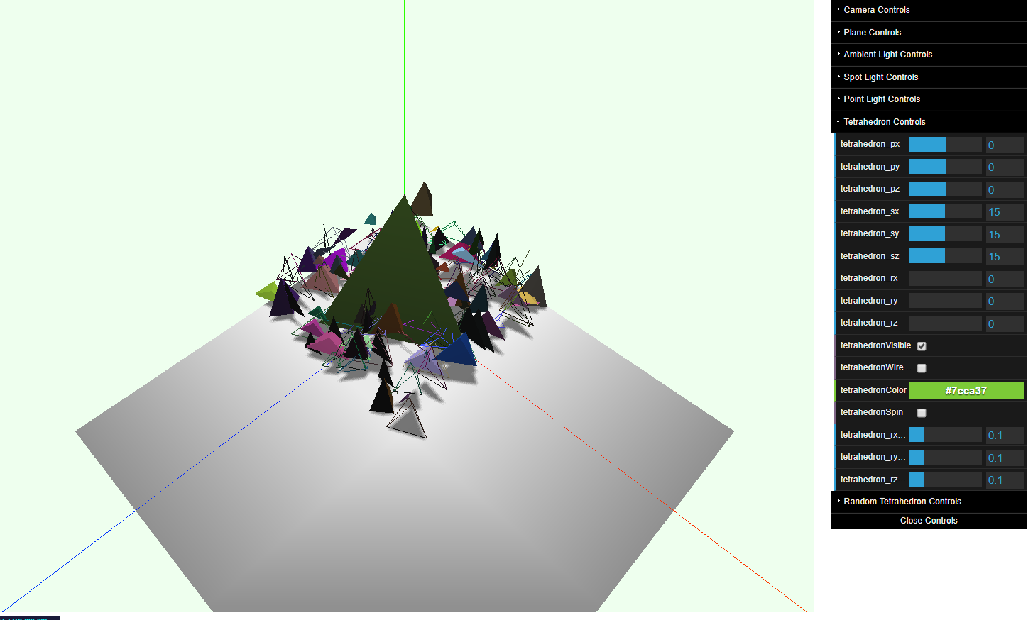

### Using Controls

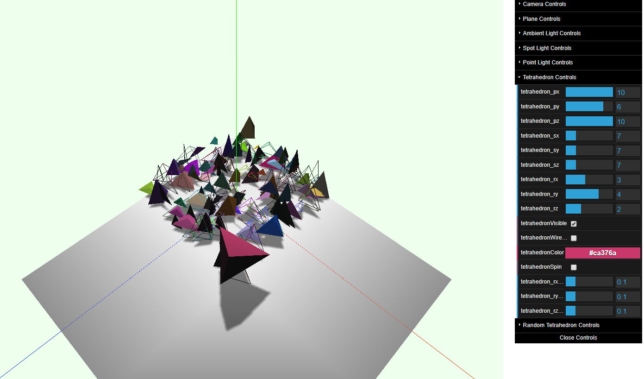

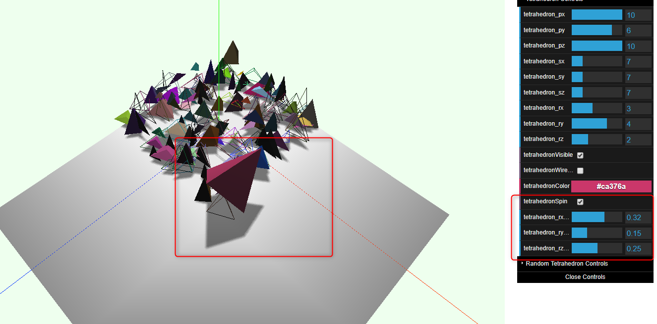

## Random tetrahedrons

### Original

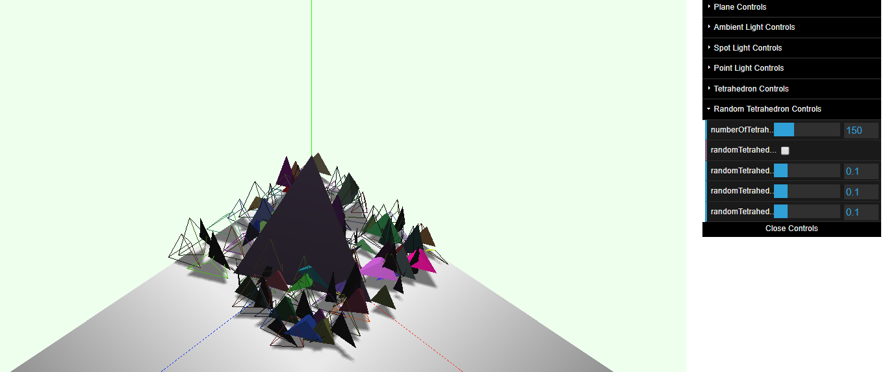

### Using Controls

