RBAC model you shared yesterday, that table is the wrong abstraction. It mixes roles, permissions, data scope, and platform administration into one huge matrix
Just to clarify the RBAC approach we need to follow:
- Roles are not predefined. Roles can be created and configured within each instance based on the customer's requirement.
- Super Admin is an exception. It is a default backend/system role with access to all modules and all permissions. It is not created or configured from the application.
- Permissions are not limited to CRUD. Permissions should represent actual business actions within each module. For example, Incident can have permissions such as Create Incident, View Incident, Edit Incident, Review Incident, Approve Incident, Close Incident, etc.
- Permissions are predefined by the application, while roles are created/configured by the instance admin by selecting the required permissions.
- A role will have a set of permissions, and users are assigned a role based on what they need to do.
- Business Unit access should be separate from the role/permission structure. The role defines what the user can do, while Business Unit scope defines where the user can do it.
- A user can have access to a parent Business Unit and its child Business Units, or to specific additional Business Units as permitted.
- The same role can therefore be assigned to different users with different Business Unit scopes.
- The overall structure should be: User → Role → Permissions and separately User → Business Unit Scope.
- This separation will make the RBAC flexible and scalable as we add more modules, permissions, Business Units, and customer-specific roles.

The following permissions should be disabled for selection in the frontend for normal Admin users. These should be available to Super Admin only.
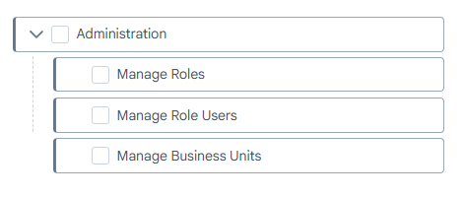
Manage Roles: Used to manage the roles that are already created.
Manage Role Users: Used to assign/add another role to a user or activate an employee as system user. This should also be handled by the Super Admin only.
Manage Business Units: Used to manage the organization structure, including adding new Business Units within organizations
User Management: Actions such as activating users and assigning additional permissions can be reviewed separately to decide whether they should also be restricted to Super Admin.

Setup
These permissions are used to manage the Master Data under the Setup section.
The Setup section will contain different master data lists.
Access to these masters will be based on the user's Business Unit access.
If the user has access to only one Business Unit, they can view and edit master data only for that Business Unit.
If the user has access to multiple Business Units, they can view and manage master data for those Business Units.
