Course Title: Web and Internet Programming Lab
Course Code: CSE472.3
Student Name: Khaleda Bhuiyan Nishat
Id:2023200010113
Lab: Lab 03

Report Title: SEU Tech Event Information
Output screenshot

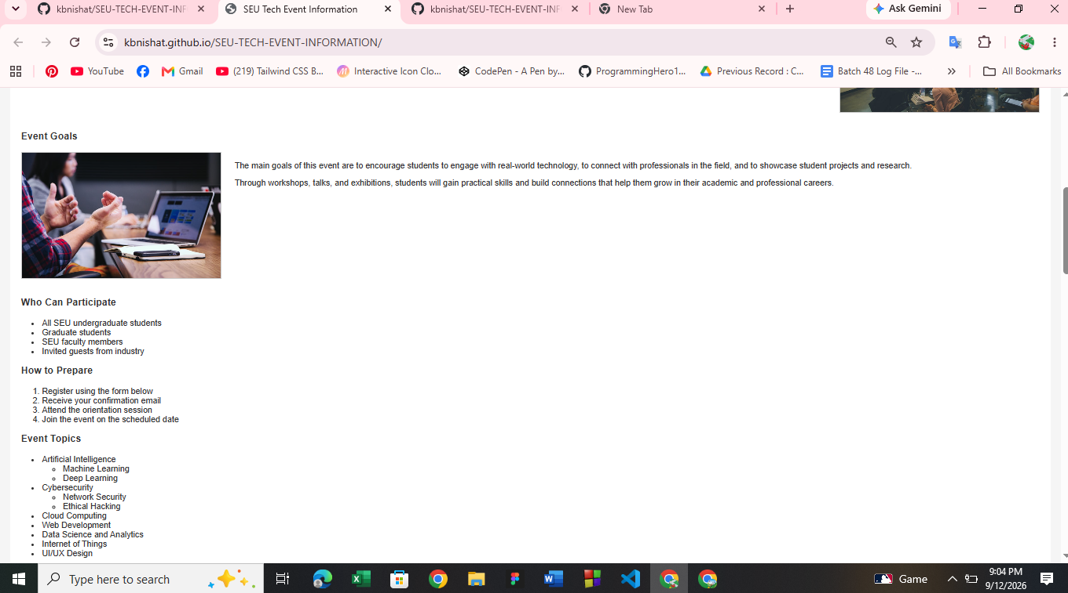
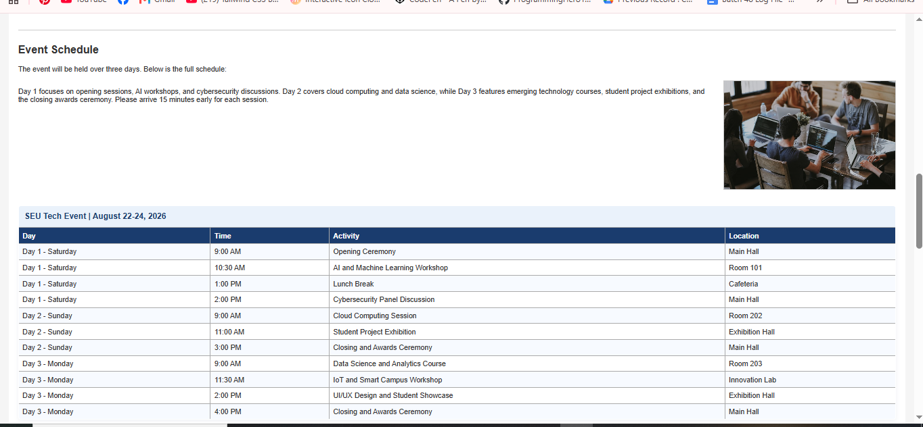
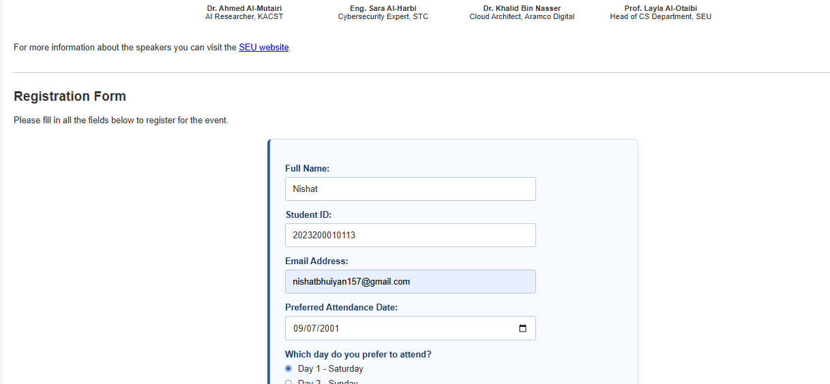

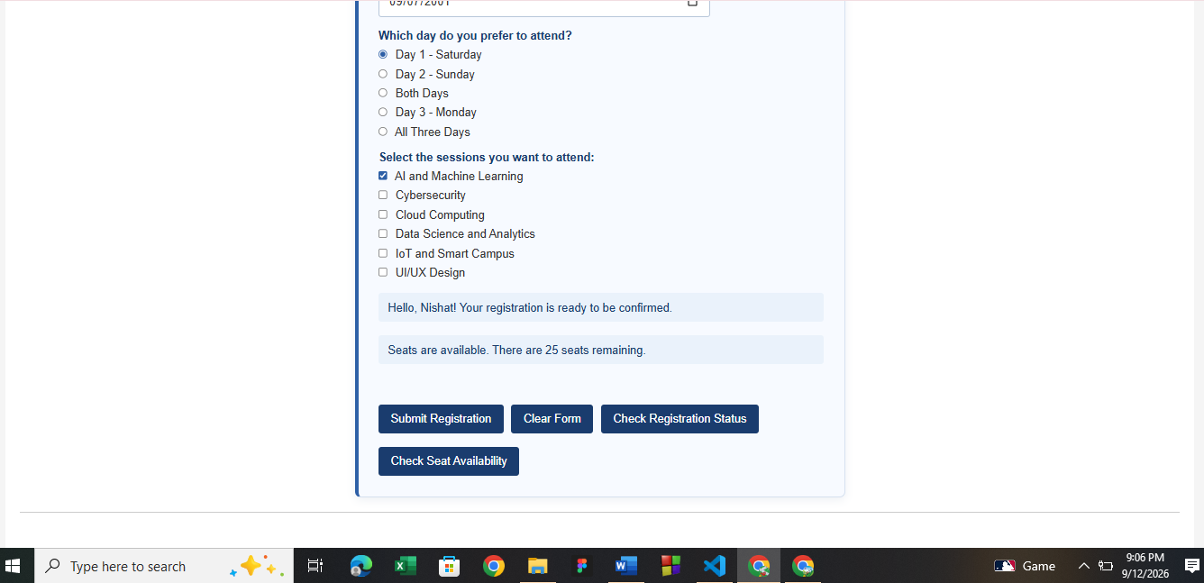

Githubrepo link: https://github.com/kbnishat/SEU-TECH-EVENT-INFORMATION

Testing and Corrections
The website was thoroughly tested to ensure that all major features were working correctly and providing the expected results. Different parts of the website, including the navigation menu, buttons, images, registration form, and overall page layout, were tested in the browser.
During testing, some minor issues related to image paths, CSS styling, and element alignment were identified. These issues were carefully checked and corrected to improve the appearance and functionality of the website. The registration form was also tested with different inputs, and the successful submission message was verified.
After completing the corrections, the website was tested again to ensure that the changes worked properly without affecting other features. Finally, the complete project was uploaded to the GitHub repository, and the GitHub Pages live link was tested successfully.
Overall, the testing and correction process helped ensure that the website was functional, visually consistent, and ready for submission.

Learning Reflection
Through this lab, I gained practical experience in developing a functional and user-friendly website using HTML, CSS, and JavaScript. I learned how to organize a web project into different files and folders, design a responsive and attractive interface, and add interactive features using JavaScript.
I also learned how to test a website, identify errors, and make necessary corrections to improve its functionality and appearance. Another important learning outcome was understanding how to use Git and GitHub to manage and publish a web project. I successfully uploaded my project to a GitHub repository and deployed it using GitHub Pages.
Overall, this lab improved my practical web development skills and gave me a better understanding of how a complete web project is developed, tested, corrected, and published online.

AI Assistance Declaration
I declare that AI tools, including ChatGPT, were used as an assisting tool during the preparation of this lab report and project. AI assistance was used for understanding concepts, improving explanations, identifying and correcting minor errors, and organizing the report. The final implementation, testing, and submission of the project were reviewed and completed by me.
AI Tool Used: ChatGPT
Purpose: Learning assistance, explanation, debugging support, and report organization.

