Information about the processing of personal data
In accordance with Article 13 of Regulation (EU) 2016/679 of the European Parliament and of the Council of 27 April 2016 on the protection of individuals with regard to the processing of personal data and on the free movement of such data and repealing Directive 95/46 / EC (General Data Protection Regulation , hereinafter the "General Regulations"), the Jagiellonian University reports that:
- The administrator of your personal data is the Jagiellonian University, 24 Gołębia Street, 31-007 Krakow, represented by the Rector of the Jagiellonian University.
- A Data Protection Officer has been appointed by the Jagiellonian University who is based at 24 Gołębia Street, 31-007 Krakow, room Nr 5. The Officer can be contacted via e-mail: iod@uj.edu.pl or by phone – 12 663 12 25.
- Your personal data will be processed for the promotional and informational purposes on the basis of the consent expressed by you.
- Providing your personal data is voluntary, but it is obligatory for promotion of the event.
- You have the right to: access your data and demand its rectification, as well as the right to delete the data, limit processing of the data, transfer the data, object to processing the data - in cases and under the conditions stipulated in “General Regulations”.
- If the processing of data is based on your consent, such consent may be withdrawn at any time. Withdrawal of the consent does not affect the legality of the processing carried out prior to its withdrawal. The withdrawal of consent to the processing of personal data may be sent by e-mail to the following address: iaisp.sekretariat@uj.edu.pl
by traditional mail to the address Instytut Amerykanistyki I Studiów Polonijnych, ul. Reymonta 4, 30-059 Kraków or withdrawn in person at the seat of our Institute.
The withdrawal of your consent to the processing of personal data will result in removing the information about the event with your participation.
- You have the right to file a complaint with The President, Personal Data Protection Office if you consider the processing of your personal data to be in violation of the provisions of the “General Regulations”.

I hereby confirm that I have read and understood the above information.
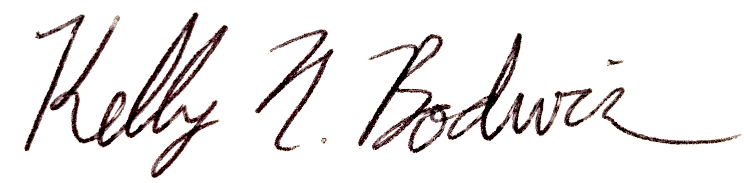
San Luis Obispo, CA, 9 March 2023
...........................................................................
place, date, legible signature
* delete as appropriate

First name and surname: …………………………………
Address ……………………………………………………………
Contact …………………………………………………………….

CONSENT TO USE IMAGE
I hereby consent to the processing of my personal data and the use of my image by the Jagiellonian University - Institute of American Studies and Polish Diaspora (JU) for the purpose of placing information on website iaisp.uj.edu.pl and social media platforms (Facebook, Instagram) for promotional and informational purposes in accordance with GDPR and Polish copyright law (art. 81 – use of image) and in accordance with the information clause attached to my consent. I consent to the publication and dissemination of the information (including my image combined with the note on my academic background and career), free of charge, through website iaisp.uj.edu.pl and social media platforms (Facebook, Instagram).

At the same time, I reserve the right to obtain information about the processing of my personal data and the use of my image by JU at any time, and to withdraw this consent whenever I consider appropriate. The consequence of the consent withdrawal will be the removal of the above-mentioned image from JU’s website and social media.

I have been acquainted with or have personally provided JU with the materials to be published on website iaisp.uj.edu.pl and social media platforms (Facebook, Instagram) and they do not infringe my personal rights.

.................................................. ......................
Date and legible signature

