**Deployment instructions**

Unpack rplKiosk.zip.

Archive rplKiosk.zip includes:

* rplKiosk/ – project directory.

Project structure:

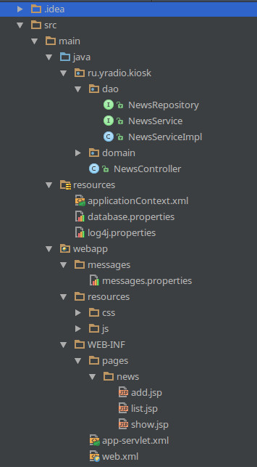

Project build via Maven. To build application go to project directory and run command **mvn clean package**.

Web archive (**war** file) will be created in **{project directory}/target/rplKiosk.war**.

To deploy application copy web archive rplKiosk.war to **/war/lib/tomcat/webapps** and restart Tomcat.

An installed RDBMS PostgreSQL is required for running project.

To restore test database from dump run command **psql voip < testDBDump.sql** (where voip – database name).

All configure settings are in **/webapp/message/messages.properties**

All database settings are in **/resources/database.properties**