Linear Regression Tutorial

In this tutorial you will perform a linear regression and make the machine learn.  
Now, to run a code block in Jupyter Notebooks, click into it and hit ctrl + enter.  
If the key command doesn’t work, hit the triangle button in the upper left.  
The first step, of course, is to load the data. We will be using a dataset of shampoo sales over 3 years.

import csv  
import datetime as dt  
  
with open("shampoo.csv", "r") as shamwow:  
 data = list(csv.reader(shamwow))[1:]  
  
# Convert the sales into a float  
sales = [float(point[1]) for point in data]  
dates = [dt.datetime.strptime("199" + point[0],'%Y-%m').date()   
 for point in data]  
  
print(sales[0:5])  
print(dates[0:2])

[266.0, 145.9, 183.1, 119.3, 180.3]  
[datetime.date(1991, 1, 1), datetime.date(1991, 2, 1)]

Let’s plot the data in a plot that’s as scattered as my brain while writing this tutorial:

import matplotlib.pyplot as plt  
import matplotlib.dates as mdates  
  
# Format X-axis properly  
plt.gca().xaxis.set_major_formatter(mdates.DateFormatter('%m/%Y'))  
plt.gca().xaxis.set_major_locator(mdates.MonthLocator(interval=5))  
plt.gcf().autofmt_xdate()  
  
# Plot with X-axis as date and Y-axis as sales  
points = plt.scatter(dates, sales)

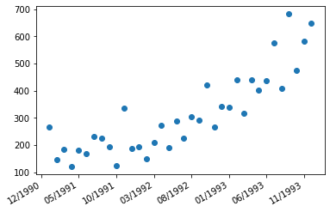

Now let’s perform the actual linear regression. We’re fitting the data to a line. What degree polynomial does that correspond to? Hopefully I have at least that many degrees by the time I leave college…

import numpy as np  
  
# Converting the datetime objects into an integer  
counter = 1  
numeric_months = []  
for date in dates:  
 numeric_months.append(counter)  
 counter += 1  
  
# Linear regression using a polynomial of a certain degree  
linear_regression = np.polyfit(numeric_months, sales, 1)

Remember like 5 years ago when you learned about slope-intercept form? Y’know, y = mx + b where m is the slope and b is the y-intercept? Don’t ask me why I still remember that, but we’re gonna use it now to plot the linear regression line:

import matplotlib.ticker as ticker  
  
m, b = linear_regression  
  
# Replicate the same formatting as the dates  
formatted_dates = [date.strftime('%m/%Y') for date in dates]  
formatted_dates.insert(0, "12/1990")  
ticks = [0] + numeric_months  
  
# Plot with X-axis as dates  
plt.gca().set_xticks(ticks, formatted_dates)  
plt.gcf().autofmt_xdate()  
plt.gca().xaxis.set_major_locator(ticker.MultipleLocator(5))  
points = plt.scatter(numeric_months, sales)  
  
# One of them is the Y-intercept, and one of them is slope  
line = plt.axline((0, b), slope=m, color="red")

MatplotlibDeprecationWarning: Passing the minor parameter of set_ticks() positionally is deprecated since Matplotlib 3.2; the parameter will become keyword-only two minor releases later.  
 plt.gca().set_xticks(ticks, formatted_dates)

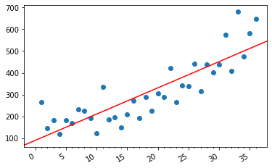

Congratulations, you did it! Now go to the upper left corner, hit file, press new, open a terminal, get to the right directory, and type  
quarto render 00_core.ipynb --to docx

Then, simply convert it to a PDF and email it to Alejandro and CC Prof. Poshyvanyk!

References:  
Where I found the shampoo data: https://machinelearningmastery.com/time-series-datasets-for-machine-learning/  
Original Source: Makridakis, S., Wheelwright, S.C. and Hyndman, R.J. (1998) Forecasting: Methods and Applications. 3rd Edition, Wiley, New York.