Class 4 R Intro
Kiana Bohanon
2026-01-15
x <- 1:50
plot(x,sin(x))
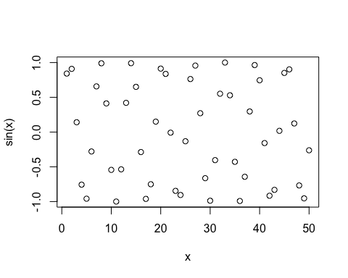
plot(x,sin(x),type="l",col="pink",lwd=2)
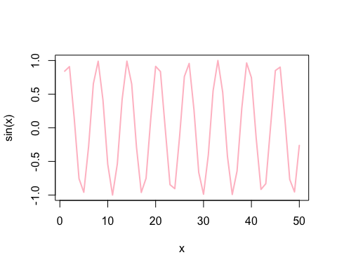
log(10,base=10)
## [1] 1

