**CMT3319**

**Winter Term**

**Android Grid Based Game**

The whole project is based on the actual «snake» game which was shown as an example.

This game strictly follows preassigned framework.

It represents itself a variation of old-school game called «Pac Man». Game moves around the map with 2 control buttons , which turn pac man left or right. Gamer needs to collect the red balls.

On the map there is three enemies which moves in one direction. If pac man hits the enemy - game ends.

There is a preset amount of ghosts , which is three.

If there is a need making game more complicated it is possible to make more enemies.

Unfortunately in the scope of this project , i did not figure out how to develop the proper AI of the enemies, so they are preset to move in one direction. Although, it can be a bit tricky, because the red ball is appearing at random locations.

The detailed class structure of is going to be provided in the Javadoc.

Enemies are developed separately. Each enemy has its one class.

The overall application does fully support the version of Android lvl15. preset resolution is 480x800.

The app was also tested on real tablet. And it does scales one work properly on Sony Xperia.

**Userguide**

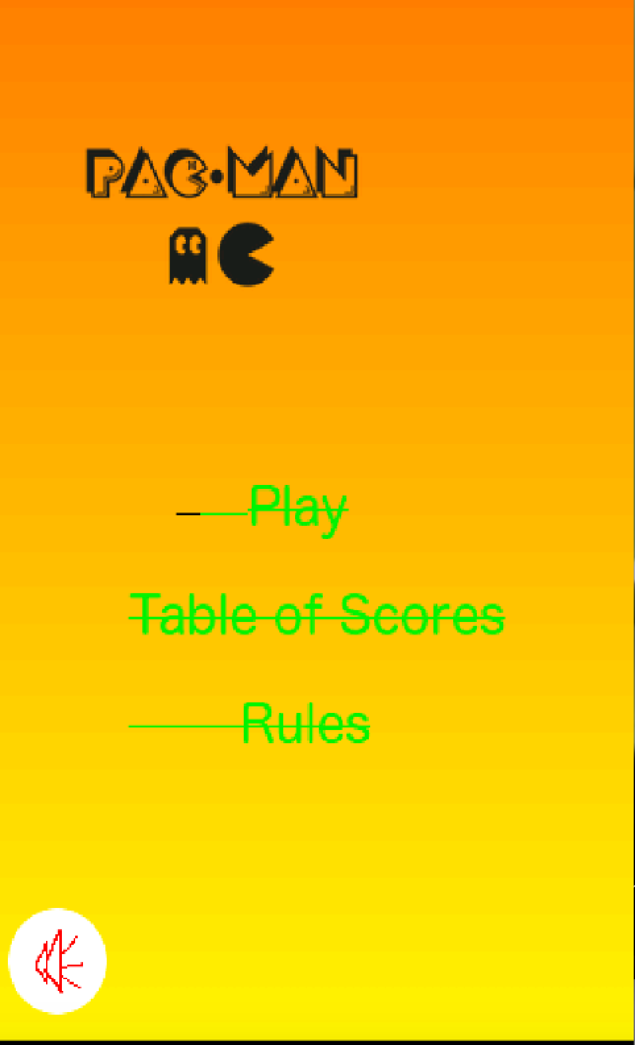

This is the starting screen of the application and the main menu of it. Which after pressing will lead user to 3 different location - Play (starts playing), Table of scores (shows the highest scores) and rules (shows the rules of the game).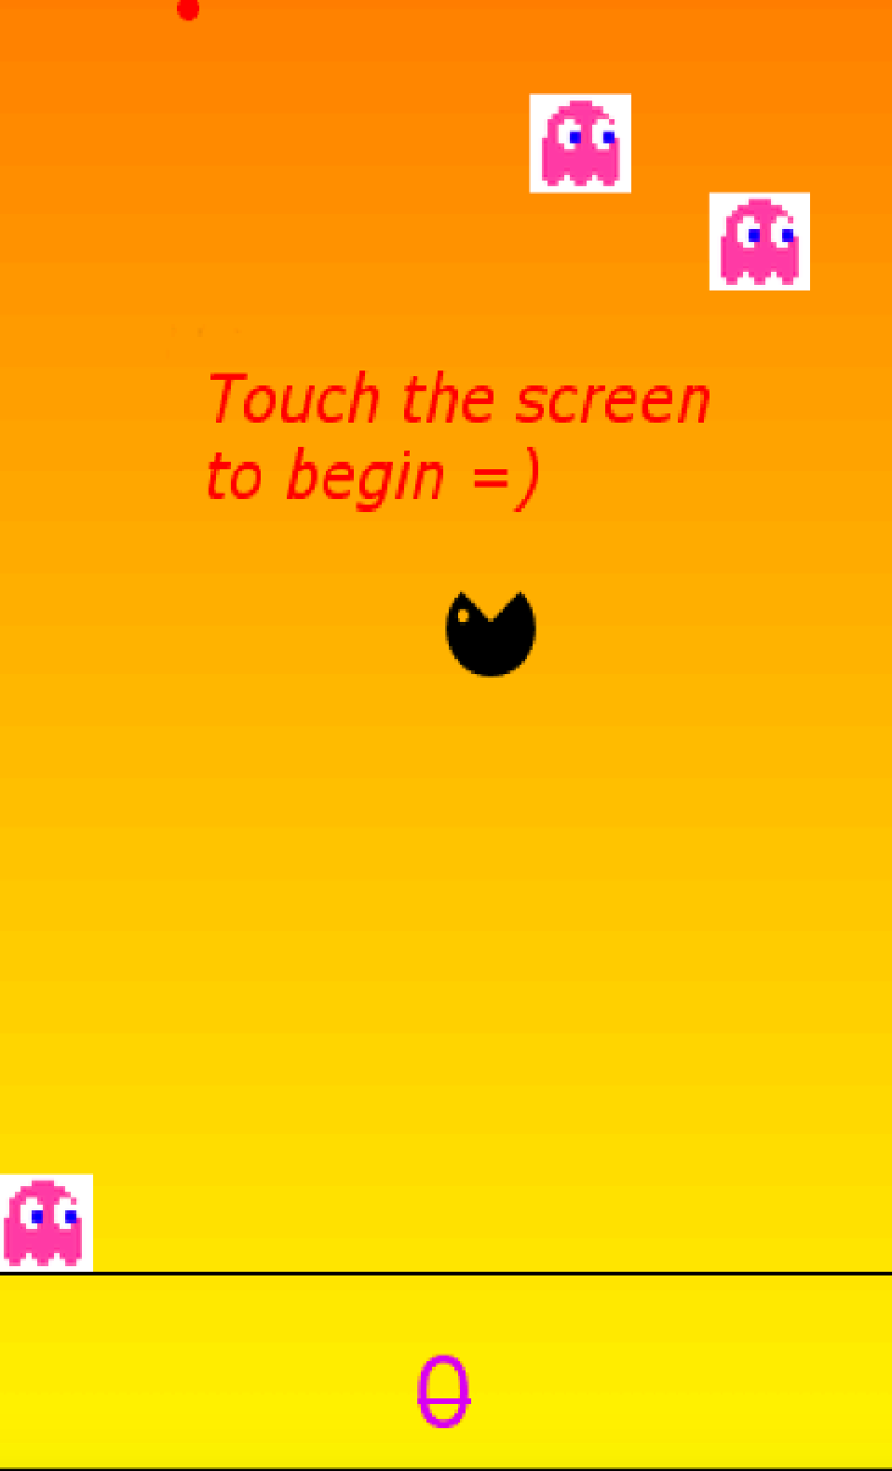

After user presses the Play button, the actual game starts. To begin playing user just needs to touch the screen. And the game starts.

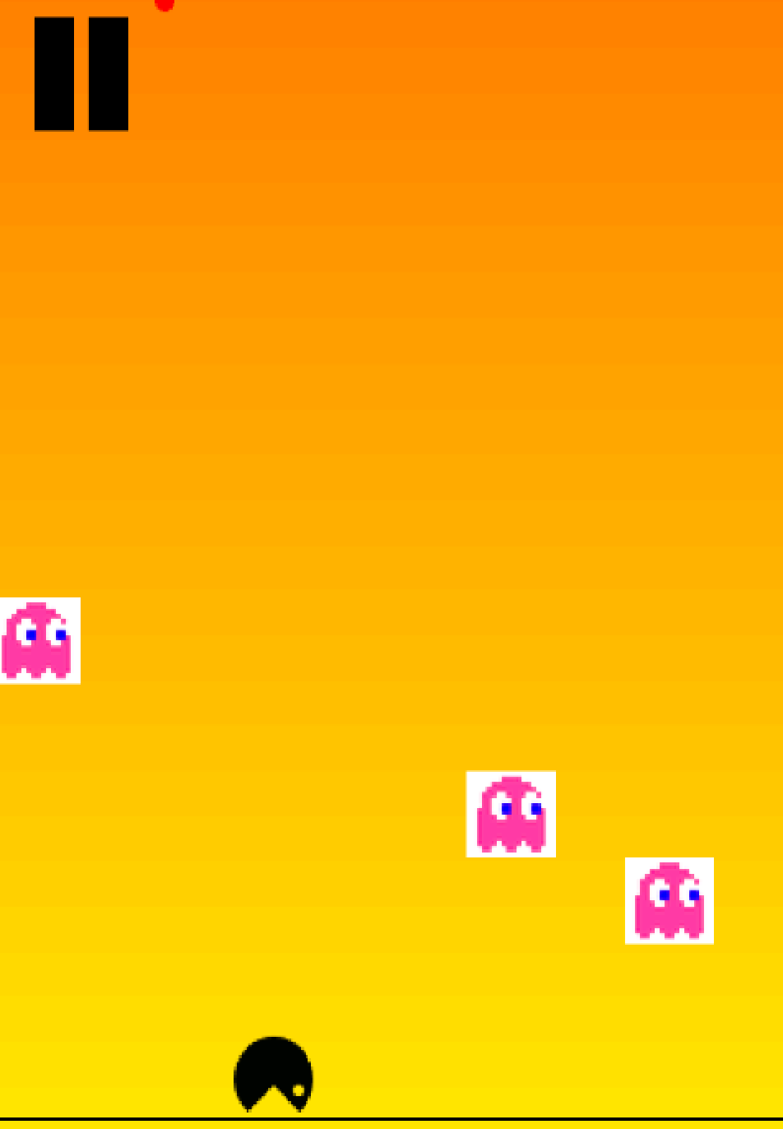

This picture shows the red bell near the ghosts and that they are actually moving , not just standing on static field.

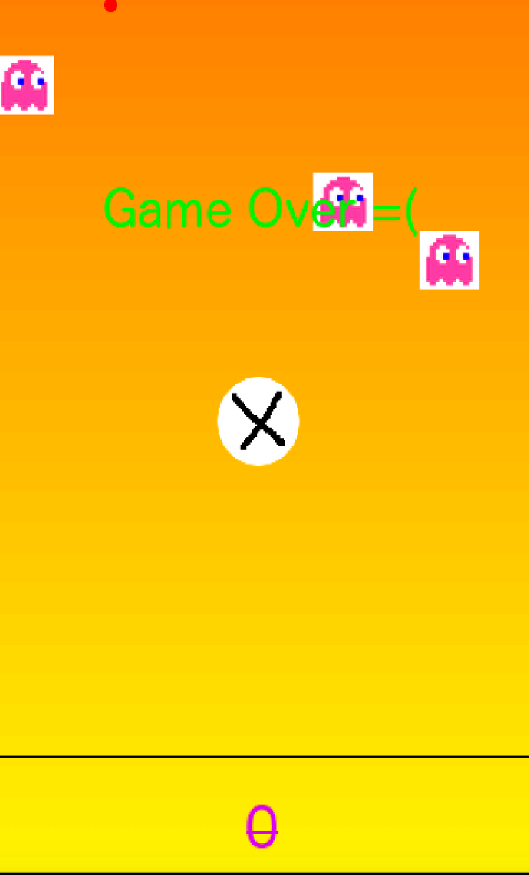

If user collides with the enemy - he/she has lost. The cross button will appear and you will need to press on it to come back to the main menu.

This menu appears if the user presses on Highest Score.

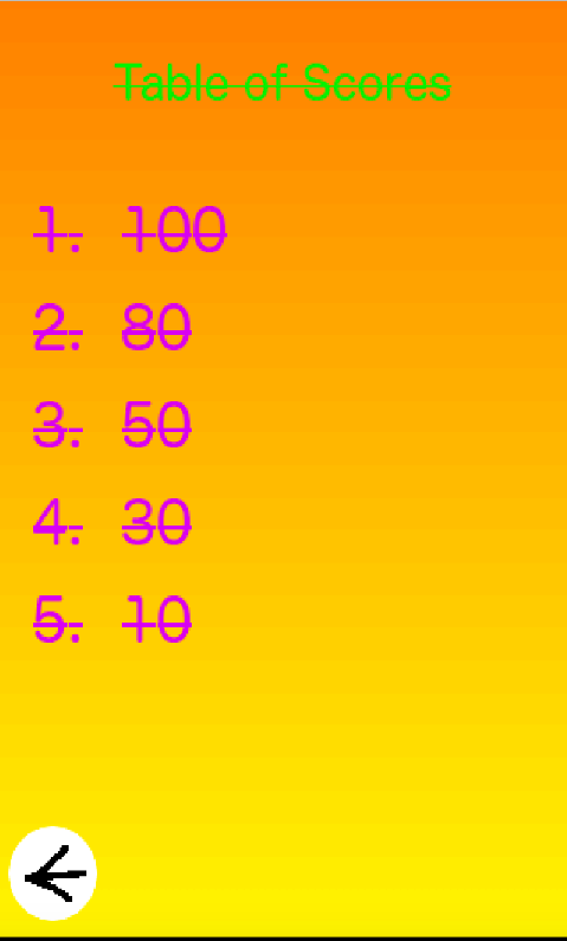

Small instructions also appear when user goes to the Rules section.

