|  |  |
| --- | --- |
| PHY 477/577: Obs. Methods & Data Analysis in Phys. Ocn. | Derek J. Grimes |
| Assignment 4: Plotting & Evaluating Periodic Fit to Data | grimesdj@uncw.edu |

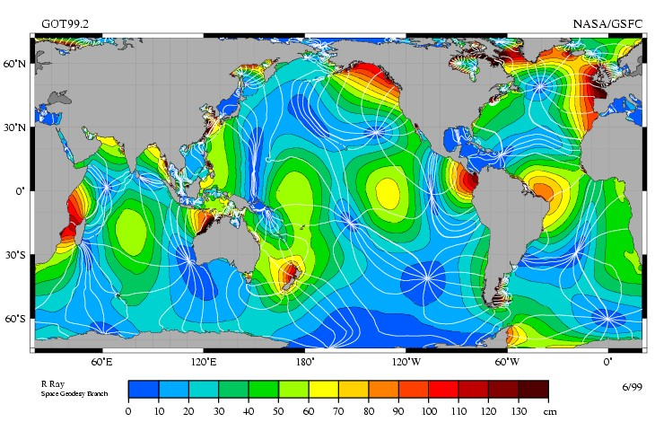

Figure 1: TOPEX/Poseiden derived map of M2-tidal amplitude and co-tidal lines (at 30 ◦ intervals, ≈ 1 hr).

NASA: GSFC & JPL; <https://svs.gsfc.nasa.gov/stories/topex/tides.html>

Goal: develop familiarity with auto-correlation and cross-correlation function.

Task: Astronomical tides are an excellent example of a complex periodic spatiotemporal signal. The degree of similarity between water-level variations at two locations will be effected by distance, ocean basin geometry (location of amphidromic points and orientation of cotidal lines), and differences in local shoaling/refraction (e.g., within bays and estuaries versus the open coast). Find two coastal tidal records [(https://tidesandcurrents.noaa.gov/)](https://tidesandcurrents.noaa.gov/) separated by a minimum of 100 km and no more than 6*,*000 km along the same continent/coastline. The west-coast of the US works particularly well for this problem.

1. A map with a blue line

   Description automatically generatedOn a google earth basemap, or using MATLAB’s built in routine, *geoscatter*(), plot the location of each data record. What is the distance between them? Is the line connecting these points roughly perpendicular to the co-tidal lines in Figure 1?

376.51 miles/ 605.93km from Cresent City CA to Monterey CA. Yes, the line connecting these pints is roughly perpendicular to the co-tidal lines in Figure 1.

1. Download ASCII water-level files (*e.g.,* .csv) of the 6-minute verified observations from two sites. You can either do this manually, or develop code to download data directly from the NOAA API (see HW2 for instructions). Make sure you use the same start/end time, sample interval, vertical datum, and units for both records.

-6min intervals from August 1-August 31 for both data sets

1. Make a line plot of the two records, labeling them by color or line type to indicate which-is-which. Are there similarities/differences between spring/neap cycle, or semi-diurnal inequalities, etc.? Explain.

Yes, both Cresent City and Monterey CA display very similar water level patterns. The main difference between these two data sets is that Cresent City has a greater range/ a greater difference between max and min values.

1. Estimate the sample means (*η*¯1 & *η*¯2), standard deviations (*s*1 & *s*2). How are they similar/different between the two sites? Is there a rational explaination?

SAMPLE MEAN CC 3.8003172043010753

SAMPLE MEAN M 3.3275766129032256

SD CC 2.1691320935264398

SD M 1.7096670510897929

As one would expect by looking at the graph the standard deviation is greater for Crescent City. Additionally, the sample mean for Crescent City is a little higher at 3.8, which suggests that not only does Cresent City change more from max to min water levels when compared to Monterey but also that Monterey pairs better with the min values from Cresent City than with Cresent cities max water levels. Overall Crescent City is skewed slightly toward higher water levels.

1. Zero center and normalize your records by their respective mean and standard deviation,

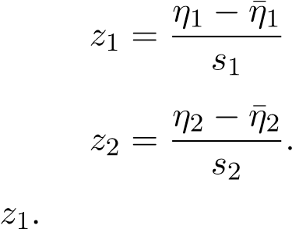*,*

then make a scatter plot of *z*2 versus

1. Estimate the correlation coefficient *ρ*ˆ1*,*2 = *C*ˆ*z*1*,z*2. Plot a dashed line with this slope through your scatter plot.

Estimated Correlation Coefficient (ρ^1,2): 0.89

1. Estimate the lagged auto-correlation function for both *z*1 and *z*2,

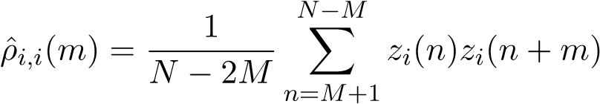 for *m* = [−*M,*−*M* + 1*,...,M*]

limiting the maximum lag to *M*∆*t <* 5 days. Plot them as line plots versus time *τ* = *m*∆*t* with the same color/linetype convension as before (or include a legend). Describe how *ρ*ˆ varies with *τ*. Is this behavior similar/different between sites? At what lags are there peaks in *ρ*ˆ? Are all of the peaks the same amplitude? How does this relate to patterns in the original records?

P^ for both Cresent City and Monterey goes closer to one as the time lag approaches zero, and decreases as the time lag approaches positive or negative 4. At a time lag of zero both Cresent City and Monterey reach their peak values of P^ and the peaks for both Cresent City and Monterey are approximately the same amplitude. However, Crescent City has a steeper slope than Monterey as the time lag moves to positive or negative 4 time lag. This all makes sense in comparison to the original records as Cresent City did experience great differences between maximum and minimum water levels so one would expect a steeper slope. Additionally, from original records the water levels didn’t stay the same day after day which aligns with what we see in the Lagged Auto-Correlation Graph.

8. Now estimate the lagged cross-correlation function between *z*1 and *z*2,

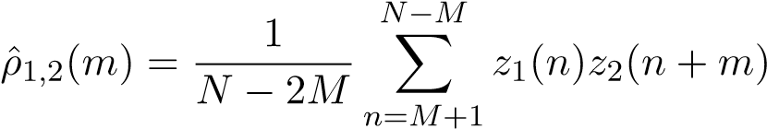 for *m* = [−*M,*−*M* + 1*,...,M*]*.*

limiting the maximum lag to *M*∆*t <* 24 hr. Plot your cross-correlation function *ρ*ˆ1*,*2 versus time-lag *τ* = *m*∆*t*.

1. What is the maximum cross-correltation max(ˆ*ρ*1*,*2)? At what time-lag *τ*max is the cross-correlation maximal? In what direction does this imply tidal signals are propagating? From 1 to 2, or vice-versa?

This suggests that P^1 (Cresent City) tides are propagating to P^2 (Monterey), and the tide is occurring at Cresent City about ten hours before the tide at Monterey.

Maximum Cross-Correlation (max(ρ^1,2)): 0.98

Time Lag at Maximum Cross-Correlation: -10 hours

1. Remake your scatter plot, but now scatter *z*2(*n*+*m*max) versus *z*1. Include a dashed line whose slope is max(ˆ*ρ*1*,*2). How does this compare to your zero lagged version? Explain.

This Scatter Plot demonstrates a more circular pattern than the previous zero-lagged version which was more like a stretched-out oval, which suggests a weaker correlation.

1. The barotropic tide is a shallow water wave that propagates with a speed,

*c* = p*gd,*

where *g* is Earth’s gravitational acceleration and *d* is the water depth. Using the time-lag of maximum correlation *τ*max and the distance ∆*x* between the two locations, approximate the average depth of the ocean. Does this value seem reasonable (within an order of magnitude)? Discuss why or why not (Hint: you might get insight from Figure 1).

Using the tau max of -10 hours and the distance of 605.93km between Cresent City and Monterey I calculated the average depth of the ocean to be(d): 28.878251980531324 meters. This value does seem reasonable for coastal waters along the coast of California.

2