Final Project

Due: November 27, 2019

Objective: To design and implement a basic Send-And-Wait protocol simulator. The protocol will be half-duplex and use sliding windows to send multiple packets between to hosts on a LAN with an “unreliable network” between the two hosts. The following diagram depicts the model:

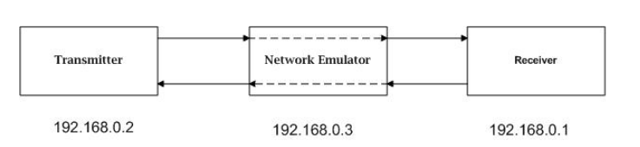

- C programming language

- UDP sockets only for data transmission between hosts

- Handle errors such as packet loss and duplicate packets.

- Implement timeouts and ACKs

- Usage and Instructions

- Tests and Verifications

- Future improvements can be done

-