TopCoder System Test Data Generator Deployment Guide

Revision History
Author | Revision Number | Date
isv | 1.0 | 01/31/2011
isv | 1.1 | 01/01/2012
isv | 1.2 | 05/01/2012

Deployment Instructions 3
1. Organization of Submission 3
2. Application Setup 3
2.1 Ant .Properties File 3
2.2 Build Scripts Setup 4
3. Database Setup 5
4. Deployment Instructions 5
5. Starting 5
6. Verification 5
7. Resource Contact List 21

Deployment Instructions

Organization of Submission

The submission follows directory structure provided below:

docs

Contains this document which is the Deployment Guide for the TopCoder System Test Data Generator assembly.

lib

Contains the binary distributions for TopCoder and external components used by the TopCoder System Test Data Generator assembly.

src

Contains all the sources for TopCoder System Test Data Generator tool.

test_files

Contains the helper files to be used for testing/review purposes only.

build.xml

Build script for TopCoder System Test Data Generator tool.

Application Setup

The application is expected to be deployed to the following environment:

JRE 1.5
Informix DS 11.0

Ant .Properties File

Property Name | File property is stored | Example Setting
number_of_clients | build.properties | Number of client accounts to be generated
min_number_of_billing_accounts_per_client | build.properties | Minimum number of billing account per client to be generated
max_number_of_billing_accounts_per_client | build.properties | Maximum number of billing account per client to be generated
min_number_of_direct_projects_per_account | build.properties | Minimum number of TC Direct projects per billing account to be generated
max_number_of_direct_projects_per_account | build.properties | Maximum number of TC Direct projects per billing account to be generated
min_number_of_active_contests_per_project | build.properties | Minimum number of active contests per TC Direct project to be generated
max_number_of_ active_contests_per_project | build.properties | Maximum number of active contests per TC Direct project to be generated
id_generator_start | build.properties | The initial starting ID for all ID generation sequences
out | build.properties | A path to a file to write generated SQL statements to
db_host | build.properties | A host running the database server
db_port | build.properties | A port for running database server
db_server | build.properties | A name of the database server instance
db_user | build.properties | A username used to establishing connection to database
db_password | build.properties | A password used to establishing connection to database
studioSubmissionIdsFile | build.properties | A path to text file listing the Studio submission IDs available in Production environment (look at test_files/studioSubmissionIds.txt for reference)
submissionDeclarationsFile | build.properties | A path to a text file to write the generated data for submission declarations to
INFORMIXDIR | build.properties | A path to installation of Informix DB server
DBACCESS | build.properties | A path to DBACCESS tool provided by Informix
INFORMIXSERVER | build.properties | A name of Informix server instance
INFORMIXLOCALE | build.properties | Locale set for Informix server instance
min_project_fulfillment | build.properties | Minimum project fulfillment
max_project_fulfillment | build.properties | Maximum project fulfillment
average_project_fulfillment | build.properties | Average project fulfillment
min_contest_registrants | build.properties | Minimum number of a registrants for single contest
max_contest_registrants | build.properties | Maximum number of a registrants for single contest
average_contest_registrants | build.properties | Average number of a registrants for single contest
average_contest_submissions | build.properties | Average number of a submissions for single contest
average_submission_failure_rate | build.properties | Average rate of a failed submissions for single contest
outTerms | build.properties | A path to a file to write note on users terms of use acceptance

Build Scripts Setup

The build script (build.xml) provides the following targets which are to be used:

- compile – compiles the TopCoder System Test Data Generator tool
- run - runs the TopCoder System Test Data Generator tool for generating the SQL scripts for sample projects
- bulk-test-data-load – loads the database tables with sample data for projects generated by the tool (this task is to be used only for testing/review purposes in VM environment).
- submission-declarations-load – loads the database tables with sample data for submission declarations generated by the tool

Database Setup

No changes to existing database schema have been introduced with this assembly.

For testing the tool on VM environment run test_files/calendar.sql script to set some lokup data which currently may not be set in the database.

Deployment Instructions

- Setup the parametes for TopCoder System Test Data Generator tool in build.properties file
- Run TopCoder System Test Data Generator tool using ant run command to generate the SQL scripts
- Run SQL scripts generated by TopCoder System Test Data Generator tool using ant bulk-test-data-load command
- Run SQL scripts for submission declarations generated by TopCoder System Test Data Generator tool using ant submission-declarations-load command (Note that this command uses dbaccess tool and must be run by user granted permission to execute that tool, 'informix' for instance).
- For testing/review purposes run TCS DW Data Loader tool. To do so copy test_files/tcs_dw_loader.jar to some directory on VM. Login to VM and unpack the archive. Execute ant tcs_dw and ant weeklystat commands (Note that the former task may take more than 10 hours to execute depending on the amount of the generated data)

Starting

- Build TopCoder System Test Data Generator tool
- Run TopCoder System Test Data Generator tool to generate data for sample projects
- Run the generated SQL scripts against target database

Verification

1.1.1.1 Project Fulfillment Range - this configuration should be configured via 3 properties

- In TC Direct application navigate to Enterprise Dashboard page using an URL like http://cockpit.cloud.topcoder.com/direct/dashboardEnterprise
- The page with enterprise dashboard data must be displayed. The fulfillment values must be within the range from min_project_fulfillment to max_project_fulfillment
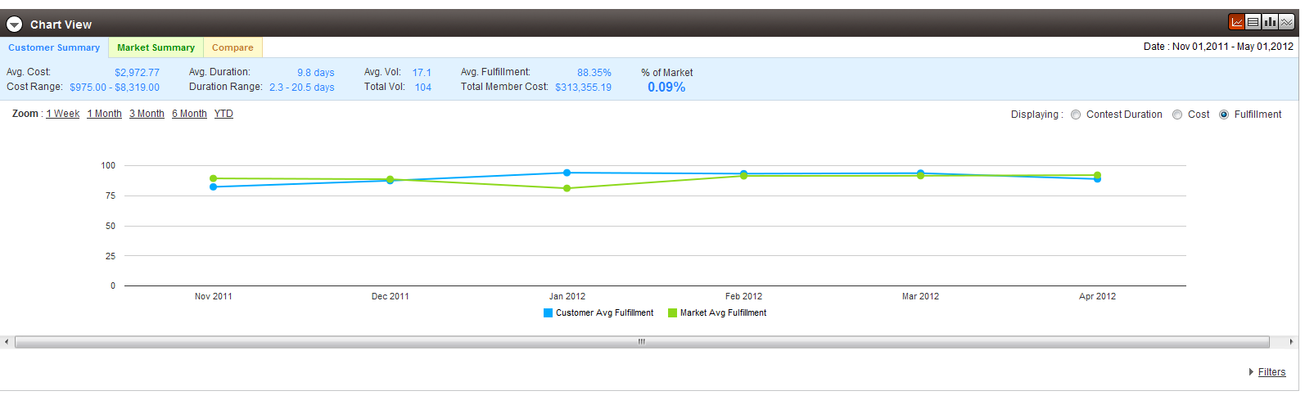
1.1.1.2 Contest Registrants Range - this configuration should be configured via 3 properties

- In TC Direct application navigate to Dashboard page using URL like http://cockpit.cloud.topcoder.com/direct/dashboardActive.action
- The page listing active contests must be displayed. The Registrants column for each generated contest must contain the value (if not equal to 0) in range from min_contest_registrants to max_contest_registrants

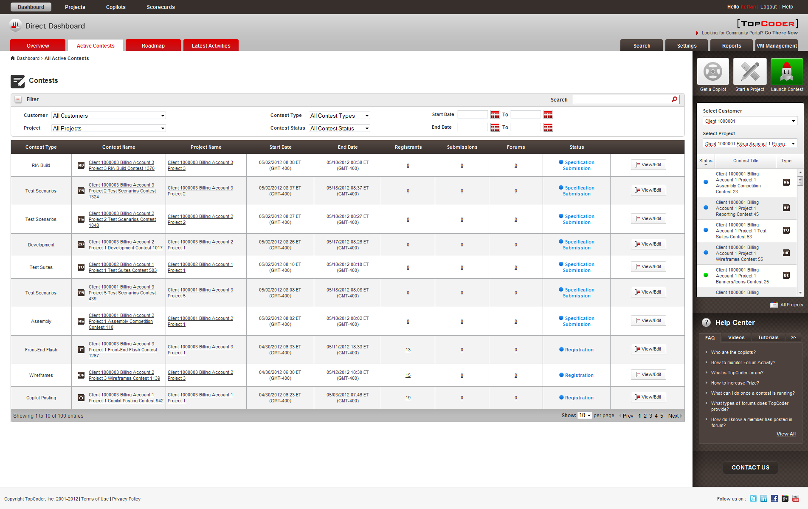

1.1.1.3 Contest Submissions Range - this configuration should be configured via 3 properties

- In TC Direct application navigate to Dashboard page using URL like http://cockpit.cloud.topcoder.com/direct/dashboardActive.action
- The page listing active contests must be displayed. The Submissions column for each generated contest must contain the value (if not equal to 0) in range from 1 to max_contest_registrants

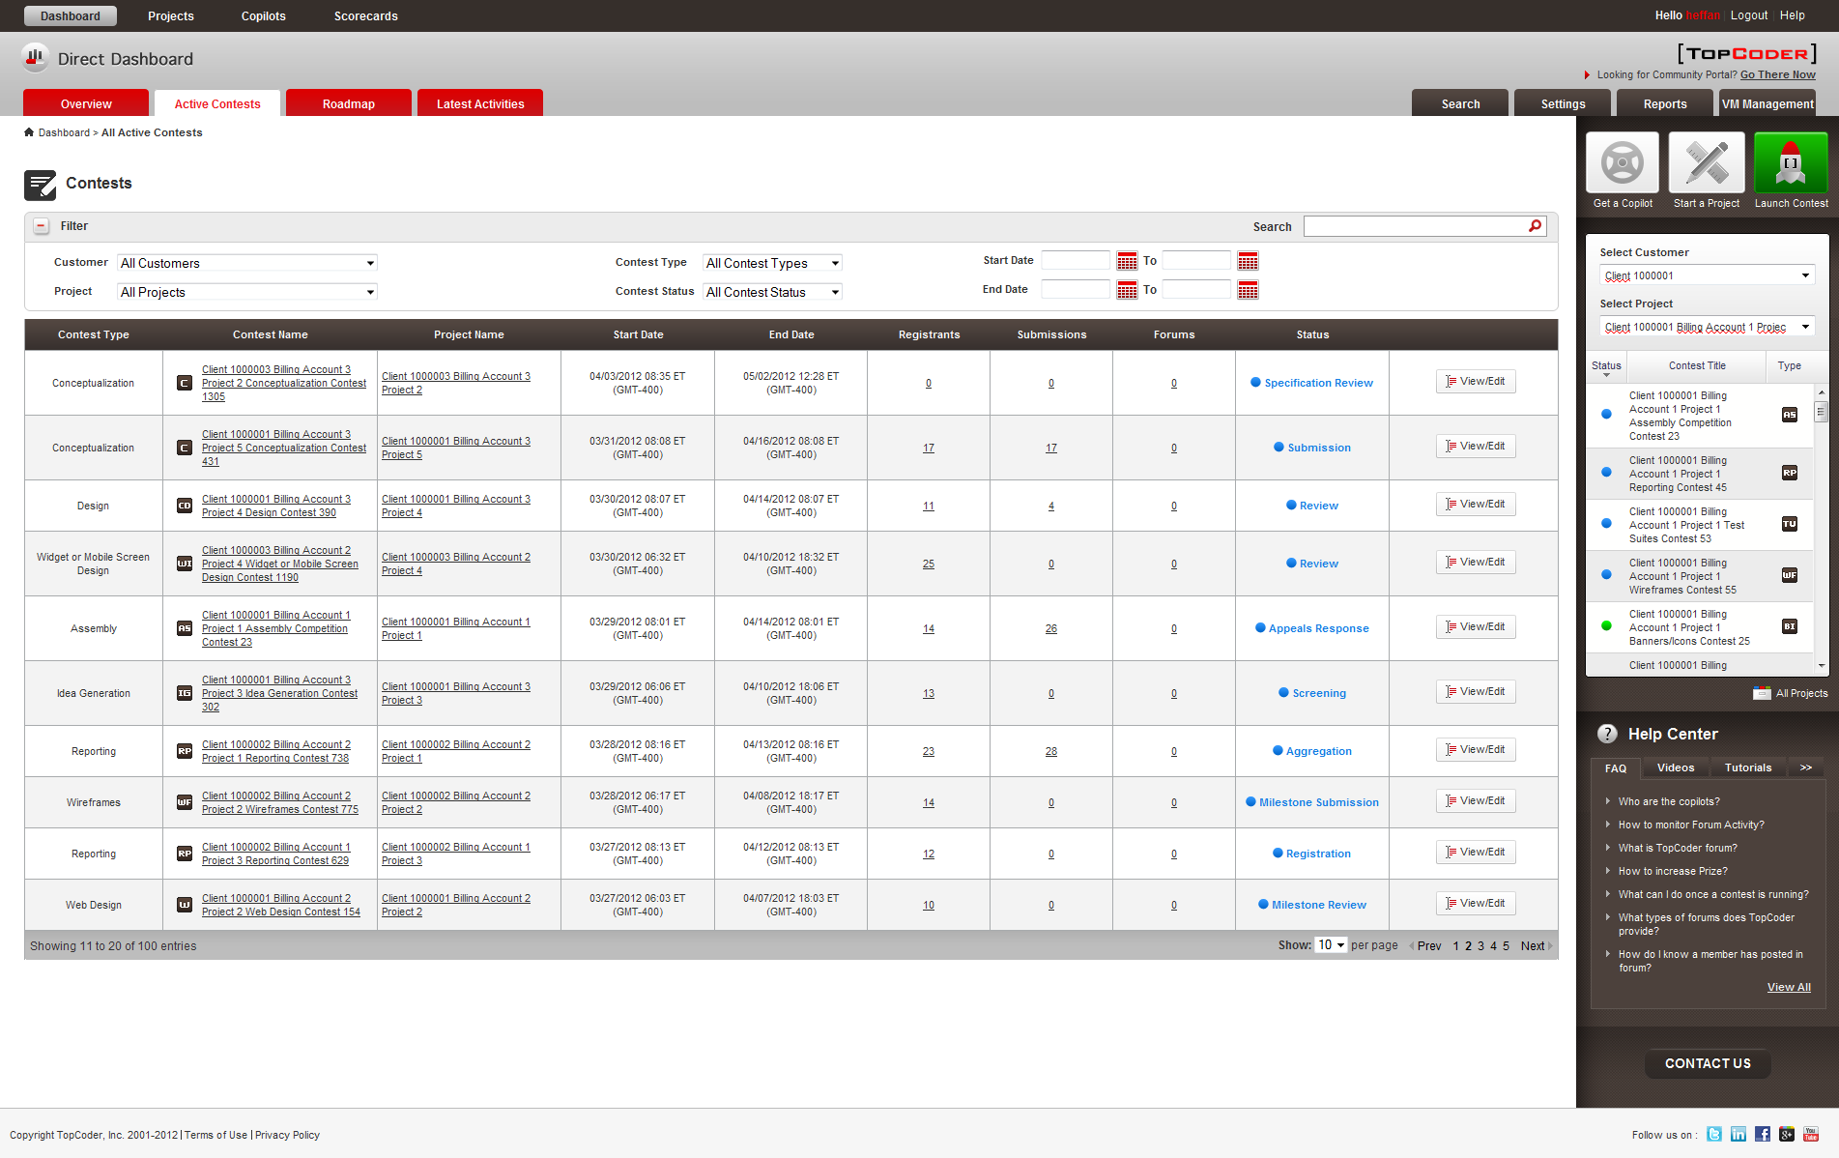

1.1.1.4 Average Failure Rate of the contest submissions - this configuration should be configured via 1 property

- In TC Direct application navigate to Dashboard page using URL like http://cockpit.cloud.topcoder.com/direct/dashboardActive.action and click the number in Submissions column for desired contest which has reviews finished.

- The page listing submissions must be displayed. The number of submissions which failed to pass review (scored with 25) must satisfy the rate set by average_submission_failure_rate parameter

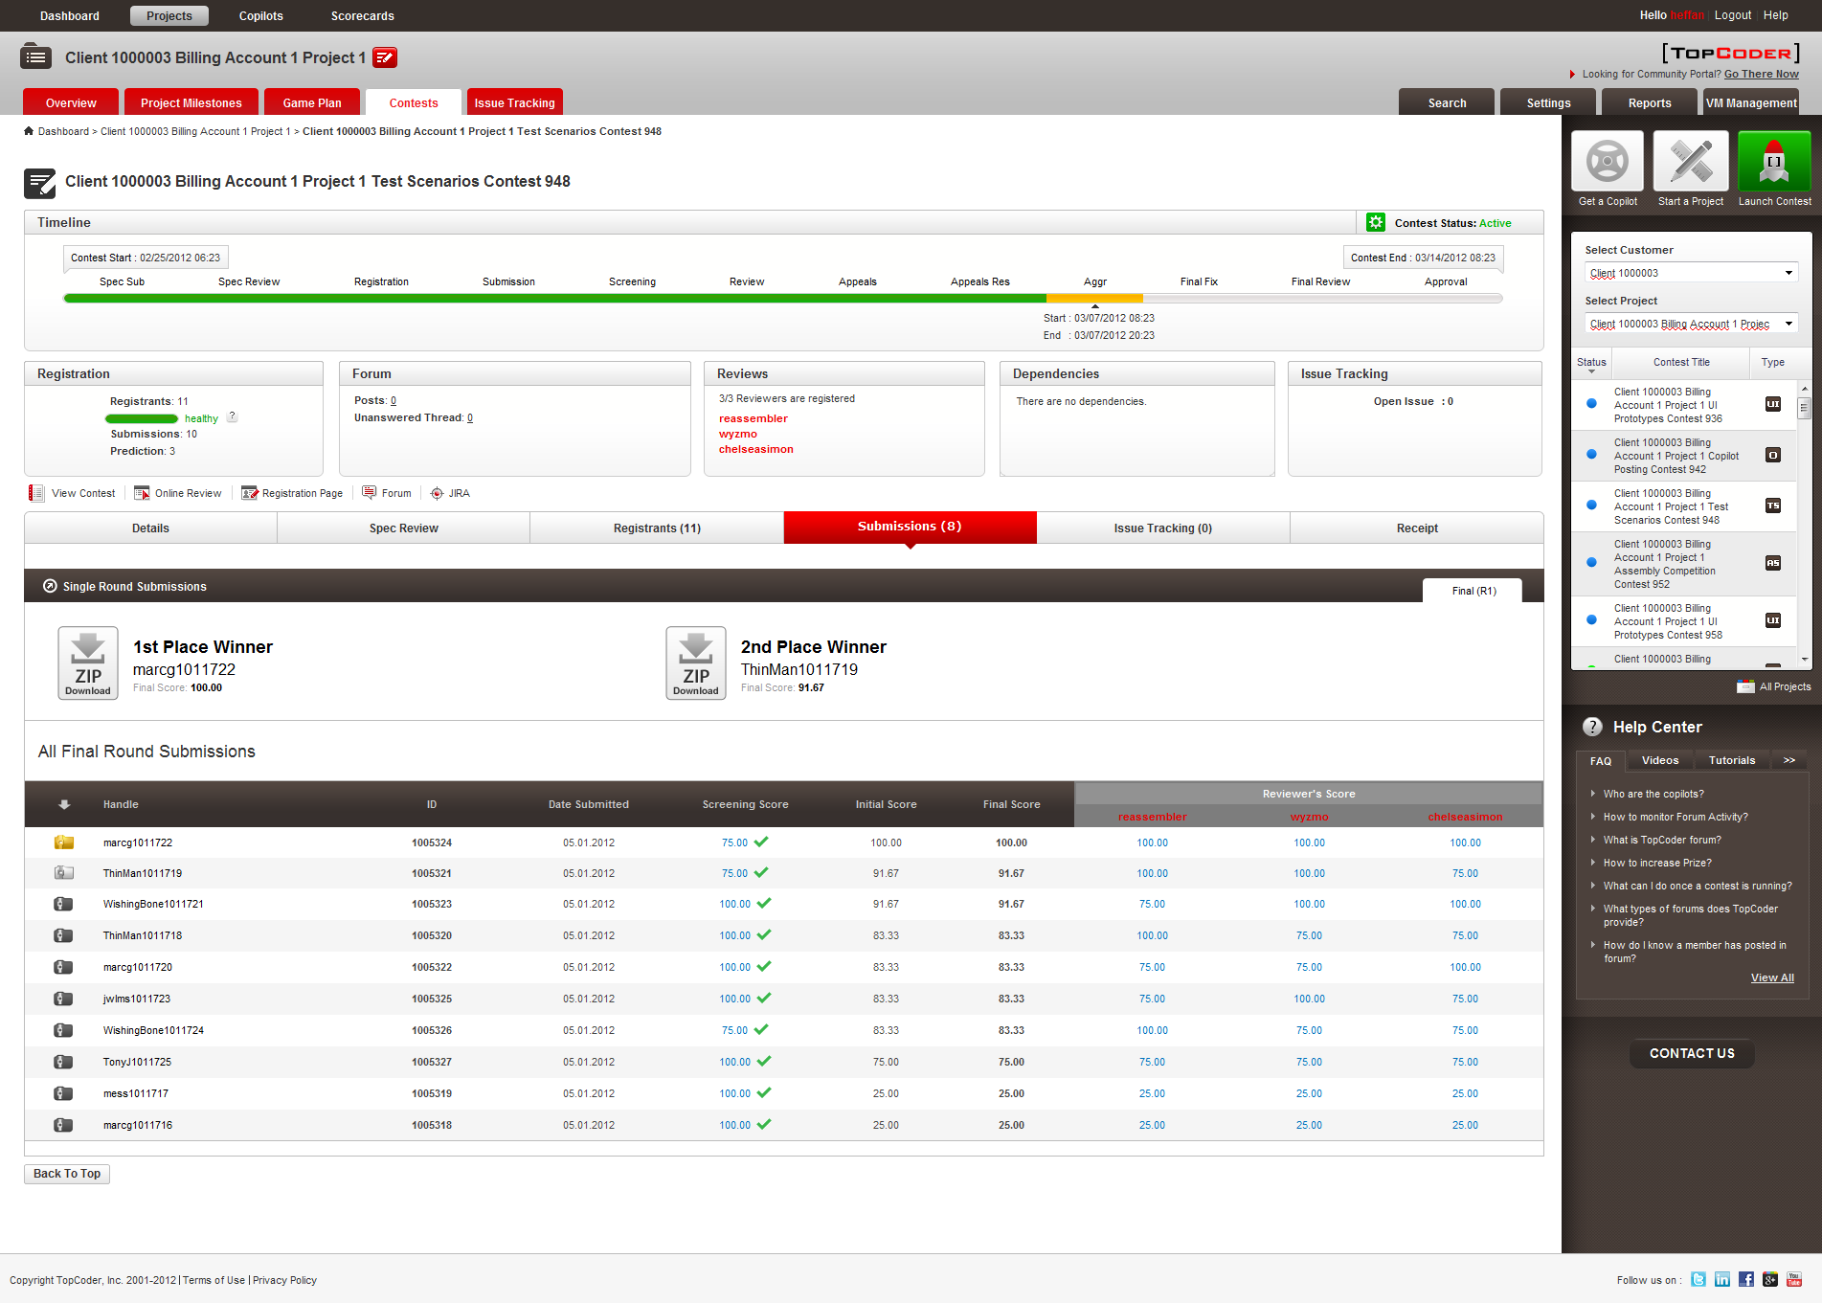
1.1.2.1 Insert user rating data

- In TC Direct application navigate to Dashboard page using URL like http://cockpit.cloud.topcoder.com/direct/dashboardActive.action
- The page listing active contests must be displayed. The handle for the current user at the top-right corner must be colored according to rating as shown.

1.1.2.2 Add review board for different contest tracks
- In Topoder Web Module application navigate to Home page using URL like http://tc.cloud.topcoder.com/tc and then click Meet The Review Board link for any sort of the contest types on the left-hand navigation menu
- The page listing the review board members must be displayed.

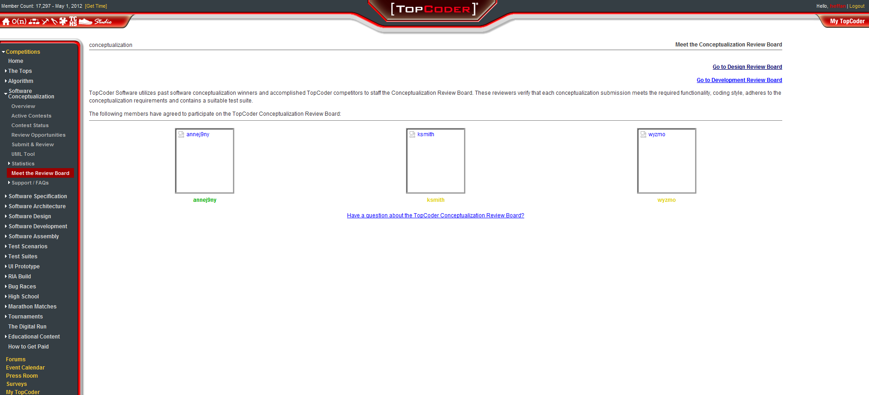

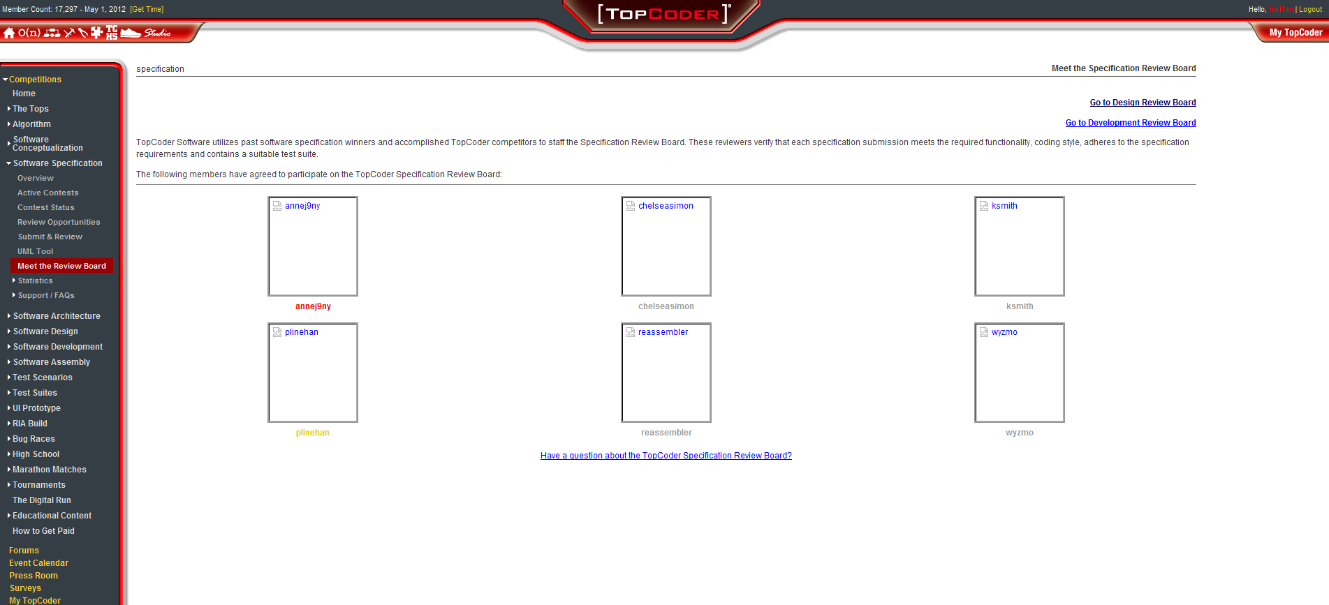
1.1.2.3 Add Copilot Pool Data

- In TC Direct application navigate to Get A Copilot page by clicking Copilots button at the top of the page

- The page with available copilots from the pool must be displayed.

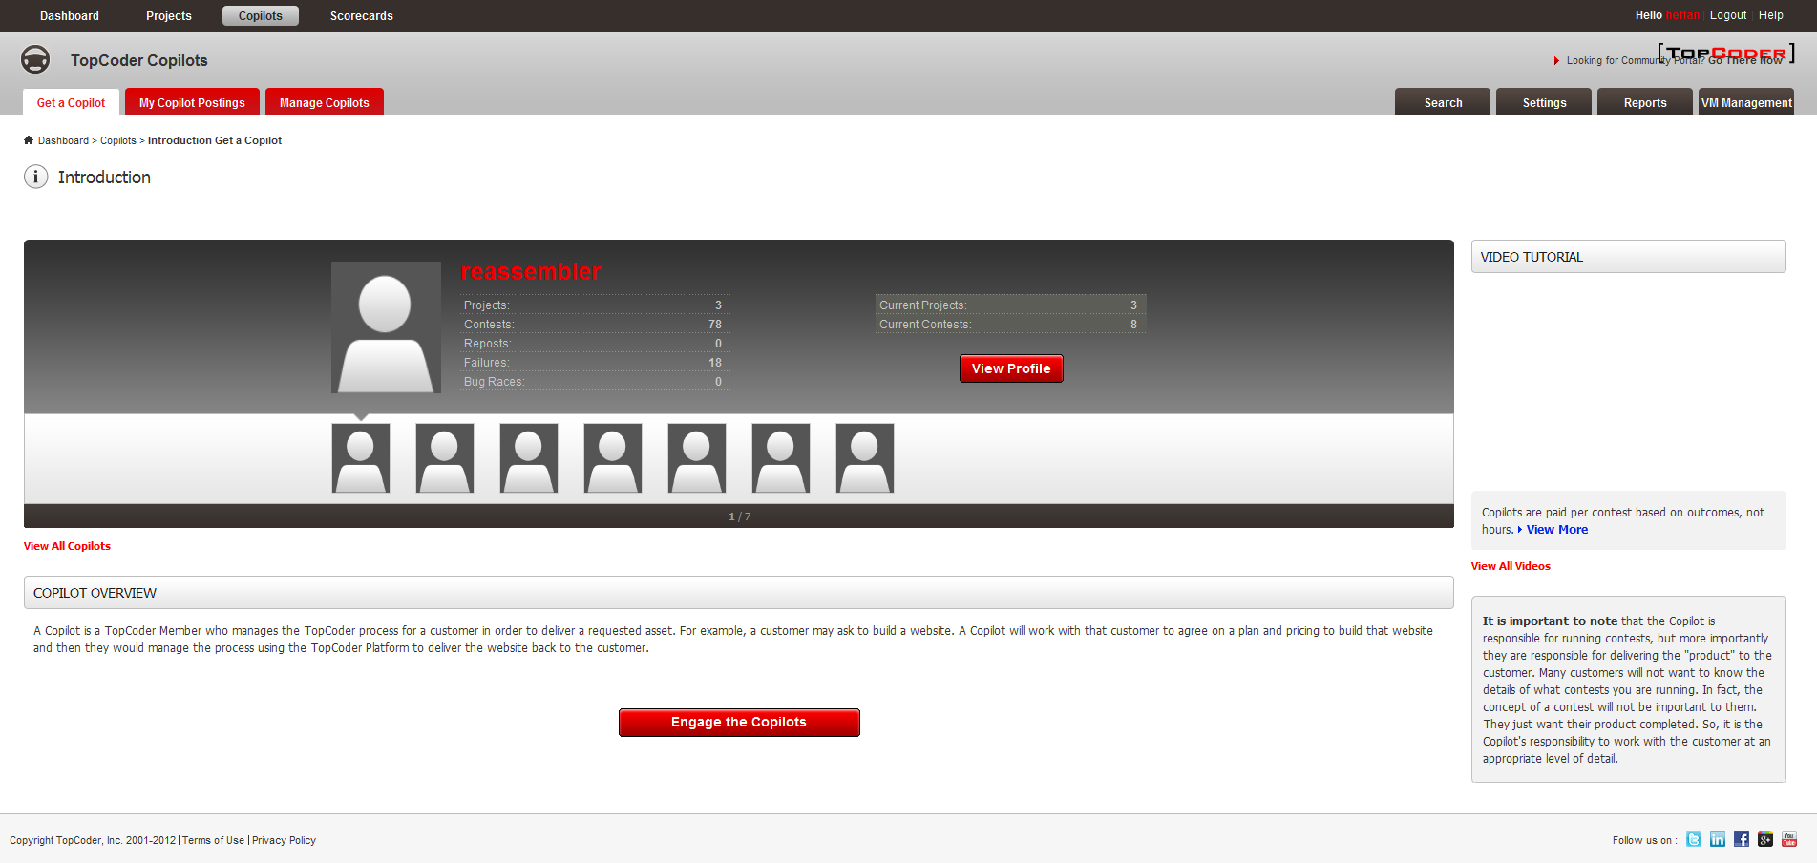

1.1.2.4 Set up different roles for user and add user terms

- After running the test data generator tool check the following results
- The file mentioned in value of outTerms property in build.properties must be created.
- That file must contain a content looking as follows

Following users accepted specified terms of use:
User: 20 - dok_tester
17 - Reviewer terms of use text
20493 - Another terms of use text
20543 - Submitter terms of use text 20543
20623 - Submitter terms of use text
20703 - Submitter terms of use text 20703
20704 - Reviewer terms of use text 20704
20713 - CCA terms of use text 20713
20753 - Assignment 2.0
20794 - Approved OR Managers - TopCoder Technical Team
20893 - MSA
20963 - Government id term

User: 21 - dok_tester1
17 - Reviewer terms of use text
20493 - Another terms of use text
20543 - Submitter terms of use text 20543
20623 - Submitter terms of use text
20703 - Submitter terms of use text 20703
20704 - Reviewer terms of use text 20704
20713 - CCA terms of use text 20713
20753 - Assignment 2.0
20794 - Approved OR Managers - TopCoder Technical Team
20893 - MSA
20963 - Government id term
1.1.2.5 Project Copilot / Contest Copilot

- In TC Direct application navigate to Project Overeview page for desired project by selecting it from Select a Project drop-down on the right-hand panel

- The page with project details must be displayed. The Project Copilots area must list from 1 to 2 of copilots assigned to project.

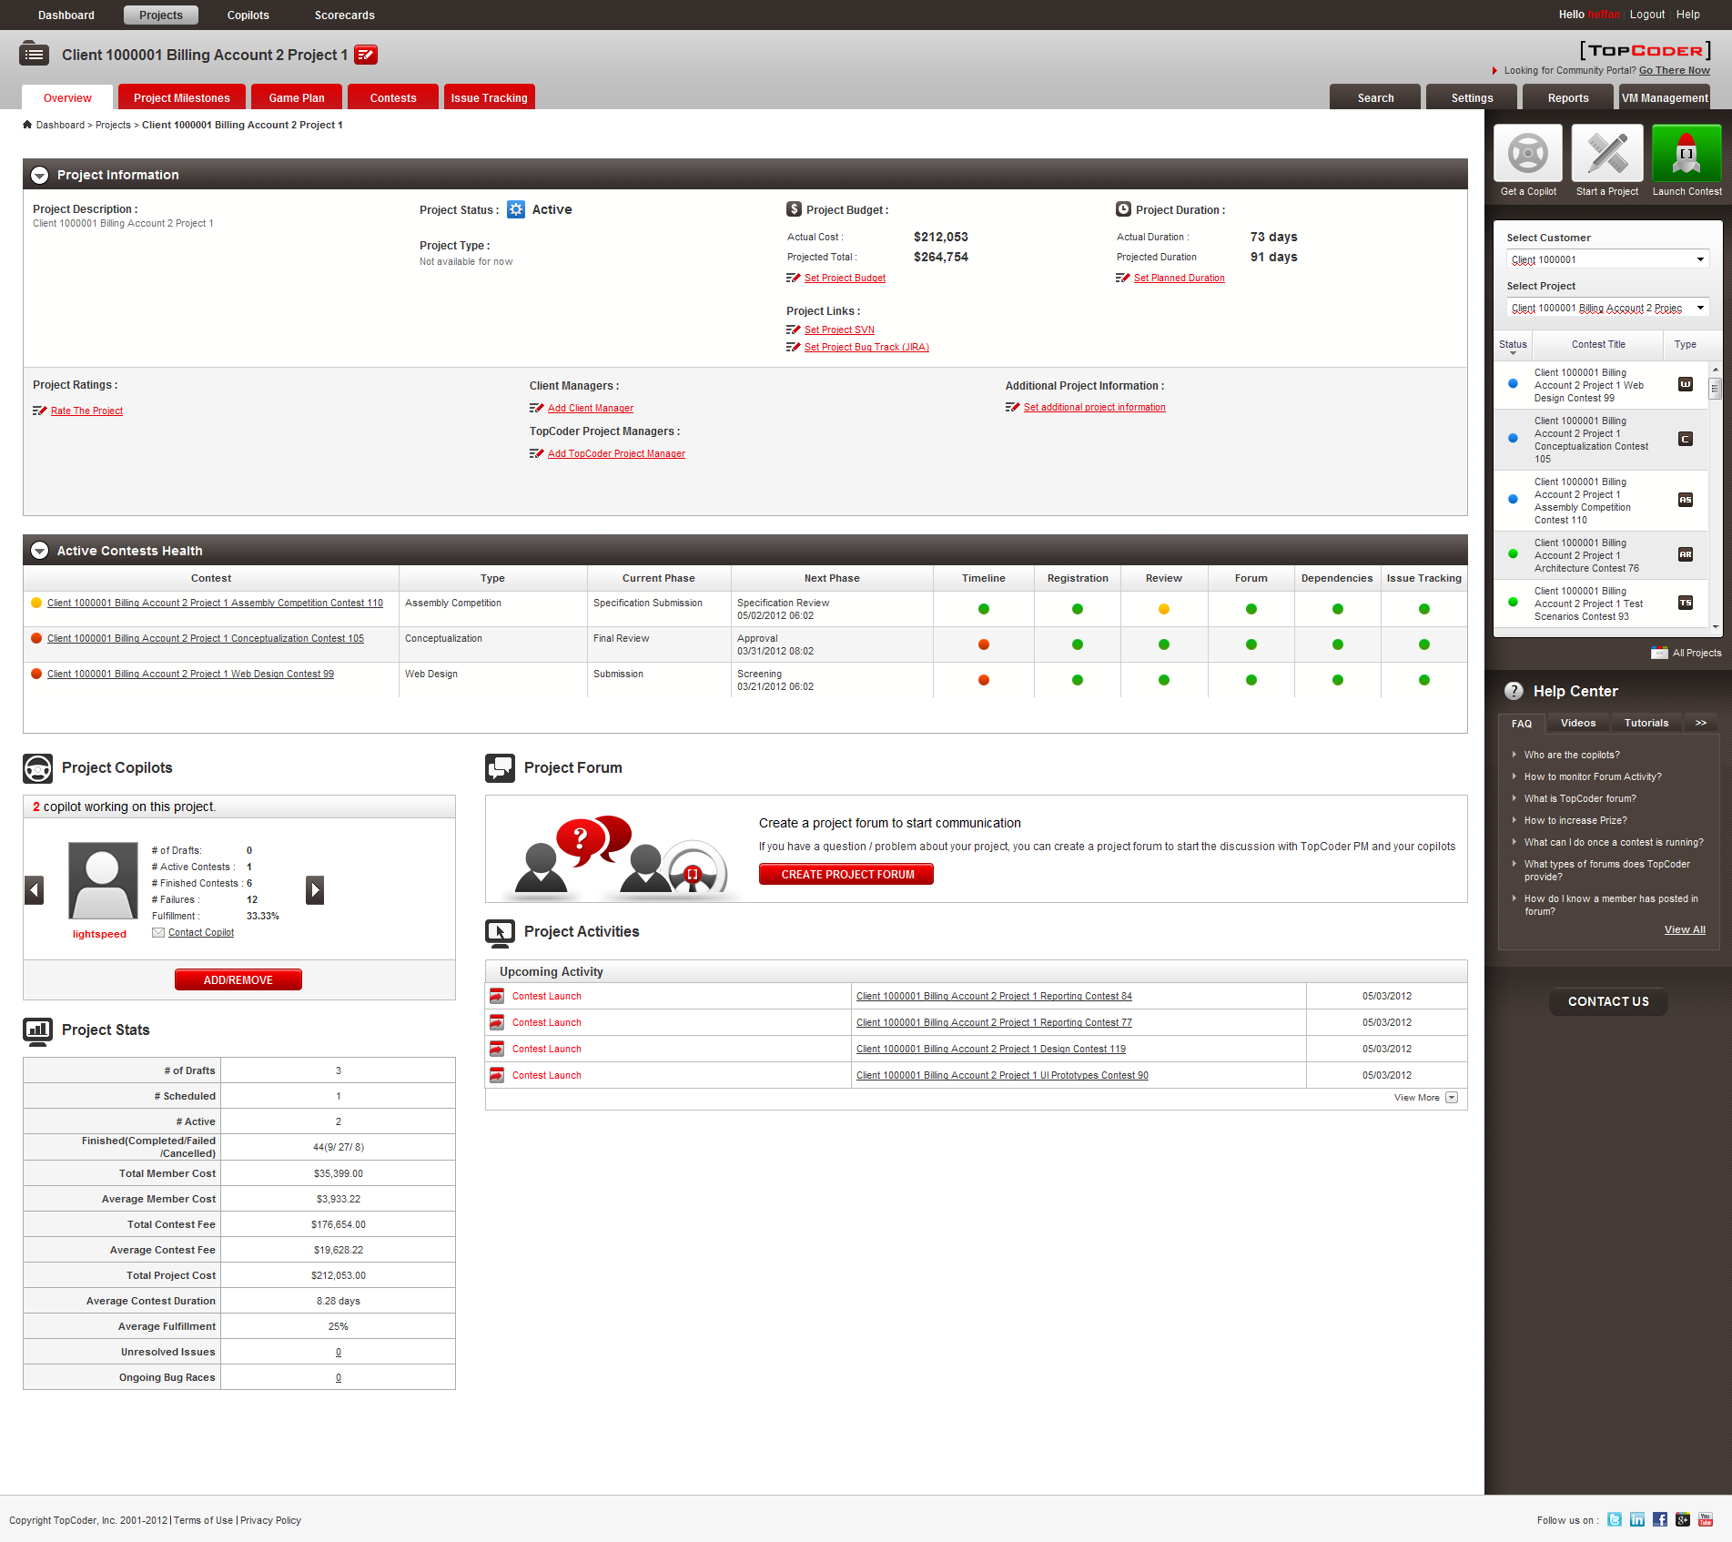

1.1.3 Payment Entries

- In TC Direct application click Reports tab, then select Invoice History from the Select a Report drop-down and once the form for submitting invoice history report parameters is displayed click APPLY button
- The report data must be displayed once retrieved from the server (may take several minutes to retrieve). The data must contain invoice history records of various values in Payment Type column, like Winner, Spec Review, Digital Run, Review, Copilot.

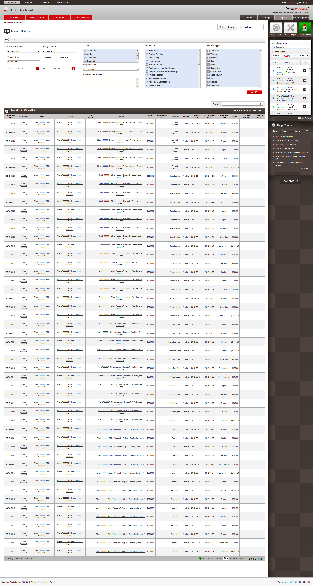
1.1.4 Fixes

Update the billing accounts expiring time to a future date so it's always visible after inserting test data.

- In TC Direct application click Launch Contest button, then expand the Billing Account drop-down
- The drop-down must list the generated billing accounts

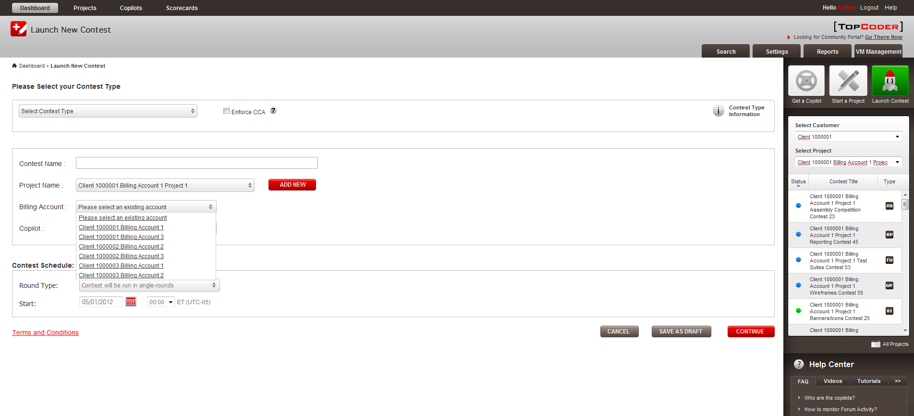
For Copilot Posting contest type, the timeline is not correct. It should always be single round and only have 3 phases, see the following screenshot

- In Online Review application navigate to My Open Projects page using URL like http://tcs.cloud.topcoder.com/review/actions/ListProjects.do?method=listProjects&scope=my , find a Copilot Posting contest and click to open Project Details page
- The Project Details page must be displayed and the timeline for contest must have only Registration, Submission and Review phases.

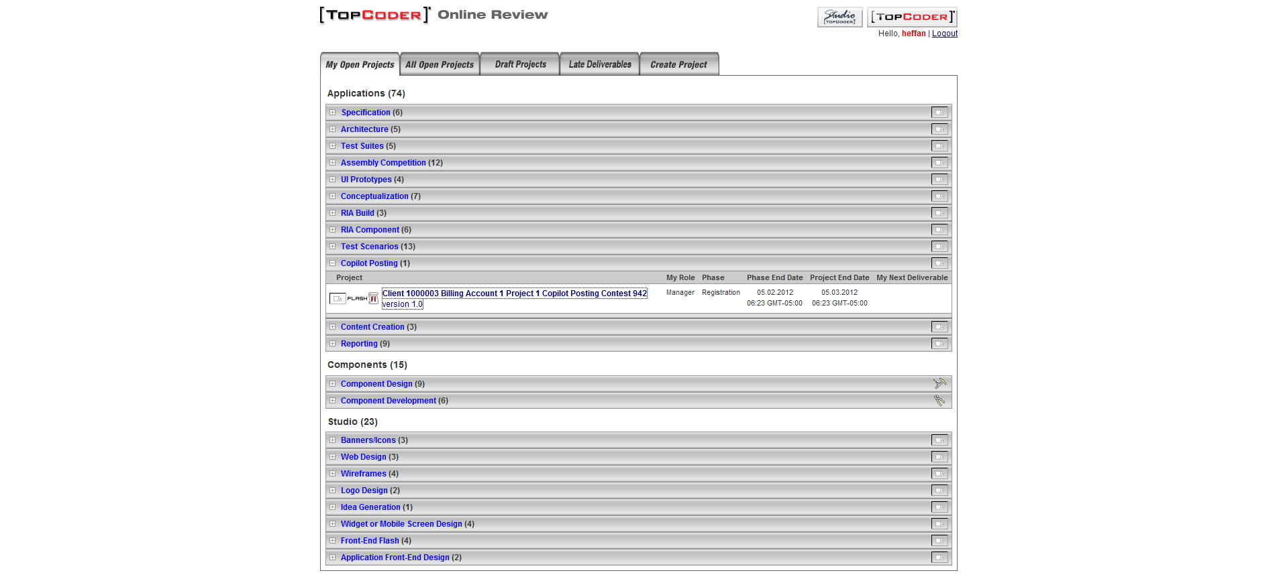
Some contests cannot be opened in online review, the log shows the following error, this should be fixed.
- In Online Review application navigate to My Open Projects page using URL like http://tcs.cloud.topcoder.com/review/actions/ListProjects.do?method=listProjects&scope=my , find a contest which has Submission phase closed and click to open Project Details page
- The Project Details page must be displayed successfully for such a contest.

The active contests within a project all have the same current phase, this should be fixed. The active contests of a project should have different current / active phases.

- In TC Direct application navigate to Dashboard page using URL like http://cockpit.cloud.topcoder.com/direct/dashboardActive.action and sort records by clicking Project Name column header
- The page listing active contests must be displayed. The contests belonging to single TC Direct project must have various open phases but not just single one.
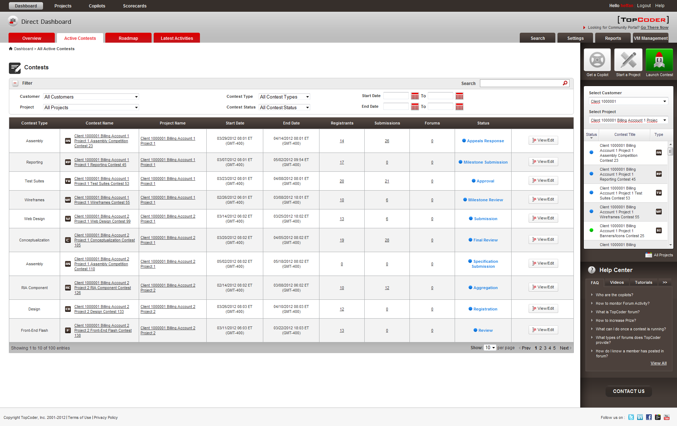

Resource Contact List

Name | Resource Email
isv

