MINIPROJEKT
TicketHub
Online Eventbilletsystem
Microservices med C#, Dapr og Aspire

Varighed: 5–7 uger
Teknologier: .NET / C#, Dapr, .NET Aspire
Op til 5 microservices med messaging, REST og SAGA

9. Vejledende Arkitektur
Nedenfor er en oversigt over den samlede arkitektur. Pilene viser kommunikationsretningen.

9.1 Serviceoversigt

Service | Port (forslag) | Database | Dapr-funktioner
Event Catalog | 5001 | POSTGRESQL/POSTGRESQLite | Pub/sub (publish)
Inventory | 5002 | POSTGRESQL/POSTGRESQLite | Pub/sub (subscribe), Service invocation
Ordering | 5003 | POSTGRESQL/POSTGRESQLite | Workflow, Pub/sub (publish), Service invocation
Payment | 5004 | Ingen (stateless) | Service invocation
Notification | 5005 | Ingen (log-baseret) | Pub/sub (subscribe)

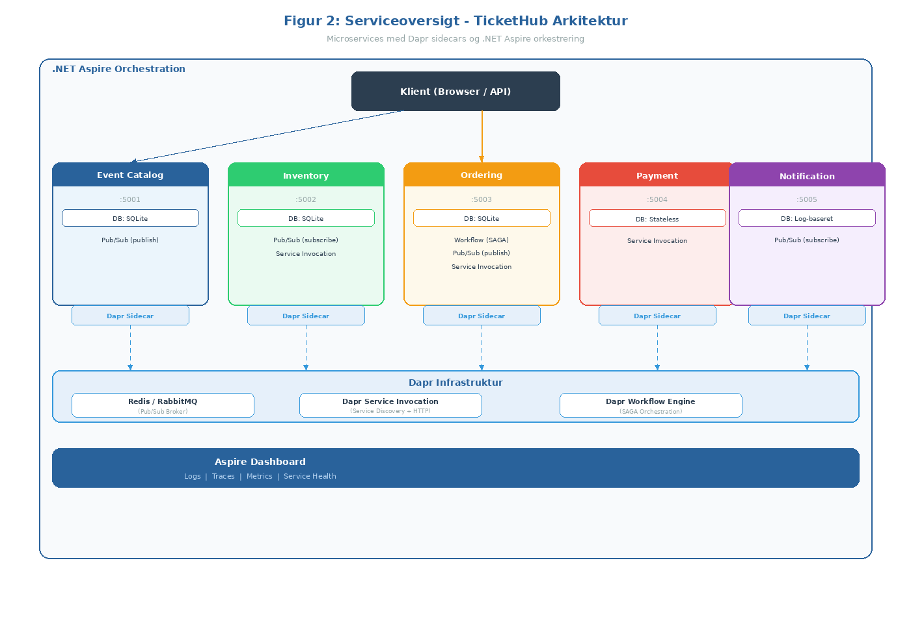
Figur 2: Serviceoversigt – TicketHub Arkitektur med Dapr og Aspire

9.2 Kommunikationsoversigt
Asynkron messaging (pub/sub):
- Event Catalog → [EventCreated] → Inventory
- Event Catalog → [EventUpdated] → Inventory
- Ordering → [OrderConfirmed] → Notification
- Ordering → [OrderCancelled] → Notification
- Inventory → [InventoryLow] → Event Catalog

Synkron REST (Dapr service invocation):
- Klient → Event Catalog (browse/søg events)
- Klient → Ordering (placér bestilling)
- Ordering → Event Catalog (prisopslag)
- Ordering (workflow) → Inventory (reserve/release)
- Ordering (workflow) → Payment (process payment)

