
RTOS-Based Fire and Smoke Hazard Detection System using STM32F746 Report

EE-423: Embedded Systems Design

Group Members:
Bushra Rehman (405946)
Sabika Fatima (429648)
Noor Fatima (412641)

1. Introduction
This project implements a real-time fire and smoke hazard detection system using the STM32F746 microcontroller with FreeRTOS. Independent tasks monitor fire and smoke sensors concurrently. When a hazard is detected, an alert is sent via a FreeRTOS queue to a centralized Alert Task that controls an LED alarm.

2. System Architecture
Hardware Components:
- STM32F746 board
- Fire sensor (digital)
- Smoke sensor (ADC)
- LED (visual alarm)
Software Components:
- STM32 HAL
- FreeRTOS kernel
- FreeRTOS tasks and queues

3. FreeRTOS Tasks
Fire Task: Reads a digital GPIO to detect flame/fire and sends alerts on detection.
Smoke Task: Reads ADC values, compares against threshold, and sends alerts when exceeded.
Alert Task: Highest priority task that receives alerts from the queue and turns the LED ON for a fixed duration.

4. Inter-Task Communication
A FreeRTOS queue is used for safe communication between sensor tasks and the Alert Task. This design prevents race conditions and ensures a single task controls the LED hardware.

5. Sensors used:
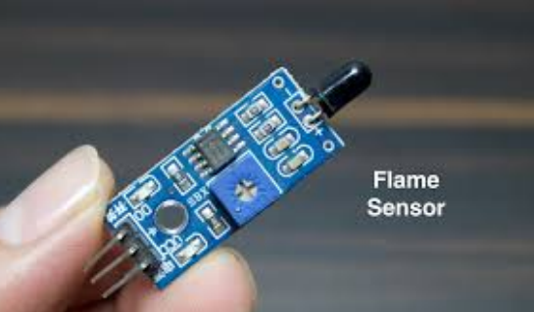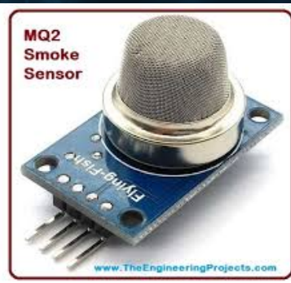

6. Outputs and Results
Output Screenshot 1: Fire Detection → LED ON
Output Screenshot 2: Smoke Detection → LED ON
Output Screenshot 3: Normal Condition → LED OFF
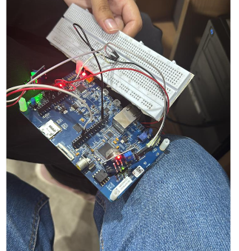

7. Testing and Validation
The system was tested for fire-only, smoke-only, and simultaneous conditions. The LED alarm activated correctly without missed detections, demonstrating reliable RTOS scheduling.

8. Student Roles
Sabika Fatima: FreeRTOS task design and scheduling.
Noor Fatima: Sensor interfacing and ADC configuration.
Bushra Rehman: Testing, validation, and documentation.

9. Conclusion
This project demonstrates effective use of FreeRTOS on STM32F746 for real-time fire and smoke detection. Task-based design with queue communication provides fast response and system reliability.

