FINAL REQUIREMENTS
NAME | KAYE ASHLEY B. MIZAL
PROJECT TITLE | FireGuard: A Centralized Endpoint Firewall Management System with Basic Host-Based Intrusion Detection
SUBJECT | INFORMATION ASSURANCE AND SECURITY 2
CODE | 12808
TIME | 9:00 - 12:00 NN
DATE OF PROJECT  PRESENTATION | July 10, 2026
PROJECT NAME | #19 Firewall Rule Management System

Technologies and Framework
Finalized stack actually implemented in the FireGuard codebase (app.py, agent.py):
Programming Language | Python 3 (Flask web server + agent script), PowerShell (start_live_admin.ps1 for elevated launch), Windows netsh command-line firewall control
Network / Security Libraries | psutil (live process, connection, CPU/RAM inspection), werkzeug.security (pbkdf2/scrypt password hashing), secrets (cryptographically random agent bearer tokens), socket-level netsh advfirewall integration
Backend Technology | Flask (Python) — session-based web app + token-authenticated REST API consumed by the agent
Frontend Technology | HTML5 / CSS3, Jinja2 templating, vanilla JavaScript for dashboard interactivity (auto-refresh widgets, charts)
Database | Microsoft SQL Server (localdb) for local development/demo; MySQL schema (deploy/schema_mysql.sql) for cloud hosting (e.g., PythonAnywhere)
Reporting | ReportLab (PDF generation), native CSV export

Detection Techniques / Functions / Features
These are the detection techniques actually implemented in the FireGuard traffic monitor (background thread started by start_monitor()), replacing the generic template examples with the finalized project features:
Technique | Description | Severity
1. Repeated Connection  Attempts Detection | Flags any single source IP that opens more than 5 new connections within a 30-second window. | WARNING
2. High Connection Count  Detection | Flags the system when total live connections (system-wide) exceed 100 concurrently — an indicator of possible flooding/DoS-style activity. | HIGH
3. Restricted Port Access  Detection | Flags any connection touching a sensitive port — 22 (SSH), 23 (Telnet), 135 (RPC), 445 (SMB), 3389 (RDP) — common lateral-movement / exploit targets. | HIGH
4. Rule-Based Traffic  Classification | Every live connection is classified ALLOW or BLOCK against the active firewall rule set and logged to traffic_logs for later review. | INFO
5. Automatic IP Blocking | Any IP matched to an active BLOCK rule, or flagged by a detector above, is auto-inserted into blocked_ips and rejected globally by the before_request gate (enforce_ip_block) before it can reach any page or route. | CRITICAL
Note: A live Attack Simulator (/simulate/attack) can synthesize a fake port scan + connection flood from a chosen IP, so alerting and auto-block behavior can be demonstrated live during the defense without needing a real attacker machine.

Required Data (Sample Data Provided by the System)
1. User Information | users table — user_id, full name, username, email, role (Administrator / Security Analyst / Viewer), account status, last login.
2. Network Device Inventory | endpoints table — registered lab PCs: hostname, IP, MAC, device type, online/offline/warning status, last-seen timestamp, agent version.
3. Connection / Traffic Logs | traffic_logs table — every classified connection event (source IP, destination port, protocol, ALLOW/BLOCK verdict, timestamp) captured via psutil on the monitored machine.
4. Intrusion Detection Logs | Records produced by the three detectors above (repeated connections, high connection count, restricted port access) prior to being raised as alerts.
5. Alert Logs | alerts table — alert_type, source IP, description, severity, timestamp, read/acknowledged status and acknowledging user.
6. Network Traffic Statistics | Aggregated dashboard figures — live connection counts, ALLOW vs. BLOCK ratio, top source IPs, per-endpoint CPU/RAM/connection trends.
7. System Activity Logs | endpoint_heartbeats (time-series health snapshots every 30s) plus Flask application logs (flask.log / flask.err.log) for server-side events.
8. Report Information | reports table — record of every generated PDF/CSV traffic report: type, generated_by, generated_at, file reference.
9. System Configuration | fireguard_settings.json (Live Mode on/off, apply_firewall_rules flag) and agent_config.json (server URL, bearer token, heartbeat_interval) per endpoint.
10. Threat Intelligence  (Blocklist) Database | blocked_ips table — every IP currently blocked fleet-wide, with the reason and the rule/detector that triggered it.
11. Dashboard Analytics | dashboard.html aggregate view combining endpoint fleet status, recent alerts, and traffic summary in one screen for the Administrator/Analyst.

Security Problems Identification (Assumed Target: School Computer Laboratory)
Assumed environment: a college/senior-high computer laboratory of ~20-40 identical Windows PCs on one LAN, managed by one or two IT/lab staff, with heavy daily student use (browsing, USB drives, remote-access tool installs for demos, printer/router sharing).
Security Problem | CIA / AAA Affected | Why It Matters | How FireGuard Addresses It
Decentralized, inconsistent firewall configuration | Availability, Integrity, Accountability | Each lab PC's Windows Firewall is configured individually; a single misconfigured or disabled machine silently weakens the whole lab's network baseline, with no record of who changed what. | The /rules module lets one Administrator define ALLOW/BLOCK policy once and apply or push it fleet-wide; every rule is stamped with created_by and created_at for a clear change record.
No visibility into endpoint health or connectivity | Availability | Lab staff typically only discover a disconnected, overloaded, or firewall-disabled machine when a student reports a problem. | Each agent sends a heartbeat (CPU%, memory%, connection count, firewall on/off) every 30 seconds; a machine is auto-flagged Offline after 90s of silence on the /endpoints fleet dashboard.
Unrestricted lateral movement between lab machines | Confidentiality, Integrity, Availability | Identical, same-subnet Windows PCs with services like RDP (3389), SMB (445), or Telnet/SSH left open are a classic vector for worm/ransomware spread across an entire lab in minutes. | The Restricted Port Access detector flags any connection touching those ports (22/23/135/445/3389); the matched IP is auto-blocked fleet-wide via blocked_ips and the global enforcement gate.
Reconnaissance / port-scanning and brute-force attempts | Confidentiality, Integrity | Before a targeted attack, a student or outside attacker on the same network commonly probes for open services or repeatedly hammers a login/service port. | The Repeated Connection Attempts detector (>5 new connections from one IP within 30s) and High Connection Count detector (>100 concurrent connections) raise WARNING/HIGH alerts and log the event automatically.
Weak console access control, brute-force login attempts, and lack of role separation | Confidentiality, Authorization, Authentication | If every staff account had full administrative rights and login was a single unguarded password check, one compromised or brute-forced credential could reconfigure firewall policy for the entire lab. | Passwords are hashed (werkzeug pbkdf2/scrypt); three enforced roles (Administrator / Security Analyst / Viewer) restrict who may create rules, push deployments, or only observe; accounts auto-lock for 15 minutes after 5 wrong passwords; and optional TOTP-based Two-Factor Authentication requires a 6-digit authenticator-app code in addition to the password before a session is granted.
No audit trail for incident review or compliance reporting | Accountability | Without a record of rule changes, unblocks, or historical traffic, the lab cannot reconstruct what happened during an incident or produce evidence for an audit. | Every rule is tied to created_by; every alert can be acknowledged_by a named user; and the /reports module exports timestamped PDF/CSV traffic history on demand.

Security Deployment
Application Type: Client–Server Application with a Web-Based Management Console (hybrid deployment).
FireGuard is deployed as two cooperating components inside the school's computer laboratory LAN:
- FireGuard Server (app.py) — runs on one lab/faculty machine (or a small on-prem server); hosts the Flask web dashboard and the SQL Server/MySQL database; is the only component a human logs into.
- FireGuard Agent (agent.py) — runs on every managed lab PC; authenticates to the server with a per-endpoint Bearer token (secrets.token_hex(20)); sends heartbeats and applies pushed rules via netsh — the only part that needs elevated OS privileges.
- IT staff/instructors reach the dashboard from any browser on the lab LAN (or remotely through the tunnel in deploy/ for off-site administration).
Security Controls Mapped to CIA / AAA:
Confidentiality | Hashed passwords (pbkdf2/scrypt via werkzeug); Bearer-token authentication on every agent↔server API call; optional HTTPS tunnel for remote access.
Integrity | Server-side form validation (parse_rule_form) rejects malformed rule input; rule application is the single source of truth pushed from the server, not edited ad-hoc per machine.
Availability | Endpoint heartbeat + 90s offline detection keeps the lab's network health visible; auto-blocking contains flooding/lateral-movement attempts before they affect other machines.
Authentication | Session-based login for humans (login_required); Bearer token for machine-to-machine agent calls (_verify_agent_token).
Authorization | Three enforced roles — Administrator, Security Analyst, Viewer — via the roles_required() decorator on every sensitive route.
Accountability | created_by on every firewall rule; acknowledged_by on every alert; timestamped, exportable PDF/CSV reports of all traffic activity.

Security Implementation (Possible Target Site)
Selected Site: School Computer Laboratory (College / Senior High IT Department)
A computer laboratory is a natural fit for FireGuard because it is exactly the environment the project was built for: a fleet of many near-identical Windows machines administered by very few IT staff, with high daily behavioral risk (USB drives, remote-access tool installs during demos, shared printers/routers, and frequent student logins). The lab does not need enterprise-grade SIEM/SOC infrastructure — it needs centralized policy control and basic host-based intrusion visibility, which is precisely FireGuard's scope: a firewall rule manager with lightweight, endpoint-aware intrusion monitoring rather than full deep-packet inspection.
- Confidentiality: student/staff credentials are hashed; only Administrators can view or modify firewall policy; Viewers (e.g., lab instructors) get read-only access to alerts and dashboards.
- Integrity: a single authoritative rule set is pushed to every lab PC instead of manual, inconsistent per-machine changes.
- Availability: heartbeat monitoring plus auto-blocking of flooding/reconnaissance IPs keeps the shared lab network usable during class hours.
- Authentication & Authorization: role-gated web console for humans; token-gated API for agents.
- Accountability: every rule change and alert acknowledgment is tied to a named user, supporting post-incident review by the school's IT department.

Use Case Diagram
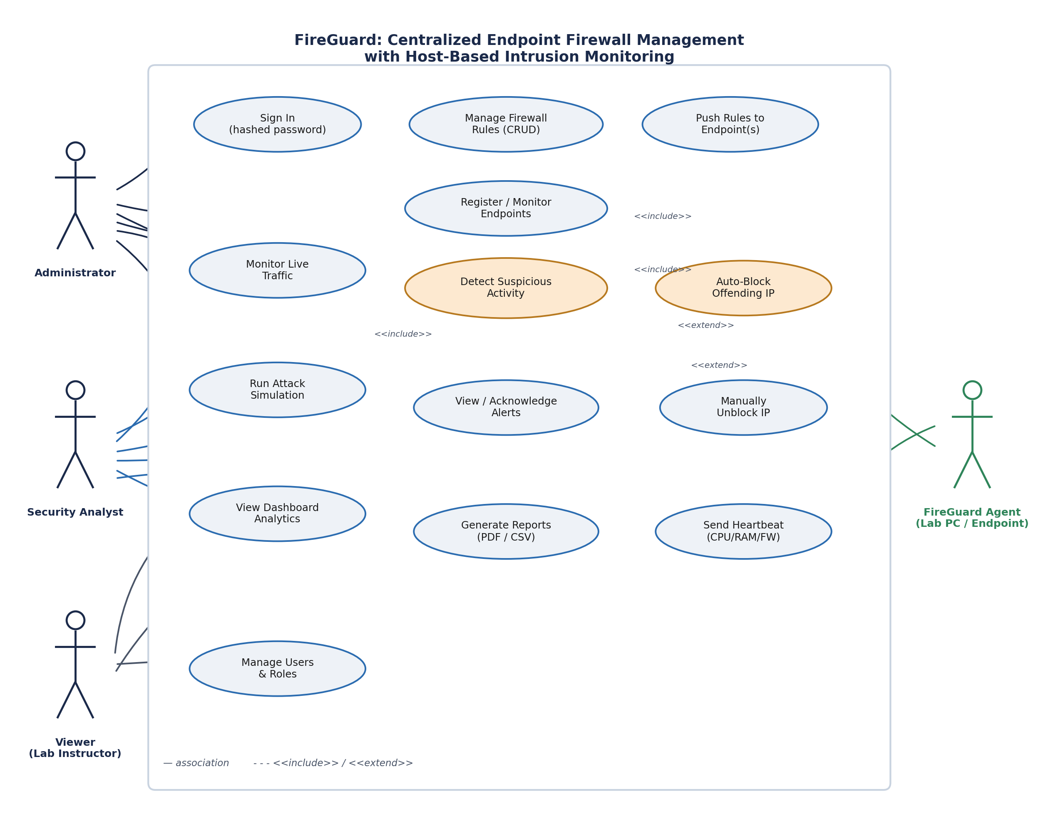
Actors: Administrator (full control), Security Analyst (monitor + respond to alerts), Viewer / Lab Instructor (read-only), and the FireGuard Agent running on each lab PC as an external system actor.

Target Users
- Network / Lab Administrators
- IT Security Officers / Cybersecurity Analysts
- System Administrators
- Lab Instructors (read-only Viewers)
- Educational Institution IT Departments

System Screenshots (UI)
The cells below are placeholders — insert your own live screenshots from the running FireGuard dashboard (each Description line is already written and matches what that screen actually shows).
User Information (/users)
[ INSERT SCREENSHOT HERE ]
Description: Administrator-only view listing every account: full name, username, email, role (Administrator / Security Analyst / Viewer), status, and last login — supports the Authorization and Accountability controls described above.
Network Device Inventory / Endpoint Fleet (/endpoints)
[ INSERT SCREENSHOT HERE ]
Description: Live fleet view of every registered lab PC: hostname, IP, MAC, Online/Offline/Warning status, last-seen time, and current CPU/RAM/connection count/firewall state from its latest heartbeat.
Connection / Traffic Logs (/logs)
[ INSERT SCREENSHOT HERE ]
Description: Chronological log of classified connection events (source IP, port, protocol, ALLOW/BLOCK verdict) produced by the traffic monitor thread.
Alert Logs (/alerts)
[ INSERT SCREENSHOT HERE ]
Description: Paginated list of every raised alert (Repeated Connections, High Connection Count, Restricted Port Access) with severity, timestamp, read status, and the currently blocked-IP list with manual unblock control.
Firewall Rule Management (/rules)
[ INSERT SCREENSHOT HERE ]
Description: CRUD screen for ALLOW/BLOCK rules (name, IP, port, protocol, status), each tagged with the Administrator who created it (created_by).
Reports (/reports)
[ INSERT SCREENSHOT HERE ]
Description: PDF/CSV export screen for traffic activity, with a history of previously generated reports.
Two-Factor Authentication Setup (/account/security)
[ INSERT SCREENSHOT HERE ]
Description: Self-service QR code enrollment for TOTP-based 2FA — scan once with an authenticator app, confirm with a 6-digit code, and every future login requires that code in addition to the password.
2FA Verification / Account Lockout (/login/verify-2fa)
[ INSERT SCREENSHOT HERE ]
Description: Second login step shown only to accounts with 2FA enabled. Repeated wrong passwords (5 attempts) instead show a temporary account-lockout message on the sign-in page itself.

Security Mechanisms — Source Code
Actual code from app.py — screenshot your own editor/IDE view of these exact locations if the rubric requires an IDE screenshot; the code and description are accurate to the current implementation.

Role-Based Authorization (RBAC)
def roles_required(*roles):
def decorator(view):
@wraps(view)
def wrapper(*args, **kwargs):
if session.get("role") not in roles:
flash("Your account does not have permission to do that.", "danger")
return redirect(url_for("dashboard"))
return view(*args, **kwargs)
return wrapper
return decorator
Description: A route decorator enforcing least-privilege access — e.g. @roles_required("Administrator") on the rules and users routes so only Administrators can modify firewall policy or accounts.

Password Hashing & Secure Authentication
from werkzeug.security import check_password_hash, generate_password_hash
def password_matches(stored_password, submitted_password):
if stored_password.startswith(("pbkdf2:", "scrypt:")):
return check_password_hash(stored_password, submitted_password)
return stored_password == submitted_password
Description: Login credentials are never stored in plaintext — passwords are hashed with werkzeug's pbkdf2/scrypt before comparison.

Global IP Enforcement Gate (Network Access Control)
@app.before_request
def enforce_ip_block():
client_ip = request.remote_addr
if not client_ip or client_ip in ("127.0.0.1", "::1"):
return
blocked = fetch_one(
"SELECT block_id FROM blocked_ips WHERE ip_address = ?", [client_ip]
)
if blocked:
return Response("403 Blocked", status=403, mimetype="text/html")
Description: Runs before every single request in the application. Any IP already blocked (manually, or auto-blocked by a detector) is rejected with 403 before it can reach any route — enforcing Availability and Integrity at the earliest possible point.

Client–Server Communication (Bearer-Token Agent API)
def _verify_agent_token(req):
"""Extract and validate the Bearer token from an agent request."""
auth = req.headers.get("Authorization", "")
if not auth.startswith("Bearer "):
return None
token = auth[7:].strip()
return fetch_one("SELECT * FROM endpoints WHERE agent_token = ?", [token])
@app.route("/api/agent/heartbeat", methods=["POST"])
def api_agent_heartbeat():
ep = _verify_agent_token(request)
if not ep:
return jsonify({"error": "Unauthorized"}), 401
...
Description: Each lab PC's agent authenticates with a unique, cryptographically random Bearer token (secrets.token_hex(20)) generated at registration — machine identity is never shared or guessable across endpoints.

Login Attempt Lockout & Two-Factor Authentication (2FA)
MAX_LOGIN_ATTEMPTS = 5
LOGIN_LOCKOUT_MINUTES = 15
def _register_failed_login(user):
execute("UPDATE users SET failed_attempts = failed_attempts + 1 "
"WHERE user_id = ?", [user["user_id"]])
refreshed = fetch_one("SELECT failed_attempts FROM users WHERE user_id = ?",
[user["user_id"]])
if refreshed["failed_attempts"] >= MAX_LOGIN_ATTEMPTS:
execute("UPDATE users SET locked_until = "
"DATEADD(MINUTE, ?, GETDATE()) WHERE user_id = ?",
[LOGIN_LOCKOUT_MINUTES, user["user_id"]])
# --- inside /login, after a correct password ---
if user.get("totp_enabled"):
session["pending_2fa_user_id"] = user["user_id"]
return redirect(url_for("verify_2fa")) # hold off on a full session
# --- /login/verify-2fa ---
totp = pyotp.TOTP(user["totp_secret"])
if code and totp.verify(code, valid_window=1):
_start_authenticated_session(user)
Description: Five wrong passwords locks the account for 15 minutes (failed_attempts/locked_until on users). If TOTP 2FA is enabled, a correct password alone is not enough — the session is only granted after a valid 6-digit code from the user's authenticator app is verified with pyotp. Setup is self-service at /account/security, which generates a QR code (pyotp + qrcode) the user scans once to link their authenticator app.

Accountability / Audit Trail
execute(
"""
INSERT INTO firewall_rules
(rule_name, ip_address, port, protocol, action_type, status, created_by, created_at)
VALUES (?, ?, ?, ?, ?, ?, ?, GETDATE())
""",
[rule_name, ip_address, port, protocol, action_type, status, session["user_id"]],
)
Description: Every firewall rule is permanently tied to the session user_id who created it, and every alert can be acknowledged_by a named user — giving the lab's IT department a traceable record of who changed network policy and when.

System Flow (Final Flow)
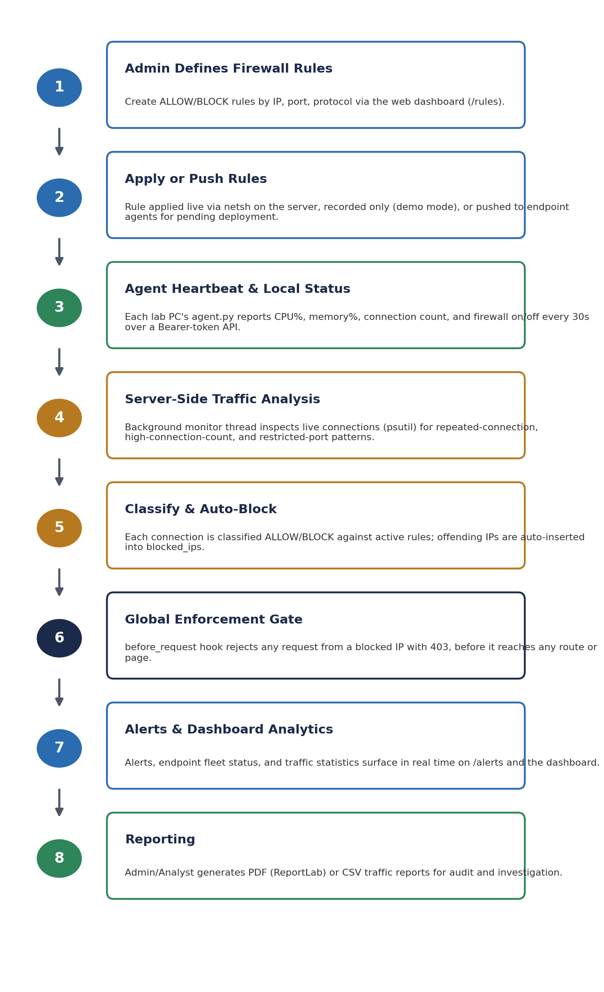

Date Submitted: | July ____ , 2026
Teacher's Feedback | _______________________________________________________  _______________________________________________________  _______________________________________________________  _______________________________________________________  _______________________________________________________  _______________________________________________________

________________________________________ ________________________________________
Student's Signature (after feedbacking) Teacher's Signature

