KIRUBA KARAN K,

Sri Sairam Engineering College,

Chennai 16

Assignment Version 1.1

Date : 13-06-2023

**LAB1 :**

In this networking lab, the objective is to establish a connection between two PCs and assign specific IP addresses to them. The main task is to examine the communication process using the "ping" command. Additionally, we will explore the purpose of Address Resolution Protocol (ARP) and understand why both MAC and IP addresses are necessary. We will also learn about ARP tables and how to view them.

commands such as "arp -d" and "arp -a" on the computers. These commands allow you to manage the Address Resolution Protocol (ARP) cache. By using "arp -d", you can delete entries from the ARP cache, and with "arp -a", you can view the contents of the ARP cache, which provides information about the IP-to-MAC address mappings.

**LAB2:**

In this networking lab, the objective is to establish a connection between multiple computers using a switch and assign unique IP addresses to each computer. The lab involves performing "ping" tests between neighboring computers to verify connectivity. Additionally, we will explore the MAC table in the switch and gain an understanding of its fundamental functionalities such as learning, flooding, and forwarding. Furthermore, we will experiment with basic configuration and view commands on the switch to familiarize ourselves with its operation.

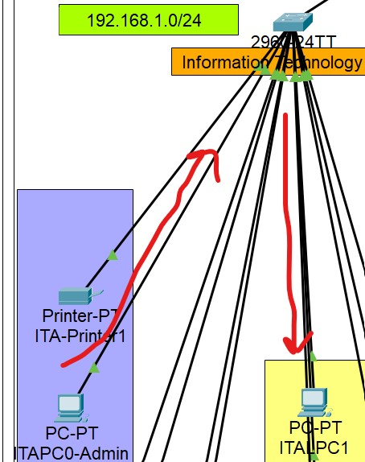

**LAB 3:**

In this lab setup, two computers are connected directly to each other using a wire, and different IP addresses are assigned to them with separate subnets. When attempting to ping one PC from the other, the ping operation fails. The objective is to investigate the reason behind this failed ping, despite the direct connection between the computers More Information: We observe that the ARP resolution is not occurring, leading to the failure of the ping. The Address Resolution Protocol (ARP) is responsible for mapping IP addresses to MAC addresses. In this case, since the computers are on different subnets, they are not in the same broadcast domain. As a result, the ARP messages from one PC cannot reach the other PC, preventing the MAC address resolution and subsequent successful communication.

This situation highlights the need for routers. Routers are devices that operate at the network layer (Layer 3) of the OSI model and facilitate communication between different subnets or networks. By connecting the two computers through a router, it can perform the necessary routing functions, including ARP resolution between subnets. This enables successful communication between devices on different subnets by forwarding packets between them.

**LAB 4:**

In this lab, the objective is to establish a connection between two computers using a router. The computers are configured to have different IP addresses. The lab involves performing a ping test from one computer to the other. Additionally, we will examine the routing table and route entries using commands such as "show ip route" and "show ip inter brief". This will allow us to understand how routing works and observe the routing entries.

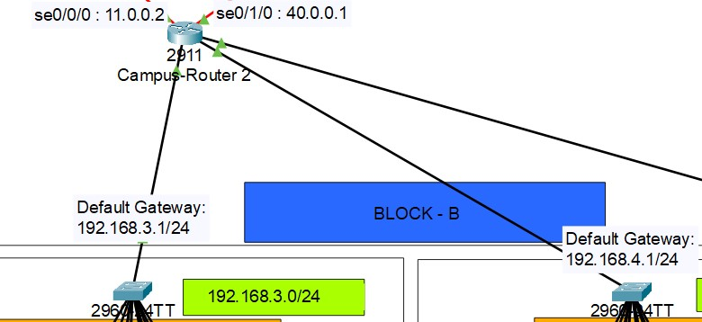

It is also important to understand the concept of a default gateway and its significance in networking. The default gateway refers to the IP address of the router that serves as the exit point for traffic from a local network to other networks.

The need for a default gateway arises when a device within a network needs to communicate with devices outside of its immediate network or subnet. When a device receives a packet destined for an external network, it checks its routing table to determine if it has a specific route for that destination. If there is no specific route available, the device forwards the packet to the default gateway.

The default gateway acts as the intermediary, forwarding packets from the local network to external networks, such as the internet. It serves as the entry and exit point for traffic going in and out of the local network, enabling communication with devices located in different networks or subnets.

In summary, the default gateway plays a crucial role in enabling network connectivity beyond the local network. It facilitates the routing of packets to external networks, allowing devices to communicate with resources outside of their immediate network.

**LAB 5:**

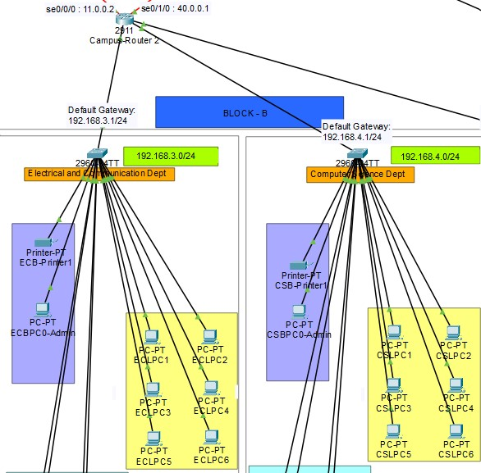

In this lab, the objective is to establish connectivity between multiple computers by utilizing two separate networks, a router, and a switch. The setup involves connecting the computers to the switch, which in turn is connected to the router, thereby enabling communication between the two networks.

The lab focuses on understanding how ping operations work between the two networks. By initiating ping commands from computers in one network to computers in the other network, we can examine the functionality of inter-network communication.

Additionally, we will explore the routing table in the router, which contains information about network routes and helps determine the best path for forwarding packets between the networks. The ARP table, which maintains IP-to-MAC address mappings, will also be examined to observe how address resolution occurs across the networks.

Furthermore, we will investigate the MAC table within the switch. The MAC table stores MAC addresses and associated ports, allowing the switch to efficiently forward frames to the correct destination.

By examining the routing table, ARP table, and MAC table, we can gain insights into the network's routing and switching operations, addressing resolution, and how the switch manages and forwards traffic between the connected networks

**LAB 6:**

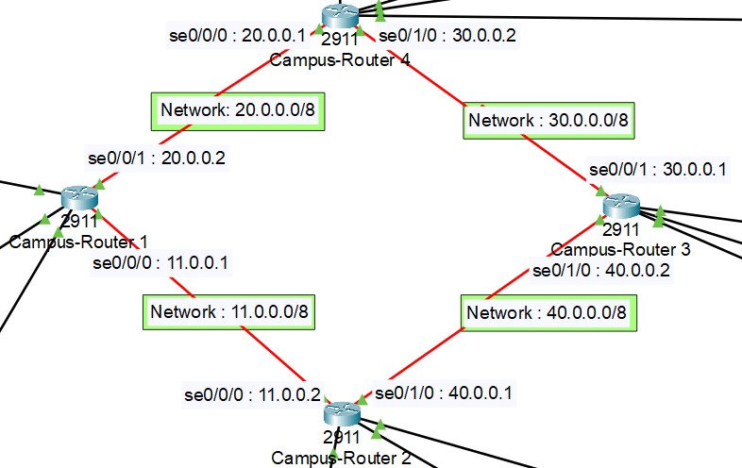

In this lab, the objective is to establish connectivity between different networks using routers. We will configure static routes to connect multiple networks. By utilizing the appropriate router commands, we can configure static routes and examine their configuration using the "show ip route" command.

Static routes are manually defined routes that specify the network destinations and next-hop routers to reach those destinations. By configuring static routes, we can direct traffic from one network to another through specific routers.

We will explore the routing information base (RIB) within the routers. The RIB is a database that contains routing information, including static routes, dynamic routes, and administrative distance values. It helps the router determine the best path for forwarding packets based on the destination IP address.

By using the "show ip route" command, we can view the contents of the RIB and observe the configured static routes. This command provides valuable information about the routing table, including network prefixes, next-hop routers, and administrative distances.

Understanding the RIB and how routers work is crucial for comprehending the decision-making process involved in routing packets. Routers analyze the destination IP addresses of incoming packets, consult the RIB, and use various routing protocols or static route configurations to determine the best path for forwarding the packets toward their destinations.

By configuring static routes, examining the RIB, and studying the router's operation, we can gain insights into how routers handle packet forwarding and how network connectivity is established between different networks.

**LAB 7:**

In this lab, the objective is to establish connectivity between multiple networks using routers. We will configure a dynamic routing protocol, such as RIP. The focus will be on understanding the RIP protocol(Routing Information Protocol).

We will utilize RIP to execute Dynamic Routing instead of Static. Each and every hop is determined by the router itself.

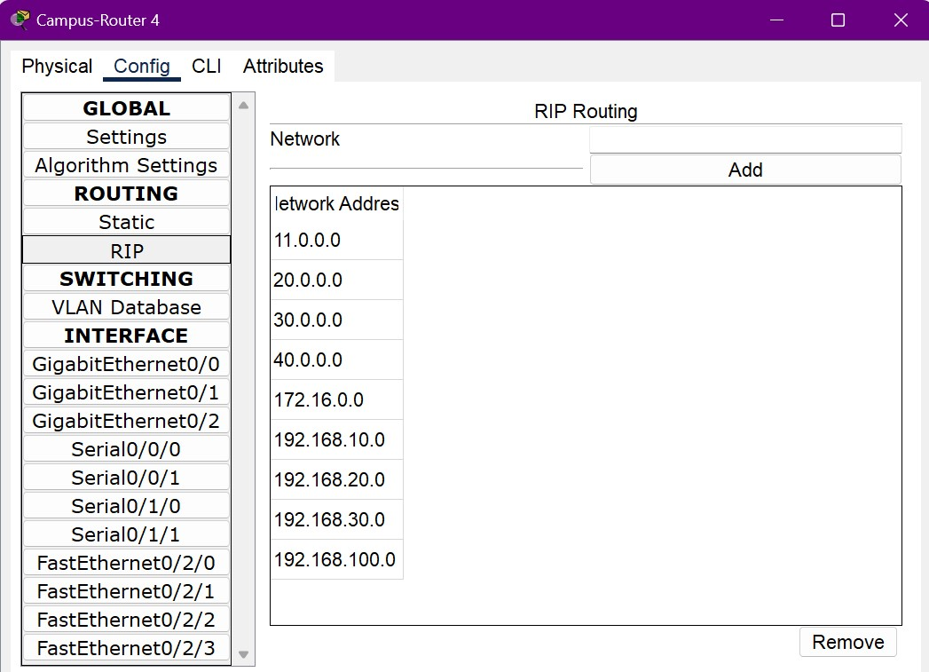

We configure the Routing Table by adding each and every Network that is connected to the routers.