Explainable AI Email Triage:
Model Selection and Baseline
Keith G. Broussard
University of the Cumberlands
MSAI 699-B01: Capstone
Dr. Gamini Bulumulle
July 19, 2026

Explainable AI Email Triage: Model Selection and Baseline
The purpose of this stage of the capstone was to select and implement an initial model for classifying email urgency, establish a performance benchmark, and identify areas for improvement. The Enron Email Dataset provides authentic organizational email data and has been used in prior email classification research (Cukierski, 2016; Klimt & Yang, 2004). The current experiment used 199 human-reviewed messages: 169 nonurgent and 30 urgent. Because urgent messages were the minority class, accuracy was evaluated alongside urgent precision, recall, F1-score, and false negatives.
Model Architecture and Justification
The baseline combines term frequency–inverse document frequency (TF-IDF) features with logistic regression. Subject and body text were combined, converted to lowercase, and represented with unigram and bigram TF-IDF features. English stop words were removed, and terms appearing in fewer than two training messages were excluded. Logistic regression was selected because it is efficient with sparse text, provides a clear initial benchmark, and produces coefficients that can be inspected for transparency. Beginning with a comparatively simple model also makes later improvements easier to evaluate (Burkov, 2019).
The approved records were divided into an 80/20 stratified split: 159 training messages and 40 test messages. The test set contained 34 nonurgent and six urgent messages. A random state of 42 made the split reproducible, and TF-IDF was fit within the training pipeline to prevent test-set information from influencing feature construction. The implementation used scikit-learn (Pedregosa et al., 2011).
Three models were compared exploratorily on the fixed holdout: a majority-class dummy, unweighted logistic regression, and a class-balanced variant. Class weighting gave urgent examples more influence without changing labels or the split. Because this holdout also identified the preferred variant, its result is preliminary rather than an untouched final estimate.
Initial Results
The dummy and unweighted models predicted every test message as nonurgent, making their 85.0% accuracy misleading. The class-balanced model achieved 87.5% accuracy, 66.7% urgent precision, 33.3% urgent recall, and 44.4% urgent F1. It produced 33 nonurgent true negatives, one false positive, two urgent true positives, and four urgent false negatives; therefore, urgent recall remains the primary weakness.
Figure 1
Class-Balanced Logistic Regression Confusion Matrix
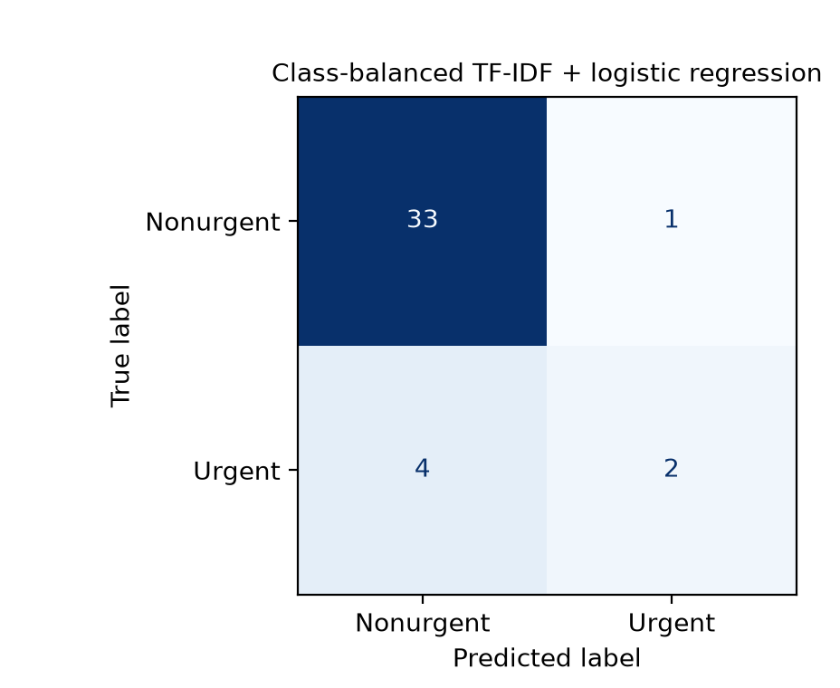
Note. Rows are actual labels; columns are predicted labels. Four of six urgent messages were missed.
Potential Improvements and Conclusion
The misses included urgent notices, a near-term deadline, and an active outage, showing inconsistent generalization across contexts. This preliminary baseline is not deployment-ready: only six urgent messages were tested, sampling was urgency-enriched, and the holdout helped select the variant. Future work should expand the dataset, group related messages, reserve evaluation data, and evaluate thresholds using cross-validation.
Acknowledgment of Generative AI Assistance
OpenAI ChatGPT and Codex were used from July 15–19, 2026, to assist with project planning, code review, debugging, documentation organization, interpretation of model outputs, and proposing candidate labels under the project’s labeling guide. I reviewed the complete messages, corrected or approved the final labels, executed and verified the notebook, selected the modeling decisions, checked the supporting sources, and revised the final submission. I take responsibility for the project’s methodology, analysis, interpretations, and submitted content.

References
Burkov, A. (2019). The hundred-page machine learning book. Andriy Burkov.
Cukierski, W. (2016). Enron email dataset [Data set]. Kaggle. https://www.kaggle.com/datasets/wcukierski/enron-email-dataset
Klimt, B., & Yang, Y. (2004). The Enron corpus: A new dataset for email classification research. In J.-F. Boulicaut, F. Esposito, F. Giannotti, & D. Pedreschi (Eds.), Machine learning: ECML 2004 (pp. 217–226). Springer. https://doi.org/10.1007/978-3-540-30115-8_22
Pedregosa, F., Varoquaux, G., Gramfort, A., Michel, V., Thirion, B., Grisel, O., Blondel, M., Prettenhofer, P., Weiss, R., Dubourg, V., Vanderplas, J., Passos, A., Cournapeau, D., Brucher, M., Perrot, M., & Duchesnay, É. (2011). Scikit-learn: Machine learning in Python. Journal of Machine Learning Research, 12, 2825–2830. https://jmlr.org/papers/v12/pedregosa11a.html

