Week 4 Model Optimization Report
Keith G. Broussard
University of the Cumberlands
MSAI 699-B01: Capstone
Dr. Gamini Bulumulle
July 24, 2026
Week 4 Model Optimization Report
Purpose and Experimental Design
Week 4 required a documented model-improvement experiment, evaluation of accuracy, precision, recall, and F1-score, an explainability method, and an ethical discussion (Course instructor, 2026). I preserved the submitted Week 3 class-balanced TF-IDF and logistic-regression model as the comparison point. The purpose was not to claim that a small historical email sample is ready for automated triage. I wanted to determine whether a bounded, reproducible tuning experiment provided enough evidence to retain a candidate for further refinement.
The reviewed dataset contains 199 messages: 169 nonurgent and 30 urgent. I preserved the Week 3 split of 159 training messages and 40 holdout messages. Model selection used five-fold stratified cross-validation on the training partition only. Because the 40-message holdout informed the earlier Week 3 exploration, it remains preliminary comparison evidence rather than an untouched final estimate. Repeatedly selecting models from that holdout would make the result look more certain than the evidence supports.
GridSearchCV evaluated 24 class-balanced TF-IDF/logistic-regression configurations. The grid varied regularization (C = 0.1, 1.0, or 10.0), unigram versus unigram-plus-bigram features, minimum document frequency (1 or 2), and sublinear term frequency. I selected urgent-class F1 because accuracy alone can look acceptable while urgent messages are missed (Burkov, 2019). The selected candidate used C=0.1, unigram TF-IDF, min_df=2, and sublinear term frequency. Tied configurations were resolved by the deterministic GridSearchCV winner, not by reviewing holdout outcomes.

Results and Tradeoffs
In mean five-fold cross-validation, urgent F1 increased from 6.7% for the frozen baseline to 11.4% for the selected candidate. Urgent recall increased from 4.0% to 8.0%, while mean accuracy increased from 83.7% to 86.2%. Mean urgent precision remained 20.0% for both models. The candidate therefore improved the primary model-selection evidence while using a smaller feature space.
Table 1
Cross-Validation and Preliminary Holdout Comparison
Measure | Baseline | Candidate
Mean CV accuracy | 83.7% | 86.2%
Mean CV urgent precision | 20.0% | 20.0%
Mean CV urgent F1 | 6.7% | 11.4%
Mean CV urgent recall | 4.0% | 8.0%
Preliminary holdout urgent F1 | 44.4% | 44.4%
Preliminary holdout false negatives | 4 | 4
TF-IDF features | 4,097 | 2,895
The result is useful but not conclusive. The urgent class is small, and the fold-level urgent F1 varied substantially. The candidate used 2,895 features instead of 4,097 and had lower single-run fit and scoring times, but those lightweight efficiency measures are not deployment benchmarks. The preliminary holdout did not improve: both models retained four urgent false negatives and one false positive.
Figure 1
Preliminary Holdout Confusion Matrices
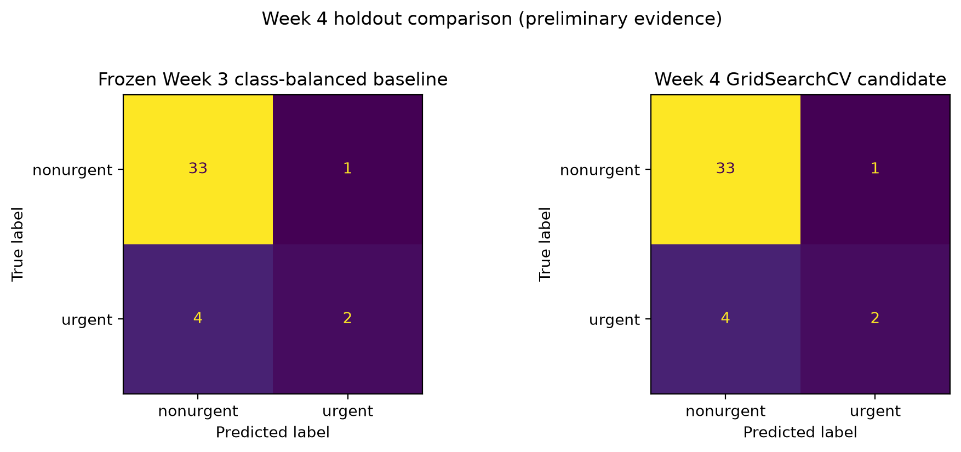
Note. Both models have four urgent false negatives and one false positive on the preliminary holdout.
Explainability, Error Analysis, and Ethical Decision
I implemented SHAP for global and local explanation. The notebook includes global feature attribution plus local explanations for a correct urgent prediction, an urgent false negative, and a false positive. Figure 2 includes terms such as meeting, need, today, and tomorrow among the more influential global features. They are learned associations in this model, not proof that a message is urgent.
Figure 2
Global SHAP Feature Attributions for the Selected Candidate
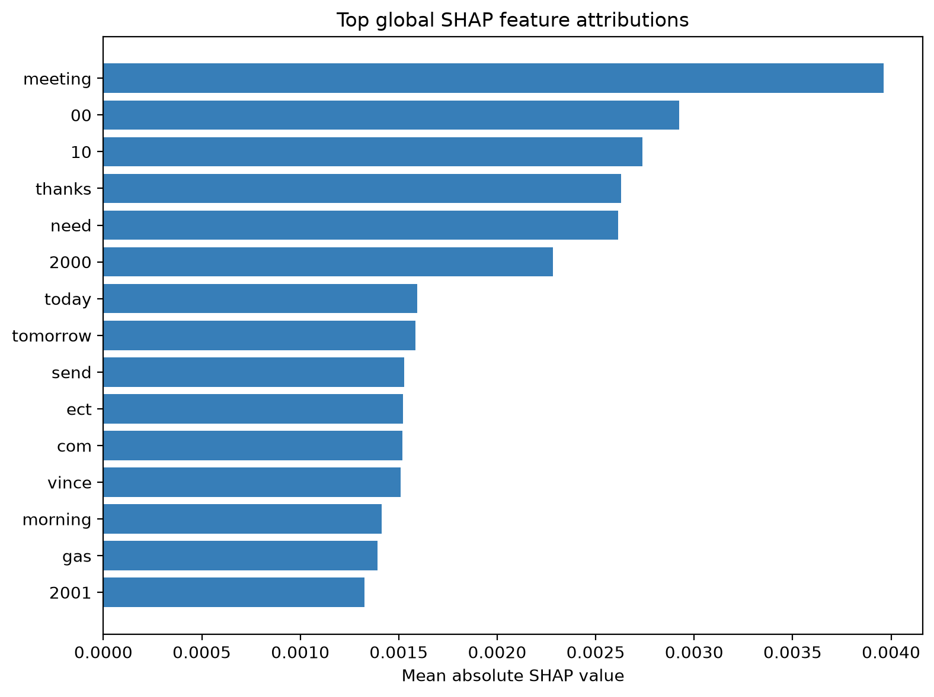
Note. Higher mean absolute SHAP values indicate stronger average influence on model output within the evaluated data.
Names, dates, numbers, and organization-specific terms can reflect the small historical sample instead of a reusable urgency rule. Explainability supports inspection and error analysis, but it does not establish causation, fairness, or generalizability (Keita, 2023). The error review found four urgent false negatives and one false positive. Missed messages covered deadline or administrative requests, operational outage context, technical or forwarded notices, and explicit urgency with a deadline.
An exact-text check found no train-holdout duplicates, but it cannot identify related messages. The repository excludes raw bodies and reports only aggregate metrics and error categories. No reliable protected attributes are available for fairness measurement. Because the holdout remains preliminary with four urgent false negatives, I retained the candidate for refinement, not deployment. It remains human decision support.
References
Burkov, A. (2019). The hundred-page machine learning book. Andriy Burkov.
Course instructor. (2026). Week 4 model optimization report assignment [Course assignment]. MSAI-699 Capstone.
Keita, Z. (2023, May 10). Explainable AI: Understanding and trusting machine learning models. DataCamp. https://www.datacamp.com/tutorial/explainable-ai-understanding-and-trusting-machine-learning-models

