Model Testing and Debugging Report
Keith G. Broussard
University of the Cumberlands
MSAI 699-B01: Capstone
Dr. Gamini Bulumulle
August 8, 2026

Model Testing and Debugging Report
This Week 6 test evaluated whether a change in the probability threshold could improve urgent-message reliability without creating an unusable review burden. Nested cross-validation revealed a threshold failure rather than a deployable gain: 0.45 achieved 100% urgent recall only by labeling every message as urgent, while 0.50 missed most urgent examples. I froze the revise disposition before the preliminary holdout comparison, which repeated the tradeoff and did not change the decision.

Testing Method and Results
The population contained 199 messages: 159 training and 40 preliminary holdout. The frozen class-balanced logistic-regression candidate used unigram TF-IDF and C = 0.1. Five outer stratified folds evaluated the procedure, while four inner folds selected thresholds from 0.20 through 0.50, keeping selection separate from evaluation (Scikit-learn developers, n.d.-a). Urgent F1 was primary; recall and false negatives were safety measures; and false positives measured review burden (Scikit-learn developers, n.d.-b).
Table 1
Cross-Validation and Preliminary Holdout Threshold Evidence
Measure | Threshold 0.45 | Threshold 0.50
Outer-CV urgent precision | 15.1% | 100.0%
Outer-CV urgent recall | 100.0% | 8.3%
Outer-CV urgent F1 | 26.2% | 15.4%
Outer-CV FP / urgent FN | 135 / 0 | 0 / 22
Holdout urgent precision | 15.0% | 66.7%
Holdout urgent recall | 100.0% | 33.3%
Holdout urgent F1 | 26.1% | 44.4%
Holdout FP / urgent FN | 34 / 0 | 1 / 4

Error Analysis and Debugging
Across 159 outer-fold predictions, 0.45 found all 24 urgent messages but created 135 false positives. A threshold of 0.50 produced no false positives but found only two urgent messages. The recall-and-F1 rule was incomplete because it lacked a specificity or review-capacity guardrail.
Figure 1
Outer-Fold Confusion Matrices for the Two Threshold Strategies
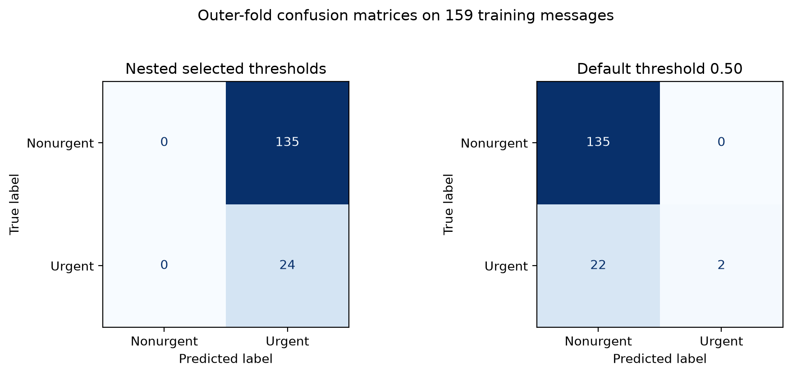
Note. Matrices summarize one prediction for each training message across the five outer folds.
The error file contained 135 false positives at 0.45 and 22 false negatives at 0.50. Probabilities spanned only 0.4643 to 0.5054, with 157 of 159 between the two thresholds. ROC AUC was 0.715 and average precision was 0.388, indicating some ranking signal, but the Brier score was 0.237, compared with 0.128 for a constant prevalence probability. Because class weighting shifts probabilities, this is a calibration warning rather than proof that class weighting should be removed.
The failure appeared in both sampling strata: 0.45 mislabeled every nonurgent example, while 0.50 missed 15 of 16 general-random and 7 of 8 urgency-enriched urgent messages. The common problem was probability compression around the operating boundary.

Reliability, Best Practices, and Final Decision
The Week 6 improvement was a more reliable evaluation process, not better model performance. Nested validation separated selection from evaluation, the decision was frozen before the holdout, and reproducibility hashes tied results to saved artifacts. The workflow also rejected a favorable recall number after the confusion matrix exposed an unusable all-urgent queue.
Three practices should guide the next test. First, register minimum specificity or maximum review burden before evaluating thresholds. Second, keep model and threshold choices within nested training and validation, and reserve an untouched test set. Third, preserve the notebook, aggregate metrics, error types, figures, and hashes without exporting message content or reviewer notes. Direct headings and consistent terminology also strengthen technical documentation (Google for Developers, n.d.).
The preliminary holdout supported the frozen revise decision but did not authorize another selection step. Threshold 0.45 labeled all 40 messages as urgent; 0.50 found two of six urgent messages, missed four, and created one false positive. The decision file remained byte-identical. Because this holdout influenced earlier work, the comparison remains descriptive.
The final disposition is revise, with no approval for deployment or shadow testing. False negatives can delay attention, while an all-urgent rule overwhelms the reviewer. The enriched sample does not estimate production prevalence, the holdout is not untouched, and protected demographic attributes are unavailable. I therefore cannot claim production reliability or demographic fairness. Human review remains required. Next, I would expand urgent examples, register review burden, test calibration inside nested validation, and reserve a new grouped test set.

References
Course instructor. (2026). Week 6: Testing, evaluation & documentation [Course assignment]. MSAI-699 Capstone.
Google for Developers. (n.d.). Google developer documentation style guide. https://developers.google.com/style
Scikit-learn developers. (n.d.-a). Nested versus non-nested cross-validation. https://scikit-learn.org/stable/auto_examples/model_selection/plot_nested_cross_validation_iris.html
Scikit-learn developers. (n.d.-b). Precision, recall, F-measure, and support. https://scikit-learn.org/stable/modules/generated/sklearn.metrics.precision_recall_fscore_support.html

